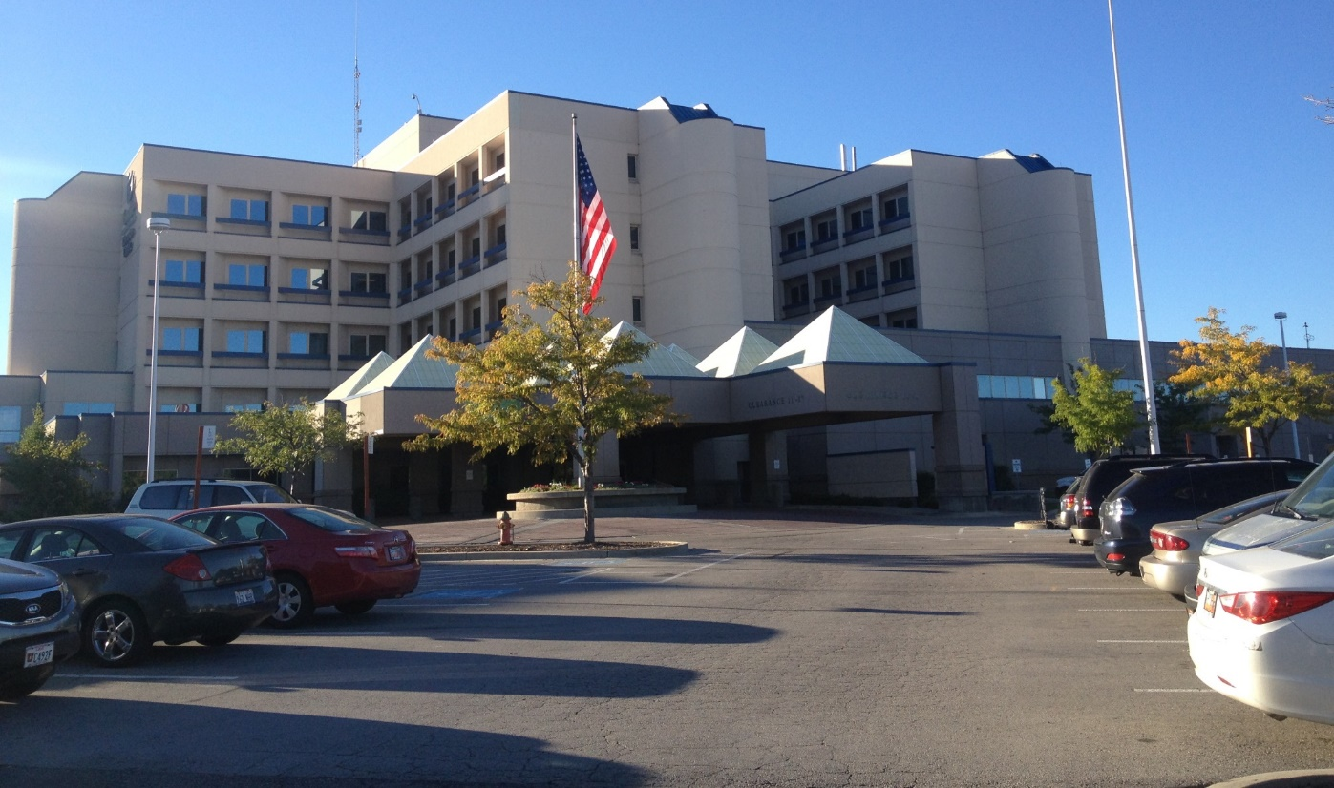

**Granite Technical Institute**

The Granite Technical Institute is an opportunity for students to gain career-level education in many fields, and to prepare students for post-secondary education. Collaboration with Salt Lake Community College through the concurrent enrollment program serve to ease the transition to college even more.

**Mission Statement:**

THE MISSION OF THE GRANITE TECHNICAL INSTITUTE IS TO SUPPORT STUDENTS IN FINDING PERSONAL PURPOSE, POTENTIAL AND A PATHWAY TO THEIR FUTURE.

This is accomplished by helping students achieve in their program and to move seamlessly to further training and employment. Efforts are being made to directly align critical academic subjects with career and technical education courses, thus promoting real-world application to academic theory in such areas as mathematics, science and English. In addition, articulation and collaboration with Salt Lake Community College and other post-secondary institutions is being enhanced in order to make the transition to further education easier for students. Clear pathways of training have been designed to support student growth from the 9th through the 12th grades.

The Department of Career and Technical Education in Granite School District has a well-earned reputation for providing high- quality programs that are targeted at high-demand industries. To further this focus, The Granite Technical Institute offers courses in Health Science & Technology, Engineering, Information Technology, Biotechnology/Biomanufacturing, Culinary Arts, Aviation, Agriculture, Cosmetology/Barbering, and Home Building/Construction.

**How to Sign Up**

In order to register for any of the classes offered through the Granite Technical Institute, students must first pick up an application in the Career Center of their high school or click on the link below. Once the application is complete and signed by both the student and their guardian, it should be returned to the Career Center for review and approval by the Career Center Coordinator. The Career Center Coordinator will then help the student determine whether or not additional information is required and will help facilitate the scheduling process.

Application 2016-2017(hyperlink: <http://schools.graniteschools.org/gti/files/2015/11/App.2016.17.pdf> )

**Transportation (Bus)**

Transportation (bus) will be provided for students twice daily from the student’s home high school to the GTI. All courses listed in the catalog will be taught at the Granite Technical Institute unless otherwise specified. This schedule is designed to accommodate the two-period block enrollments. Students interested in registering for these courses should see the Career Center Coordinator at their high school.

Address: 2500 State St, Salt Lake City, UT 84115

Phone: (385) 646-4350

Course Catalog

(Hyperlink: GTICourseCatalogCurrent.pdf)

GTI Website

(Hyperlink: <http://schools.graniteschools.org/gti/> )