

(Banner Image)

**Fundraising**

As anyone can understand, raising money is important. This is especially important for TSA chapters who have to provide materials for members as well as paying for the state and national conferences. Skyline TSA uses a variety of fundraising ideas to gain funds to pay for the chapter.

**Grants & Sponsorships**

1. VEX Robotics - The FRC foundation offers some grants that you can apply to to receive financial aid as well as products.
2. Sponsorships - Many STEM companies are willing to give out money to STEM related organizations such as TSA. If you create a written proposal and presentation for companies such as Adobe, Microsoft, I Am Flash and others would be willing to listen.

**Fundraising Ideas**

1. Candy Cane Crush - Send candy canes to friends and crushes during the holiday season.
2. Papa Murphy's Gift Card Promotions - Purchase Papa Murphy's gift cards to save over $50 on pizza.
3. Donut Friday's - Sell donuts on friday before and after school.
4. Carwashes - Wash student and faculty cars.
5. Concession Sales - Sell cookies, popcorn, muffins, hot chocolate, candy, sodas, and other snacks during lunch, before school, and after school.
6. Autumn/Spring Yard Cleanup - Offer service to do yardwork for Autumn/Spring season cleanup.

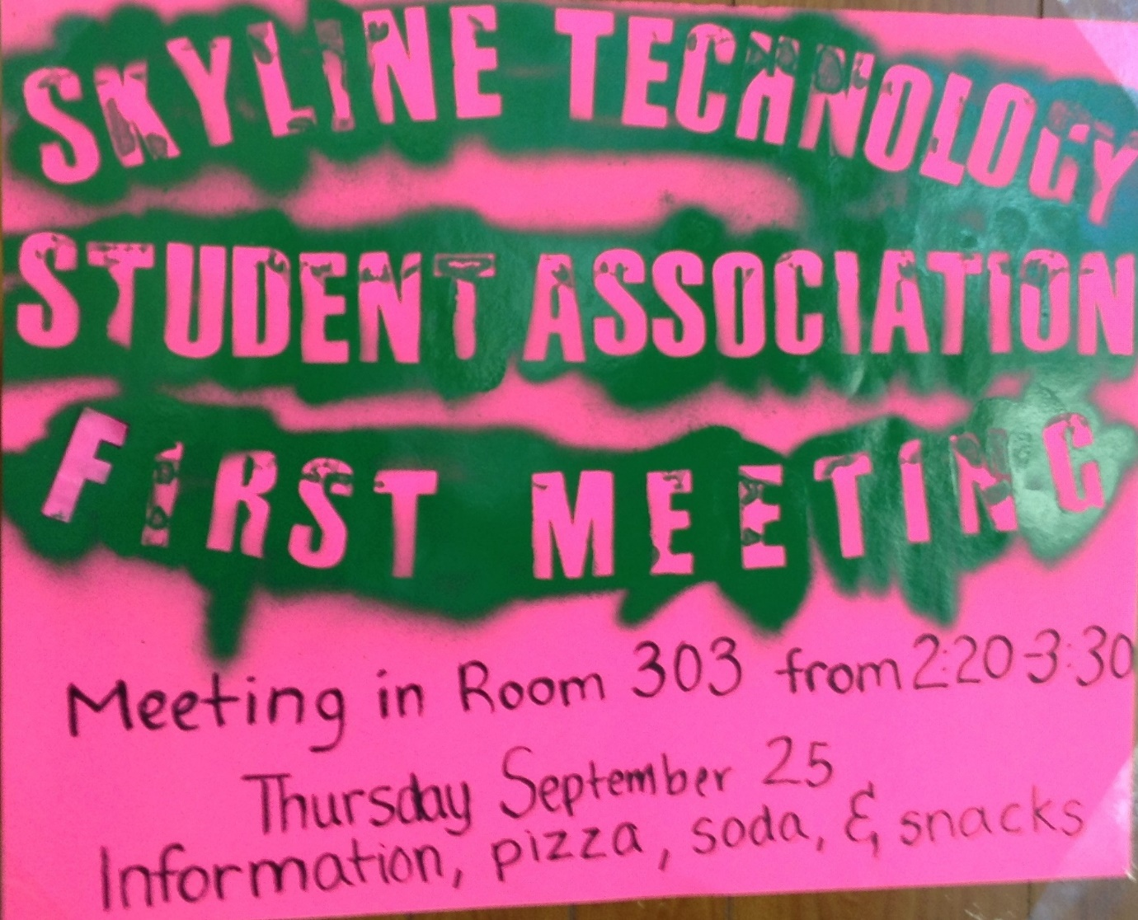

(idk about this image, its advertisement, but it looks pretty shitty, optional)