**Skyline TSA General**

[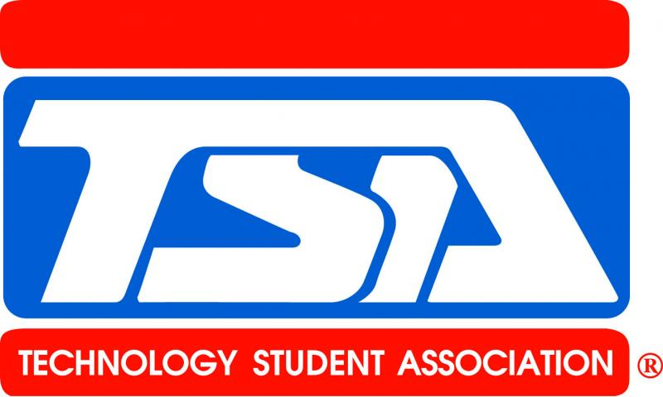](http://skylinehs.github.io/SkylineTSAWebsite/TSA/General.html)

**Who Are TSA Members?**

The Technology Student Association (TSA) is a national student organization devoted exclusively to the needs of students who are engaged in science, technology, engineering and mathematics (STEM).  Open to students enrolled in or who have completed technology education courses, TSA’s membership includes over 200,000 middle and high school students in approximately 2,000 schools spanning 49 states. TSA is supported by educators, parents and business leaders who believe in the need for a technologically literate society. Members learn through exciting competitive events, leadership opportunities and much more. The diversity of activities makes TSA a positive experience for every student. From engineers to business managers, our alumni credit TSA with a positive influence on their lives.

**School Chapters**

TSA chapters take the study of STEM beyond the classroom and allows students the chance to pursue their interests among friends with similar goals and interests. Together, chapter members work on competitive events, attend conferences on the state and national levels and have a good time raising funds to get there. Chapter organization develops leadership, as members may become officers within their state and then run nationally. Our chapters are committed to a national service project and are among the most service-oriented groups in the community.

**How To Start A TSA Chapter**

All that is needed is a motivated teacher and an eager group of students. An expensive array of high-tech equipment is not necessary. Just call 801-867-0372 or click on Join TSA for more information.

**Competitions**

In order to engage students with the drive to make a difference in the worl, TSA offers activities that captivate and intrigue students into spending hours working on it after school for weeks at a time. TSA members have the opportunity to compete at exciting state conferences and then the annual National Conference. These competitions focus on the subjects of science, technology, engineering and math, however can vary greatly to suit the interests of the member. Students can work individually or as a team member in areas such as agriculture and biotechnology, website design, dragster design, flight challenge, film technology, CAD with 3D modeling, desktop publishing, debate, fashion design, radio controlled transportation, or scientific visualization.

**Curriculum Integration - STEM**

Education directives at the federal and state levels focus on providing avenues for initiatives such as STEM (Science, Technology, Engineering and Mathematics) education. TSA helps teachers meet the criteria for STEM education goals through exciting programs that include technology activities, competitions, leadership, and teamwork for students. In addition, all TSA activities are correlated to the Standards for Technological Literacy, as set forth by the International Technology and Engineering Educators Association (ITEEA). Teachers can use TSA’s activities during the school day in their classroom and extend the learning beyond the classroom through a TSA chapter.

**Mission Statement**

The Technology Student Association fosters personal growth, leadership, and opportunities in Science, Technology, Engineering, and Mathematics (STEM); members apply and integrate these concepts through co-curricular activities, competitions, and related programs.

**TSA Motto**

“Learning To Live In A Technical World”

**TSA Creed**

I believe that Technology Education holds an important place in my life in the

technical world.

I believe there is a need for the development of good attitudes concerning work, tools, materials, experimentation, and processes of industry.

Guided by my teachers, artisans from industry, and my own initiative, I will strive to do my best in making my school, community, state and nation better places in which to live.

I will accept the responsibilities that are mine.

I will accept the theories that are supported by proper evidence.

I will explore on my own for safer, more effective methods of working and living.

I will strive to develop a cooperative attitude and will exercise tact and respect for other individuals. Through the work of my hands and mind, I will express my ideas to the best of my ability. I will make it my goal to do better each day the task before me, and to be steadfast in my belief in my God, and my fellow Americans.

Utahtsa.org

Tsaweb.org