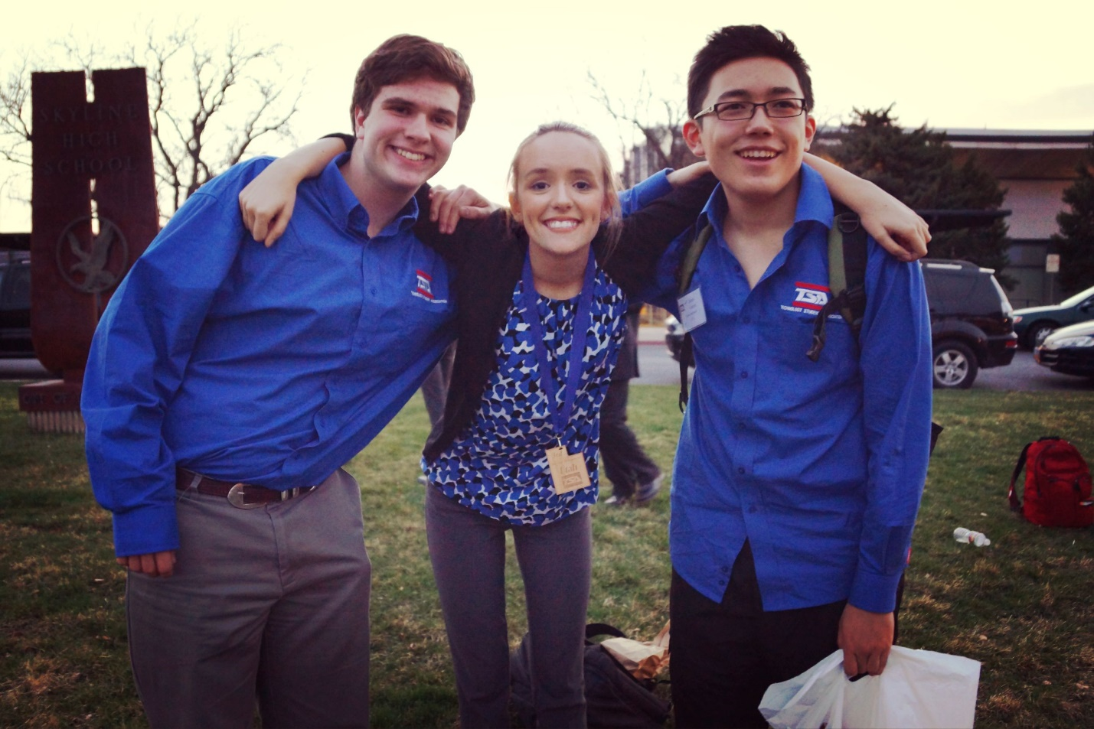

(Banner Image)

**Leadership**

**Advisor**

**Mr. Ken Kapptie**

Email: [kkapptie@graniteschools.org](mailto:kkapptie@graniteschools.org)

Phone: (801) 209-5262

Bio: Mr. Kapptie is the dedicated and vigilant advisor to Skyline TSA. He is a very capable mentor, willing to help any of his students at a moment’s notice with TSA, technology, or computer projects. He also has interests in Harley Davidson Motorcycles, electric guitars, corvettes, basketball, programming, WoW, and his children.

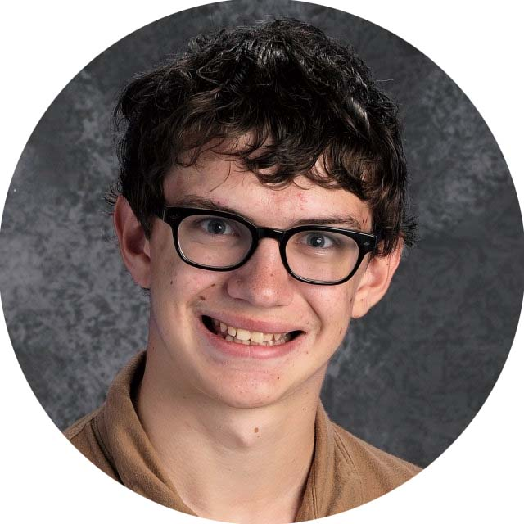**President**

**Mr. Preston Richey**

Email: [jpyrichey@gmail.com](mailto:jpyrichey@gmail.com)

Phone: (801) 875-2742

Bio: Preston has always loved TSA all the way back to his humble beginning in 7th grade. He has spent 5 years of his life, dedicated to building up TSA both at Skyline and past schools. As our president he is confident in the capabilities of Skyline’s members and will always support them in everything they do.

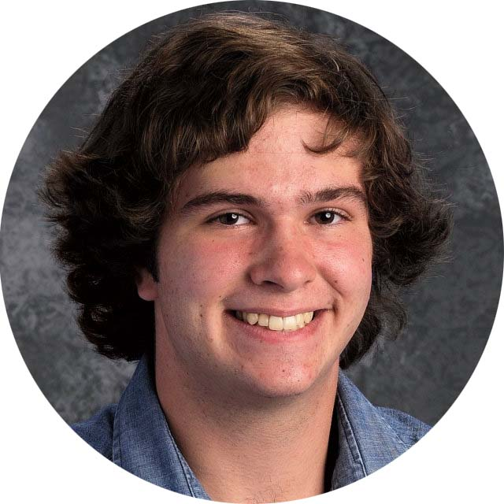**Vice President**

**Jeffrey Worley**

Email: [jeff@theworleys.com](mailto:jeff@theworleys.com)

Phone: (801) 842-1218

Bio: Jeff has big dreams of becoming an engineer in the future. TSA is the perfect place for him to display his tech skills and affinity for computer science and robotics.

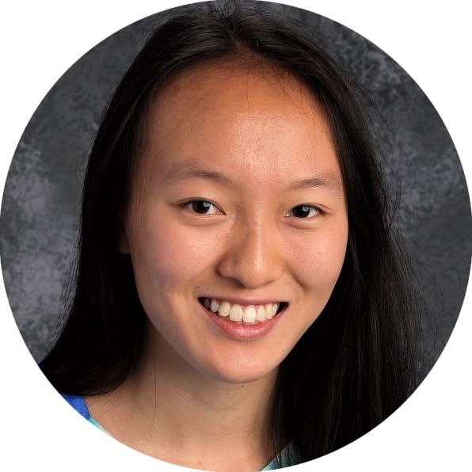**Secretary**

**Lydia Duan**

Email: [lydiatiger18@gmail.com](mailto:lydiatiger18@gmail.com)

Phone: (702) 480-7192

Bio: Lydia is one of the strongest academic students of her class and the sweetest person you could meet. You can always find her splitting time between debate, the play, or piano to name a few extra-curricular’s she’s a part of, but of course, TSA is her favorite.

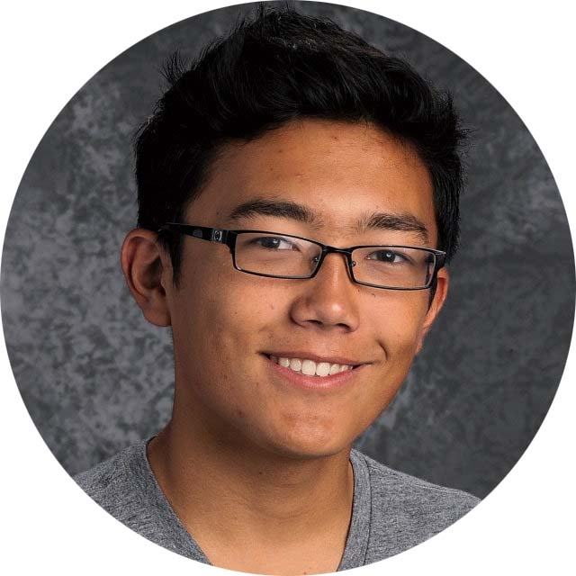**Treasurer**

**Alexei Garcia**

Email: [alexeig9@gmail.com](mailto:alexeig9@gmail.com)

Phone: (385) 290-5434

Bio: Alexei loves VEX Robotics, Webmaster, Debating Technology Issues and working on TSA instead of doing schoolwork (procrastination). Outside of TSA, he plays volleyball and runs cross-country where he finds it a bit difficult to show his tech skills on the court.

**Reporter**

**Emi Radetich**

Email: [radetichemi@gmail.com](mailto:radetichemi@gmail.com)

Phone: (801) 440-6328

Bio: Emi Radetich is the reporter for TSA! She enjoys TSA because of the people. Emi is participating in Biotechnology Design, Career Prep, Future Tech Teacher, and Promotional Graphics this year. She wants to major in biomedical engineering and eventually wants to become a professor, influencing her to join the first three competitions, while her hand in art assists her in Promotional Graphics.

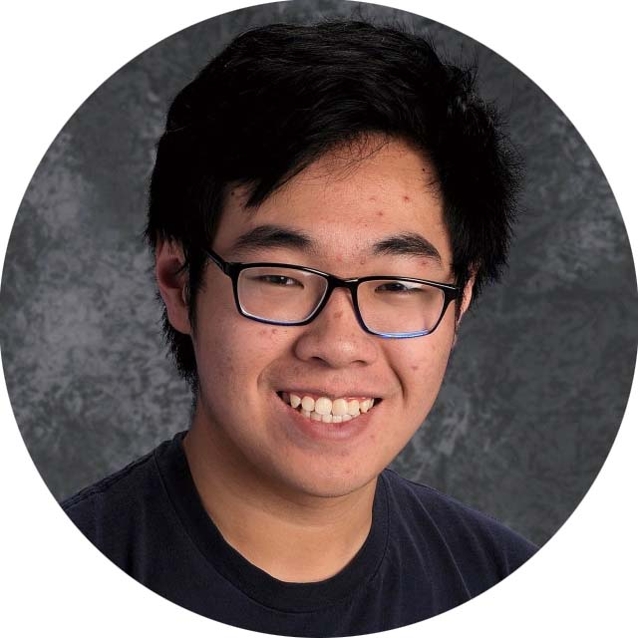

**Sergeant-at-Arms**

**Bernard Li**

Email: [bernardli123@gmail.com](mailto:bernardli123@gmail.com)

Phone: (801) 541-7797

Bio: Bernard brings a fresh perspective to Skyline TSA with his charming and unique character. He is always has a way to lighten the mood and also provides meaningful contributions to his projects. His focus in the future is a pathway in music and STEM.

**Parliamentarian**

**Colin Shen**

Email: [colin.m.shen@gmail.com](mailto:colin.m.shen@gmail.com)

Phone: (801) 643-9643

Bio: Colin enjoys tech bowl and VEX robotics. He is one of the officers in charge of keeping the competition list updated, and help with miscellaneous tasks as he puts it, “the Chapter's 7th Wheel”.

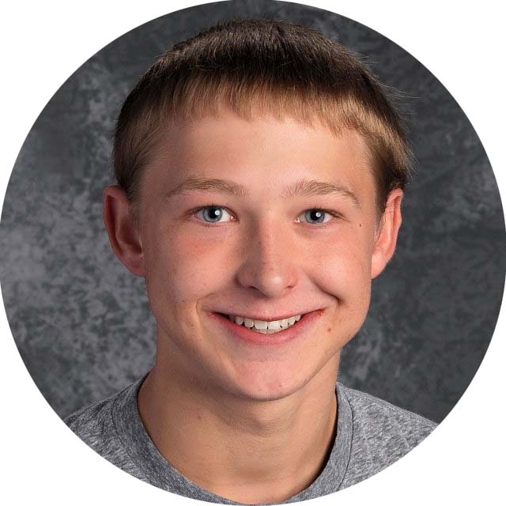**Historian**

**Joshua Norman**

Email: [joshdnorman@gmail.com](mailto:joshdnorman@gmail.com)

Phone: (385) 216-0573

Bio: Josh and his experience with TSA goes back to his junior high days. There, he cultivated his love for science, technology, and physics and was really invigorated with TSA. Nowadays he stays busy in high school but still works hard on his competitions.