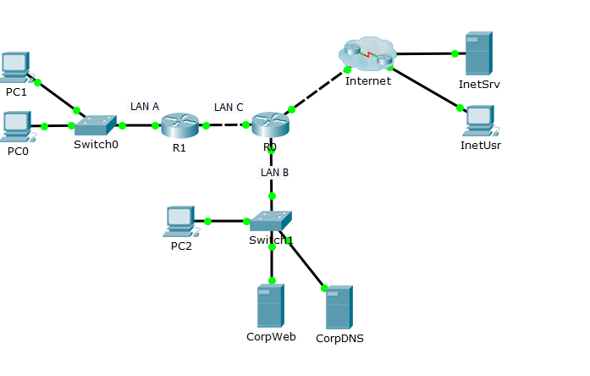

Рис.1. Схема сети.

### Сведения о конфигурации устройств

| Устр-во | Интерфейс | IP-адрес | Маска подсети | Шлюз |
| --- | --- | --- | --- | --- |
| R1 | F0/0 | 192.168.5.1 | 255.255.255.0 | - |
| F0/1 | 172.16.5.1 | 255.255.255.0 | - |
| R0 | F0/1 | 172.16.5.2 | 255.255.255.0 | - |
| F0/0 | 172.17.5.1 | 255.255.255.0 | - |
| E0/1/0 | 10.0.1.2 | 255.255.255.0 | - |
| PC 0 | NIC | 192.168.5.2 | 255.255.255.0 | 192.168.5.1 |
| PC 1 | NIC | 192.168.5.3 | 255.255.255.0 | 192.168.5.1 |
| PC 2 | NIC | 172.17.5.254 | 255.255.255.0 | 172.17.5.1 |
| CorpWeb | NIC | 172.17.5.252 | 255.255.255.0 | 172.17.5.1 |
| CorpDNS | NIC | 172.17.2.253 | 255.255.255.0 | 172.17.5.1 |
| InetUsr | NIC | 192.168.1.3 | 255.255.255.0 | 192.168.1.1 |
| InetSrv | NIC | 192.168.1.2 | 255.255.255.0 | 192.168.1.1 |

### Сведения о настроенных NAT

|  |  |  |  |
| --- | --- | --- | --- |
| Устр-во | Интер-фейс inside | Интер-фейс outside | Команды конфигурирования NAT  (включая пул и ACL) |
| R1 | F0/0 | F0/1 |  |
| R0 | F0/1,  F0/0 | Eth0/1/0 |  |

### Анализ пакетов в режиме симуляции

|  |  |  |  |
| --- | --- | --- | --- |
| **PC0 –** [**www.corp.com**](http://www.corp.com) | | | |
| На устройстве | Source IP | Destination IP | Тип NAT |
| PC0 - out | 192.168.5.2 | 172.17.5.252 |  |
| R1 - in | 192.168.5.2 | 172.17.5.252 | динамический |
| R1 - out | 172.16.5.100 | 172.17.5.252 |  |
| R0 - in | 172.16.5.100 | 172.17.5.252 |  |
| R0 - out | 172.16.5.100 | 172.17.5.252 |  |
| CorpWeb - in | 172.16.5.100 | 172.17.5.252 |  |
| CorpWeb - out | 172.17.5.252 | 172.16.2.100 |  |
| R0 - in | 172.17.5.252 | 172.16.2.100 |  |
| R0 - out | 172.17.5.252 | 172.16.2.100 | динамический |
| R1 - in | 172.17.5.252 | 172.16.2.100 |  |
| R1 - out | 172.17.5.252 | 192.168.5.2 |  |
| P0 - in | 172.17.5.252 | 192.168.5.2 |  |
| **PC0 – internet.com** | | | |
| На устройстве | Source IP | Destination IP | Тип NAT |
| PC0 - out | 192.168.5.2 | 10.0.2.99 |  |
| R1 - in | 192.168.5.2 | 10.0.2.99 | динамический |
| R1 - out | 172.16.5.100 | 10.0.2.99 |  |
| R0 - in | 172.16.5.100 | 10.0.2.99 | перегруженный |
| R0 - out | 10.0.1.2 | 10.0.2.99 |  |
| ISP - in | 10.0.1.2 | 10.0.2.99 |  |
| ISP - out | 10.0.1.2 | 10.0.2.99 |  |
| InetSrv - in | 10.0.2.99 | 192.168.1.2 |  |
| InetSrv - out | 192.168.1.2 | 10.0.1.2 |  |
| ISP - in | 10.0.2.99 | 10.0.1.2 |  |
| ISP - out | 10.0.2.99 | 10.0.1.2 |  |
| R0 - in | 10.0.2.99 | 10.0.1.2 | перегруженный |
| R0 - out | 10.0.2.99 | 172.16.5.100 |  |
| R1 - in | 10.0.2.99 | 172.16.5.100 | динамический |
| R1 - out | 10.0.2.99 | 192.168.5.2 |  |
| PC0 - in | 10.0.2.99 | 192.168.5.2 |  |

|  |  |  |  |
| --- | --- | --- | --- |
| **PC2 –** [**www.corp.com**](http://www.corp.com) | | | |
| На устройстве | Source IP | Destination IP | Тип NAT |
| PC2 - out | 172.17.5.254 | 172.17.5.252 |  |
| CorpWeb - in | 172.17.5.254 | 172.17.5.252 |  |
| CorpWeb - out | 172.17.5.252 | 172.17.5.254 |  |
| PC2 - in | 172.17.5.252 | 172.17.5.254 |  |
| **PC2 – internet.com** | | | |
| На устройстве | Source IP | Destination IP | Тип NAT |
| PC2 - out | 172.17.5.254 | 10.0.2.99 |  |
| R0 - in | 172.17.5.254 | 10.0.2.99 | перегруженный |
| R0 - out | 10.0.1.2 | 10.0.2.99 |  |
| ISP - in | 10.0.1.2 | 10.0.2.99 |  |
| ISP - out | 10.0.1.2 | 10.0.2.99 |  |
| InetSrv - in | 10.0.1.2 | 192.168.1.2 |  |
| InetSrv - out | 192.168.1.2 | 10.0.1.2 |  |
| ISP - in | 10.0.2.99 | 10.0.1.2 |  |
| ISP - out | 10.0.2.99 | 10.0.1.2 |  |
| R0 - in | 10.0.2.99 | 10.0.1.2 | перегруженный |
| R0 - out | 10.0.2.99 | 172.17.5.254 |  |
| PC2 - in | 10.0.2.99 | 172.17.5.254 |  |

|  |  |  |  |
| --- | --- | --- | --- |
| **InetUsr –** [**www.corp.com**](http://www.corp.com) | | | |
| На устройстве | Source IP | Destination IP | Тип NAT |
| InetUsr - out | 192.168.1.3 | 10.0.1.103 |  |
| ISP - in | 10.0.2.2 | 10.0.1.103 |  |
| ISP - out | 10.0.2.2 | 10.0.1.103 |  |
| R0 - in | 10.0.2.2 | 10.0.1.103 | перегруженный |
| R0 - out | 10.0.2.2 | 172.17.5.252 |  |
| CorpWeb - in | 10.0.2.2 | 172.17.5.252 |  |
| CorpWeb - out | 172.17.5.252 | 10.0.2.2 |  |
| R0 - in | 172.17.5.252 | 10.0.2.2 | перегруженный |
| R0 - out | 10.0.1.103 | 10.0.2.2 |  |
| ISP - in | 10.0.1.103 | 10.0.2.2 |  |
| ISP - out | 10.0.1.103 | 10.0.2.2 |  |
| InetUsr - in | 10.0.1.103 | 192.168.1.3 |  |
| **InetUsr – internet.com** | | | |
| На устройстве | Source IP | Destination IP | Тип NAT |
| InetUsr - out | 192.168.1.3 | 192.168.1.2 |  |
| InetSrv - in | 192.168.1.3 | 192.168.1.2 |  |
| InetSrv - out | 192.168.1.2 | 192.168.1.3 |  |
| InetUsr - in | 192.168.1.2 | 192.168.1.3 |  |