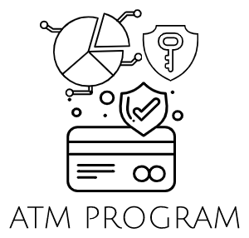

Understanding The Program

+--Automated Teller Machine

+--Flowchart

PROGRAM WILL IDENTIFY IF 1:2

START

INITIALIZE THE PROGRAM

2

1

EXIT

PROCESS OF VALUE INPUTED

INPUT AND OUTPUT

EXIT/ REPEAT THE PROGRAM

PROGRAM OUTPUT DEPENDS ON THE INPUT



Is a type of electronic banking that allows consumers to conduct simple transactions without the assistance of a teller or branch personnel. ATMs are also known as automated bank machines (ABM) or cash machines in different regions of the world.