**ATEC (Agrupación Tectónica de Expresión Contemporánea, or *Tectonic Association of Contemporary Expresion* also known as Agrupación Técnica de Estudios Contemporáneos, or *Technical Association of Contemporary Studies*)**

The modern movement in Cuba cannot be defined by any one major dominant school of thought or institution. ATEC, essentially the Cuban branch of the CIAM (Congrés International d’Architecture Moderne) represents only one form of a renewal of creative spirit that occurred in Cuba during the modern period. Its creation paralleled the foundation of other important collaborative bodies such as the Patronato Pro-Urbanismo (*Pro-Urbanism Foundation*), founded in 1943 as an independent think-tank and lobby-group committed to urbanism and regional planning, and ARCA (La Asociación Renovadora del Colegio de Arquitectos or *Reformist Association of the College of Architects*), founded in 1952 as an organization devoted to professional reform. It’s place of significance within the Cuban modern movement rests in that its membership consisted of a diverse cross-section of Cuba’s most innovative young modern architects, and the topics of interest that it represented provide a broad yet telling description of the major polemics and trends in Cuban architectural discourse during the period.

Formally organized as the Cuban branch of the CIAM, it is likely that the origins of ATEC date to a critical moment of galvanization in Cuban architectural modernity occurring in the late 1930’s. The brief visit to Havana in 1939 by Josep Lluis Sert, then vice-president of the Congresses, also served as an important catalyst. Founding members included Eugenio Batista, an architect often credited as one of the first to successfully rationalize the island’s colonial language, creating a synthesis between tradition and modernity, as well as Nicolás Arroyo, recent graduate from the University of Havana, successful architect and later Minister of Public Works from 1955-1958. Other early members included Eduardo Montoulieu, a planner and theorist who studied and maintained close ties with the Harvard Graduate School of Design (GSD), Gabriela Menéndez, wife of Arroyo and partner in their firm Arroyo & Menéndez, Miguel Gastón, and Rita Gutiérrez. A significant majority of the Cuban-educated members of ATEC were former students of architect and urbanist Pedro Martínez Inclán.

Aside from functioning as a local disseminator of theory relating to international artistic, architectonic, and urban achievements, its declarations from a manifesto published in 1943 also asserted the goal of developing a praxis that was “truly Cuban.” The role of the tropical climate in architectural and urban design as well as the use of both modern and traditional materials in design and construction figured centrally in the discourses associated with the members of the ATEC. Reflecting many of these themes of discussion was an exhibition on the colonial-era city of Trinidad directed that same year by members Montoulieu, Gastón, as well as Emilio del Junco in conjunction with the Patronato Pro-Urbanismo. Rather than use its historical architecture as a valorization of pure traditionalism in design, however, the exhibit titled “Trinidad, lo que fue, es, y será” (*Trinidad, what it was, is, and will be*) promoted the town as a candidate for modern planning. Capitalizing on the cultural and economic value of national architectonic patrimony – a nascent preservationism – was evident, and would remain a relevant concept in subsequent treatments of Trinidad by members of ATEC through the 1950’s.

Later projects associated with ATEC also sought examples from the vernacular as points from which to develop their discourse. These included the studies “Los Bateyes de las centrales azucareras” (*The worker villages of the sugar refineries*), done in 1951 by Alberto Beale and Eugenio Batista, and “Las villas pesqueras” (*The fishing villages*), carried out by Frank Martínez, Ricardo Porro, René Calvache, Alberto Beale, and Nicolás Quintana.

Members of ATEC were present at the following CIAM conferences: Bridgwater (1947), Hoddesdon (1951), Aix-en Provence (1953), and Dubrovnik (1956). During the dissolution of the CIAM in the mid-1950s, the mission of the ATEC apparently underwent a shift as evidenced by the change in the meaning of its acronymous name. During this period, the young architect Nicolás Quintana assumed a more important role of leadership in the group of young modernists, possibly introducing his misgivings on CIAM ideology that stemmed from his involvement with Team 10 during the Congress at Dubrovnik.

Further Reading:

Gómez Díaz, Francisco (2008) *De Forestier a Sert: ciudad y arquitectura en La*

*Habana de 1925 a 1960,* Madrid: Abada Editores, S.L.

Hyde, Timothy (2012) *Constitutional Modernism: Architecture and Civil Society 1933-*

*1959,* Minneapolis: University of Minnesota Press.

Rodríguez, Eduardo Luís (2000) *Havana Modern Guide: Modern Architecture 1925-*

*1965,* New York: Princeton Architectural Press.

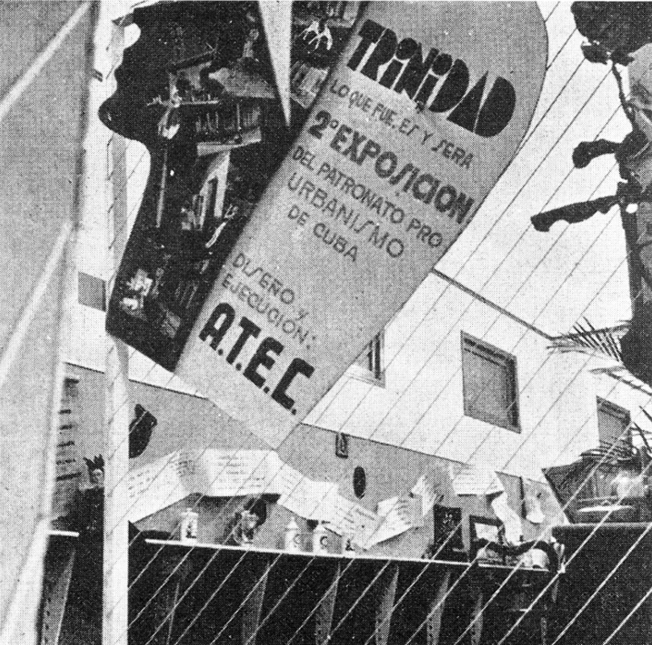

Entrance to the exhibition “Trinidad, lo que fue, es, y sera,” held at the Club Fotográfico de la Habana, 1943. (Image in *De Forestier a Sert,* pg. 259. Author credits image as being originally published in *Arquitectura*)

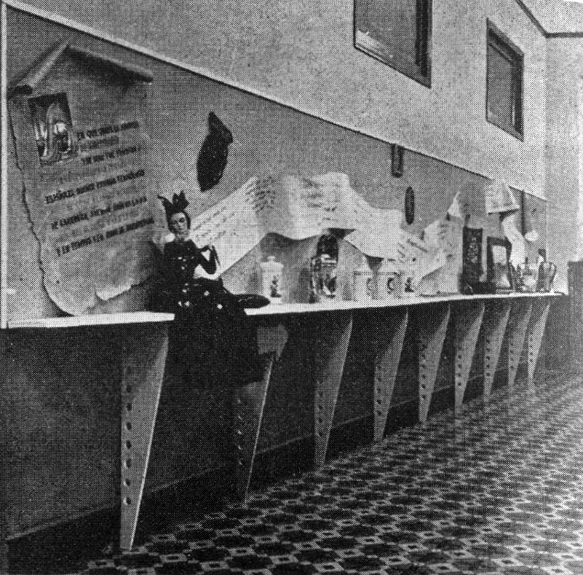

“Trinidad, lo que fue, es, y sera,” displaying a “graphic” history of the city, 1943. (Image in *De Forestier a Sert,* pg. 258. Author credits image as being originally published in *Arquitectura*)

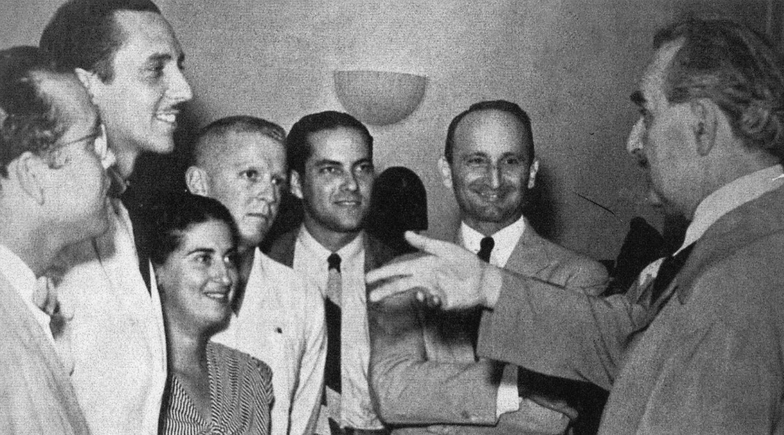

Richard Neutra in Havana meeting with members of ATEC, 1944. From left to right: Miguel Gastón, Eduardo Montoulieu, Rita Gutiérrez, Emilio del Junco, Nicolás Arroyo, Eugenio Batista, and Neutra. (Image in *Havana Guide,* pg xix. Author credits image as “Archival.”)