**Morley Callaghan (1903-1990)**

Morley Callaghan was a renowned Canadian novelist and short-story writer during the twentieth century. While he had a long literary career, his early work is particularly Modernist in its experimentation with colloquial language, pared-down syntax, reportorial prose, and unconventional subject matter. Callaghan was also a well-known Canadian radio and television personality.  
  
Callaghan was born on February 22, 1903 in Toronto to an Irish-Canadian Roman Catholic family and studied at University of Toronto from 1921 to 1925. During the 1920s, he reported for the *Toronto Star Weekly* where he met Ernest Hemingway, a friend and early literary mentor.

Callaghan's earliest short stories were published in *Paris in This Quarter* (1926) and *transition* (1927). Despite finishing a law degree at Osgoode Hall Law School in 1928, Callaghan chose a writing career.

In the late 1920s, his stories were published in an issue of Ezra Pound's *The Exile* as well as such notorious publications as *Atlantic Monthly*, *Harper's Bazaar*, *Scribner's* and *The New Yorker*, earning Callaghan a literary reputation by the age of twenty-five. Callaghan's first novel, *Strange Fugitive*, appeared in 1928, and his first collection of short stories, *A Native Argosy*,followed the next year*.*

After marrying, Callaghan and his wife, Loretto, travelled to France for the summer of 1929, a trip that profoundly influenced Callaghan's writing. In Paris, they associated with the Montparnasse group of Modernist writers, including Hemingway, Ezra Pound, Gertrude Stein, F. Scott Fitzgerald, and James Joyce.

In an incident recounted in Callaghan`s memoir, *That Summer in Paris* (1964), sparring partners Callaghan and Hemingway engaged in a boxing match in which Callaghan floored Hemingway, ending their strained friendship. While in Paris, Callaghan also published his second novel, *It's Never Over* (1929), and began to write a sexually risqué novella, *No Man`s Meat* (1931), and to plan his next novel *A Broken Journey* (1932).

During the 1930s, Callaghan wrote prolifically, and his work significantly departed from the American naturalism that influenced his early fiction. His novels *A Broken Journey* (1932), *Such Is My Beloved* (1934), *They Shall Inherit the Earth* (1935), and *More Joy in Heaven* (1937) shifted toward spiritual enquiry about personal morality. In this period, Callaghan also wrote sixty-five short stories, including the collection *Now That April's Here and Other Stories* (1936); four stories from this collection inspired a film of the same title released in 1958. In 1939, Callaghan wrote two plays, *Turn Again Home* (1939) and *Just Ask for George* (1939).

During World War Two, Callaghan worked with the Royal Canadian Navy on assignment for the National Film Board of Canada. Publishing relatively little in the 1940s, Callaghan acted as chair and panelist for several radio and television shows and became a well-known figure of the Canadian Broadcasting Company. Callaghan also wrote for periodicals and published a popular children's novel about a boy and his dog, *Luke Baldwin's Vow* (1947), as well as a fictionalized depiction of University of Toronto, *The Varsity Show* (1948).

Reclaiming his literary reputation, Callaghan`s *The Loved and the Lost* (1951), a novel addressing contemporary racial issues, won the Governor General`s Award. Callaghan also wrote several later works and died of natural causes on August 25, 1990.

**Chronology of All Works**  
Novels  
*Strange Fugitive* (1928)  
*It's Never Over* (1930)  
*A Broken Journey* (1932)  
*Such Is My Beloved* (1934)  
*They Shall Inherit the Earth* (1935)  
*More Joy in Heaven* (1937)  
*The Loved and the Lost* (1951)  
*The Many Coloured Coat* (1960)  
*A Passion in Rome* (1961)  
*A Fine and Private Place* (1975)  
*A Time For Judas* (1983)  
*Our Lady of the Snows* (1985)  
*A Wild Old Man On the Road* (1988)

Short Fiction

*A Native Argosy* (1929)

*Now That April's Here and Other Stories* (1936)

*Morley Callaghan's Stories* (1959)

*The Lost and Found Stories of Morley Callaghan* (1985)

*The Complete Stories* (four volumes) (2003)

Novellas

*No Man's Meat* (1931)

*Luke Baldwin's Vow* (1948)

*The Varsity Story* (1948)

*An Autumn Penitent: Two Novels* (1929)

*Close to the Sun Again* (1977)

*No Man`s Meat and The Enchanted Pimp* (1978)

Drama  
*Turn Again Home* (1939) – based on the novel *They Shall Inherit the Earth*; produced as *Going Home in Toronto* (1950)

*Just Ask for George* (1939)

*To Tell the Truth* (1949)

*Season of the Witch* (1976)

Memoirs

*That Summer in Paris: Memories of Tangled Friendships with Hemingway, Fitzgerald, and Some Others* (1964)

*A Literary Life: Reflections and Reminiscences, 1928-1990* (2008)

**Key Biographies**Boire, Gary. *Morley Callaghan: Literary Anarchist* (1994)

Conron, Brandon. *Morley Callaghan* (1966)

Hoar, Victor. *Morley Callaghan* (1969)  
Morley, Patricia. *Morley Callaghan* (1978)

**Paratextual Material**

**Videos**

“Morley Callaghan and Ernest Hemingway Boxing Match Video.” “The Life and Times of Morley Callaghan.” *CBC: Life and Times.* CBC. 25 Mar. 2003. Television. Youtube. 21 July 2009. 1 May 2012. <<http://www.youtube.com/watch?v=XLtxG6ciA7g>>.

“Morley Callaghan`s *The Loved and The Lost* Wins The Governor General`s Award.”  
*“*The Life and Times of Morley Callaghan.” *CBC: Life and Times.* CBC. 25 Mar. 2003. Television. Youtube. 21 July 2009. 1 May 2012. <<http://www.youtube.com/watch?v=0fENd88bPDI>>.

Morley Callaghan as a panelist on a Canadian debate television show, *Fighting Words*.

“Whither Montreal Intellectuals?” *Fighting Words*. CBC. 8 Dec. 1956. Television. “Fighting Words: Whither Montreal Intellectuals?” CBC Player. Web. 2012. 1 May 2012.  
<http://www.cbc.ca/video/#/News/Digital_Archives/Society/Education/1399607133/ID=1872283466>.

**Radio**"Is Canada merely suffering through growing pains, passing through an awkward stage of nationalistic adolescence? Or, has the country never really matured, its growth constantly stunted by the vestiges of colonialism? These arguments are examined in this CBC Radio debate moderated by author and lawyer Morley Callaghan."  
“Canada's Consistutional Debate: What Makes a Nation? A Nation Divided Against Itself?” *Citizens' Forum*. CBC. 22 Feb. 1944. Radio. “A Nation Divided Against Itself.” CBC Digital Archives. Web. 26 Jan 2012. 1 May 2012. <<http://www.cbc.ca/archives/categories/politics/the-constitution/canadas-constitutional-debate-what-makes-a-nation/a-nation-divided-against-itself.html>>.

“Callaghan Reminisces About His Friend Ernest Hemingway Two Days Following His Death.”

CBC Radio. 4 July 1961. Radio. CBC Digital Archives. 19 Apr. 2012. 1 May 2012. Web. <<http://www.cbc.ca/archives/categories/arts-entertainment/literature/general-6/goodbye-ernest-hemingway-old-friend.html>>.

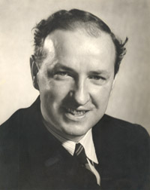**Images**

Morley Callaghan

Source: http://www.cbc.ca/lifeandtimes/callaghan.htm

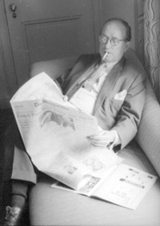Morley Callaghan  
Source: <http://www.cbc.ca/lifeandtimes/callaghan.htm>

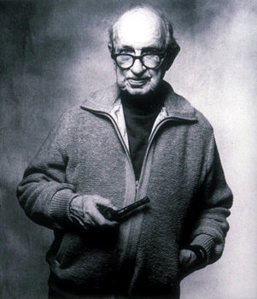Source: <http://www.thecanadianencyclopedia.com/articles/morley-callaghan>  
They credit Macmillan of Canada/Nigel Dickson

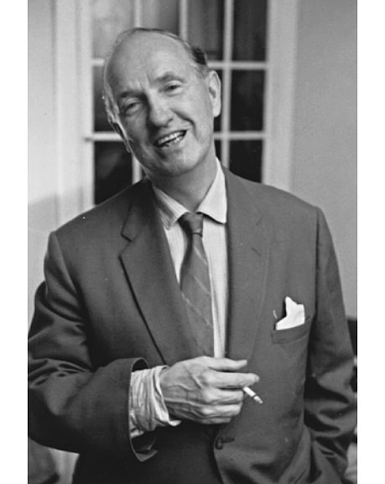Source: <http://www.canadianheritage.org/images/large/20218.jpg>

Credit: Walter Curtin, National Archives of Canada, PA137071

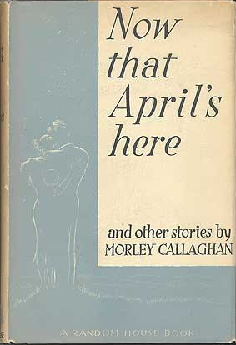*Now That April's Here and Other Short Stories* (1936)

Source:

http://2.bp.blogspot.com/-tgAlkjjgJEI/T3i3myxPfMI/AAAAAAAAGBM/jiyxjiybNws/s1600/Now+That+April%27s+Here+and+other+stories+Morley+Callaghan+1st+edition.png

Images of *The Loved and The Lost* (1951).

Copyright: public domain. McMaster University owns the rights to the archival copy of the digital image in TIFF format.

Source: <http://hpcanpub.mcmaster.ca/media/loved-and-lost-novel-morley-callaghan>