**Paratextual Material**

Figure 1: Illustrations of the cancan by Quillenbois (Charles Marie de Sarcus) published in *Le Conservatoire de la Danse Moderne* (1845)

Location: New York Public Library (I have previously obtained permission to reproduce this image for another publication. The original is in colour)

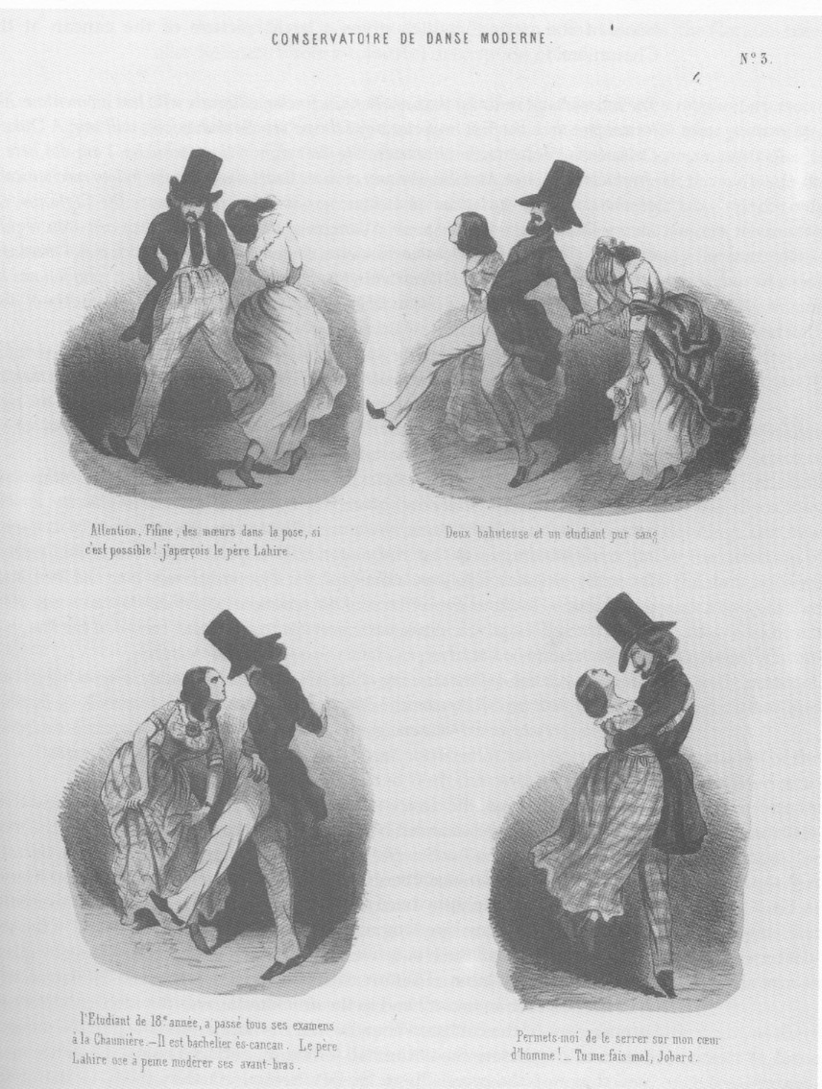

Figure 2: *Dressage des Nouvelles, par Valentin le Désossé* (1890) by Henri de Toulouse-Lautrec

Location: Philadelphia Museum of Art

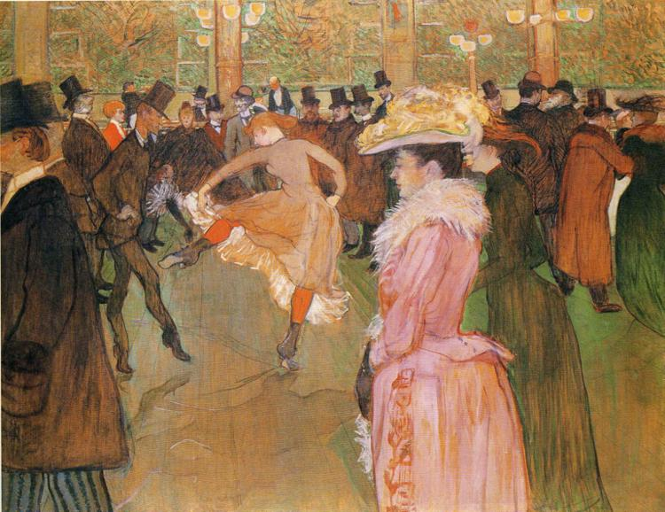

Figure 3: [A still from *An American in Paris* (1951), *Moulin Rouge* (1952), *French Cancan* (1955) or *Can-Can* (1960), showing the cancan, e.g. the following still from *French Cancan*]

Location: New York Public Library holds folders of publicity stills for *An American in Paris*, *French Cancan* and *Can-Can*

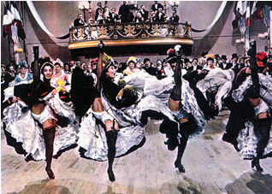

http://ivoblom.wordpress.com/page/2/