**Gutai**

Gutai Art Association (*Gutai Bijutsu Kyōkai* / 具体美術協会) was an influential post-WWII Japanese avant-garde collective with an outward-looking mindset. Founded 1954 in Ashiya, near Osaka by Japanese artist Jirō Yoshihara (1905–1972), it had fifty-nine member artists over the course of its eighteen-year lifespan. *Gutai* – meaning ‘embodiment’ and ‘concreteness’ – saw its artists engage a plethora of media and presentation contexts, often beyond gallery walls and frequently with more emphasis upon process than on finished product. A unifying factor among its multifarious tendencies was a spirit of adventure, exemplified by Yoshihara’s call to “do what no one has done before”. Embracing performance, theatricality and outdoor manifestations, with a characteristic impromptu modus operandi, Gutai’s experimental tendencies and liberal ideals breathed new life into art and into a society remaking itself following the cataclysm and repressions of WWII. As Japan entered the 1960s, consolidating its economy and engagement with the rest of the world, the decidedly offbeat stance of Gutai’s earlier years assumed a cooler demeanour, due in part to nation-wide technological advancement, growing internationalism, and an evolving audience base and receptivity. The Gutai group disbanded following Yoshihara’s passing in 1972.

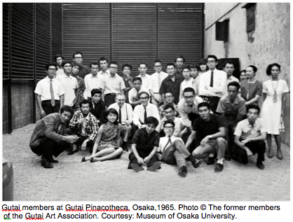

Gutai’s public announcement of its formation was via the first issue of its own journal, *Gutai 1*, in January 1955. Often bilingual, and documenting its activities and ideas, copies later went to American painter Jackson Pollock, French critic Michel Tapié, and other notables. Members also contributed to *Kirin* (Giraffe) magazine, its focus on children’s art and poetry consistent with Gutai’s stance on unfettered artistic originality.

The Gutai Manifesto (*Gutai Bijutsu Sengen*), a polemic penned by Yoshihara and appearing in *Geijutsu Shinchō 7*, No.12, 1956 sought to outline the movement’s aims and harness momentum. Proclaiming the art of the past as “fakes fitted out with a tremendous affectation”, it charged members to “take leave of these piles of counterfeit objects on alters, in palaces, in salons, and antique shops”. Approving references to French artist Georges Mathieu, Tapié, and Pollock (whose paintings Yoshihara had encountered in 1951 in Japan), and to Art Informel and Dada, also figured. With regards artists and their media – and here Gutai members utilised highly unorthodox materials alongside more traditional ones – the manifesto highlighted the importance, as Yoshihara saw it, of refraining from forcing materials into submission, and of letting the material speak “as it is, presenting it just as material … with a mighty voice.”

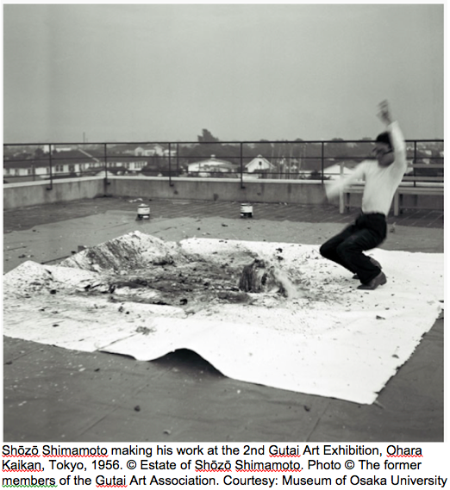

Contrasting with romantic notions of artists closeted in ateliers, the dissemination of these publications in tandem with artistic activity –amounting to a charter and a public relations exercise – posited a different artistic identity. In the 1950s this helped court attention in a Japan still preoccupied with post-war renewal, also assisting Gutai in expanding its reach with exchanges and exhibitions in Europe and America.

Gutai is often seen as consisting of two phases, allowing primary shifts in tandem with changing times to be discerned. The initial phase (1954–1961), is testament to the decisive individualism of its artists and a rejection of the conformism and totalitarianism of the wartime period. Members brought to life not only their own autonomy and that of their materials, but also that of their audience. Gutai manifestations during this time were often staged in outdoor contexts, with expansive and sculptural artworks in tandem with those of a performative and theatrical nature helping generate audience participation. Two early exhibitions exemplifying this direction held in Ashiya Park – ‘Experimental Outdoor Exhibition of Modern Art to Challenge the Mid-Summer Sun’ of 1955 and ‘The Outdoor Gutai Art Exhibition’ of 1956 – featured work by early members among whom were Shōzō Shimamoto (1928–2013), a Gutai co-founder credited with coining the group’s name, Masatoshi Masanobu (1911–1995), Tsuruko Yamazaki (1929–), Sadamasa Motonaga (1922–2011), Saburō Murakami (1925–1996), Kazuo Shiraga (1924–2008), Akira Kanayama (1924–2006), and Atsuko Tanaka (1932–2005). Other manifestations of this period included ‘The First Gutai Exhibition’ at Ohara Hall, Tokyo, 1955; ‘Performance of the Gutai Group’ at Yoshihara Oil Mill Refinery, Nishinomiya, 1956; and ‘Gutai Art on the Stage’ at Sankei Hall, Osaka and Tokyo, 1957.

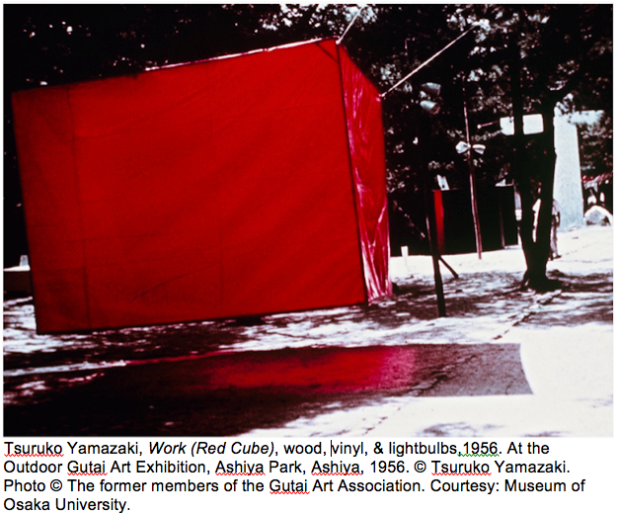

In line with Japan’s growth and modernisation, Gutai’s second phase (1962–1972) witnessed considerable experimentation with newer technologies, their artworks sometimes wryly critiquing the dehumanisation perceived with such advancement. The collectively made *Gutai Card Box* of 1962, assuming the form and function of a vending machine distributing postcard-size Gutai artworks, is a good example. Much Gutai artwork from these years is imbued with restraint and technical sophistication, its artists including Minoru Yoshida (1935-2010), Tsuyoshi Maekawa (1936–), Sadaharu Horio (1939–), Kumiko Imanaka (1939–), Norio Imai (1946–), and Keiko Moriuchi (1943–). The year 1962 marked the opening of Gutai Pinacotheca in central Osaka, as the group’s headquarters, exhibition venue, and networking base. With Japanese and foreign artists, critics, curators, gallerists, and collectors crossing paths at what Tapié dubbed the group’s “manifesto museum”, the venue was a keystone and catalyst for Gutai’s inclusion in strategic events at home and abroad, including the ‘NUL Exhibition’ at the Stedelijk Museum, Amsterdam in 1965 and the 1970 World Exposition (Expo ’70) in Osaka. Pinacotheca closed in April 1970, before Yoshihara’s death and Gutai’s dissolution in 1972.

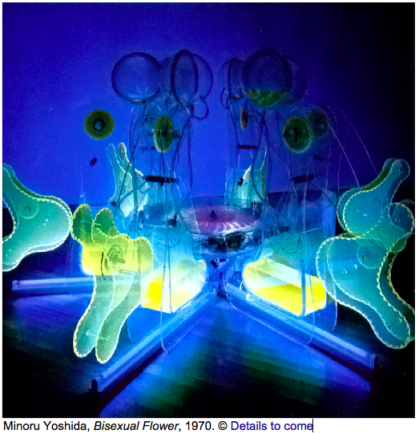

The 21st century has seen Gutai the focus of renewed critical attention, in part addressing its relationship to Modernism while questioning notions of Modernist influence as a one-way dynamic from centres to the peripheries. Gutai exhibitions have included participation in the 53rd Venice Biennale International Exhibition, *Making Worlds*, 2009; ‘Under Each Other’s Spell: Gutai and New York’, Pollock-Krasner House and Study Center, New York, 2009; ‘Gutai: Painting with Time and Space’, Museo Cantonale d’Arte, Lugano, Switzerland, 2010-11; ‘GUTAI: The Spirit of an Era’ at The National Art Center, Tokyo; ‘Tokyo 1965–1970: A New Avant-Garde’ at MoMA, New York, 2012-13; and ‘Gutai: Splendid Playground’ at Solomon R. Guggenheim Museum, New York, 2013.

**References and further reading**

*Gutai – Splendid Playground* exhibition:

<http://web.guggenheim.org/exhibitions/gutai/>

Gutai at Nippon-Lugano:

<http://www.nipponlugano.ch/en/gutai/index.html>

Atsuko Tanaka exhibition – MOT, Tokyo:

<http://www.mot-art-museum.jp/eng/2012/atsuko_tanaka/>

Shōzō Shimamoto Association:

<http://www.shozoshimamoto.org/en>

Tofu Magazine:

<http://www.tofu-magazine.net/newVersion/pages/Gutai56.html>

Gutai Manifesto:

<http://web.archive.org/web/20070630202927/http://www.ashiya-web.or.jp/museum/10us/103education/nyumon_us/manifest_us.htm>

TIAMPO, Ming; MUNROE, Alexandra (2013) *Gutai: Splendid Playground*. New York: Guggenheim Museum (Exhibition catalogue; ISBN: 9780892074891).

HIRAI, Shōichi; YAMADA, Yukako; YONEDA, Naoki (2012) *GUTAI: The Spirit of an Era*. Tokyo: The National Art Center, Tokyo. (Exhibition catalogue).

TIAMPO, Ming (2011) *Gutai:* *Decentering Modernism*. Chicago/London: University of Chicago Press. (ISBN-10: 0-026-80166-7).

KATŌ, Mizuho; WATKINS, Jonathan (2011) *Atsuko Tanaka: The Art of Connecting*. Tokyo: Museum of Contemporary Art, Tokyo

(Touring exhibition catalogue: UK, Spain, & Japan 2001-12; ISBN: 9781904864707).

HIRAI, Shōichi (2004) *What’s GUTAI*? Tokyo: Bijutsu Shuppan-Sha. (ISBN/ISSN: 4568201772).

N.B.TO: ROUTLEDGE (REM) EDITORIAL & DESIGN

FROM: NEILTON CLARKE (Tokyo)

Email: neil@unswalumni.com

RE: GUTAI ENTRY IMAGES

Dear REM Staff,

For the Gutai entry, 3 images from Osaka University Museum have

been pasted into the word document. If seeing publication, the image

files for those 3 images are to be procured from:

(Ms) Mizuho KATO

Visiting Associate Professor;

Museum of Osaka University

1-13, Machikaneyama-cho

Toyonaka

JAPAN 560-0043

Tel. 81-6-6850-6714

Fax. 81-6-6850-6720

E-mail: mizuhozumi@museum.osaka-u.ac.jp

An illuminating, key Gutai image from the same source is:

Atsuko Tanaka wearing the Electric Dress (1956) at the 2nd Gutai Art

Exhibition, 1956. © Ryōji Itō. Photo © The former members of the Gutai Art

Association. Courtesy: Museum of Osaka University

*Use of the above Atsuko Tanaka image incurs a charge of

approximately 5000 JPY, to be clarified upon provision of REM details

listed below to Mizuho Kato. It has not been pasted into my

document, however I understand inclusion of this image has been

given at least a provisional go-ahead by REM editorial.

Assoc. Prof. Mizuho Kato requires the following sent to her:

1) Outline of the REM project (media, publisher, publication date,

exact use the images).

2) Letter of request addressed to Mr. Setsuya HASHIZUME, Director

of The Museum of Osaka University.

3) Three letters of request addressed to applicable copyright holders:

- to Mr. Takashi Shimamoto ( for Shozo Shimamoto at work image);

- to Mr. Ryoji Ito ( for Atsuko Tanaka Electric Dress image)

- to Ms. Tsuruko Yamazaki (for Tsuruko Yamazaki image)

< Each to be signed by the appropriate REM editorial individual >

Conditions to borrow/use these images:

# Credit lines for reproduced images need to appear as shown in the

pasted images and in the Tanaka image above (I have conferred with

Ms Kato on those details).

# Online access to the publication is to be provided, for the museum

as well as the copyright holders, and in the case where REM sees

hard copy publication, copies are to be provided.

ALTERNATIVE IMAGES:

Two other key Gutai images below: one by Gutai leader Yoshihara;

one by Minoru Yoshida (currently in document) showing the ‘cooler’

style of Gutai in the ‘70s – are via the Ashiya City Museum of Art &

History, a key repository for the Gutai legacy. Should either see

publication, letters of request from REM staff are to be addressed to

the copyright holders and museum director listed below, and sent to:

Ms. Aya KUNII; Ashiya City Museum of Art & History: 12-25 Isecho,

Ashiya City, Japan 659-0052.

*By email is suitable: kunii_aya@ahiya-city-museum.jp

The letter of request for the museum director:

Ms. Tadako HIROSE – Director; Ashiya City Museum of Art &

History.

Jirō Yoshihara,

Black Circle on White, paint on canvas, 1967.

Collection of Ashiya City Museum of Art& History.

© To be clarified.- For the Jirō YOSHIHARA image above:

Letter addressed to copyright holder Mr. Shinichiro Yoshihara.

Minoru Yoshida, Bisexual Flower, mixed media, 1970.

© To be clarified - For the Minoru Yoshida image above:

Letter addressed to copyright holder Ms. Midori Yoshida

An outline of the REM publication would need to go to Ms Aya Kuni,

giving details regards contents, pricing, distribution mode, and outline

of distribution & numbers, etc.

Yours sincerely,

Neil Clarke

Neilton Clarke

1056 Itsukaichi,

Akiruno-shi,

Tokyo, JAPAN 190-0164

neil@unswalumni.com

Tel: 81-42-595.2987

１９０−０１６４

東京都あきる野市五日市１０５６

JAPAN