Dapeng LIU

***Lianhuanhua* (連環畫)**

Literally meaning sequentially drawn pictures, *lianhuanhua* is a form of modern Chinese popular art commonly produced as palm-size black-and-white picture books incorporating short text in each frame. *Lianhuanhua* emerged and became popular in response to the introduction of modern printing techniques in late nineteenth and early twentieth-century China. The genre continued as a popular art form attracting large audiences until its decline in the late 1980s due to the emergence of new media in China. In the early twentieth century *lianhuanhua* mainly inherited styles from traditional Chinese ink drawings. Influenced by Western art, artists and intellectuals soon introduced new media and modern artistic styles to the field. These included Lu Xun’s (鲁迅, 1881-1936) promotion and use of woodcut prints and German Expressionism. From 1949, *lianhuanhua’s* popularity continued, though its content changed. After 1949 in the People’s Republic of China, revolutionary realism and Soviet Constructivism shaped mainstream forms of *lianhuanhua*, with the aim of serving the Chinese party-state’s political power. Despite political constraints during its century-long lifespan, *lianhuanhua* continued to feature diverse artistic styles encompassing Chinese and Western, traditional and modern. As a collector’s item, *lianhuanhua* is now a valuable visual resource that acts as art form as well as primary material helping to trace historical and artistic ebbs and flows in modern China.

The development of modern *lianhuanhua* was derived from the use of lithographic printing in the late Qing dynasty (1644-1912). Although not yet titled as *lianhuanhua*, a group of serial pictures published in *Dianshizhai Pictorial* (點石齋) in 1884 marked the initiation of modern *lianhuanhua*. In this period, serial pictures of this type were called *huihuitu* (回回圖), literally meaning ‘the pictures of book chapters.’ Two picture books of *Sanguozhi* (三國志, *Records of the Three Kingdoms*) published by Shanghai Wenyi Publishing House in 1899 and 1908 are regarded as the earliest published volumes of *lianhuanhua*. The earliest use of the term *lianhuantuhua* was in 1925 when the first of a series of five picture books on Chinese classic literature was published. Here both *tuhua* (圖畫) and *hua* (畫) translated as ‘picture’ and the term *lianhuantuhua* was later abbreviated as *lianhuanhua*.

From the late 1920s and throughout the 1930s, *lianhuanhua* flourished in China, with production centered in Shanghai. Representative works of this period are considered as some of the most important *lianhuanhua* of all time, such as Li Yishi’s (李毅士, 1886-1942) *Changhenge* (长恨歌, *The Song of Everlasting Regret*) drawn in the style of classicism, *Jinpingmei* (金瓶梅, *The plum in the golden vase*) drawn by Cao Hanmei (曹涵美, 1902-1975) in the style of traditional Chinese line drawing and *Adventures of Sanmao* (三毛流浪記) drawn by Zhang Leping (張樂平, 1910-1982) in the style of Western cartoon art. The latter could also be categorised as a Chinese cartoon, as there is no clear boundary between *lianhuanhua* and serialised cartoons.

In the Republican period of China (1912-1949), the subjects of *lianhuanhua* were largely drawn from Chinese classical literature and traditional Chinese opera, but the artistic styles are not only confined to Chinese art. Apart from Li Yishi’s use of classicism, expressionism and the style of Art Deco are also seen from this period’s works.

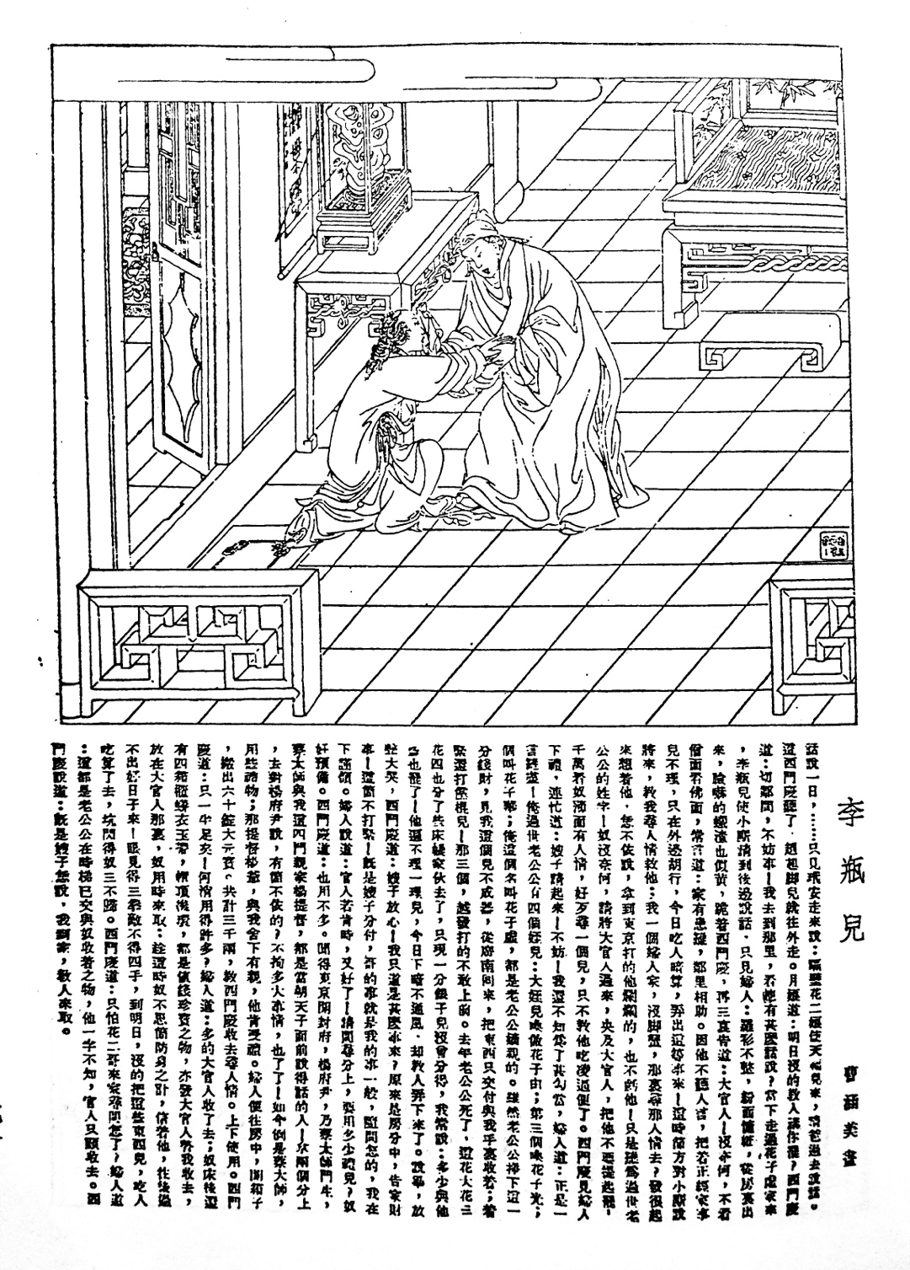

Cao Hanmei, *Li Ping’er,* (1936), originally published in a monthly pictorial *Shanghai Sketch* (上海漫畫) in July 1936 and republished in 2004 in a ten-volume collection of cartoons from journals and pictorials published during the Republican period of China. For this particular work, see Jiang, Yasha, Li Jing, and Zhanqi Chen, ed., (2004). *Minguo Man Hua Qi Kan Ji Cui*. Zhongguo Wen Xian Zhen Ben Cong Shu. 10 vols Beijing: Quan guo tu shu guan wen xian suo wei fu zhi zhong xin. Vol 3, p71.

The foundation of the People’s Republic of China in 1949 marked a drastic change in the development of *lianhuanhua*. Under state control of culture and art, *lianhuanhua* was used as a major tool for political propaganda and was one of the most important components of *dazhong meishu* (大眾美術, the art for the masses). From 1949 to 1966, large numbers of renowned artists devoted themselves to the creation of *lianhuanhua*, which led to the emergence of high quality works, such as *Shanxiang jubian* (山鄉巨變, *Great changes in the mountain villages*) drawn by He Youzhi (賀友直, b.1922). During the Cultural Revolution (1966-1976), many established and experienced artists were marginalised by the Party-State. As a result, worker and peasant artists created the majority of *lianhuanhua* during this period. Contemporary scholars are generally critical of these so-called proletarian *lianhuanhua*, judging them to be repetitive in content and generally low in artistic quality.

The end of the Cultural Revolution and the start of economic reform from 1979 allowed for more freedom in artistic creations, and the development of *lianhuanhua* became prosperous again between 1976 and 1985, displaying a higher level of diversity in subjects and artistic styles. Representative examples of this period are *Yao* (藥, *Medicine*) drawn by the renowned realistic oil painter Chen Yifei (陳逸飛, 1946-2005), and Wang Hongli’s (王弘力, b.1927) *Shiwuguan* (十五貫, *Fifteen strings of coppers*).

From 1985 onwards, following the popularisation of new media such as video games, as well as the importing of Western and Japanese cartoons to China, the demand for *lianhuanhua* publications decreased dramatically. In the late 1990s, *lianhuanhua* became a category of art collection in China. For example, in 2002, the two volumes of *Luotuo Xiangzi (*駱駝祥子*, Camel Xiangzi)*- a *lianhuanhua* published in 1951 and drawn by a renowned artist of the Republican period of China- Sun Zhijun (孫之儁, 1907-1966) using a renovated style of cinematographic effects, was sold for 4,200 RMB in an auction in Beijing. Original *lianhuanhua* drafts owe their high market value to their rarity. For example in 2005, artist Cheng Shifa’s (程十髮, 1921-2007) original drafts of the *lianhuanhua* *Zhaoshutun he Nannuona* *(*召樹屯和喃諾娜*, Zhaoshu Village and Nannuona)* were sold for 11 million RMB at the China Guardian Auction.

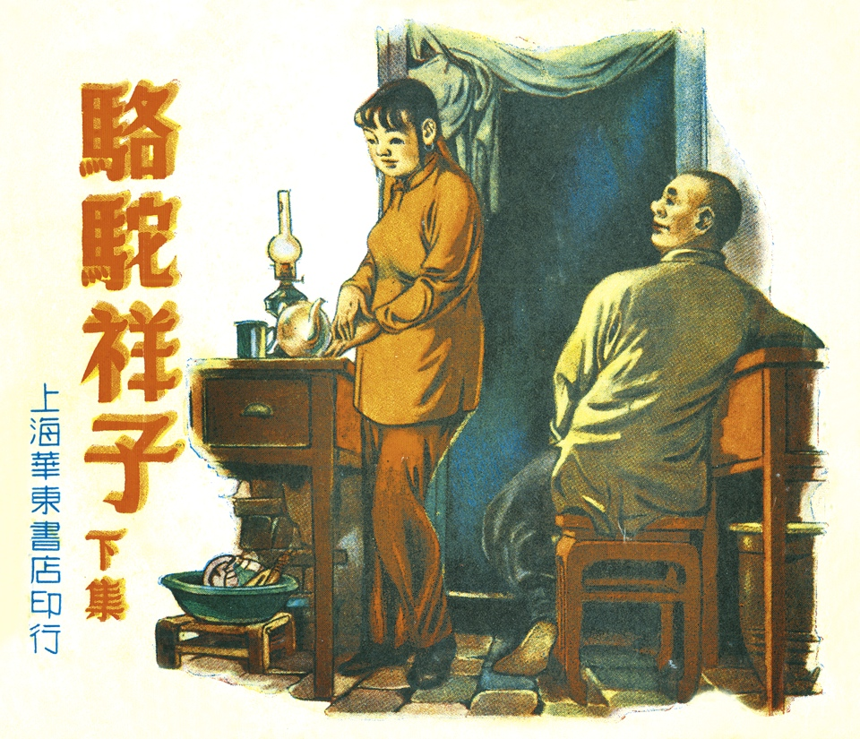

Sun Zhijun, *Camel Xiangzi,* (1951)

A considerable amount of literature concerning the history, appreciation and collectible market of *lianhuanhua* can be found mostly in the Chinese language. Existing studies on *lianhuanhua* largely focus on the period after 1949. The study of the *lianhuanhua* of the Republican period of China is still in its infancy.

**References and further reading**

Lent, John A. (1994) ‘Comic Art,’ in Wu Dingbo and Patrick Murphey, eds., *Handbook of Chinese Popular Culture*, Westport: CT: Greenwood Press.

Shen, Kuiyi. (January 1997) ‘Resources: Selected Bibliography Related to Lianhuanhua and Manhua,’ *INKS: Cartoon and Comic Art Studies*, vol. 4, no. 3: 33-35.