**Mavo**

Mavo was a coterie of vanguard artists, designers and poets centred on Tokyo between July 1923 and late 1925. It sought to politicise art amidst the repressive ultra-nationalist atmosphere of inter-war Japan. As such, it was the first Japanese movement to move away from conventional academic practices like painting and sculpture, and explore the inter-medial spaces of collage, assemblage, architecture, theatre, dance, typography and the mass media. Some of these artists, like Masamu Yanase and Shūzo Ōura, had formerly worked in a Cubo-Futurist idiom. Yet, Mavo signalled a turn away from the hegemony of Paris and salon painting, toward a dialogue with the anti-art of German Dadaism and Russian Constructivism. In the wake of the Bolshevik Revolution, radical left wing ideas were popular among Japan’s intelligentsia, and Mavo was a magnet for artists of this persuasion, who occasionally paid for it with police beatings and detainments. Despite subtle ideological differences, there was also the conviction that bourgeois aesthetics and artistic institutions needed to be demolished to make way for the absolute freedom of the artist, and constructive activity that would make art central to life. Like the term Dada, Mavo had no agreed meaning, but for Tomoyoshi Murayama – its principal founder – it signified the ‘conscious constructivism’ that was to follow the vital work of negativity and nihilism.

Mavo was mobilized under Murayama, who had first-hand exposure in Berlin to the more radical factions of avant-gardism. Like Dada, Mavo was born of disgust with a morally corrupt establishment, and much of its work was expressly intended to shock and garner media attention. This was the case whether it was the dynamic graphic design of the Mavo magazine, Yanase’s caustic illustrations satirising politicians and militarism, or welded works like Shūichirō Kinoshita’s *Psychological Portrait of an Anarchist of Direct Action* (1925). Mavo was regarded as seditious, and one of its first clashes with the police occurred in July 1923 when the movement’s members rioted against the exclusivity of the Nika Society by violently parading their rejected works through Ueno Park. After the Great Kanto Earthquake of September, Mavo came to view the ruined city as an ideal medium for bridging art and life, and conceived several of its most exciting projects including posters, billboards, displays, interiors, towers, monuments and other architectural schemes. Much of this was utopian fantasy and remained unrealised, like Murayama’s maquette for the Mavo headquarters (1924). Other projects did get built, including Tatsuo Okada’s bizarre contraption for the Second Sanka Exhibition of September 1925 – a machine assembled with found materials and signage that served as both an entrance gate and mobile ticket booth. Stage design was related to this activity, and several Mavoists were also actors or dancers, who flirted with androgynous sexuality, cross-dressing, and quasi-pornographic nudity, as part of Japan’s first experimental theatre. Performance was central to Mavo, and it was in fact Murayama’s gravitation toward writing for the theatre as well as internal squabbling about the ideological direction of Mavo, that caused it to peter out toward the end of 1925.

**Further Reading:**

Dachy, M. (2002) *Dada au Japon. Segments Dadas et Néo-Dadas dans les avant-gardes japonaises,* Paris: Presses Universitaires de France.

Weisenfeld, G. (2002) *Mavo: Japanese Artists and the Avant-garde, 1905-1931*, Berkeley: University of California Press.

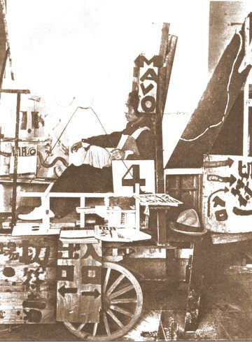

Okada Tatsuo, *Gate Light and Moving Ticket Selling Machine*, September 1925, mixed media, installed at 2nd Sanka Exhibition in Ueno Park, from *Koseiha Kenkyu* (*Study of Constructivism*), Tokyo, Chuo Bijutsusha, 1926.