**Dmitry Merezhkovsky (Дмитрий Мережковский) (1865-1941)**

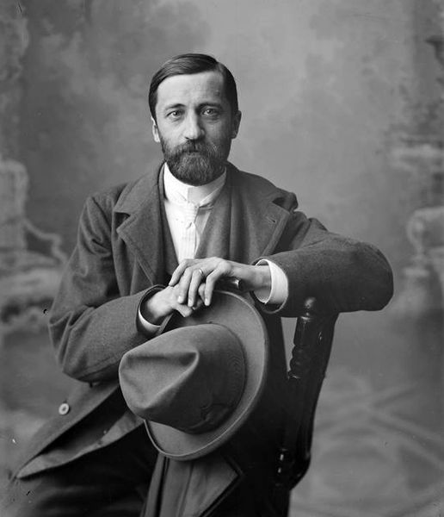Dmitry Sergeevich Merezhkovsky (1865-1941) was a prolific writer, religious thinker, literary critic, poet, playwright and one of the earliest and most eminent ideologues of Russian Symbolism. Together with his wife Zinaida GIPPIUS (1869-1945), he organized the famed Religious-Philosophical Meetings (1901-1903) and played an important role in the renewed spiritual interest of the Russian intelligentsia in the late nineteenth and early twentieth centuries. After a brief initial acceptance of the Russian Revolution of 1917, he became a fierce opponent of the Bolsheviks, and in 1919, together with his wife, he left Soviet Russia. Merezhkovsky continued his political, religious and literary activities in the Russian émigré community in Paris, France, where he died in 1941.

Merezhkovsky in Nizhny-

Novgorod at the end of the

19th century.

**Timeline of Life and Most Important Works Published During Lifetime**

**1865: born in St. Petersburg**

**1883: graduates from gymnasium and begins his studies at St. Petersburg University**

**1885: begins to contribute poetry and criticism to “Northern Herald” and other periodicals**

**1888: publishes his first book, titled *Poems* (Stikhotvoreniya); graduates from St. Petersburg University and meets his future wife Zinaida Gippius in** Borjomi

1889: marries Gippius in Tiflis (Tbilisi) and settles with her in St. Petersburg

1892: publishes his second book of poetry, *Symbols* (Simvoly); gives a public lecture called *On the Causes of the Decline and on the New Trends in Contemporary Russian Literature* (O prichinakh upadka i o novykh techeniyakh sovremennoy russkoy literatury) at the Russian Literary Society

1895: publishes his first novel, *Julian the Apostate* (Yulian otstupnik), which becomes the first book in his trilogy *Christ and Antichrist*

1897: publishes a collection of essays on literature and culture, titled *Eternal Companions* (Vechnye sputniki)

1901: publishes the first part of *Tolstoy and Dostoevsky* in “The World of Art” (Mir iskusstva)

1901-1903: initiates and plays an active role in the St. Petersburg Religious-Philosophical Meetings

1902: publishes *Leonardo Da Vinci*, the second book of his trilogy *Christ and Antichrist*

1904: publishes *Peter and Alexis*, the third book of his trilogy *Christ and Antichrist*

1906-1908: first political exile; lives in Paris in a quasi-religious “brotherhood of three” (Gippius-Merezhkovsky-Filosofov)

1910: publishes *Collection of poetry (1883-1910)*

1913: publishes the novel *Alexander I* and a complete collection of his works (15 volumes)

1914: publication of complete collection of his works (24 volumes)

1916: premieres of Merezhkovsky’s plays “There Will Be Joy” (Budet radost’) at the Moscow Art Theatre and “Romantics” at the Alexandriysky Theatre in St. Petersburg

1919: leaves Soviet Russia for Poland

1920: moves to Paris

1921: together with Gippus and Filosofov, publishes a collection of essays titled *The Kingdom of the Antichrist* (Tzarstvo Antikhrista) in German, French and Russian

1924: publishes the novel *Birth of the Gods* (Rozhdenie bogov)

1926-1939: together with Gippius, initiates and hosts a literary and philosophical society called “The Green Lamp” (Zelenaya lampa)

1929: publishes the book *Napoleon* in Russian and English

1933: publishes the book *Jesus the Unknown* in Russian and English

1937: publishes the book *Dante* in Italian, dedicating it to Mussolini

1939: *Dante* comes out in the original Russian (with no mention of Mussolini)

1941: dies in Paris

Dmitry Sergeevich Merezhkovsky was born in St. Petersburg on August 14, 1865 (August 2 – old style), into the family of a high ranking official of the imperial court. While still a gymnasium student, he began publishing poetry written in the style and spirit of the deeply personal late-nineteenth century poet Semyon Nadson (1862-1887), who became his close friend. In the spring of 1888, a year after Nadson’s premature death, Merezhkovsky published his first book, *Poems,* and graduated from **St. Petersburg University, where he had studied history and philology. In the fall of the same year, while travelling in the Caucasus, he met Zinaida Gippius (1869-1945) and married her in early 1889. In** 1892 Merezhkovsky published another book of poetry, titled *Symbols,* which he followed in 1893 with a small book of criticism, *On the Causes of the Decline and on the New Trends in Contemporary Russian Literature*. Rejecting sociological criticism and socially oriented poetry, these two books affirmed a new quasi-religious philosophy and a fresh modernist aesthetics. With his young wife, Gippius, Merezhkovsky played a major role in the literary and religious life of fin-de-siècle Petersburg, hosting an influential literary salon and organizing the famed Religious-Philosophical Meetings (1901-1903), which sought to establish a dialogue between the so-called “new religious mind” (Gippius, Merezhkovsky, Rozanov, Filosofov, Berdyaev, and others) and high-ranking Russian Orthodox clergy.

During the same period, Merzhkovsky won fame for reviving the Russian historical novel. He authored a trilogy titled *Christ and Antichrist* (Khristos i Antikhrist) that consisted of three ideologically connected works: *The Death of the Gods: Julian the Apostate* (1896), *The Resurrection of the Gods: Leonardo da Vinci* (1901) and *Antichrist: Peter and Alexis* (1904). Set in different epochs and places, the novels revealed the author’s cultural and historical erudition and served as vehicles for his theological ideas. This trilogy was followed by a group of fictional works inspired by Russian history: the play *Paul I* (1908) and two novels, *Alexander* *I* (1913) and *The 14th of December* (1918). At the beginning of the twentieth century, Merezhkovsky published several critical studies of nineteenth-century Russian literature and numerous articles about current social, political and religious issues. His favorite method was that of antithesis, which he applied not only in his historical novels but also in his critical essays, such as *Tolstoy and Dostoevsky* (1901-1902) and *Gogol and the Devil* (1906).

In 1906, after the failure of the first Russian Revolution, Merezhkovsky, together with Gippius and Filosofov (a partner of their “triangular brotherhood”), went into political exile and lived in Paris, sharing the same apartment and co-authoring *Le Tsar et la Revolution* (1907) and the play “Poppy Blossom” (Makov tsvet, 1908) with them. In 1908, after two and a 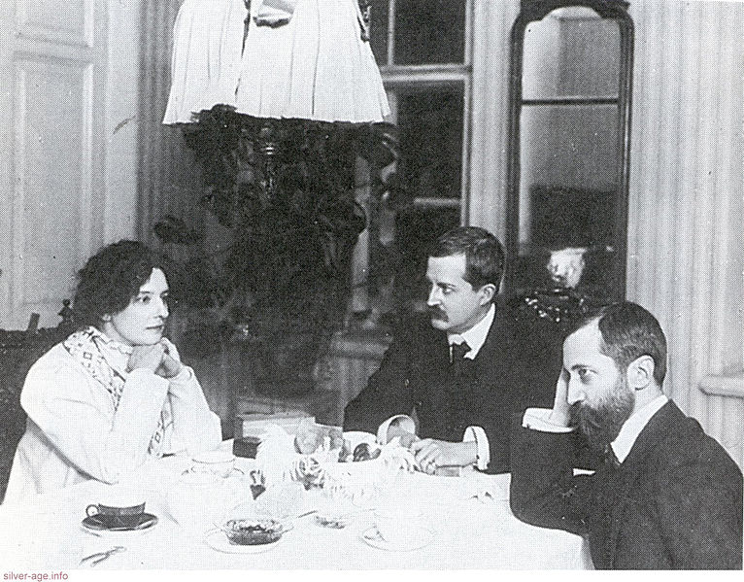half years of exile, the trio returned to St. Petersburg where Merezhkovsky continued his literary and religious activities, becoming one of Russia’s most popular writers. The Wolf publishing house released his collection of complete works in 15 volumes in 1911-1913, and the Sytin publishing house published a 24-volume collection in 1914. Like most Russian intellectuals of the time, Merezhkovsky opposed the events leading up to World War I and welcomed the first phase of the Russian Revolution of 1917. He bitterly opposed the Bolshevik seizure of power, however, and in December 1919, together with Gippius and their friends Zlobin and Filosofov, left Russia via Poland. The group tried to organize military opposition to Bolshevism, seeking the support of Poland and the Russian émigré community, but their attempts failed. In 1920 Merezhkovsky, Gippius and Zlobin left Warsaw and settled in Paris, where Merezhkovsky continued his political and literary activities, contributing to various émigré periodicals and writing historical novels on Classical and Christian topics. Merezhkovsky’s numerous books were translated into major European languages, and he was nominated several times for the Nobel Prize in Literature, coming closest to winning in 1933. Merezhkovsky died in Paris on December 9, 1941, and was buried in the Sainte-Geneviève-des-Bois Russian Cemetery outside of the French capital.

From left to right: Gippius, Filosofov

And Merezhkovsky in 1920.

**References and Further Reading**

**Selected works by Dmitry Merezhkovsky published in Russian**

***Poems* (Stikhotvoreniya), [1888]**

*Symbols* (Simvoly) [1892]

*On the Causes of the Decline and on the New Trends in Contemporary Russian Literature* (O prichinakh upadka i o novykh techeniyakh sovremennoy russkoy literatury) [1893]

*The Death of the Gods: Julian the Apostate* (Smert bogov. Yulian otstupnik) [1896]

*The Resurrection of the Gods: Leonardo da Vinci* (Voskresshiye bogi. Leonardo da Vinchi) [1901]

*Tolstoy and Dostoevsky*, “The World of Art” (Mir iskusstva) [1901-1902]

*Antichrist: Peter and Alexis* (Antikhrist. Petr i Alexei) [1904]

***Complete Collection of Works* (Polnoe sobranie sochinenii. 15 vol.) [1911]**

***Alexander I* (Aleksandr Pervyi) [1913]**

***Complete Collection of Works* (Polnoe sobranie sochinenii. 24 vol.) [1914]**

***Birth of the Gods* (Rozhdenie bogov) [1925]**

***Napoleon* [1929]**

***Jesus the Unknown* (Iisus neizvestnyi) [1933]**

***Dante* [1939]**

**Further Reading**

Bedford C. Harold, *The Seeker: D. S. Merezhkovskiy*, University of Kansas Press, [1975]

(about the evolution of Merezhkovsky’s search for new forms of Christianity in his literary, philosophical and religious writing)

Rosenthal, Bernice Glatzer, *Dmitri Sergeevich Merezhkovsky and the Silver Age: the Development of a Revolutionary Mentality*, Martinus Nijhoff Press, The Hague [1975] (about Merezhkovsky’s place in Russian culture from a historian’s point of view)

Pachmuss, Temira, *D.S.* *Merezhkovsky in exile: the master of the genre of biographie romancée,* New York: Peter Lang [1990] (This study covers Merezhkovsky’s published and unpublished texts of fictionalized biographies*,* written in exile, 1919-1941.)

Nikolyukin, A. N. (collected and edited by), *D. S. Merezhkovsky: pro et contra*, Russian Christian Academy, St. Petersburg, [2001] (a comprehensive collection of texts about Merezhkovsky’s life and works, originally published in the Russian pre-revolutionary and émigré press).

**Source URLS for photos:**

<http://commons.wikimedia.org/wiki/File:Merezhkovskiy_in_NNovgorod.jpg>

<http://commons.wikimedia.org/wiki/File:Gippius_Filosofov_Merezhkovsky.jpg>