**Nativism**

Sharon Pillai

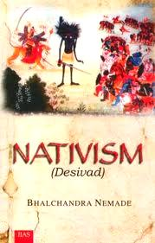

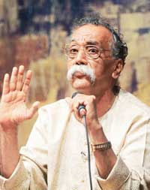NATIVISM, in Indian literary studies, refers to that bloc of thinking which advocates a return to local cultural-linguistic roots for both creative and critical writing. Operating as the English translation of “*desivad*,” nativism was first propounded as a desirable praxis by Marathi novelist and critic, Bhalchandra Nemade, in the early 1980s (see esp. his essay, “Sahityateel Deshiyata” ). Always a polemical formulation, nativism has since been a polarising term with limited influence in Anglophone Indian literary-critical circles. Besides Nemade, the works of G. N. Devy have been instrumental in arguing the nativist cause in India.

Bhalchandra Nemade

Nativism in literature and critical practice is identified by its proponents with authentic and autonomous cultural expression. Alleging “cultural amnesia” (see Devy) on the part of the postcolonial Indian literary critical establishment, nativists uphold *bhasha* (‘vernacular’ or regional) literatures grounded in *desi* (local, indigenous) traditions against the hegemonies of *marga* (high-cultural) Sanskritic, national or variously foreign-Western and international practices. They claim that only the former is truly authentic, being rooted in local reality. Nemade, in fact, privileges a *kriti* (action) oriented social realism over formalist and fantasist forms of writing (see “Marathi Novel”).

G. N. Devy

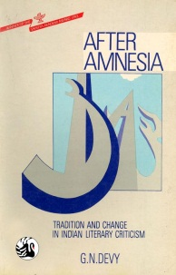While Devy’s *After Amnesia* won a Sahitya Akademi Award in 1993, and a National Seminar was co-

funded by the Akademi on the topic in 1995, Nativism has generated strong opposition over time. Its critics have alleged that nativism is not only bellicose and parochial, but also politically invidious in its vulnerability to appropriation by programmes of cultural nationalism.

**Key Reference Works**

Devy, G. N. *After Amnesia: Tradition and Change in Indian Literary Criticism*. Bombay: Orient Longman, 1992. Print.

Jaidev, *The Culture of Pastiche: Existential Aestheticism in the Contemporary Hindi Novel*. Shimla: IIAS, 1993. Print.

Nemade, Bhalchandra. *Nativism (Desivad)*. Shimla: IIAS, 2009. Print

Paranjape, Makarand, ed. *Nativism: Essays in criticism*. New Delhi: Sahitya Akademi, 1997. Print