Author: KathrinLangenohl

**Sovogi, Kolouma**

Kouloma Sovogni wasborn ca. 1965 in Touwéleou/ Val de Guinée/ Guinea Conakry. She is known for her linear ornamental paintings, which are dominated by curved lines and elongated coloured shapes. The intertwining of defined and non-defined areas in the alternation of positive and negative forms reads like rythmic movements in space. Based on the tradition of body adornment of the Loma women called Podai, Kolouma Sovogi transformed three-dimensional signs onto canvas delicately transcending body size and shape. In doing so, she exceeded the abstract canon in adding new subjects in figurative style, using a spectrum of colours. Podai ornaments are part of the female ritual of initiation of Loma people, prohibited during the government of Sekou Touré (1958 - 1984) and therefore only executed and passed on subversively in secrecy. Kolouma Sovogi nevertheless learned the technique of body painting from the older women and exercised the ornaments in her childhood. Later on, she practised her Podai skills in decorating female bodies for initiation and in executing murals, developing her individual handwriting as many podzianuti (female body painters) did.

Known for her expert draughtsmanship, Kolouma Sovogni was one of the women in Segbémé who in 1987 was appointed by Karl Heinz Krieg, a German ethnologist and trader, to compile an inventory of Podai ornament and transfer the signs onto paper and canvas. Krieg was [enthusiastic](http://www.dict.cc/englisch-deutsch/enthusiastic.html) about this female art form, provided for the materials and recorded the explanations especially given by the older female experts. Taking part in the documentation of the canon of Podai ornament in the first year, Sovogi took the chance to extend the range of artistic subjects and colours and to individualize her style in the years 1990, 1991 and 1996 when Krieg returned – always under the watchful eyes of the older women facing their critical comments. She was open for experiments whereas she still respected the Podai aesthetics which ask for accurate execution and for drawn lines which either meet each other or end up in in “heads”.

Against the notion of fixed traditions in African societies, Podai body painting is another example of the art of ornament as a repetition with differences. As body adornment, executed in black colour obtained from the nut of the Podai tree mixed with ashes with a leaf vein as a brush, change is an intrinsic element of this art form. The ornaments eventually fade away and have to be renewed. Innovation is commonly appreciated and the individual handwriting of each artist is obvious in her way of painting – a circumstance which leads to continuous fruitful discussions about aesthetics between the guardians of tradition and the reformers.

Kolouma Sovogis paintings were presented 1995 in *Hamburgisches Museum für Völkerkunde/Germany*, in 2000 at the *Biennale d’art contemporain de Lyon/France* and in 2003 at *museum kunst palast* in Düsseldorf/Germany.

Bibliography:

Langenohl, Kathrin „Podai – Malerei der Frauen in Westafrika“ in *Podai - Malerei aus Westafrika*, museum kunst palast (ed), Düsseldorf 2003:28-46 (exhibition catalogue)

*Partages d’Exotisme*, 5e Biennale d’art contemporain de Lyon, vol 2(exhibition catalogue)

*Podai. Bemalte Körper. Bemalte Häuser*. Hamburgisches Museum für Völkerkunde, Völkerkundemuseum Leipzig (Ed), Leipzig 1995. (exhibition catalogue)

For copyright of the illustrations please contact Helen Krieg (helen.krieg@gmx.de), owner of the collection.

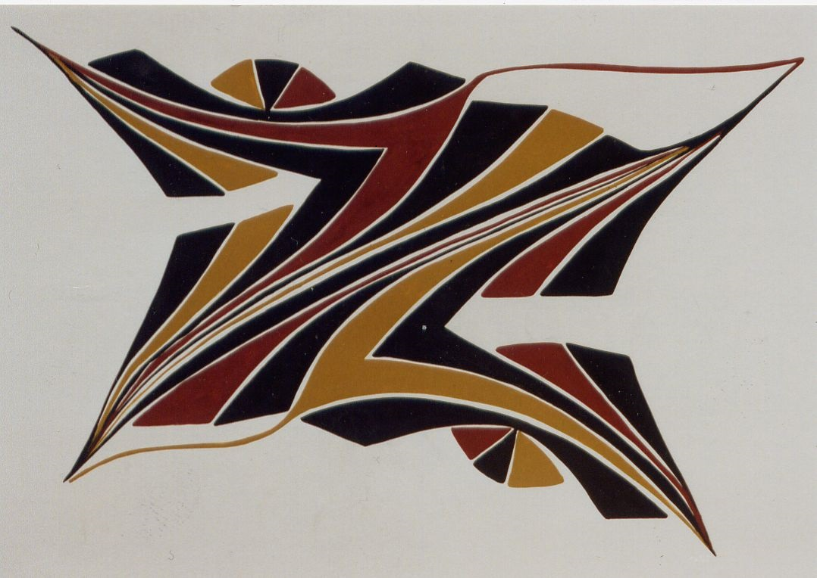

Zawagi, 1996

Acrylic paint, cardboard

68 x 95 cm

Works number: 35-1996/163

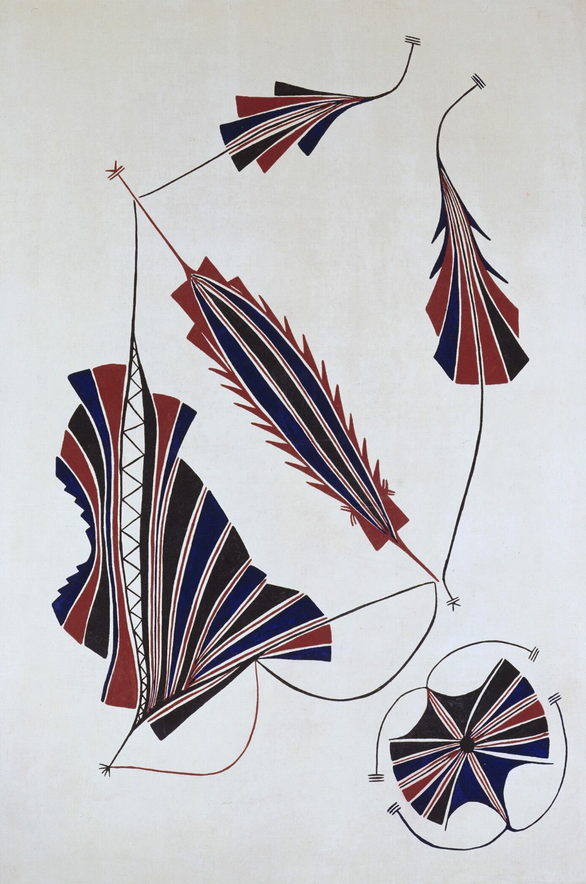

Tokobabhékpégi, Dabui, Bhékpégi, 1996

Acrylic paint, canvas

180 x 125 cm

Works number: 35-1996/155