**SIMULTANEISM (*simultanéisme)***

Also known by “simultanism” (*simultanisme*) or “simultaneity” (*simultanéité*). Neither a movement, nor a group of loosely connected artists, Simultaneism rather describes a tendency in modernist avant-garde art and literature from roughly 1912 through the 1920s, primarily but not exclusively in Paris. Artists such as Robert Delaunay, Sonia Delaunay-Terk, Marc Chagall, and others from the Orphist group, as well as writers such as Henri-Martin Barzun, Blaise Cendrars and Gustave Apollinaire were among those who explored and commented on techniques of simultaneity in their work. Simultaneist technique experimented with the concurrent presentation of elements from different places, multiple points-of-view, radically disconnected segments of time, and separate media. Like Futurism and to some extent Cubism, Simultaneism took up elements from and responded to the major developments in modernity: technological innovation, large-scale urbanisation, mass telecommunication and scientific discoveries. Perhaps the most famous and recognisably Simultaneist work to exhibit this tendency is the fold-out book published by Delaunay-Terk and Cendrars in 1913, *Prose of the Trans-siberian and of little Joan of France* (*La Prose du Transsibérien et de la petite Jehanne de France*).

The origins of Simultaneism can be traced in piecemeal to previous and contemporaneous intellectual developments in psychoanalysis, non-Euclidean geometry, and the vitalist school of philosophy associated with Wilhelm Dilthey, Friedrich Nietzsche, and especially Henri Bergson. In painting, forerunners included Cézanne and Monet, while in poetry Mallarmé’s typographic innovations and Rimbaud’s fascination with colour were equally influential. At the *Ballets Russes*, Cendrars and the Delaunays regularly witnessed disjunctive fusions of elaborate, shocking, and colourful music (Igor Stravinsky and Sergei Prokofiev), direction (Serge Diaghilev), and choreography (Michel Fokine and Vaslav Nijinsky) that clearly fed into their own creative impulses.

The Italian Futurists explored simultaneity around the same time and some of their paintings (such as Umberto Boccioni’s *Simultaneous Visions*, 1911) and poems (such as Filippo Marinetti’s *Zang Tumb Tumb*, 1914) bear a family resemblance to their Parisian counterparts, though these would be “too mechanical” for Delaunay’s tastes. Though they are sometimes linked with Cubism, especially since Delaunay-Terk began experimenting with collage shortly after Picasso and Braque, the “Simultaneists” took up abstraction, non-representation, vivid colouration, and vaguely spiritual themes in a way the Cubists never did. Finally, while the poet and critic Barzun claims to have invented the term to describe his own work, such as *Hymns of Strength* (*Hymnes de forces*, 1912), the term is more generally associated with Apollinaire, Cendrars and the Delaunays.

Simultaneity was first “discovered” by Robert Delaunay through his two series of paintings, *Simultaneous Windows on the City* (*Fenêtres simultanées sur la ville*, 1912) and *Simultaneous Disks* (*Disques simultanées*, 1912-13) . Though the analytic cubism of Braque and Picasso and especially Italian Futurism previously made great inroads in the depiction of simultaneity, multiplicity, and movement, in these series Delaunay was the first to achieve the presentation of movement through abstraction. Unlike Futurist depictions of movement, which are still figurative, Delaunay’s non-objective series, particularly the *Disks*, achieve this in a more “vital” manner, through the use of the pure painterly elements of line and colour alone. Delaunay explains: “Simultaneity of color, simultaneous contrasts and every uneven proportion that results from colour, as they are expressed in their representative movement: this is the only reality with which to construct a picture.”

Shortly after Delaunay’s series, his friend Cendrars and his wife Sonia jointly published what they called “the first simultaneous book,” *Prose of the Trans-siberian and of Little Joan of France* (1913). Measuring 79 centimeters long, the unfolded scroll of a book featured a right hand column of Cendrars’ poem juxtaposed against a left-hand series of watercolours by Delaunay-Terk. The poem, in a mélange of typesets, recounts Cendrars' journey through Siberia to the Far East in the company of a prostitute named Jehanne, though frequent spatial and temporal jumps make it barely recognizable as a standard journey-poem. Delaunay-Terk’s watercolours overlap and bleed into one another in a cacophonous tower of curvaceous colour forms whose disjunctive intermingling create the impression of vital movement. Together, the elements encourage the viewer to read the entire book in a single glance.

Cendrars’ subsequent two volumes of poetry, *Panama, or the Adventures of My Seven Uncles* (*Le Panama ou les a ventures de mes sept oncles*, 1913-14/1918) and *Nineteen Elastic Poems* (*Dix-neuf poèmes élastiques*,1919), also exhibited the Simultaneist tendency both in their poetic forms and as unfoldable objects, and his interest in the cinema is specifically centered on its Simultaneist possibilities. His later work, such as the novel *Dan Yack* (1927), betrays a preoccupation with wireless simultaneity, as when the titular character, perched in Antarctica, plays several gramophones at once to express global simultaneous transmissibility. Delaunay-Terk, meanwhile, would continue experimenting in design and bookbinding, and would even attempt to create “simultaneous clothes” and fabrics, as well as a “simultaneous boutique”.

Several other artists and writers, not directly affiliated with the core group who spoke of simultaneity directly, also exhibit traits of the Simultaneist tendency. Chagall’s paintings from this period, though thoroughly representational, also project a kaleidoscopic vision of disparate figurations in dream-like co-presence. After the war, Dada poets Tristan Tzara, Richard Huelsenback, and Walter Serner composed simultaneous sound poems that often required several people to recite separate parts, often in different languages, in a mass jumble of words. The “Synchromist” painters Stanton Macdonald-Wright and Morgan Russell, though hostile to the Delaunays, sought to use colour as the simultaneous basis for all line, light, and volume. In the cinema, Dziga Vertov’s montage practice made particular use of the Simultaneist impulse to cut between globally separate regions, while Sergei Eisenstein’s later notion of “vertical montage” evinces a similar attempt to synchronize shifts in music, light and formal composition across a succession of shots. And in music itself, the jarring, overwhelming urban “dis-symphony” of Futurist noise music, such as the “noiseism” produced and advocated for by avant-garde composer and instrument-inventor Luigi Russolo, also has clear resonances with the Simultaneism.

**References & Further Reading**

Affron, Matthew, “Contrasts of Colors, Contrasts of Words,” in *Inventing Abstraction, 1910-1925: How a Radical Idea Changed Modern Art* (exch. cat.), ed. Leah Dickerman (New York: The Museum of Modern Art, 2013), pp. 82-85. Excellent introduction to *Trans-siberian Prose*, with equal treatment to poetry and paint, along with useful references.

Bochner, Jay, *Blaise Cendrars: Discovery and Re-creation* (Toronto: University of Toronto Press, 1978). Most complete intellectual biography and study of Cendrars in English. Chapters Two (“Paris and the avant-garde before the war”) and Six (“Homer of the Transsiberian”) particularly relevant for Simultaneism.

Caws, Mary Ann, *Manifesto: A Century of Isms* (Lincoln: University of Nebraska Press, 2001). Indispensable compendium of 20th century avant-garde manifestos. Besides statements by Cendrars and Delaunay, contains all of the important documents from Italian Futurism, Noiseism, Dada, and countless others.

Cohen, Arthur A. (ed.), *The New Art of Color: The Writings of Robert and Sonia Delaunay* (New York: The Viking Press, 1978). In addition to the Delaunays’ core writings on simultaneity, this invaluable volume also contains translations of short texts by Apollinaire, Cendrars, and André Lhote, among others.

Cohen, Arthur A., *Sonia Delaunay* (New York: Harry N. Abrams, 1975). Still the most extensive catalogue of Sonia Delaunay’s work, with important coverage of her clothing and costume design, book-binding, and the “Simultaneous Boutique.” Comprehensive introductory essay by Cohen.

Damase, Jacques, *Sonia Delaunay: Fashion and Fabrics* (New York: Harry N. Abrahms, 1991). Much of Delaunay’s geometric and fabric designs in beautiful colour plates, with several interesting short essays, as well as poems by Cendrars and Tzara.

Garber, Marjorie, *The Futurist Moment: Avant-Garde, Avant Guerre, and the Language of Rupture* (Chicago: The University of Chicago Press, 1986). Excellent account of the avant-garde context in which Simultaneism appeared, with a particular emphasis on poetry and typography. Chapter 1, “Profond Aujourd’hui” discusses Cendrars at length.

Hughes, Gordon, “Envisioning Abstraction: The Simultaneity of Robert Delaunay’s *First Disk*,” *The Art Bulletin* 89, no. 2 (June 2007): 306-332. A thorough reading of Delaunay’s arguably first fully Simultaneist painting.

Kern, Stephen, *The Culture of Time and Space: 1880-1918* (Cambridge, MA: Harvard University Press, 1983). Extensive survey of technological developments in early modernity and their effect on art, literature, and film. Chapter 3, “The Present,” is highly relevant to Simultaneism and Futurism.

*Visions of Paris: Robert Delaunay’s Series*, exch. cat. (New York: Guggenheim Museum, 1997). Includes Delaunay’s *Eiffel Tour* and *Windows* series in fine colour plates, poems by Apollinaire, Cendrars, and Aragon, as well as an excellent critical essay by Matthew Drutt, “Simultaneous Expressions: Robert Delaunay’s Early Series” (pp. 15-46), which explores Delaunay’s influences and points of departure.

**Images]**

1. Cendrars & Delaunay-Terk*, Transsibérien:* <http://culturieuse.files.wordpress.com/2013/10/cendrars-delaunay.jpg>
2. Delaunay, *First Disk*: [http://www.wikipainti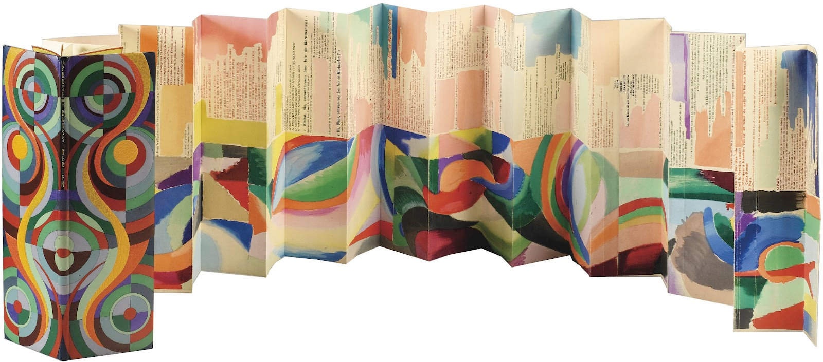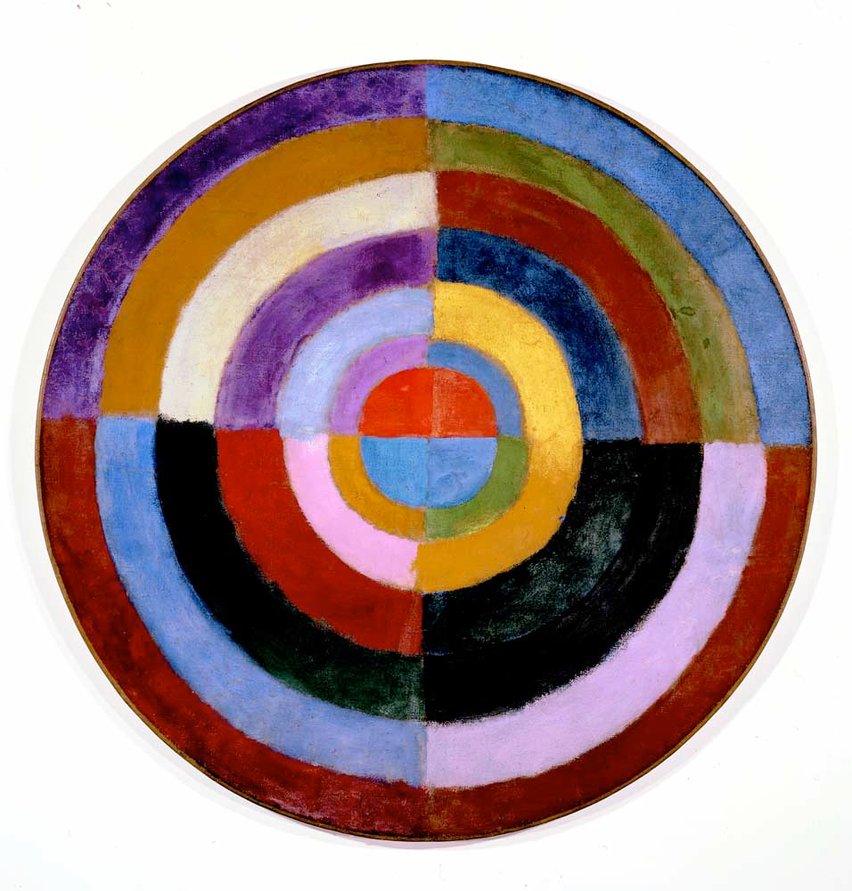ngs.org/en/robert-delaunay/premier-disque](http://www.wikipaintings.org/en/robert-delaunay/premier-disque)
3. Apollinaire, “Paysage” from *Calligrammes:* <http://www.paradis-des-albatros.fr/?poeme=apollinaire/paysage>

