**Aurelio Tello (Malpartida) (1951–)**

Rafael Leonardo Junchaya

[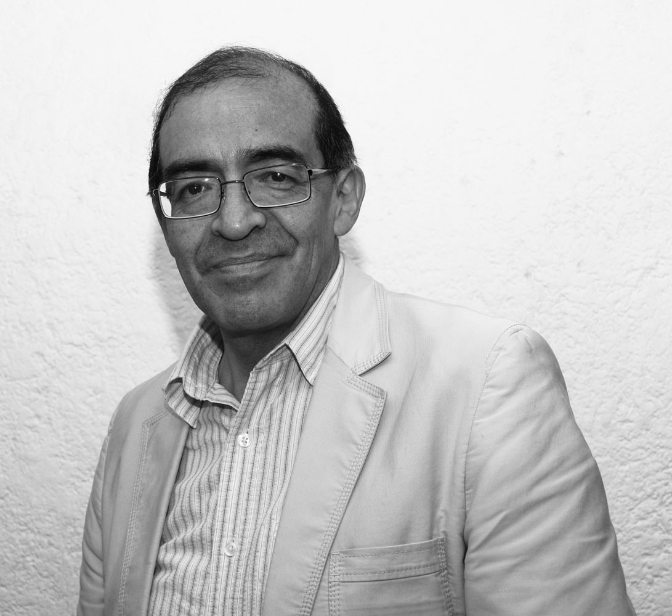](http://www.cenart.gob.mx/centros/cenidim/img/eventos/aurelio_tello.jpg)Aurelio Tello is a Peruvian composer, conductor and musicologist. Since 1982 he lives in Mexico. Tello has been awarded several prizes and distinctions, not only as a composer but also as a researcher. His main research subject is the Latin American colonial music, particularly from Mexico and Peru. Tello’s research also includes 20th-century music. He has published analyses, critics and historical accounts on composition and composers from Mexico and Peru. In 1989 Tello founded the *Capilla Virreinal de la Nueva España* ensemble, devoted to Latin-American colonial music repertoire.

Aurelio Tello was born in Cerro de Pasco, in the central highlands. He studied choral conducting and music education at the National Conservatoire of Peru. He also studied composition with ENRIQUE ITURRIAGA, EDGAR VALCÁRCEL and CELSO GARRIDO-LECCA. In 1974, Tello took part in a workshop on popular song promoted by Garrido-Lecca at the National Conservatoire. One year later, he attended a workshop on musical research with CÉSAR BOLAÑOS and FERNANDO GARCÍA. Tello began his career as a choral conductor in 1973, conducting several ensembles in Peru and Mexico. In 1980, he recorded 20th century Peruvian choral and vocal compositions with the National Conservatoire’s Choir. Since 1986 he is guest conductor of the Mexican Coro de Madrigalistas de Bellas Artes.

Aurelio Tello moved to Mexico in 1982, where MANUEL ENRÍQUEZ invited him to lead the musicological research department of CENIDIM (Centro Nacional de Investigación, Documentación e Información Musical “Carlos Chávez”–National Centre for Musical Research, Documenting and Information). Tello has published several books, articles and collections, as well as musical scores devoted to Mexican composers from the Colony, such as Manuel de Sumaya and Gaspar Fernandes. He has contributed to the collection *Tesoro de la música polifónica en Mexico* (Mexican polyphonic music treasure) with several volumes. He also edited musical collections from the cathedrals of Oaxaca and Puebla in Mexico and *Barroco* *Musical Peruano* (Peruvian Baroque music). Tello wrote his master thesis in Musicology on the songs with continuo from the Sutro codex. He is an active visiting lecturer in Latin-American universities, and has published in music periodicals such as *Plural*, *Pauta*, Casa de las Américas’ *Música* and *Revista Musical Venezolana*. Tello is also a contributor to the *Spanish and Latin-American Music Dictionary* with more than one hundred of entrances. He has been awarded the National Prize in Research granted by the INBA (Instituto Nacional de Bellas Artes of Mexico) in 1994 and in 1999 he received the Prize in Musicology from Casa de las Américas (Cuba) for his *Cancionero musical de Gaspar Fernandes*. He has also been awarded the Prize to the Academic Excellency granted by the INBA in 1999 and 2001.

In 1989, he founded the “Capilla Virreinal de la Nueva España”, vocal and instrumental ensemble devoted to Latin-American colonial music, which has participated in several festivals and concerts and has made some recordings.

As a composer, Aurelio Tello studied at the National Conservatoire of Peru. He later attended complementary courses in analysis with MARIO LAVISTA, HEBER VÁSQUEZ and CARL SCHACHTER. His choral composition *Trifábula* (1983) received an honourable mention in Colombia’s Ciudad de Ibagué’s composition contest and in 1987 he received the first prize in the Peruvian Banco Central de Reserva’s choral contest for his *Poema 9*. Tello’s compositional language is modernist, combining different techniques (like serialism and minimalism) also with traditional music. His *Dansaq* (1984–6) is a series of three different compositions based on the music for the traditional “Danza de tijeras” from the southern Andes of Peru. The first of these pieces was written for solo violin and dedicated to MANUEL ENRÍQUEZ, while the second was written for string quartet and has been premiered and recorded by the Cuarteto Latinoamericano. Another piece that shows the use of traditional music is *Ichuq parwanta*, which exist also in three different versions, the last one for marimba and piano (1998).Since the 90s he has been interested in working with one personal set/series. To this group belong *Elogio de Falami* (Praise to FAE, 1991), *Canción de cuna para despertar a un negrito* (Lullaby for waking up a little black boy, 2000, text by Nicolás Guillén) and the concerto for harp and string orchestra (2002), among others.

**List of works**

Writings (selection)

*(1983) *Tres obras de la catedral de Oaxaca,* Tesoro de la Música Polifónica en México Vol. III, México: CENIDIM.

*(1996) ‘Perspectivas de la Investigación musical’ in *Heterofonía* 114–115: 42–46.

*(1996) ‘Sor Juana Inés de la cruz y los maestros de capilla catedralicios o De los ecos concertados y las acordes músicas con que sus versos fueron puestos en métrica armonía’ in *Pauta* 57–58: 5–26.

*(1997) *Misas de Manuel de Sumaya*, Tesoro de la Música Polifónica en México Vol. VIII, México: CENIDIM.

*(1998) *Barroco Musical Peruano,* Lima: Pro-Música coral/AFP Integra.

*(2001) *El cancionero musical de Gaspar Fernandes* Vol. I, Tesoro de la Música Polifónica en México Vol. X, Mexico: CENIDIM. (Casa de las Américas Prize of Musicology 1999)

*(2003) ‘Foro de Música Nueva, ventana para la creación contemporánea’ in *México, su apuesta por la cultura. El siglo XX, testimonio desde el presente*: 305–307, México: Grijalbo.

*(2004) ‘Aires nacionales en la música de América latina como respuesta a la búsqueda de identidad’ in *Hueso Húmero* 44: 212-239.

*(2007) *Los Tonos Humanos y canciones para voz sola y bajo continuo del Manuscrito Sutro nº 1. Estudio y transcripción*, Master thesis in Musicology. MS.

*Miranda, R. and Tello, A. (2011) ‘La música en Latinoamérica del siglo XX hasta nuestros días’ in *La música en Latinoamérica*: 139–319, México: Secretaría de Relaciones Exteriores.

Compositions (selection)

*THREE PIECES FOR STRINGS (1972)

*EPITAFIO PARA UN GUERRILLERO for speaking chorus and four percussionists (1974)

*TRIFÁBULA for mixed chorus (1982). Honourable mention in Ciudad de Ibagué contest, Colombia.

*DANSAQ, HOMENAJE A MANUEL ENRÍQUEZ for solo violin (1984)

*DANSAQ II for string quartet (1985)

*POEMA 9 for mixed chorus (1987). First prize in the Banco Central de Reserva contest, Peru.

*ELOGIO DE FALAMI for clarinet, bassoon and piano (1991)

*ICHUQ PARWANTA (3rd version) for marimba and piano (1998)

*CANCIÓN DE CUNA PARA DESPERTAR A UN NEGRITO for mezzo-soprano and piano (2000)

*CONCERT FOR HARP AND STRING ORCHESTRA (2002)

*LIBER SEREGNI for ensemble (2004)

**References and further reading**

Carredano, C. (2002) ‘La rueda de la fortuna o el círculo perfecto de Aurelio Tello’ in *Pauta* 84: 68–89.

López-Calo, J. and Fernández de la Cuesta, I. (2002) *Diccionario de la música española e hispanoamericana* Vol. X, Madrid: SGAE.

Pinilla, E. (2007) ‘La música en el siglo XX’, *La música en el Perú*, 2nd edition, Lima: Fondo Editorial Filarmonía: 125–213.