Author: Marlène Biton

**Tokoudagba, Cyprien**

Cyprien Tokoudagba was born in 1939 in Abomey, former royal capital of Dahomey, nowadays Benin. As an artist appreciated locally as the restorer of the low-reliefs of the royal buildings of the Historical site of Abomey, he is also well known internationally for his manyexhibitions in France, Germany, USA, England, Australia, etc.. While conserving certain traditional aspects of the particular values of the *fon* culture, his work as an artist nevertheless opens them up to potential universal and modern dimensions. In so doing he made himself a personal path situated between the artistic traditions of his culture and the universe of contemporary art; thus enabling *fon* art to evolve while protecting its meanings and fundamental structure. Through his work over the decades and the numerous creations he completed before his death in 2012, Tokoudagba has opened the way for the young artists of Benin by setting up a space from which it is possible to work while retaining their specificity and not becoming lost in undifferentiated aesthetics.

Cyprien Tokoudagba comes from a family close to the ancient *fon* power, a descendant of Gezos' war leader, *gahu*, (1818–1858), and his son Gleles' minister of the interior, *mehu,* (1858–1889), two major kings of Dahomey from the 19th century. It is to this family heritage that he owes his deep knowledge of the *fon* culture, its values and history.

At an early age, Cyprien Tokoudagba was placed in an apprenticeship in his uncles' workshop creating religious sculptures for the churches. He learned how to model, mold clay and to paint. The artist later perpetuated the workshops where he trained, and worked as a family along with his wife who comes from a long line of creative blacksmiths and their children.

Vested with the status of religious leader, Cyprien Tokoudagba exercised his talents as a painter on the *vodoun* buildings and the convents of the divinity of the earth, *Sakpata*, and also on other buildings in the city. When he was commissioned to restore the low-reliefs of the Historical Museum of Abomey he displayed a detailed knowledge of the religious, political and historical significance of the royal buildings. This knowledge and respect for the history of the structure was also evident in the manner with which he went about the work by carefully renovating the reliefs using the original colours and maintaining the original high degree of quality.

Gradually Tokoudagba’s reputation grew as an artist who worked in a local, visual vernacular in modern materials that could weather the outdoor conditions. After he revisited the decoration on the temples of Abomey, he was commissioned to create low-reliefs on the buildings belonging to the princes and monumental sculptures for the secret societies and royal tombs, such as that of King Gezo. He also established a reputation internationally and was often invited to attend exhibitions abroad in addition to many events in Benin. In the latter years of his life the artist created his own gallery to exhibit his works of art.

Cyprien Tokoudagba’s important contributions to the art of Benin in the 20th century included breaking art out of its aesthetic and spatial confinement to embrace new forms and outdoor spaces. Conceptually, Tokoudagba produced new themes and executed them in an signature manner. He introduced large colourful paintings of *vodoun* figures rendered like individualized portraits to the walls of the temples. For effect he uses shadow in such a way that the flat surfaces spring to life. These specific aesthetic characteristics were new to art in the region. These characteristics also make his murals and monumental sculptures instantly recognizable to those who know his work.

Tokoudagba also practiced in small formats creating coloured clay statuettes. They represented traditional figures, kings, soothsayers, *bokonon*, religious chieftains, *vodounon*, etc., In his statuettes he also introduced a new aspect to local art: elements of social critique with regard to certain behavior, similar to those found on the masks of *guélédé*, borrowing the themes of the traditional works, but placing them in a new context.

By virtue of the intelligence and the diversity of his artistic expression, and the work accomplished throughout his life, Cyprien Tokoudagba has made space for artistic creativity from which talented young artists of Benin have emerged. Through him the *fon* populations' art traditions have grown to be recognized on an international level, enabling the introduction of the aesthetics and vocabulary of an oral tradition into universal art. Without succumbing to the path of least resistance the worldwide art circuit offered him, Cyprien Tokoudagba defended with courage his primary intentions and resisted both the facility of repeating tradition and conforming to international art.

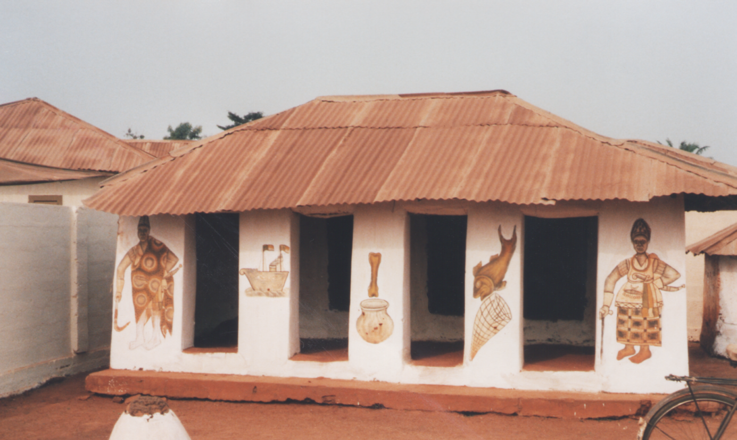

Temple dedicated to a *Tohoussou* decorated

by CyprienTokoudagba*,* Abomey, 1995

(photo by author, copyright held by author M. Biton).

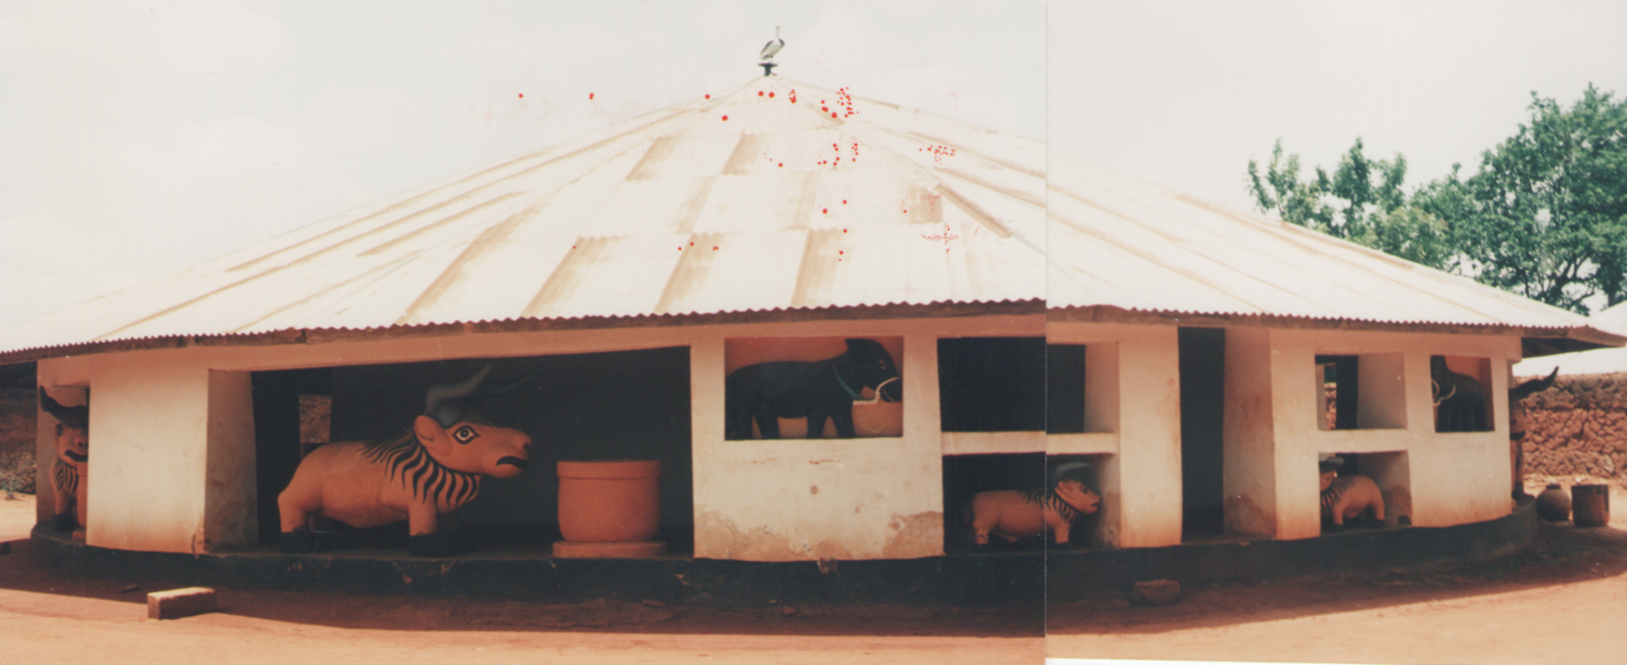

Tomb of King Gezo, Historical Museum of Abomey, Bénin, 1989

(photo by author, copyright held by author, M. Biton).

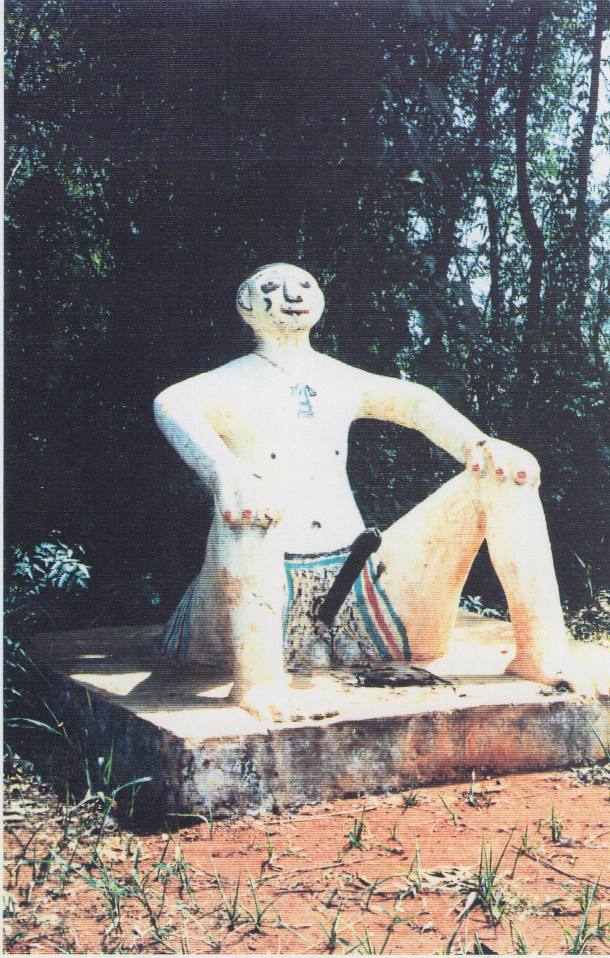

*Zangbeto-Legba*, Abomey, 1989

(photo by author, copyright held by author M. Biton).

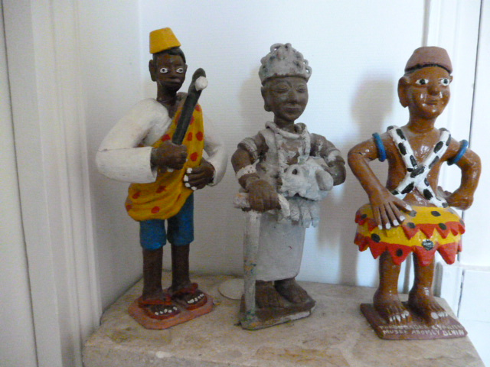

Traditionals figures : king or prince, priestess *Nessouhoue*,

priest *Sakpata* (privated coll.)

(photo by author, copyright held by author, M. Biton).

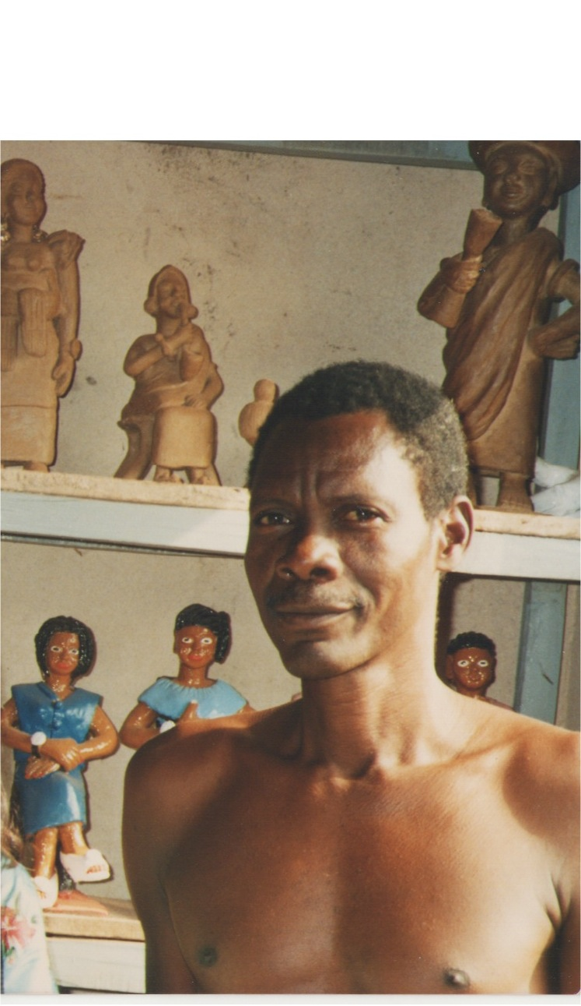

Cyprien Tokoudagba in his workshop, Abomey, dec. 1989.

(photo by author, copyright held by author, M. Biton).

Références

- Bay, E. G. (1975) « Cyprien Tokudagba of Abomey », *African arts*, 8 (4): 24-29 + 84.

- Biton, M. (2000) *L'art des bas-reliefs d'Abomey, Bénin/ex-Dahomey*, Paris : L'Harmattan.

- Biton, M. (2009) « Permanences, ruptures et traditions du statut de l'artiste à Abomey », *Artistes d'Abomey* : 87-94, Paris : Musée du quai Branly/Fondation Zinsou.

- Biton, M. (2013) « Création artistique en Afrique entre tradition et modernité : un artiste contemporain, Cyprien Tokoudagba » : *Wikicreation, l’Encyclopédie de la création et de ses usages*, Institut Acte, Université de Paris1-Panthéon-Sorbonne. http://www.soft-avenue.com/wikicreation_new/readArticle.php?articleId=20.

- *Dahomey, rois et dieux/ kings and gods, Cyprien Tokoudagba* (2006) Cotonou, Bénin : Fondation Zinsou.