**Wiesenthal, Grete (b. 9 December 1885, Vienna, Austria; d. 22 June 1970, Vienna)**

**Summary**

The Austrian dancer and choreographer Grete Wiesenthal was a transitional figure at the crossroads of ballet and modern dance. Initially trained and employed as a ballet dancer at the court opera in Vienna, she soon became disillusioned with the aesthetic traditionalism of ballet and in 1907 embarked on an independent career. Performing with two of her sisters and later as a soloist, she devised a new dance style and technique that emphasised bodily expressivity with motivational impulses provided by music. In the context of Viennese modernism, Wiesenthal’s work offered a novel interpretation of the Viennese waltz as a theatre dance form, oscillating between art nouveau and symbolism. She was groundbreaking in the Austro-German dance scene, exploring female creativity and individualism while contravening balletic principles. Although her career began in Vienna, she toured extensively across much of Europe and overseas, notably in New York, and hence extended her influence internationally. Wiesenthal shared with female contemporaries Anna Pavlova and Isadora Duncan a natural grace, expressive artistry, and flexibility of hands and arms. However, unlike Pavlova, Wiesenthal transgressed the confines and repertory of ballet, for instance eschewing pointe work. Like Duncan, her body image was liberated, but she was less daring in her choice of costumes – for instance, dancing in sandals rather than barefoot – and drew inspiration from local cultural traditions and not from Greek antiquity.

**Training and early career**

Grete Wiesenthal trained in ballet from the age of ten at the k.k. Hofoperntheater (Court Opera Ballet) in Vienna under Karoline Ellend, Eduard Voitus van Hamme, and Camilla Pagliero. Six years later, in 1901, she took a position in the corps de ballet at k.k. Hofopernballett company, which was directed by the renowned ballet master Josef Hassreiter, choreographer of *Die Puppenfee* (1888). She was promoted to the rank of coryphée in 1905, as was her younger sister Elsa, who danced with the same company. In May 1907 Grete resigned to pursue a freelance career and devise her own choreographies outside the strict academicism of established ballet institutions. Between 1907 and 1910 she often performed with her sisters, Elsa and Berta, as a trio, but later ceased this collaboration to pursue a solo career.

**Contributions to the Field and to Modernism**

Wiesenthal’s early work as an independent artist was deeply enmeshed in the latter years of Viennese modernism from around 1890 up to the First World War. These years shortly before the demise of the Austro-Hungarian double monarchy fostered a unique cultural climate, producing many of Europe’s leading artists and intellectuals. Wiesenthal’s decision to leave an artistically unsatisfying post at the court opera ballet paralleled the rebellions of other *fin-de-siècle* Viennese artists from various disciplines who sought to overthrow traditions and work beyond the confines of the established academy.

Notably, the Viennese Secession was founded in 1897 by a union of Austrian artists, which included Gustav Klimt, Koloman Moser, and Josef Hoffmann. This group had split from the Vienna Künstlerhaus in protest against its prevailing conservatism and traditional artistic concepts. The launch of Wiesenthal’s career was assisted by circles closely connected to the Secession and the Wiener Werkstätte, an outgrowth from the former, whose members helped to secure her first performance venues. Striving for a synthesis of the arts, the group was instrumental in integrating dance within the vanguard of artistic developments on a par with music, visual art, and literature.

In June 1907 Wiesenthal performed in the pantomime *Die Tänzerin und die Marionette* (*The Dancer and the Marionette*) by Max Mell at a garden party in Weigl’s Dreherpark, alongside students of leading Secessionist figures. In June 1908 she appeared in three pantomimes in the garden theatre of the Kunstschau, an art exhibition arranged by Gustav Klimt and Josef Hoffman. These open-air stages, architectural reflections of the new-found artistic freedom, manifested an affinity with the great outdoors and non-urban spaces, which is evident in much of Wiesenthal’s work.

The first public performance of the Wiesenthal sisters’ own choreographies took place in January 1908 at the Viennese cabaret *Fledermaus,* which was a project of the Wiener Werkstätte. On the programme were eight Wiesenthal dances with music by, among others, Chopin, Schumann, Johann Strauss, and Beethoven. Like Duncan and other modern dance pioneers, Wiesenthal used compositions not specifically written for the theatre stage. The evening including Grete’s *Donauwalzer*, which she danced alone, and *Lanner-Schubert-Walzer*, by Grete and Elsa, performed as a trio with Berta.

These early creations already bore many hallmarks of Wiesenthal’s style, which fused traditional and modernist elements. She relied on the conventional form of ballet in two respects: first technically, as Wiesenthal students such as Mundorf and Czerny believed that only balletically trained bodies had the strength and stability to cope with the style’s physical demands. Secondly, the aesthetic qualities of Wiesenthal’s work, such as grace, harmony, lightness, and beauty, reflected the feminised style of nineteenth-century ballet.

However, Wiesenthal’s objections to the conventions of academic ballet, which she regarded as overly technical, lacking in musicality, formulaic, and aesthetically banal, led to her abandoning many core elements of its technique and style. She advanced instead a range of modernist dance principles including female authorship, the de-emphasis of stage scenery, and the use of free-flowing costumes, sandals, and untied hair, which replaced, respectively, corsets, pointe shoes, and ballet buns or braids. Wiesenthal’s works extolled individual expression emanating from the creator’s unique physical predisposition and talents. Her works’ compositional principles, many in the *art nouveau* style, paralleled those of her contemporaries in the visual arts: the fluidity of line and floral style; the importance of hand and arm gestures in contrast to classical ballet; and the simplicity and stylisation of form. Her choreographies were often highly motivated by music, seeking to find suitable kinetic expressions for musical phrases.

The waltz became her signature form, for which she devised a new technique based on swing. Her version of this dance abandoned both the recognisable steps of the conventional nineteenth-century ballroom waltz, and those of the ballet waltz showcased in nineteenth-century classical pieces. Instead she transformed the waltz into a new modernist solo form; her technique emphasising the horizontal line rather than the vertical axis. Like other dance innovators, such as Isadora Duncan, Ruth St. Denis and later Mary Wigman and Rosalia Chladek, Wiesenthal made use of the deep backbend, which liberated the body from the symmetrical axis and stable balance seen in ballet and became a key hallmark of the new ‘free’ dance. She invented a rotation in which the head is tilted backwards and the upper body held in a backward arch with the arms widely extended, while standing on demi-pointe with bent knees. She renounced spotting during turns and, like Duncan, eschewed the forced *en dehors* (turn out) typical of ballet in favour of parallel feet.

While serious in aspiration and progressive in form, Wiesenthal’s dance also captured the popular imagination of audiences. Contemporary commentators such as Hugo von Hofmannsthal and Hans Brandenburg perceived the combination of waltzing, light music by composers such as Strauss and Lanner, the expression of joyfulness and rapture, and the evocation of rural idylls and affinity with nature as evoking something quintessentially Viennese, which – especially after the First World War – was imbued with nostalgic sentiments.

Hugo von Hofmannsthal, Wiesenthal’s most important collaborator and friend, saw in dance an expressive potential superior to that of verbal language, along with a symbol of freedom and the rejection of cultural constraints. Their collaboration ushered in four pantomimes, including *Das fremde Mädchen* (*The Foreign Girl*, 1911, film version 1913), and a ballet entitled *Taugenichts* (*Good for Nothin*g, 1912).

**Wiesenthal’s Late Career and Legacy**

Wiesenthal ended her active performing career in January 1938 at the Vienna Hofburg. She continued to teach at the Akademie für Musik und darstellende Kunst in Vienna, a post she had taken up in 1934. In 1945 she became Director of the Department of Artistic Dance at the Academy. Also in 1945, she formed the Tanzgruppe Grete Wiesenthal, a dance ensemble which existed for ten years and toured in Europe and overseas, showcasing new Wiesenthal choreographies alongside older works.

From 1951 to 1972 Wiesenthal technique was taught at the Academy by her assistant, Maria Josefa Schaffgotsch. Wiesenthal’s legacy has survived in the teachings and waltz choreographies of her own students, including Hedi Richter who still taught at the ballet school of the Vienna State Opera in 2012, as well as Schaffgotsch students such as Susanne Mundorf in Germany. From the late 1970s, Vilma Kostka and Erika Kniza, former members of the Tanzgruppe, reconstructed several works which were shown at the Vienna State Opera and in guest performances abroad.

**Alexandra Kolb**

**Selected Works**

*Donauwalzer* (*The Blue Danube*, choreographed 1906, first public performance 1908)

*Chopin-Walzer Des-Dur* (*Chopin-Waltz D flat major*, 1906/1908 by Grete and Elsa Wiesenthal)

*Lanner-Schubert-Walzer* (*Lanner-Schubert Waltz*, 1906/1908 by Grete and Elsa Wiesenthal)

*Tanz aus Manon* (*Dance from Manon*, 1906/8, by Grete and Elsa Wiesenthal)

*Frühlingsstimmenwalzer* (*Waltz of Spring Melodies,* 1909 by Elsa Wiesenthal, 1911 by Grete Wiesenthal)

*Der Wind* (*The Wind*, 1909)

*Brauttanz* (*Bride Dance*, 1913)

*Aufforderung zum Tanz* (*Invitation to Dance*, 1916)

*G’schichten aus dem Wienerwald* (*Stories from the Vienna Woods*, 1916)

*Delirienwalzer* (*Delirium Waltz*, 1921)

*Wein, Weib und Gesang* (*Wine, Women and Song*, 1922)

*Slawischer Tanz* (*Slavonic Dance*, 1924)

*Mazurka* (1926)

*Wiener* Blut (*Viennese Blood*, 1928)

*Der Taugenichts in Wien* (*A Good-for-Nothing in Vienna*, 1930)

*Gang zum Heurigen* (*Walking to the Wine Tavern*, 1933)

*Himmelswiese* (*Heaven’s Meadow*, 1936)

**Selected choreographies for the Tanzgruppe Grete Wiesenthal between 1945 and 1955/56**

*Verirrt im Walde (Lost in the Woods)*, *Eine kleine Nachtmusik (A Little Night Music)*, *Der abgestürzte Jäger (The Fallen Hunter)*, *Kaiserwalzer (Emperor Waltz)*, *An der schönen blauen Donau (At the Beautiful Blue Danube)*

**Pantomimes with Hugo von Hofmannsthal**

*Amor und Psyche* (*Cupid and Psyche*, 1911)

*Das fremde Mädchen* (*The Foreign Girl*, 1911)

*Der dunkle Bruder* (*The Dark Brother*, remained fragment)

*Die Biene* (*The Bee*, 1916)

**Films**

*Kadra Sâfa* (1913)

*Die goldene Fliege* (*The Golden Fly*, 1913)

*Erlkönigs Tochter* (*Erlkönig‘s* *Daughter* 1913)

*Die Wiener Werkstätte* (also entitled: *Der Traum des Künstlers*, *The Artist’s Dream*, 1919)

**Artist’s Writings**

Wiesenthal, G. (1919) *Der Aufstieg. Aus dem Leben einer Tänzerin* (*The Ascent. On the Life of a Dancer*), Berlin: Rowohlt.

------ (1951) *Iffi . Roman einer Tänzerin* (*Iffi*. *Novel about a Dancer*), Vienna: Amandus Verlag.

**References and further reading**

Lang, E. (1910). *Grete Wiesenthal. Holzschnitte von Erwin Lang,* Berlin: Erich Reiss Verlag.

Fiedler, L. & Lang, M., eds. (1985) *Grete Wiesenthal. Die Schönheit der Sprache des*

*Körpers im Tanz*. Salzburg/Vienna: Residenz-Verlag.

Fleischer, M. (2007). *Embodied Texts. Symbolist Playwright-Dancer Collaborations*.

Amsterdam/New York: Rodopi.

Kolb, A. (2009) *Performing Femininity: Dance and Literature in German Modernism*. Oxford: Peter Lang.

Brandstetter, G. & Oberzaucher-Schüller, G., eds. (2009*) Mundart der Wiener Moderne. Der Tanz der Grete Wiesenthal*. Munich: Kieser.

[[https://collaborate.northwestern.edu/owa/14.3.158.1/themes/resources/clear1x1.gif](https://collaborate.northwestern.edu/owa/)Wiesenthal photo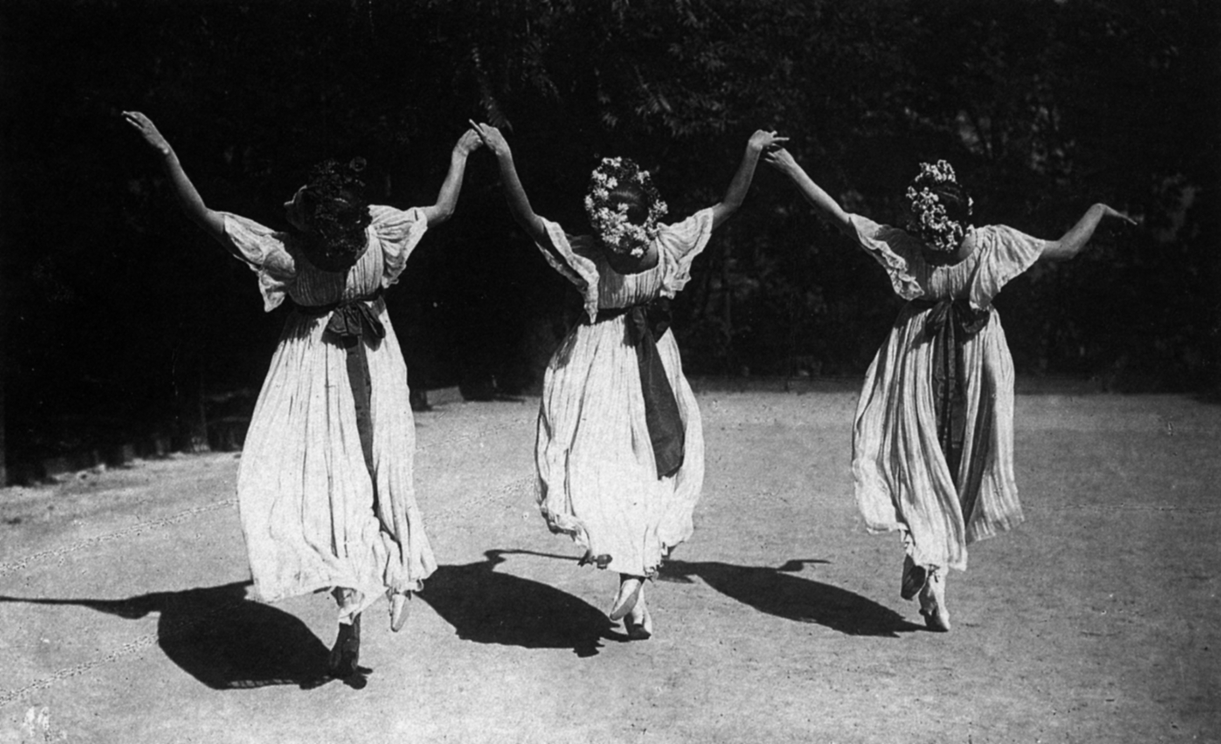graph.jpg‎ (1 MB‎)](https://collaborate.northwestern.edu/owa/" \o "Wiesenthal photograph.jpg" \t "_blank)

Elsa, Grete and Berta Wiesenthal in *Lanner-Schubert-Waltz* (1908). Photographer: Rudolf Jobst.

Permission to publish must be sought from the Derra de Moroda Archive in Salzburg.