**World Expositions of Paris (1889 and 1900) and Chicago (1893 and 1933)**

The world expositions were monumental, public spectacles originating in the industrial fairs of early-nineteenth century France and culminating in the Expositions Universelles of Paris (1889 and 1900) and the World’s Columbian Exposition (1893) and Century of Progress International Exposition (1933) of Chicago. The Great Exhibition of 1851 in London was among the first of the nineteenth century industrial exhibitions featuring monumental exposition architecture with its cast-iron and glass Crystal Palace designed by Joseph Paxton. For cultural observers of the time as well as later critics, the Crystal Palace and later expositions – particularly the *fin de siècle* expositions held in Paris (1889 and 1900) and Chicago (1893) – exemplified the culture of mass consumption that has its origins in the bourgeois society of the nineteenth century. In *The Arcades Project*, Walter Benjamin described the world expositions as ‘places of pilgrimage to the commodity fetish’ (7) in which workers where transformed into consumers through the mediation of iron and glass architecture. The American expositions of the 1930s intensified the massive displays of Utopian expectation and technological progress on offer at the fairs with their exhibits of ‘dream cars’ and ‘houses of tomorrow’, monuments to consumerism as well as science fiction visions of the future.

**The Universal Exposition of Paris (1889)**

Susan Buck-Morss has described how the 1889 Paris Exposition was received as ‘the triumph of iron’ (130). The impressive effects of iron architecture were exemplified by two structures built for the exposition: the Galerie des Machines and the Eiffel Tower. Though monumental at the time, the Galerie des Machines was, according to Benjamin, demolished ‘out of artistic sadism’ (160) in 1910. By contrast, the Eiffel Tower survives despite the famous ‘Artists Protest’ signed by French literary luminaries such as Émile Zola, Guy de Maupassant, Paul Verlaine, among others. The Universal Exposition of 1889 was also a colonial exhibition in which subjects of the French colonies and elsewhere were put on display in villages, already a feature of world expositions since the Crystal Palace. These displays included both simulations of everyday life in so-called human zoos as well as staged exhibitions of art, music and dance—such as the Javanese gamelan music that served as source of inspiration for Claude Debussy.

**The World’s Columbian Exposition of Chicago (1893)**

The Chicago Exposition of 1893 followed the 1889 Paris Exposition both in its displays of technological progress and its collection of primitivist spectacles. While Thomas Edison had already contributed a significant exhibition of electricity at the earlier Paris exposition, electrical exhibits proved to be even more significant attractions of the World’s Columbian Exposition. Both Thomas Edison and Nikolai Tesla exhibited competing electrical systems, electric lighting and other electrical effects. Eadweard Muybridge’s demonstration of the zoopraxiscope, a device for projecting moving pictures, was an important landmark of early cinema. Architecturally, the exposition was built around a White City containing exhibits of technological progress and a Midway Plaisance filled with ethnographic villages and carnival amusements—including the first Ferris Wheel. Robert Rydell has suggested that the Midway Plaisance at the Chicago exposition, with its combination of ethnographic and commercial attractions, can be seen as a ‘cultural hothouse that generated many novel mass cultural forms’ (Rydell 2005, n.p.) such as Riverview Park and Coney Island (Rydell). In response to the overt racism of the exposition and the deliberate exclusion of displays of African American progress since slavery, Ida B. Wells wrote a blistering pamphlet on ‘The Afro-American’s Contribution to Columbian Literature’. While Wells herself advocated boycotting the exposition, Fredrick Douglass used the occasion to insist on civil rights for African Americans and in fact attended as the delegate from Haiti.

**The Universal Exposition of Paris (1900)**

Using many of the same structures as the earlier Paris Exposition, including the then-still-standing Galerie des Machines, the Universal Exposition of 1900 rivaled the former in terms of spectacular excess. As Rosalind Williams has described, ‘thoughtful observers sensed that the 1900 exposition was particularly prophetic, that it was a microcosm of emerging France, a scale model of future Paris, that something rich and strange was happening there which broke decisively with the past and prefigured twentieth century society’ (60). Reflecting on the spectacles of electricity in the Galerie des Machines, Henry Adams wrote his ‘The Dynamo and the Virgin’ chapter of *The Education of Henry Adams*, in which he describes the dynamo as a ‘symbol of infinity’ and an ‘occult mechanism’ (307). The new technology of the cinema also figured strongly at the exposition; on assignment from the Edison Company, James H. White shot at least sixteen actuality films, including panoramas of the moving boardwalk and the Eiffel Tower. Although ethnographic villages and other spectacles from the colonial empire continued to be large attractions, the 1900 Paris Exposition also featured contributions to an ‘Exhibit of American Negroes’ from Booker T. Washington and W. E. B. Du Bois, documented by Du Bois in his article ‘The American Negro at Paris’.

**The Century of Progress International Exposition of Chicago (1933)**

Held in the midst of the Great Depression, the 1933 Chicago Exposition increased the Utopian emphasis already present in earlier expositions. Exhibits had a more directly consumerist focus with displays of ‘dream cars’ by American automobile manufacturers, and a ‘Houses of Tomorrow’ exhibition, including among others the modernist House of Tomorrow by George Keck featuring aluminum and glass plate walls, an airplane hanger and working air conditioning. As in other world expositions, sexuality was on display as a featured element of the consumerist spectacle: the fan dance performances of Sally Rand, inventor of the bubble dance, were among the exposition’s most popular attractions. The utopian and futuristic elements of the 1933 exposition were intensified in later World’s Fairs, particularly the New York World’s Fair of 1939, which took the ‘world of tomorrow’ as its explicit theme.

**Figures**

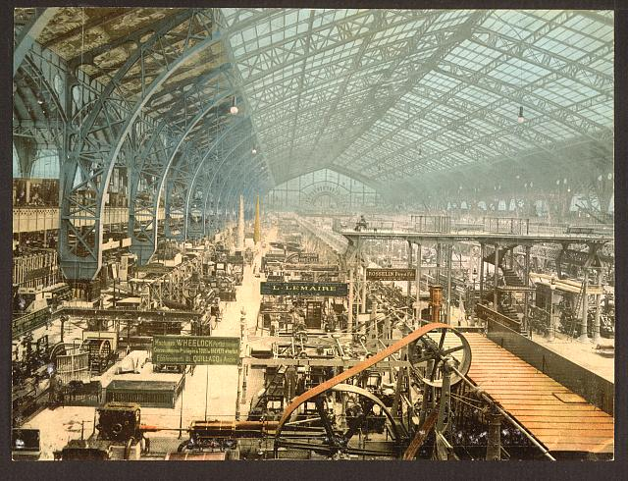

**Fig. 1** Interior view of the Galerie des Machines, Exposition universelle internationale de 1889, Paris, France, Library of Congress Prints and Photographs Division

< <http://www.loc.gov/pictures/collection/pgz/item/2001698576/>>

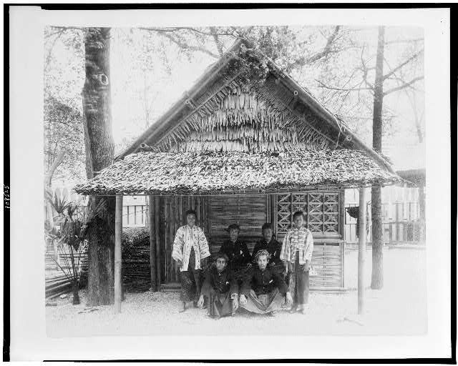

**Fig. 2** Six people posed before Javanese house in Javanese Village, Paris Exposition, 1889, Library of Congress Prints and Photographs Division

< <http://www.loc.gov/pictures/item/94500849/>>

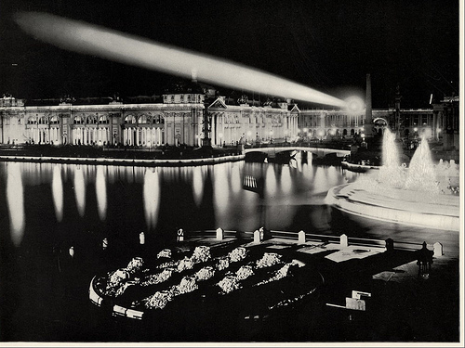

**Fig. 3** Agricultural Building at Night, from North West. With spotlight or beacon of light shining across the lagoon. Large photographic print from The White City (As It Was). Photographs by William Henry Jackson. World’s Columbian Exposition. 1893, World’s Columbian Exposition Collection at The Field Museum, The Field Museum Library

< <http://www.flickr.com/photos/field_museum_library/3409426351/in/set-72157616234589478>>

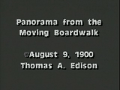

**Fig. 4** Panorama from the moving boardwalk / Thomas A. Edison, Inc.; producer, James White, 1:46 at 16 fps. Filmed July 1900, at the Paris Exposition in Paris, France, Library of Congress Motion Picture, Broadcasting and Recorded Sound Division

< <http://hdl.loc.gov/loc.mbrsmi/edmp.1761>>

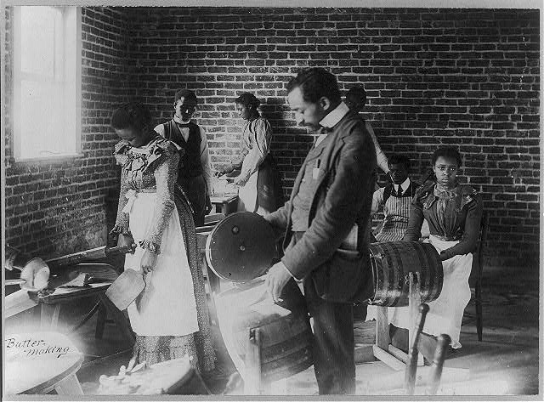

**Fig. 5** Agricultural and Mechanical College, Greensboro, N.C., displayed as part of the American Negro exhibit at the Paris Exposition of 1900, Library of Congress Prints and Photographs Division

< <http://www.loc.gov/pictures/collection/anedub/item/2001705868/>>

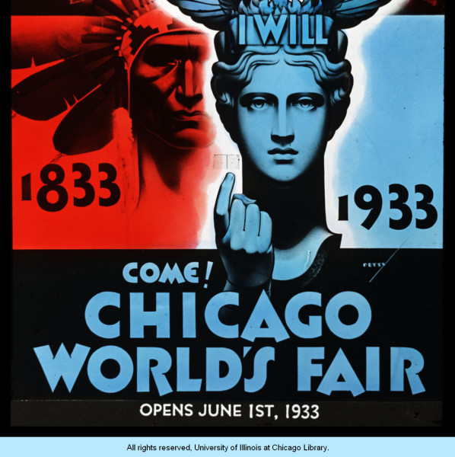

**Fig. 6** A Century of Progress promotional poster featuring the ‘I will’ maiden beckoning fairgoers to attend Chicago’s centenary celebration, Images of Progress: Views of a Century of Progress International Exposition, 1933-1934, University of Illinois at Chicago

<<http://collections.carli.illinois.edu/u?/uic_cop,1508>>

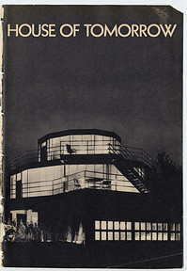

**Fig. 7** House of Tomorrow, Century of Progress 1933-34 World’s Fair Collection, The University of Chicago Library

< <http://www.lib.uchicago.edu/cgi-bin/nand/search/century?browse=%3A%3ACONFIG%3A%3Atitle&key=house+of+tomorrow&limit=0>>

**References and further reading**

Adams, H. (1999) *The Education of Henry Adams*, New York: Bartleby.com. <<http://www.bartleby.com/159/>>

Benjamin, W. (1999) *The Arcades Project*, Cambridge: Harvard University Press.

Blanchard, P. (et al.) (ed.) (2009) *Human Zoos: Science and Spectacle in the Age of Colonial Empires*, Liverpool: Liverpool University Press.

Buck-Morss, S. (1991) *The Dialectics of Seeing: Walter Benjamin and the Arcades*

*Project*, Boston: MIT Press.

Böger, A. (2011) *Envisioning the Nation: The Early American World’s Fairs and the Formation of Culture*, Frankfurt am Main: Campus Verlag.

Corbey, R. (1993) ‘Ethnographic Showcases: 1870-1930’, *Cultural Anthropology* 8 (3): 338-369.

Du Bois, W. E. B. (1900) ‘The American Negro at Paris’, *The American Monthly Review of Reviews* 22 (5): 575-577. <<http://www.webdubois.org/dbANParis.html>>

Fauser, A. (2005) *Musical Encounters at the 1889 Paris World’s Fair*, Rochester: University of Rochester Press.

Greenhalgh, P. (2011) *Fair World: A History of World’s Fairs and Expositions from London to Shanghai 1851-2010*, London: Papadakis.

Hodeir, C. (2002) ‘Decentering the Gaze at French Colonial Exhibitions’ in P. Landau and D. Kaspin (eds) *Images and Empires: Visuality in Colonial and Postcolonial Africa*, Berkeley: University of California Press, 233-252.

Musser, C. (1994) *The Emergence of Cinema: The American Screen to 1907,* Berkeley: University of California Press.

Nye, D. (1994) *American Technological Sublime*, Cambridge: MIT Press.

------ (1992) *Electrifying America: Social Meanings of a New Technology, 1880-1940*, Cambridge: MIT Press.

Ogata, A. (2010) ‘“To See is to Know”: Visual Knowledge at the International Expositions’ in J. Kromm and S. Benforado Bakewell (eds) *A History of Visual Culture: Western Civilisation from the 18th to the 21st Century*, New York: Berg, 200-210.

Pepchinski, M. (2010) ‘Woman’s Buildings at European and American World’s Fairs, 1893-1939’ in T. J. Boisseau and A. M. Markwyn (eds) *Gendering the Fair: Histories of Women and Gender at World’s Fairs*, Urbana: University of Illinois Press, 187-207.

Rydell, R. (1987) *All the World’s a Fair: Visions of Empire at American International Expositions, 1876-1916,* Chicago: University Of Chicago Press.

------ (1993) *World of Fairs: The Century-of-Progress Expositions*, Chicago: University of Chicago Press.

------ (2005) ‘World’s Columbian Exposition: (May 1, 1893—October 30, 1893.)’ *The Electronic Encyclopedia of Chicago* < http://bit.ly/3ZA6PD>.

Rydell. R. *et al.* (ed.) (2010) *Designing Tomorrow: America’s World Fairs of the 1930s*, New Haven: Yale University Press.

Wells, I. (1999) *The Reason Why the Colored American is Not in the World’s Columbian Exposition: The Afro-American’s Contribution to Columbian Literature*, Urbana: University of Illinois Press. < <http://digital.library.upenn.edu/women/wells/exposition/exposition.html>>

Williams, R. (1991) *Dream Worlds: Mass Consumption in Late Nineteenth Century*

*France,* Berkeley: University of California Press.

**Online Resources**

*World’s Fair Overview: 1851-1970, A collection of A collection of materials from the UM Architecture Library,* University Libraries, University of Maryland

<<http://www.lib.umd.edu/artarch/exhibition/index.html>>

*World’s Columbian Exposition of 1893: Paul Galvin Library Digital History Collection*, Illionois Institution of Technology

< <http://columbus.iit.edu/>>

*1893 World’s Columbian Exposition*, Flickr Commons, The Field Museum Library

< <http://www.flickr.com/photos/field_museum_library/sets/72157616234589478/>>

*World’s Columbian Exposition Chicago 1893*, Flickr Commons, Brooklyn Museum

< <http://www.flickr.com/photos/brooklyn_museum/sets/72157606873382962/>>

*Paris Exposition of 1889*, Collection Overviews, Library of Congress

< <http://www.loc.gov/rr/print/coll/250_paris.html>>

*Exposition des Nègres d'’amerique* [sic]*, Exposition Universelle, Paris 1900*, W. E. B. Du Bois Papers (MS 312). Special Collections and University Archives, University Libraries, University of Massachusetts Amherst

<<http://credo.library.umass.edu/view/full/mums312-0397>>

*The Expositions Universelles in Nineteenth Century Paris*, Brown University Library Center for Digital Scholarship

< <http://library.brown.edu/cds/paris/worldfairs.html>>

*African American Photographs Assembled for 1900 Paris Exposition*, Prints and Photographs Online Catalog, Library of Congress

< <http://www.loc.gov/pictures/collection/anedub/>>

*Paris Exposition of 1900*, Flickr Commons, Brooklyn Museum

< <http://www.flickr.com/photos/brooklyn_museum/sets/72157604656089762/>>

*Inventing Entertainment: The Motion Pictures and Sound Recordings of the Edison Companies*, American Memory, Motion Picture, Broadcasting and Recorded Sound Division, Library of Congress

< <http://memory.loc.gov/ammem/edhtml/edhome.html>>

*Century of Progress 1933-34 World’s Fair Collection*, The University of Chicago Library

< <http://century.lib.uchicago.edu/>>

*Century of Progress World’s Fair, 1933-1934*, University of Illinois at Chicago

< <http://collections.carli.illinois.edu/cdm4/index_uic_cop.php?CISOROOT=/uic_cop>>