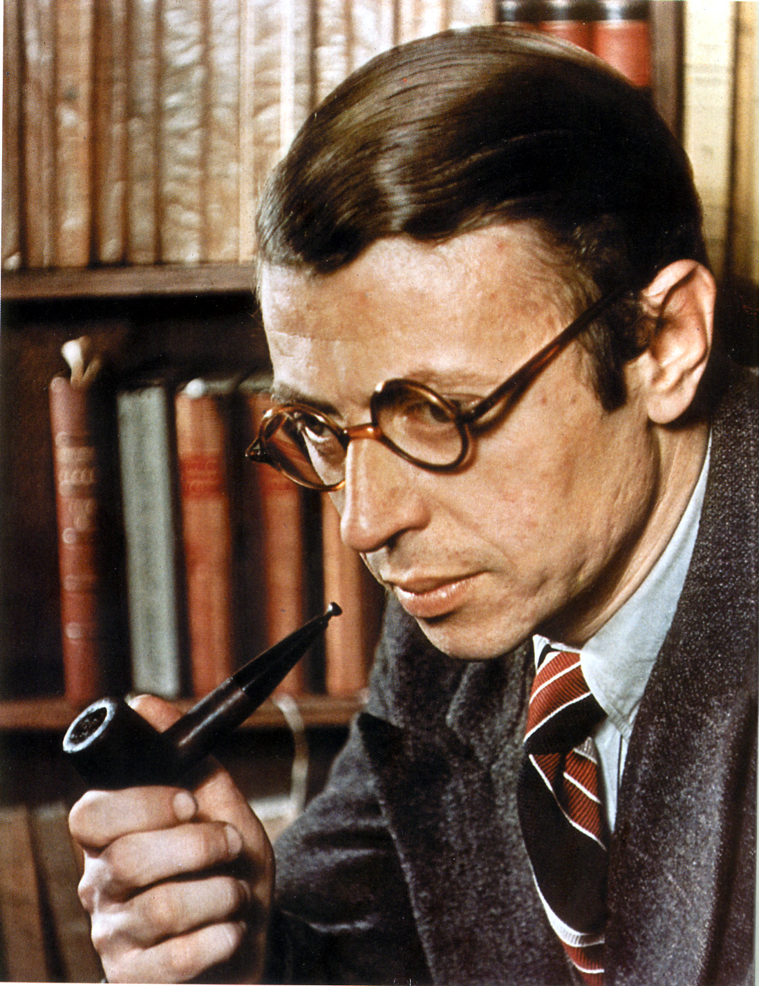

Jean-Paul Sartre (1905-1980) was a French novelist, playwright, literary critic and existentialist philosopher. He was born in Paris, France. He was one of the leading French public intellectuals of the twentieth century, most notable for advancing existentialist philosophy and thus shaping the intellectual field in the decade following the Second World War. Sartre was awarded the Nobel Prize for Literature in 1964, but he refused it.

After graduating from the École Normale Supérieure in 1929, where he met his lifelong partner and fellow philosopher Simone de Beauvoir, Sartre served in the French army from 1929 to 1931. He later taught in the lycées of Le Havre, Lao and Paris until 1945. During his years as a professor, Sartre’s first novel, La Nausée (1938; The Diary of Antoine Roquentin, tr. 1949 / Nausea, tr. 1965) was published. This epistolary novel, which is considered a canonical work of EXISTENTIALISM, explores the relationship of contingency and necessity in Roquentin’s ability to define himself and his freedom. The collection of stories Le Mur (The Wall, and Other Stories, tr. 1948), published in the same year, also brought him immediate recognition as another expression of his early themes of alienation, freedom and artistic salvation.

Sartre’s early novels reflect his close study of the German philosopher Edmund Husserl’s phenomenological method (which proposes an unprejudiced study of events); Sartre developed his own phenomenological account of imagination, in such works as: L’Imagination (1936; Imagination: A Psychological Critique, tr. 1962), Esquisse d’une théorie des emotions (1939; The Emotions: Outline of a Theory, tr. 1948), and L’Imaginaire: Psychologie phénoménologique de l’imagination (1940; The Psychology of Imagination, tr. 1948).

In 1943, Sartre’s major philosophical treatise, L’Être et le Néant (Being and Nothingness, tr. 1956) was published. This work provides the most detailed account of his existentialist thought, drawing an opposition between human consciousness or no-thingness (néant), and being or thingness (être). Sartre describes consciousness as always self-conscious, as opposed to matter; hence it escapes determinism, and thus is essentially ‘for itself’ (pour soi) the source of freedom. Freedom of choice is not idealized, according to Sartre, but rather, it is conceived within one’s contingent, historical circumstances. With freedom comes the social responsibility of giving meaning to an otherwise groundless existence.

Sartre’s existentialist ethics can be glimpsed in his novels and plays, in particular in the four-volume novel Les Chemins de la liberté (The Roads to Freedom), of which Sartre only wrote three volumes: L’Âge de raison (1945; The Age of Reason, tr. 1947), Le Sursis (1945; The Reprieve, tr. 1947) and, La Mort dans l’âme (1949; Iron in the Soul, tr. 1950 / Troubled Sleep, tr. 1953). The trilogy portrays the wartime struggles of Parisian intellectuals with the notion of freedom; it presents a more grounded view of EXISTENTIALISM, tracing the progression of the effects of the Second World War on Sartre’s thought toward ‘engagement’ in both life and literature. The shift in his philosophical position toward conceiving of freedom as a social responsibility culminated in Sartre’s immensely popular public lecture “L’Existentialisme est un humanisme” (1946; Existentialism and Humanism, 1948), which he presented in Paris on October 28, 1945.

During the same decade, Sartre wrote several successful plays, including Les Mouches (1943; The Flies, tr. 1946), which allegorizes the German occupation through the myth of Orestes, a young killer’s commitment to freedom in the face of an oppressed Jupiter. Huis Clos (1945; In Camera, tr. 1946 / No Exit, tr. 1947) explores issues of self-consciousness and tormented relationships, where three deceased characters are doomed to remain together in a room for eternity. Les Mains Sales (1948; Crime Passionnel, tr. 1949 / Dirty Hands, tr. 1949), set in a fictional Communist country in Eastern Europe during the Second World War, depicts a killer’s philosophical or political motivations behind a killing. Other plays of the same period include Le Diable et le bon Dieu (1951; Lucifer and the Lord, tr. 1952) and Les Séquestrés d’Altona (1959; Loser Wins, tr. 1960 / The Condemned of Altona, tr. 1961).

Sartre devoted a considerable part of his career to literary criticism. He co-founded the monthly journal Les Temps Modernes along with de Beauvoir. The many articles they wrote and edited were later published as a series entitled Situations, between 1947 and 1976. In his famous series of essays, Qu’est-ce que la littérature? (1948; What is Literature?, tr. 1949), Sartre expounds on his ethical shift toward the social responsibility of the intellectual, and a committed literature, which prose can achieve, whereas poetry cannot. This marks his rejection of the literary practice of “L’art pour l’art” (art for art’s sake). Other publications of literary criticism in this period include his book Baudelaire (1947; tr. 1949) and Saint Genet, comédien et martyr (1952; Saint Genet, Actor and Martyr, tr. 1963).

In the post-war years, Sartre became increasingly involved with politics, particularly Marxism. His publication of the philosophical work, Critique de la raison dialectique (1960; Critique of Dialectical Reason, tr. 1976) reflects his engagement with social and political issues in Marxism, questions of choice, historical contingency and its material restrictions on freedom.

Sartre’s last major works include his autobiography, Les Mots (1963; The Words, tr. 1964) and L’Idiot de famille (1971-72; The Family Idiot, tr. 1981-1993), a biographical study of Gustave Flaubert.

References and further reading:

Sartre, Jean-Paul. (1981) The Words: The Autobiography of Jean-Paul Sartre. New York: Random House, Inc.

Jean-Paul Sartre - Biography. (2012, July 1) Nobelprize.org. Retrieved from http://www.nobelprize.org/nobel_prizes/literature/laureates/1964/sartre-bio.html

List of Major Works:

1936 – L’Imagination (Imagination: A Psychological Critique, tr. 1962)
1938 – La Nausée (Nausea, tr. 1949)
1939 – Le Mur (The Wall, tr. 1948)
1939 – Esquisse d’une théorie des émotions (The Emotions: Outline of a Theory, tr. 1948)
1940 – L’Imaginaire (The Imaginary, tr. 2004)
1943 – L’Être et le néant (Being and Nothingness, tr. 1956)
1943 – Les Mouches (The Flies, tr. 1946)
1945 – Huis Clos (No Exit, tr. 1947)
1945 – L’Âge de raison (The Age of Reason, tr. 1947)
1945 – Le Sursis (The Reprieve, tr. 1947)
1946 – L’Existentialisme est un humanisme (Existentialism and Humanism, tr. 1948)
1947 – Baudelaire (Baudelaire, tr. 1949)
1948 – Qu’est-ce que la littérature? (What is Literature?, tr. 1949)
1949 – La Mort dans l’âme (Iron in the Soul, tr. 1950 / Troubled Sleep, tr. 1951)
1951 – Le Diable et le bon dieu (Lucifer and the Lord, tr. 1952)
1952 – Saint Genet, comédien et martyr (Saint Genet, Actor and Martyr, tr. 1963)
1960 – Critique of Dialectical Reason (Critique of Dialectical Reason, tr. 1976)
1960 – Les Séquestrés d’Altona (Loser Wins, tr. 1960 / The Condemned of Altona, tr. 1961)
1964 – Les Mots (The Words, tr. 1964)
1971-1972 – L’Idiot de Famille: Gustave Flaubert de 1821-1857 (The Family Idiot: Gustave Flaubert, 1821-1857, tr. 1981-1993)

Photographic Source: http://3.bp.blogspot.com/-nWUTuaZF8FM/T5Z6fX6YkKI/AAAAAAAACgU/RT7z3js92CU/s1600/jean-paul-sartre-.jpg

Other photograph (taken with Simone de Beauvoir):
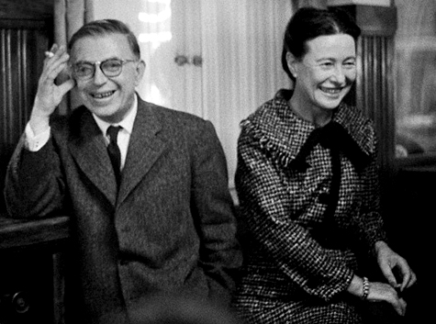
source: http://4.bp.blogspot.com/-3XMDzVplih0/T4GVQmZtEjI/AAAAAAAALF0/bOZetswHn3c/s1600/tumblr_lf6ydnvByL1qa9op5o1_500.jpg

