Katarzyna Kobro (1898 Moscow – 1951 Łódź)
was artist of German-Russian origin, active in Russia, Latvia, but mainly based in Poland. An outstanding sculptor and art theoretician, painter, graphic artist, stage, fashion and architecture designer, Kobro is one of the most distinguished sculptors and female artists of the 20th century and a main representative of POLISH CONSTRUCTIVISM and INTERNATIONAL CONSTRUCTIVISM.
Career
Kobro studied at the Moscow School of Art, Sculpture and Architecture (1917) and the Free Art Workshops (SVOMAS, 1918-20). In 1918 she joined the radical leftist Trade Union of Painters of the City of Moscow. In 1920 she was a lecturer of sculpture at the school of ceramics in Smoleńsk, where she moved together with Władysław Strzemiński, her partner in life and art. In 1921 she co-organized with Strzemiński the Smoleńsk branch of the UNOWIS group, collaborating with its Vitebsk branch, which was organized by Kazimir Malevich and El Lissitzky.
A member and co-founder of the Polish constructivist groups Blok (1924-25), Praesens (1926-28) and a.r. (1929-36), Kobro participated in their exhibitions and other important shows in Poland, among them The Modernists’ Salon at the Warsaw Trade Union of Artists (1928) and the Institute for the Propaganda of Art (1933).
In her theoretical statements on post-suprematism, constructivism and functionalism in the magazines Europa (2/1929), Forma (4/1936) and Głos Plastyków (Visual Artists’ Voice, 1-7/1937), she promoted non-individualised sculpture as a sequence of subsequent shapes in space which produces a spatio-temporal rhythm and, like Strzemiński, refused to accept a separation between fine and applied arts. Together with Strzemiński, she published the theory of unism in the book Spacial Composition: Calculation of Spatio-Temporal Rhythm in 1931 and founded the International Collection of Modern Art in the City Museum of History and Art in Łódź.
In 1932 Kobro joined Abstraction-Création and was also invited to Internationaler Ring der neuen Werbegestalter. In 1933 she became a member of the Forma editorial staff, a vice-member of the board and, from 1935 on, she served as treasurer of the Trade Union of Polish Artists in Łódź. In 1937 she signed the Dimensionist Manifesto published by Hans Arp, Marcel Duchamp and László Moholy-Nagy.
Kobro’s early sculptures, known from photographs and reconstructions: Tos 75 – Structure (1920) and two Hanging Constructions (c. 1921-22), were assemblages of metal elements, wood, glass and cork, partly achieving kinetic effects. In her Abstract Compositions (1924-26), the architectural projects (Tobacco Cabin, 1927-28, Functional Kindergarten, 1932-34) and Spatial Compositions (1931-1933), the sculpture is an open form that penetrates and absorbs space into itself and integrates it into the surrounding environment. In Abstract Sculptures she respected the natural colour of materials, sometimes adding black and white, while in the Spatial Compositions she used colours typical of the design created by De Stijl artists – yellow, red, blue, black and white.
In her original concept and practice of unism, the arithmetical principles of art were derived from the golden section and forms followed the organic order of nature. Biological qualities found a special depiction in her Nudes (1933-35) and Seascape (1936/37). Her Nudes from 1931-33 are even figurative “classical” ones.
Legacy
Kobro’s work has been internationally rediscovered, first with the revision of constructivism as a tradition of conceptualism and minimal art in the 1960s and then with feminist interpretations and exhibitions of works by female artists. Her artistic rank in the field of sculpture and avant-garde art theory has been honoured by the establishment of the Katarzyna Kobro Award, which since 2001 has been given annually to especially innovative artists, who inspire cultural exchange.
References and further readings:
Christina Lodder, ‘International Constructivism and the Legacy of Unovis in the 1920s: El Lissitzky, Katarzyna Kobro and Władisław Strzemiński, in: Local Strategies, international ambitions. Modern art and Central Europe 1918-1968, ed. Vojtěch Lahoda, Prague: Artefactum, 2006, pp. 195-204.
Janina Ładnowska, ‘Katarzyna Kobro: A Sculptor of Space’, Artibus et Historiae, Vol. 22, No. 43 (2001): 161-185.
Andrzej Turowski, Budowniczowie świata. Z dziejów radykalnego modernizmu w sztuce polskiej, Kraków: Universitas, 2000.
Janusz Zagrodzki, Katarzyna Kobro i kompozycja przestrzeni, Warszawa: PWN, 1984.
Katarzyna Kobro 1989-1951. W setną rocznicę urodzin, ed. Elżbieta Fuchs et al., Łódź: Muzeum Sztuki, 1998.
Marzenna Donajski i Juliusz Donajski, Katarzyna Kobro, http://kobro.art.pl/
Małgorzata Kitowska-Łysiak, Katarzyna Kobro, http://www.culture.pl/web/english/resources-visual-arts-full-page/-/eo_event_asset_publisher/eAN5/content/katarzyna-kobro
Katarzyna Kobro, http://www.answers.com/topic/katarzyna-kobro

Suggested images:
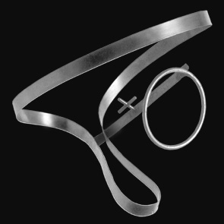
1. Katarzyna Kobro, Suspended Construction (2), 1921/22, lost, reconstruction 1971, steel, 40 x 30 x 30 cm, Museum of Art, Łódź
http://kobro.art.pl/prace/konstrukcja_03.html

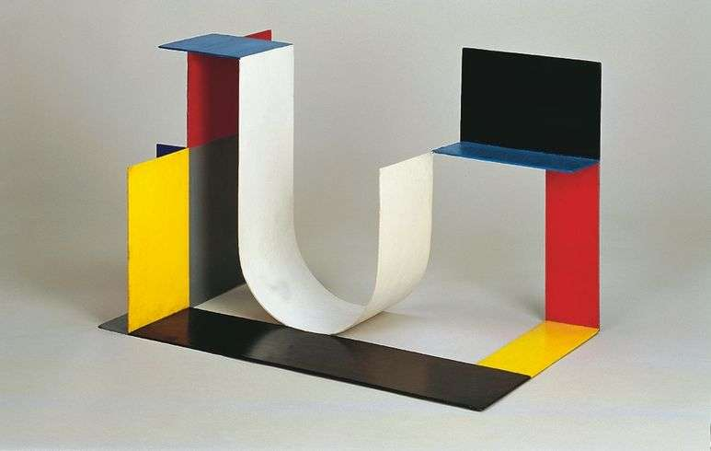
2. Katarzyna Kobro, Spatial Composition (4), 1929, steel, painted, colourfull, 40 x 64 x 40 cm, Museum of Art, Łódź
http: //www.presentandcorrect.com/blog/katarzyna-kobro

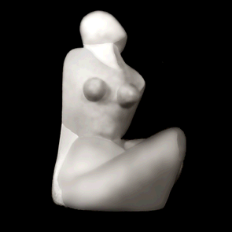
3. Katarzyna Kobro, Nude (1), 1925-30, plaster, 22 x 13 x 19 cm, Museum of Art, Łódź
http://kobro.art.pl/prace/akt_01.html

