Kolatkar, Arun (1932-2004)

Rajeev S. Patke

Kolatkar was a bilingual poet who wrote in English and Marathi, and also worked as a graphic artist. He was one among several writers from mid-twentieth century India to succeed in adapting a modernist outlook to his times and circumstances. Born in Kolhapur into a middle-class Hindu family, he studied art in Mumbai and worked most of his professional life in advertising. Intensely private in nature and Bohemian by temperament, he shunned publicity, read eclectically, published sporadically, and developed the attitude of a flâneur browsing the street-life of Mumbai. For many years he frequented its humble cafes, and from such vantage points wrote poems that provide a sardonic collection of marginalia on the cultural transformations undergone by his corner of contemporary Asia, refracted through a temperament impatient of cant, indifferent to bourgeois attitudes, and skeptical of much that passes for tradition in India. His work could be said to imply a search for values in a world where the conventions and orthodoxies of the past no longer appeal or apply. It is also of particular interest from the point of view of the theory and practice of self-translation, given that he would write a poem in one language, and then recreate it, concurrently, or many years later, in his other language. Kolatkar practiced his unique form of bilingual creativity without any apparent sense of cultural schizophrenia.

His writing is notable for its affinity for the vernacular tradition of Bhakti (devotional) poetry in Marathi, from which he often translated. In tone his poems can appear casual and almost inconsequential. Their laid-back manner belies a seriousness of intent that can be scathing in satire, unsparing in its honesty, and consistent in its sympathy for the underdog. Their style keeps close to the rhythms and vocabulary of contemporary speech. It is often spiced by locutions typical of contemporary Mumbai. Their humor is of the laconic kind, clear-eyed and dry. The writing is sharp in its distaste for all forms of social totalization, including those perpetrated in India by casteism and Brahminism. Early work in Marathi was collected in Arun Kolatkarchya Kavita (Arun Kolatkar’s Poems, 1977). The same year he won the Commonwealth Poetry Prize for a volume in English, Jejuri (1976). Its loose sequence constitutes a kind of pilgrim’s progress for agnostics. A visit to a temple mixes myth and skepticism in noting the dereliction of religion amidst a thirst for a need once fulfilled for many by religion. Kolatkar worked for many years on the Marathi versions, and they were finally published in book form in 2011.

In 2003 and the final year of his life, decades of apparent silence were followed by a spate of books in both languages: four in Marathi and one in English. These appeared just as the poet succumbed to stomach cancer. They add to the historical scope and range covered by his work, especially in Marathi, which engages more intensively than the work in English with the critical residue of his cultural inheritance. Long admired by a small circle of friends and writers, his books had circulated during his lifetime from Mumbai and Pune. Posthumously, his reputation has become international. The belatedness of this recognition is ironic, given the tension in his career between reticence and the impulse to create, between the urgency to share a unique perspective on experience and his acute wariness about the likelihood of complicity with the culture industry.

Career Timeline

1953 1976 2003 2004
Periodical publication Book in English Three books in Marathi Death

| | | | | | |
1966 1977 2004
Starts work in advertising Book in Marathi Two books (Marathi, English)

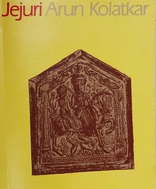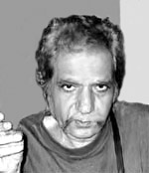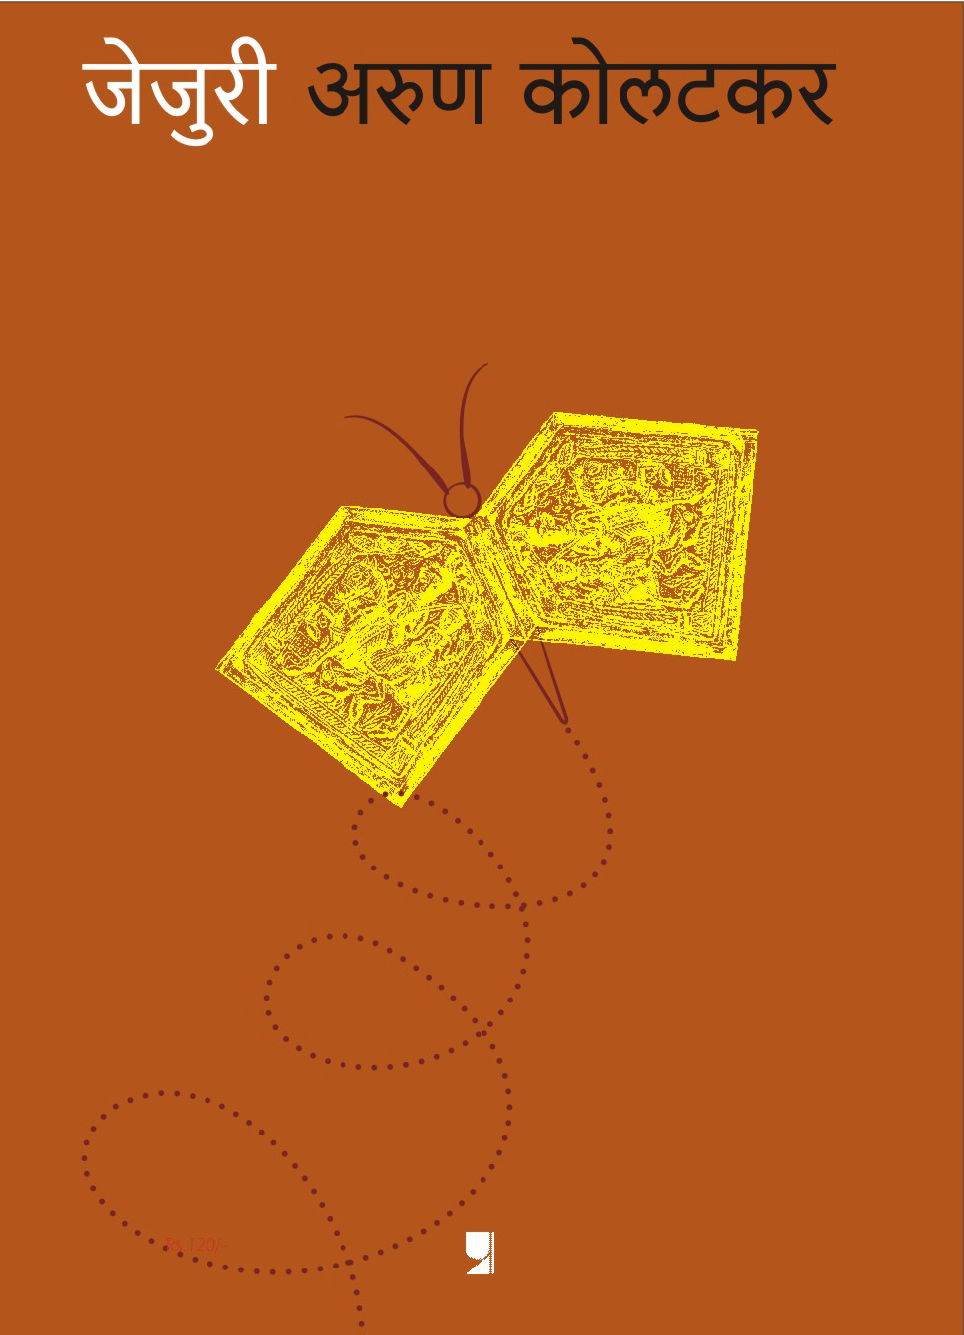

Works in Marathi:

Arun Kolatkarchya Kavita (1977)
Bhijki Vahi (2003)
Chirimiri (2003)
Droan (2003)
Sarpa Satra (2004)
Jejuri (2011)

Works in English:

Jejuri (1976, 2005)
Kala Ghoda Poems (2004)
The Policeman (2005)
The Boatride and Other Poems (2008)
Collected Poems in English (2010)

Interviews:

Ramnarayan, G. (2004) ‘No easy answers’, The Hindu (Sunday, 2 September). Online.
Souza, E. de. (1999) Talking Poems, New Delhi: OUP.

Videos:

Three video clips of reminiscences (in Marathi) about his book collection: http://www.ovguide.com/arun-kolatkar-9202a8c04000641f800000000062ada2. 27 August 2012.

Works on Kolatkar:

Bird, E. (2012) ‘Re-reading postcolonial poetry: Arun Kolatkar’s Jejuri’, The Journal of Commonwealth Literature 47: 229-243.
Chaudhuri, A. (2006) ‘Pilgrims’ progress’, The Guardian (21 October). Online.
Nemade, B. (1985) ‘Arun Kolatkar and Bilingual Poetry’, in Amur, G.S., Prasad, V.R.N., Nemade B.V. and Nihalani, N.H. (eds) Indian Readings in Commonwealth Literature, New Delhi: Sterling, 71-86.
Raykar, S. (1995) Arun Kolatkar's ‘Jejuri’, Pune: Prachet Publications.

Note: This entry derives from the author's discussion of Kolatkar in Modernist Literature and Postcolonial Studies (Edinburgh: Edinburgh University Press, forthcoming).

