Osma (The Eight)

Osma (The Eight, 1907-1908) was a short-lived artist group in Prague that made a pivotal contribution to the development of Expressionism in the Czech lands (Bohemia and Moravia). Their paintings present a local variant of the pan-European turn away from naturalism. The founding members of Osma gradually replaced naturalism with a treatment of idiosyncratic line invested with psychological intensity, color imbued with symbolic meaning, and subjects derived from spiritual concerns. Emulating the existentialist mood in Edvard Munch’s paintings, which were exhibited in Prague in 1905, they painted imagery that exposed the dissolution of belief in stability prevalent among a populace weary of Habsburg rule. Ethnic, religious, and class tensions visible in contemporary Prague often manifested in the art world in the form of separate exhibition groups based on language. Outright violence occasionally erupted between mobs of Czech- and German-speakers, as the fissures in a decadent empire began to show. In contrast to this divisiveness, however, Osma radically combined Czechs and Germans in its membership.

Early exposure to Auguste Rodin’s sculpture and especially Munch’s paintings through exhibitions in Prague (1902 and 1905 respectively) set the artists of Osma on their expressive trajectory. Reviews of these exhibitions as well as commentaries on Paul Cézanne’s art by Czech critics and art historians were published in the Mánes Union’s journal Volné Směry (Free Directions) and had a decisive impact on the Osma group. To varying degrees, Osma artists were interested in Arthur Schopenhauer’s philosophy; Dostojevsky’s literature; Symbolist themes; Czech fin-de-siècle mood, emotive directness of German Expressionism; colorism of French Fauvism; the concepts of ‘the primitive’ and ‘primitivism’; and the artists František Kupka, Honoré Daumier, Cézanne, Vincent Van Gogh, Munch, Paul Gauguin, and others. Many artists in the group maintained contacts with gallerists and artists in Berlin, Vienna, and Paris and later facilitated valuable connections for their Osma colleagues. Although Osma artists pursued individual styles, they are united in their subjective use of line and autonomous color laden with spiritual meaning. Subject matter characteristic of Osma’s imagery included self-portraits; portraits of group members, their supporters, and their intellectual idols; landscapes with Symbolic references; religious and mythological imagery updated with modern psychological intensity; literary references; still lifes; peopled city scenes; and genre scenes depicting modern life’s labor and amusements. Compositions often echo those of Osma’s heroes, such as Munch and Cézanne.

Osma’s first exhibition was held April 18 – May 18, 1907, at Králodvorská Street no. 16 in Prague. Artists exhibited included Otokar Kubín, Antonín Procházka, Bohumil Kubišta, Emil Filla, Friedrich (Bedřich) Feigl, Max Horb, Willy (Vilém) Nowak and the student Emil Pittermann-Longen. Negative reviews from mainstream critics in Prague were counteracted by Max Brod’s laudatory essay ‘Spring in Prague’ in the Berlin journal Die Gegenwart. Osma’s second exhibition was held June – July, 1908, at the Topič Salon in Prague. Artists exhibited included Procházka, Kubišta, Filla, Vincenc Beneš, Feigl, Nowak, and Linka Scheithauerová. Again, negative reviews in Prague’s conservative art press beset the group, this time denouncing the manipulation of naturalistic form as caricature. Even the progressive-minded brothers Josef and Karel Čapek published a mixed response, which criticized the paintings’ amorphous quality but praised the Osma artists’ eye for color and light along with their ability to evoke the spiritual. After their second and final exhibition as a group, the artists of Osma carried on with their careers individually, many becoming prolific and influential. In 1909 many of the artists of Osma joined the Mánes Union (est. 1887) in Prague. Two years later some former Osma members (Beneš, Filla, Kubín, Kubišta, Procházka) seceeded from Mánes along with other young artists. Many of these secessionists joined the newly founded Skupina výtvarných umělů (The Group of Fine Artists, est. 1911; e.g. Beneš, Filla, Procházka), while others chose to return to Mánes (e.g. Kubišta).

Key Bibliographic Sources

Anděl, Jaroslav, et al. Czech Modernism, 1900-1945, exh. cat. Houston Museum of Fine Arts (Boston: Bulfinch Press, 1989).

Benson, Timothy O. and Éva Forgács, eds. Between Worlds: A Sourcebook of Central European Avant-Gardes, 1910-1930 (Cambridge, Mass.: MIT Press, 2002).

Lamač, Miroslav. Osma a Skupina výtvarných uměců, 1907-1917 (Prague: Odeon, 1988).

Mansbach, Steven A. Modern Art in Eastern Europe: From the Baltic to the Balkans, ca. 1890-1939 (Cambridge: Cambridge University Press, 1999).

Padrta, Jiří with Miroslav Lamač. Osma a Skupina výtvarných uměců – 1907-1917: Teorie, Kritika, Polemika (Prague: Odeon, 1992).

Pomajzlová, Alena, ed. Expresionismus a České Umění 1905-1927 [Expressionism and Czech Art] (Prague: Národní Galerie, 1994).

Relevant Websites

National Gallery in Prague, Collection of 19th and 20th-century art
http://www.ngprague.cz/en/5/sekce/veletrzni-palace/ (significant number of works by Osma artists)

The Gallery of West Bohemia in Pilsen
http://www.zpc-galerie.cz/cs/collections (works by artists of Osma generation)

Museum of Modern Art in Olomouc
http://www.olmuart.cz/MMU/ (works by artists of Osma generation)

Topič Salon in Prague
http://www.topicuvsalon.cz/index.php?option=com_content&view=category&layout=blog&id=50&Itemid=89 (site of 2nd Osma exhibition, 1908)

History of S.V.U. Mánes (1887-2007)
http://www.svumanes.cz/ospolku.html (from a documentary exhibition; text by Jindřich Bořecký, Lucie Gočárová, and Václav Špale)

Suggested images

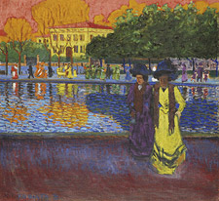 Bohumil Kubišta, Promenade u Arna (Promenade on the Arno), 1907, oil on canvas. Gallery of West Bohemia in Pilsen
Source: http://www.zpc-galerie.cz/cs/collections

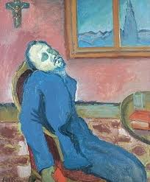 Emil Filla, Čtenář Dostojevského (Reader of Dostojevsky), 1907, oil on canvas. National Gallery, Prague.
Source: http://imageshack.us/photo/my-images/507/fillaemilctenardostojevox4.jpg/

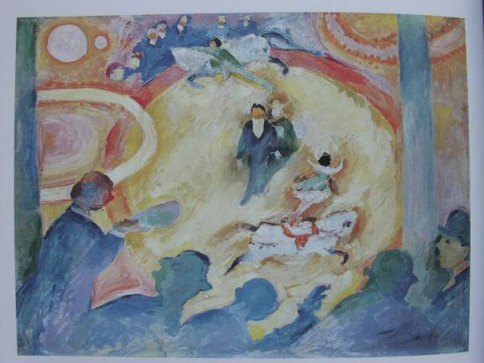 Antonín Procházka, Cirkus (Circus), 1907-08 (shown at Osma’s 2nd exhibition). National Gallery, Prague.
Source: scanned from Lamač, Miroslav. Osma a Skupina výtvarných uměců, 1907-1917 (Prague: Odeon, 1988), pg. 83.

