André Malraux (1901 - 1976) was a French statesman, resistance fighter, novelist, and art historian. He served as France's first Minister of Cultural Affairs under Charles de Gaulle from 1959 until the president's abdication in 1969. In 1933, Malraux won the Prix Goncourt for La Condition humaine (Man's Fate).

Resistance and Legend
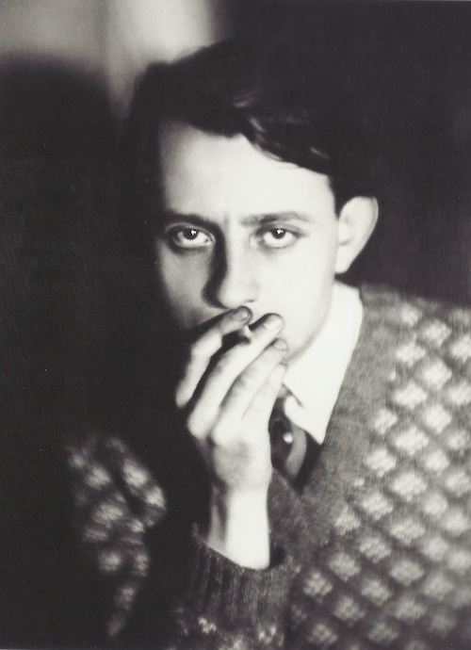
André-Georges Malraux was born on November 3rd, 1901 in Paris, France. An insatiable reader, particularly inspired by the revolutionary-themed writing of Hugo, Michelet, and Dumas, Malraux abandoned formal education at the age of sixteen and made his way into the literary and cultural world through selling rare books and art. His first major publication was Lunes en papier (Paper Moons, 1921).

During an expedition in French-ruled Cambodia in 1923, a twenty-two year old Malraux was caught notoriously removing a bas-relief from an abandoned Khmer temple with the goal of selling it to a museum. French colonial authorities sentenced him to three years in prison. Although the sentence was eventually dropped, his treatment during the lengthy appeal process and the poverty he witnessed in Indochina sparked the anti-colonialist sentiment that would prompt him to return to the region in 1925 and found the newspaper L'Indochine, which protested against the injustices of the French Empire.

First picture: Malraux in 1930
http://fantomas-en-cavale.tumblr.com/post/34234797765/germaine-krull-andre-malraux-vers-1930

Upon his return to France, Malraux joined the Popular Front and continued to write. He published his first novel, Conquérants (The Conquerors), in 1928 and what is considered his masterpiece, Man's Fate, in 1933.

His anti-fascist convictions led him to join the Republican forces during the Spanish Civil War, despite France's declared neutrality. He served in the Spanish Republican Air Force and was eventually made the leader of the España squadron. In 1938, Malraux published the novel L'Espoir (Man's Hope), which was inspired by his experiences during the Spanish Civil War.

Malraux's cinematic version of Man's Hope, Espoir, Sierra de Teruel (also translated as Man's Hope), was filmed in Spain in 1938 but not shown in France until 1945.

Film Espoir :
http://m.youtube.com/watch?v=ACNA33Ijdk&desktop_uri=%2Fwatch%3Fv%3DACNA33I-jdk

Malraux joined the French Army at the beginning of World War II and was captured during the Battle of France. After his escape, he participated in the French Resistance until 1944, when the Gestapo captured him. He remains one of the most well known figures of the French Resistance. In 1964, when de Gaulle had the ashes of resistance fighter Jean Moulin transferred to the Pantheon to commemorate the 20th anniversary of his passing, Malraux gave a speech that transformed the legacy of the then-largely- unknown Moulin into that of a legend:

Video excerpt of Speech “Entre ici…”
http://www.ina.fr/video/I00013183/hommage-d-andre-malraux-a-jean-moulin-entre-ici-video.html

After the war, in 1945, de Gaulle appointed Malraux as Minister for Information, and when de Gaulle was re-elected president in 1958, he named Malraux France's first Minister of Cultural Affairs.

Malraux died on November 23rd, 1976 in Créteil. Reminiscent of the ceremony for Jean Moulin, in commemoration of the twentieth anniversary of his death, President Jacques Chirac had his ashes transferred to the Pantheon on November 23, 1996.

Major Works
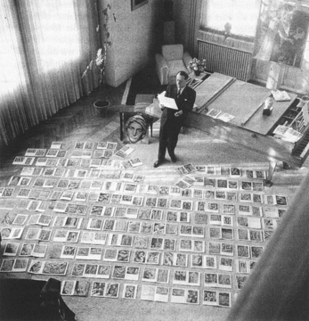
Malraux's writing is best known for its political engagement and metaphysical analysis of the human condition. Following Nietzsche, Malraux declares in his early essay La Tentation de l'Occident (The Temptation of the West, 1926) that "Man is dead, after God". Indeed, from his trilogy on revolution in Asia, The Conquerors, La Voie royale (The Royal Path, 1930), and Man's Fate, to Le Temps du mépris (Days of Contempt, 1935) and Man's Hope, Malraux describes the human condition as meaningless and absurd. With the Marxist convictions that would later dissipate into Gaullist fidelity, Malraux's most famous social novels suggest that humankind's dour, socially determined destiny may only be defeated through selfless solidarity.

As an art historian, Malraux argues that it is art, the ultimate expression of human creativity, which enables one to transcend their limited, insignificant condition. His histories of art, particularly Les Voix du silence (The Voices of Silence, 1951), as well as La Métamorphose des Dieux (The Metamorphosis of the Gods, 3 vol., 1957-76), develop this idea and that of the imaginary museum, what he describes as the limitless collection of art from all cultures and centuries, in and outside of museum walls, which we deem important.

Image 2: Malraux and his "imaginary museum" http://www.medienkunstnetz.de/works/das-imaginaere-museum/

Collected Works
Bibliothèque de la Pléiade (1989), Œuvres Complètes, I, Paris: Gallimard.
--(1996), Œuvres Complètes, II, Paris Gallimard.
--(1996), Œuvres Complètes, III, Paris Gallimard.
--(2004), Œuvres Complètes, IV, Paris Gallimard.
--(2004), Œuvres Complètes, V, Paris Gallimard.
--(2010) Œuvres Complètes, VI, Paris Gallimard.

Major Works
Lunes en papier (1922), Paris: Édition de la galerie Simon.
La Tentation de l'Occident (1926), Paris: Grasset (Les cahiers rouges).
Les Conquérants (1928), Paris: Grasset.
La Voie royale (1930), Paris: Grasset.
La Condition humaine (1933), Paris: Gallimard.
Le Temps du mépris (1935), Paris: Gallimard.
L'Espoir (1937), Paris: Gallimard.
Espoir, sierra de Teruel (1938 Screenplay).
Les Noyers de l'Altenburg (1948), Paris: Gallimard.
Le Musée imaginaire (1947), Genève: Skira.
Les Voix du silence (1951), Paris: Gallimard.
La Métamorphose des dieux, Paris: Gallimard.
*Vol 1. Le Surnaturel (1957)
*Vol 2. L'Irréel (1974)
*Vol 3. L'Intemporel (1976)
Antimémoires (1967), Paris: Gallimard.
Les Chênes qu'on abat... (1971) Paris: Gallimard.
Oraisons funèbres (1971) Paris: Gallimard.
L'homme précaire et la littérature (1977) Paris: Gallimard, (Cahiers de la NRF).

Further reading
C. Cate (2006), Malraux, Paris: Perrin.
G. Harris (1996). André Malraux: a reassessment, Basingstoke: Palgrave Macmillan.
J.-L. Jeannelle (2006), Malraux, mémoire et métamorphoses, Paris: Gallimard.
J. F. Lyotard (2001), Signé, Malraux, Paris: Grasset.
O. Todd (2001), André Malraux, une vie, Paris: Gallimard.

