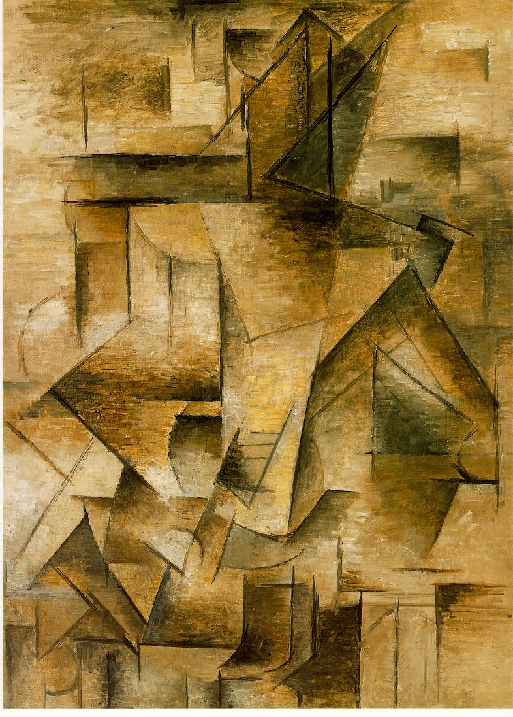
Cubism
Cubism was a highly influential visual arts style of the twentieth century that was created principally by the painters Pablo Picasso and Georges Braque in Paris between 1907 and 1914. Cubist artists were greatly inspired by African sculpture, by painters Paul Cézanne (French, 1839-1906) and Georges Seurat (French, 1859-1891), and by the Fauves (see FAUVISM). The style flattens out its subject, taking it apart and reassembling it on the canvas so that all planes, all visual perspectives, can be experienced simultaneously.
Picasso, The Guitar Player, 1910.

Also see Groupe du Bateau-lavoir, isms and -ism, Neo-Impressionism, pique assiette (also called picassiette), Post-Impressionism, trencadis, and Vorticism.

Cubist Technique
The Cubist style emphasized the flat, two-dimensional surface of the picture plane, rejecting the traditional techniques of perspective, foreshortening, modeling, and chiaroscuro, and refuting time-honoured theories of art as the imitation of nature. Cubist painters were not bound to copying form, texture, colour, and space; instead, they presented a new reality in paintings that depicted radically fragmented objects, whose several sides were seen simultaneously. In cubist artworks, objects are broken up, analyzed, and re-assembled in an abstracted form—instead of depicting objects from one viewpoint, the artist depicts the subject from a multitude of viewpoints to represent the subject in a greater context. Often the surfaces intersect at seemingly random angles, removing a coherent sense of depth. The background and object planes interpenetrate one another to create the shallow ambiguous space, one of cubism's distinct characteristics.

Conception and Origins
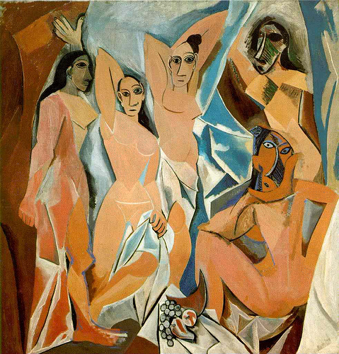
During the late nineteenth and early twentieth centuries, the European cultural elite were discovering African art, Micronesian art, and Native American art for the first time. Artists such as Paul Gauguin, Henri Matisse, and Pablo Picasso were intrigued and inspired by the stark power and simplicity of styles of those foreign cultures. Around 1906, Picasso met Matisse through Gertrude Stein, at a time when both artists had recently acquired an interest in primitivism, Iberian sculpture, African art and African tribal masks. They became friendly rivals and competed with each other throughout their careers, perhaps leading to Picasso entering a new period in his work by 1907, marked by the influence of Greek, Iberian and African art. Picasso's paintings of 1907 have been characterized as Protocubism, as notably seen in Les Demoiselles d’Avignon, the antecedent of Cubism.
Picasso, Les Demoiselles D’Avignon, 1907.

Some believe that the roots of cubism are to be found in the two distinct tendencies of Cézanne’s later work: firstly to break the painted surface into small multifaceted areas of paint, thereby emphasizing the plural viewpoint given by binocular vision, and secondly his interest in the simplification of natural forms into cylinders, spheres, and cones.

However the cubists explored this concept further than Cézanne; they represented all the surfaces of depicted objects in a single picture plane, as if the objects had all their faces visible at the same time. This new kind of depiction revolutionized the way in which objects could be visualized in painting and art.

Analytic Cubism
The invention of Cubism was a joint effort between Picasso and Braque, then residents of Montmartre, Paris. These artists were the movement's main innovators. A later active participant was the Spaniard Juan Gris. After meeting in 1907 Braque and Picasso in particular began working on the development of Cubism. Picasso was initially the force and influence that persuaded Braque by 1908 to move away from Fauvism. The two artists began working closely together in late 1908–early 1909 until the outbreak of World War I in 1914. The movement spread quickly throughout Paris and Europe.

French art critic Louis Vauxcelles first used the term “cubism,” or “bizarre cubiques,” in 1908 after seeing a picture by Braque. He described it as “full of little cubes,” after which the term quickly gained wide use although the two creators did not initially adopt it. Art historian Ernst Gombrich described cubism as “the most radical attempt to stamp out ambiguity and to enforce one reading of the picture—that of a man-made construction, a coloured canvas.”

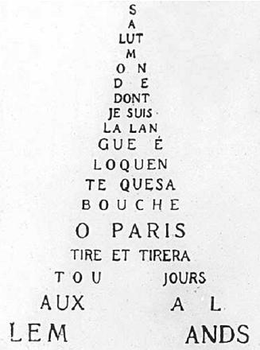
Cubism was taken up by many artists in Montparnasse and promoted by art dealer Daniel-Henry Kahnweiler, becoming popular so quickly that by 1911 critics were referring to a “cubist school” of artists. However, many of the artists who thought of themselves as cubists went in directions quite different from Braque and Picasso. The Puteaux Group or Section d’Or was a significant offshoot of the Cubist movement; it included Guillaume Apollinaire, Robert Delaunay, Marcel Duchamp, his brothers Raymond Duchamp-Villon and Jacques Villon, and Fernand Léger, and Francis Picabia. Other important artists associated with cubism include Albert Gleizes, Jean Metzinger, Marie Laurencin, Max Weber, Diego Rivera, Marie Vorobieff, Louis Marcoussis, Jeanne Rij-Rousseau, Roger de La Fresnaye, Henri Le Fauconnier, Alexander Archipenko, František Kupka, Amédée Ozenfant, Jean Marchand, Léopold Survage, Patrick Henry Bruce among others. Section d’Or is basically just another name for many of the artists associated with cubism and orphism. Purism was an artistic offshoot of Cubism that developed after World War I. Leading proponents of Purism include Le Corbusier, Amédée Ozenfant, and Fernand Léger.
Apollinaire, Calligramme

The break with homogeneous form was completed the following year. Braque and Picasso's similar compositions are broken into planes with open edges, sliding into each other while denying all depth. Color is reduced to a gray-tan cameo, applied uniformly in small brushstrokes creating vibrations of light. The interpenetration of the forms lends these paintings a previously unknown aspect of continuity and density. Withdrawing before the abstract and hermetic character of this new space, Braque and Picasso brought recognizable illusionistic features back into their paintings during their stay in Céret, from 1911 to 1913. They used letters, fragments of words, musical notes, then significant material elements: sand or sawdust which create relief, and tend to make the picture more physically an object.

Cubism and modern European art was introduced into the United States at the now legendary 1913 Armory Show in New York City, which then traveled to Chicago. In the Armory show Jacques Villon exhibited seven important and large drypoints, his brother Marcel Duchamp shocked the American public with his painting “Nude Descending a Staircase, No. 2” (1912) and Georges Braque, Pablo Picasso, Fernand Léger, Raymond Duchamp-Villon, Roger de La Fresnaye, Marie Laurencin, Albert Gleizes, and other cubist painters contributed examples of their cubist works. Braque and Picasso themselves went through several distinct phases before 1920, and some of these works had been seen in New York prior to the Armory Show, at Alfred Stieglitz's “291” gallery. Czech artists who realized the epochal significance of cubism of Picasso and Braque attempted to extract its components for their own work in all branches of artistic creativity—especially painting and architecture. This developed into Czech Cubism which was an avant-garde art movement of Czech proponents of cubism active mostly in Prague from 1910 to 1914.

Synthetic Cubism
Whereas Analytic Cubism was an analysis of the subjects (pulling them apart into planes), Synthetic Cubism is more of a pushing of several objects together. Less pure than Analytic Cubism, Synthetic Cubism has fewer planar shifts (or schematism), and less shading, creating flatter space. Synthetic Cubism was the second main movement within Cubism that was developed by Picasso, Braque, Juan Gris and others between 1912 and 1919. Synthetic cubism is characterized by the introduction of different textures, surfaces, collage elements, papier collé and a large variety of merged subject matter. It was the beginning of collage materials being introduced as an important ingredient of fine art work.

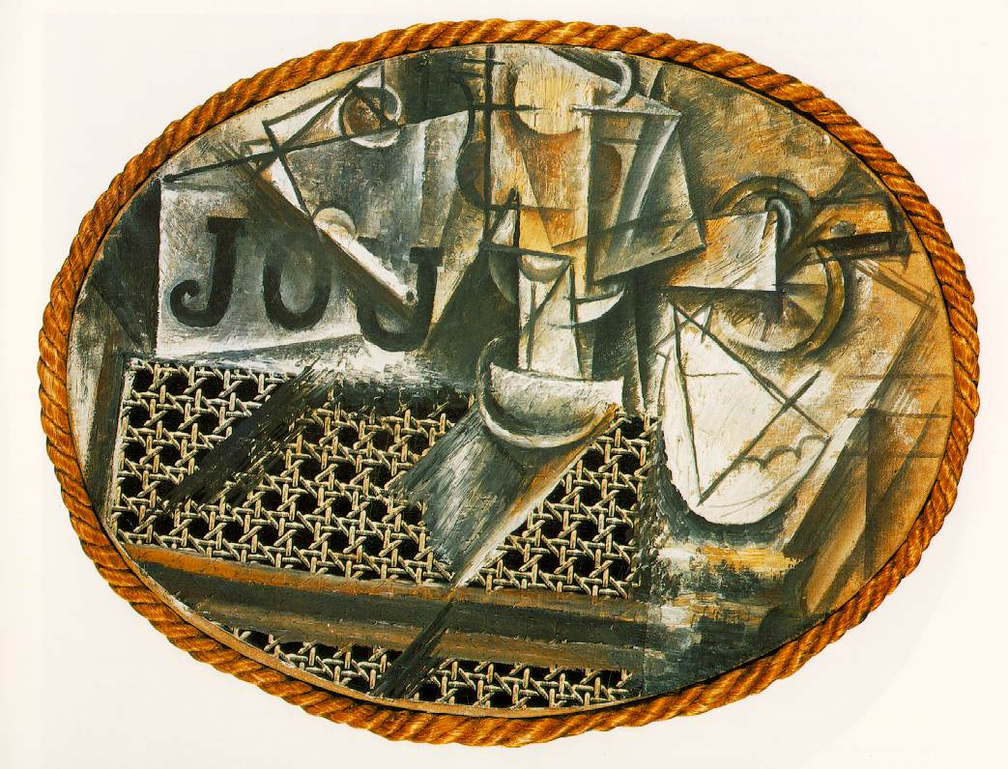
Considered the first work of this new style was Pablo Picasso’s “Still Life with Chair-caning” (1911–1912), which includes oil cloth that was printed to look like chair-caning pasted onto an oval canvas, with text; and rope framing the whole picture. Also, color returned in force in 1912, in parallel to the creation of the “papiers collés” — collages. Creating a simple geometric armature and pieces of glued paper with trompe l’oeil patterns imitating wood, marble or newsprint, then introducing “already made” (cf. Ready-Mades) elements (musical scores, tobacco packets or playing cards), the “papiers collés” definitively dissociate color and form. Picasso, then Henri Laurens would create construction pieces from ordinary materials, cut out and assembled into colored geometric planes, where empty and full spaces combine to sketch out the forms. Newspaper clippings were a common inclusion, physical pieces of newspaper, sheet music, and like items were also included in the collages. JOU may also at the same time be a pun on the French words jeu (game) or jouer (to play). Picasso and Braque had a friendly competition with each other and including the letters in their works may have been an extension of their game.
Picasso, Still Life with Chair Caning, 1912.

Although the Great War (WWI) ended Picasso and Braque’s collaboration, the cubist core group remained active until the 1920s, through the explorations of Braque, Matisse, Laurens, Lipchitz and Fernand Léger, whose geometric world and abstractly organized canvases with their contrasting, dynamic forms owe almost everything to the pioneering breakthroughs of Cézanne, Braque and Picasso.

Cubist sculpture
Cubist sculpture developed in parallel to Cubist painting, by many of the same artists. Different sources name the first cubist sculpture as either Picasso’s 1909 bronze “Head of a Woman” or Otto Gutfreund’s “Anxiety” (Úzkost in Czech) shown in Prague in 1912.

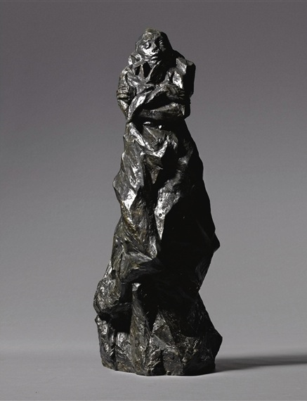
Gutfreund, Anxiety, 1911- 1912

Many other European sculptors were quick to follow their lead: the French Raymond Duchamp-Villon, whose career was cut short by his death in military service, the Ukrainian Alexander Archipenko, whose 1912 “Walking Woman” was the first to introduce an abstracted void, and the Lithuanian Jacques Lipchitz, identified as the first Cubist sculptor.

Just as in Cubist painting, the style is rooted in Paul Cezanne's reduction of painted objects into component planes and geometric solids (cubes, spheres, cylinders, and cones). And just as in painting, it had its course by about 1925, to become a pervasive influence and contribute fundamentally to Constructivism and Futurism.

Cubism in Other Fields
The written works of Gertrude Stein employ repetition and repetitive phrases as building blocks in both passages and whole chapters. Most of Stein's important works utilize this technique, including the novel The Making of Americans (1906–08) Not only were they the first important patrons of Cubism, Gertrude Stein and her brother Leo were also important influences on Cubism as well. Picasso in turn was an important influence on Stein's writing.

In the field of American fiction, William Faulkner’s 1930 novel As I Lay Dying can be read as an interaction with the cubist mode. The novel features narratives of the diverse experiences of 59 characters which, when taken together, produce a single cohesive body.

The poets generally associated with Cubism are Guillaume Apollinaire, Blaise Cendrars, Jean Cocteau, Max Jacob, André Salmon and Pierre Reverdy. As American poet Kenneth Rexroth explains, Cubism in poetry “is the conscious, deliberate dissociation and recombination of elements into a new artistic entity made self-sufficient by its rigorous architecture. This is quite different from the free association of the Surrealists and the combination of unconscious utterance and political nihilism of Dada.” Nonetheless, the Cubist poets’ influence on both Cubism and the later movements of Dada and Surrealism was profound; Louis Aragon, founding member of Surrealism, said that for Breton, Soupault, Éluard and himself, Reverdy was “our immediate elder, the exemplary poet.” Though not as well remembered as the Cubist painters, these poets continue to influence and inspire; American poets John Ashbery and Ron Padgett have recently produced new translations of Reverdy's work.

Wallace Stevens’ “Thirteen Ways of Looking at a Blackbird” is also said to demonstrate how cubism's multiple perspectives can be translated into poetry.

The composer Edgard Varèse was heavily influenced by Cubist writing and art.

Key Reference Works:
Antliff, Mark and Patricia Leighten. Cubism (Art of Century).
Rosenblum, Robert. Cubism and 20th Century Art.
Robinson, Shannon. Cubism (Movements in Art).

