Egon Schiele (1890-1918)

Egon Schiele is one of the most original artists of the early twentieth-century and a major figure associated with the stylistic movement Expressionism. He has a unique linear technique that conveys a heightened energy or dynamic intensity, to which chromatic dissonance is frequently added with the application of watercolor.

The majority of Schiele’s artworks explore extreme facets of the human experience expressed through the human body, with external physical appearances serving as expressions of an existential reality or an internal state of being. With his interest in psychological and sexual subject matter, he is aligned with OSKAR KOKOSCHKA, the other foremost representative of AUSTRIAN EXPRESSIONISM.

In order to study facial expression, gesture, and pose, and seeking to delve beneath surface appearances to uncover psychological truths, Schiele did many expressive self-portraits. These contributed to perceptions of him as defiant and rebellious, and one who suffers for their art.

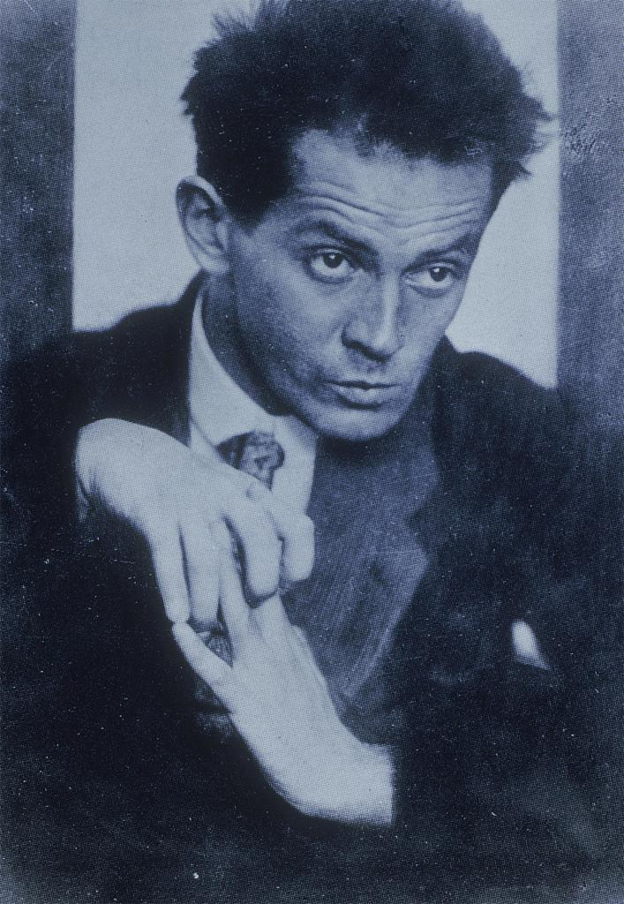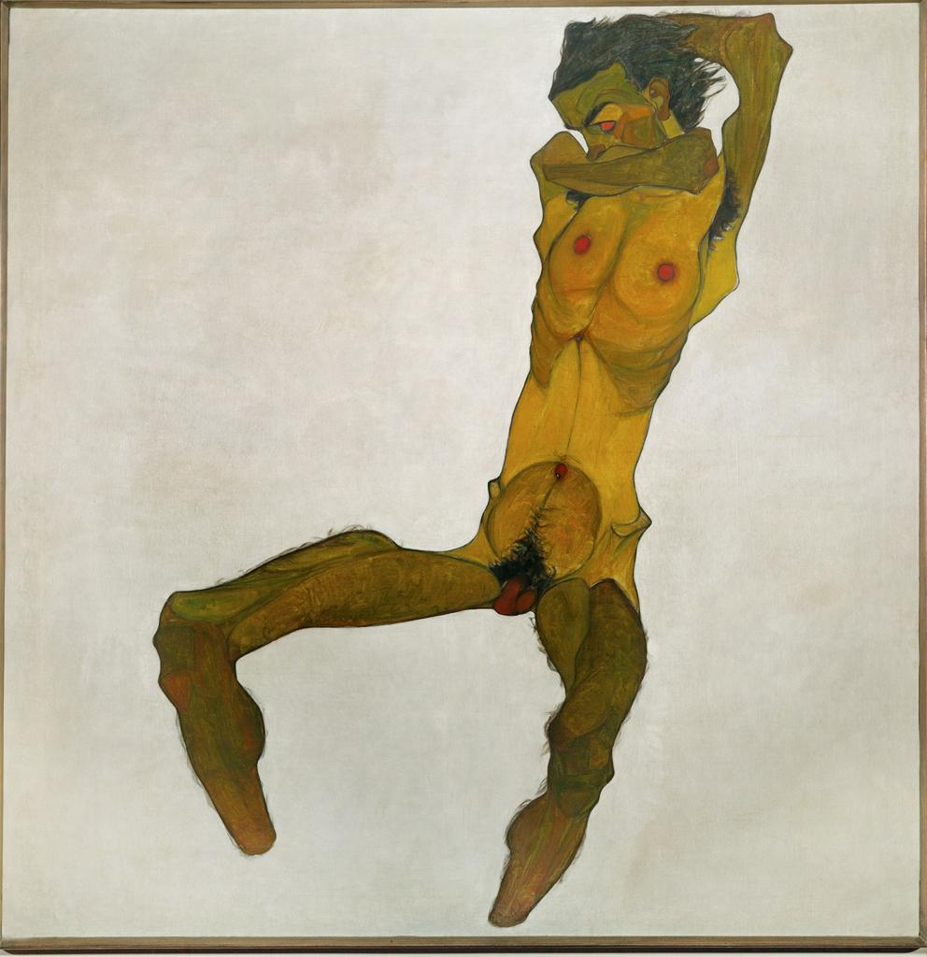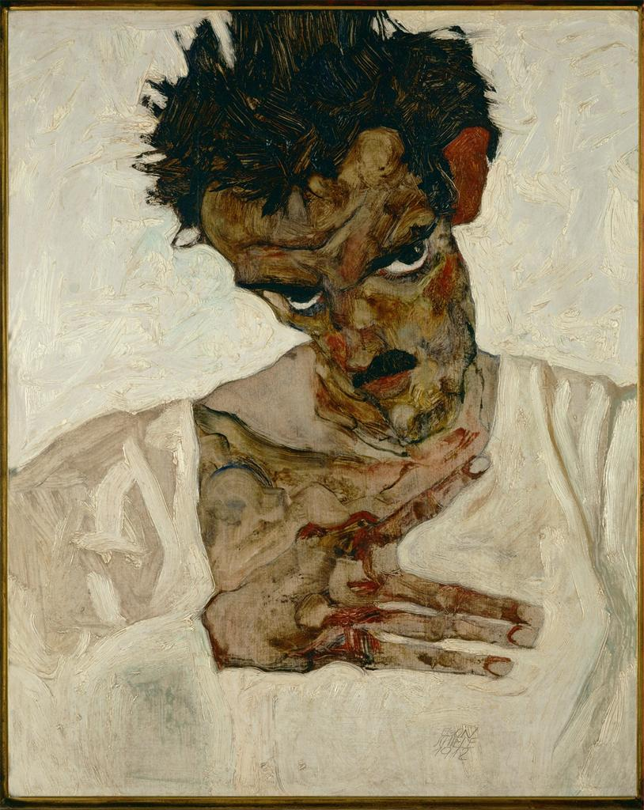

Early Life and Work
Schiele was born in Tulln, a small Austrian town, in 1890. His father passed syphilis on to his wife early in their marriage. Physical manifestations of disease are seen frequently in Schiele’s work in his use of emaciated figures and putrescent colors. At one time, the artist visited the morgue to do sketches and like his mentor, GUSTAV KLIMT, he did a series of women with heavily pregnant bodies, seeking them out at a charity hospital in Vienna.

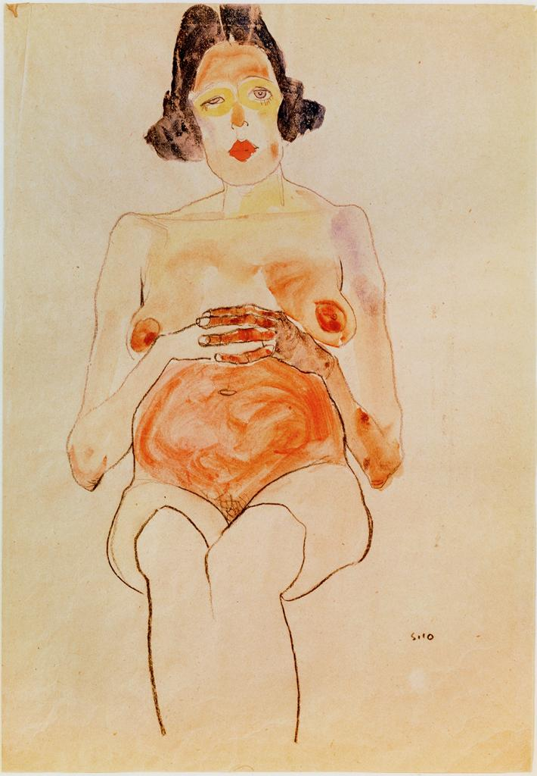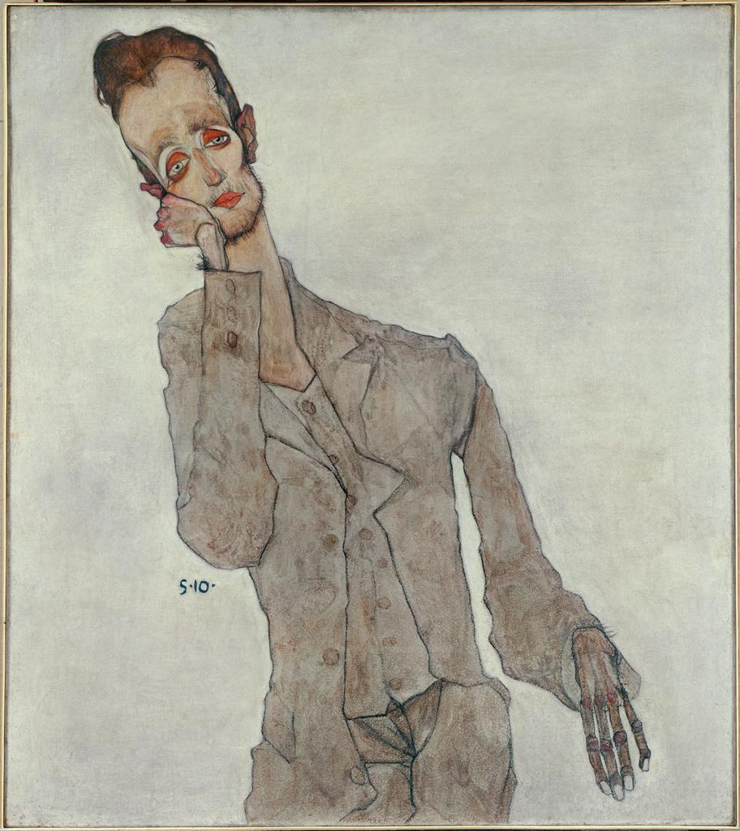

From Klimt, Schiele learned contour and linear complexity, leading to a stylistic progression in his work away from flat, decorative forms associated with Jugendstil ART NOUVEAU to highly structured paintings and a unique linear quality in his figural drawings.

Scandal
In 1911, Schiele and his companion Wally Neuzil, one of Klimt’s former models, moved to Krumau, his mother’s birthplace in Bohemia. Initially, Schiele was fond of the small Gothic town situated on a picturesque river bend, which inspired many landscapes and cityscapes.

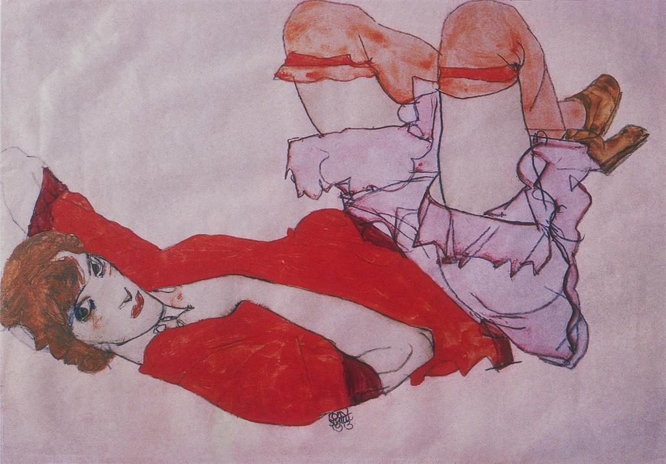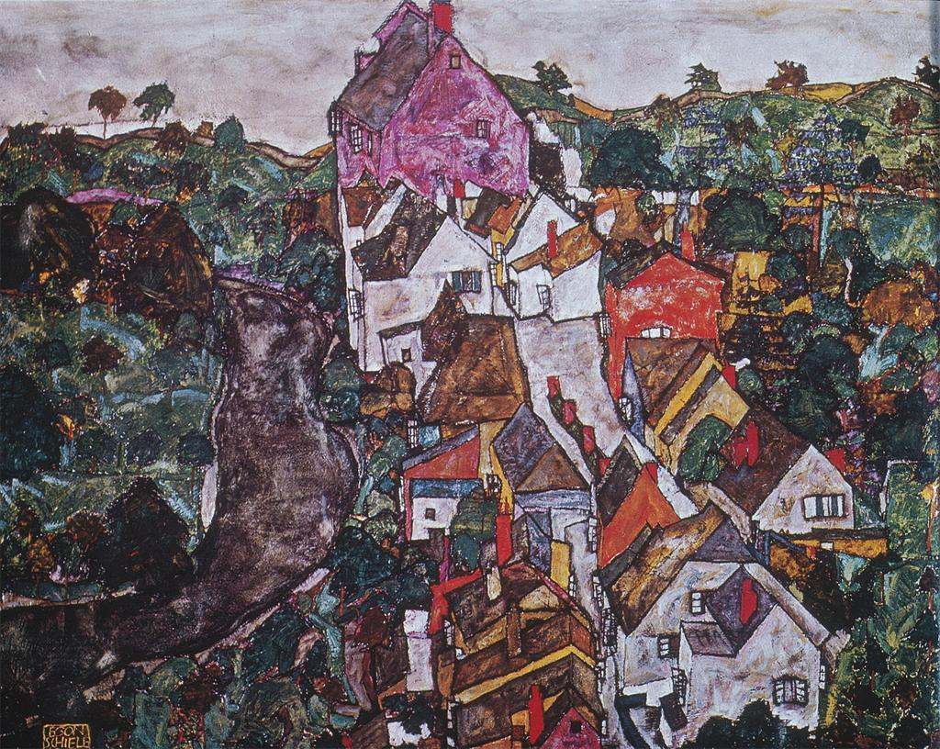

Soon, the prejudices of the local population towards the free-spirited, unmarried couple led them to move to nearby Neulengbach. There, Schiele was imprisoned for a twenty-four day period on unsubstantiated charges of seducing a minor. Though the charges were unfounded, the possibility of an extended prison term weighed heavily on him as he awaited trial, as seen in the self-portraits made during his ordeal. He was eventually charged with exposing minors to pornography, in the form of his own drawings, and one of them was burned during the court’s proceedings.

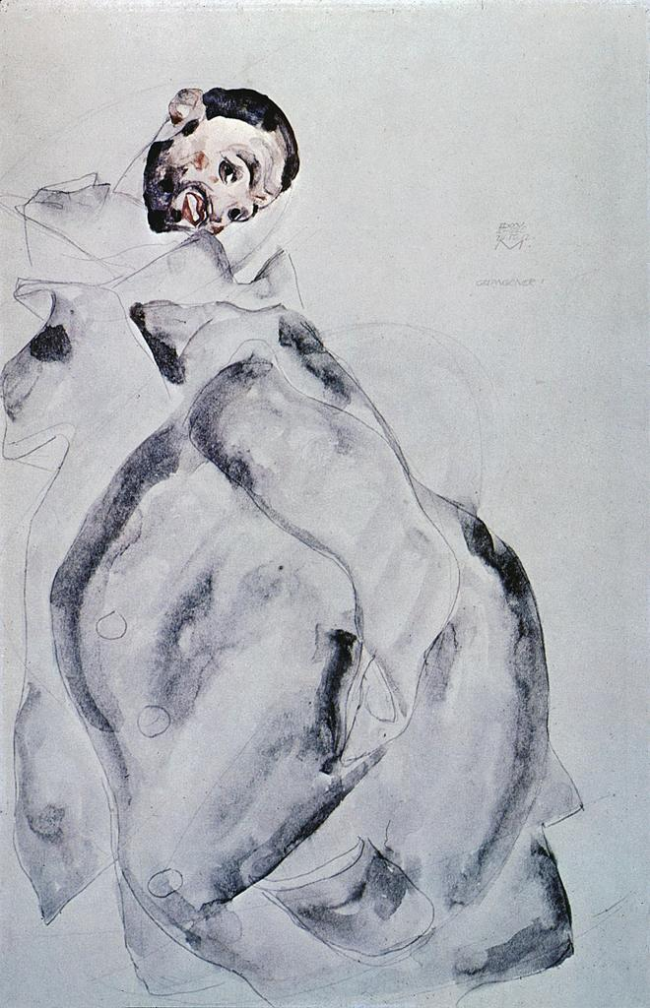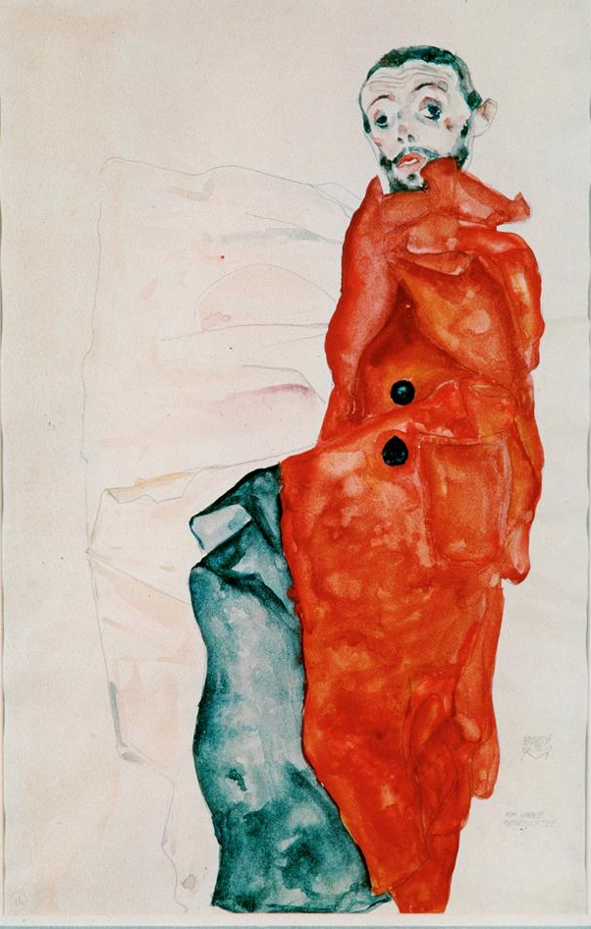

Solace
In 1915, Schiele married Edith Harms. This was the beginning of an increasingly optimistic phase in his personal life, despite difficulties from the onset of World War One. Schiele was initially sent to Prague, but was soon able to secure a post in Vienna. While guarding the transport of Russian prisoners-of-war, Schiele made a series of portraits that typify the power of his images in cataloguing personality and emotional states of being. These, along with his series of pregnant woman, show the humanistic interest that underlies his work, but which is frequently overshadowed by its strong erotic and sexual content.

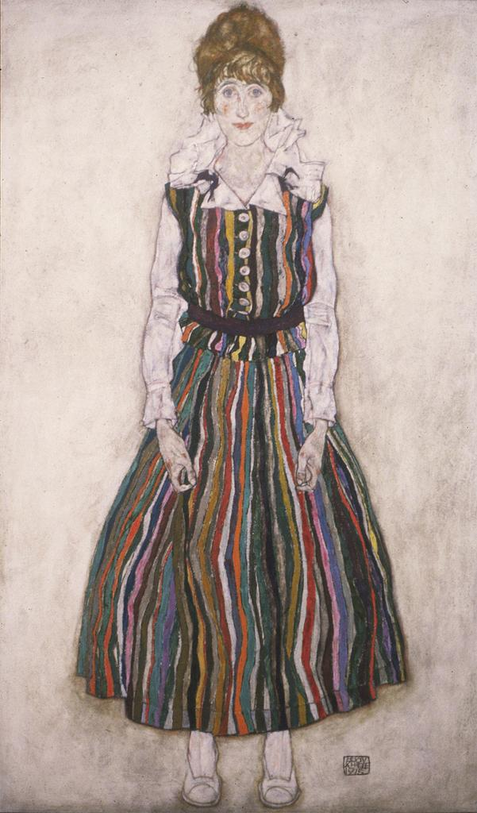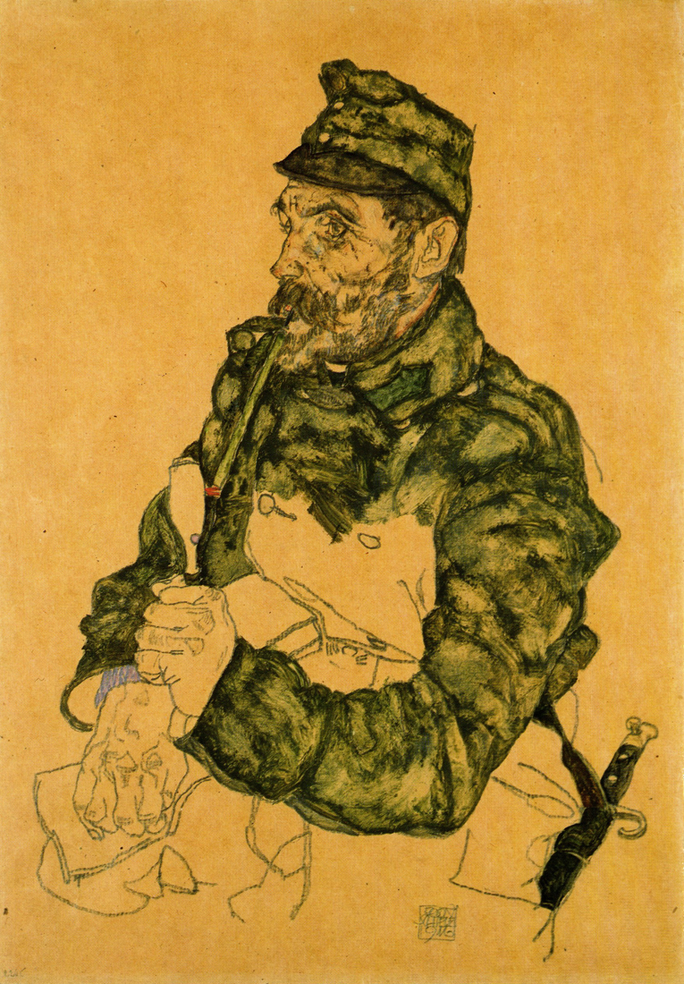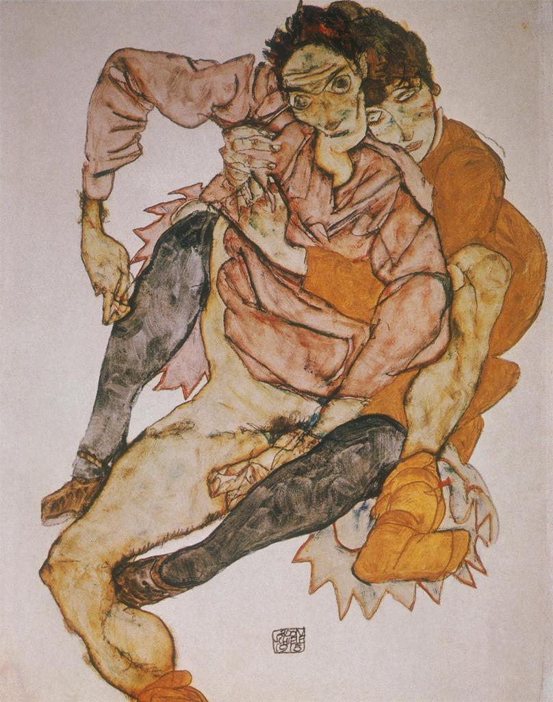

Inspired by his new companion and the reality of a stable home life, Schiele embarked on a series of large-scale oil paintings that ushered in a long-awaited period of critical praise, including a triumphant reception for nineteen of his works, including Embrace (The Lovers) (1917), at the 49th Secession exhibition in March 1918. Schiele’s hopes for the future, seen in The Family (1918) were short-lived; in October, six months pregnant with their first child, Edith died from the epidemic of Spanish influenza sweeping Europe and three days later, Schiele died.

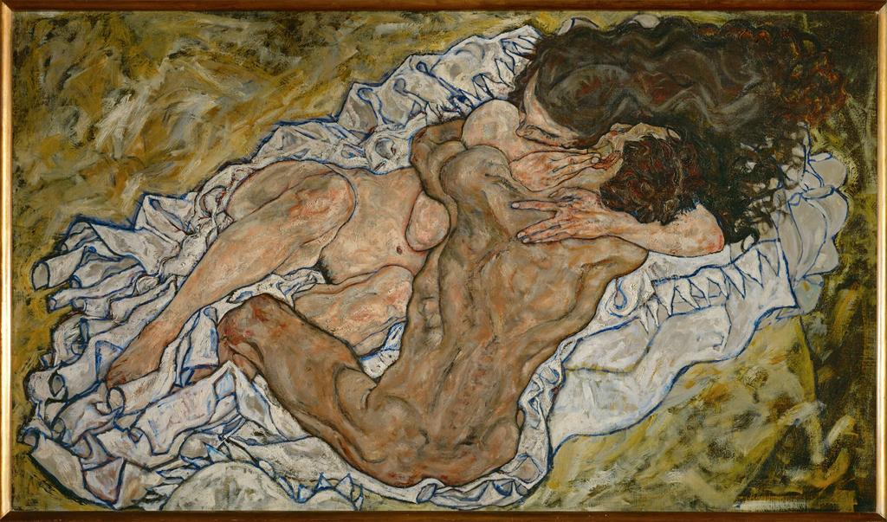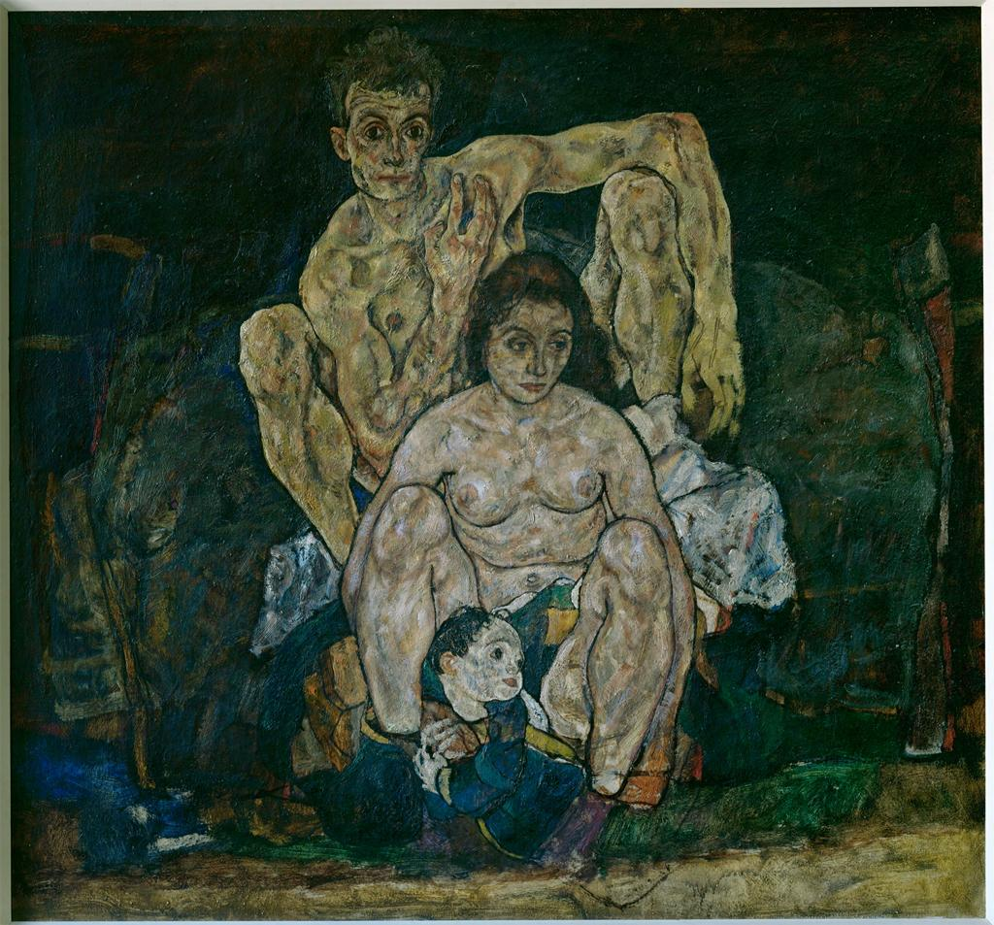

Legacy
Schiele’s outsize influence in relation to his short life continues to be felt to this day. Because of the revolutionary frankness of his highly sexualized, psychologically probing imagery, coupled with his early tragic death at age twenty-eight, Schiele is often seen as a misunderstood, rebellious or suffering artist, much like Vincent Van Gogh, one of his early influences. The stylized appearance of his drawings, together with his personal notoriety, has been very influential on twentieth-century music, film, fashion, photography and the fine arts.

References and further readings:

Jane Kallir, Egon Schiele: The Complete Works catalogue raisonné (New York: Harry N. Abrams, 1990).

Rudolf Leopold, ed. Egon Schiele Landscapes (Munich and New York: Prestel, 2010).

Egon Schiele: The Leopold Collection, Vienna, Magdalena Dabrowski, ed. (Munich and New York: Prestel, 2009).

Egon Schiele. Exh. cat. Klaus Albrecht Schröder, ed. (Vienna and Munich: Albertina and Prestel Verlag, 2005).

Egon Schiele: The Ronald S. Lauder and Serge Sabarsky Collections Exh. cat. (Munich and New York: Prestel, 2005).

Peter Vergo, Art in Vienna 1898-1918: Klimt, Kokoschka, Schiele and their Contemporaries. (London: Phaidon, 1981).

TIMELINE:

1890 Egon Schiele born in Tulln, Austria

1905 his father dies, his uncle became his guardian

1906 accepted into Academy, the youngest student in his class at age 16, would study their until 1909

1907 Schiele met Gustav Klimt; journeyed to Trieste several times with his younger sister Gertrude

1909 Kunstschau exhibition organized by Klimt, was his Viennese debut, represented by 4 paintings; organizes an exhibition group, called the Neukunstgruppe and writes a manifesto for the group, which is published in popular art journal Die Aktion

1911 moved with Wally Neuzil, his mistress, to Krumau, Bohemia, his mother’s birthplace; autumn 1911, moved to Neulengbach, 30 kilometers west of Vienna

1912 he was arrested on charges of seducing a minor; the couple had taken in a 13-year old runaway, her father, a retired naval officer, files a charge of abduction
March and April 1912 spends twenty-four days in prison pending trial

1912 exhibited at Munich Secession and the Sonderbund exhibition in Cologne; returns to Vienna and establishes a new studio

1914 moves to new studio; meets Edith Harms

May 1915 marries Edith; declared fit for service, has to report at end of June

1916 Die Aktion journal publishes a Schiele issue, with 6 drawings inside and a self portrait on title page

March 1918 receives praise for exhibition of paintings at 49th Secession exhibition
October 1918 Edith dies from Spanish influenza; three days later, Schiele, twenty-eight years old, also dies and is buried on November 3, 1918

