Japonisme

The term Japonisme refers to the reception of Japanese art products and stylistic forms in Europe and the United States occurring in the second half of the 19th century and continuing until the early 20th century. Japonisme involves the collecting of Japanese products by Western artists and art lovers as well as the adaptation of East Asian motifs and forms for the invention of pictures and objects. Paris was the centre of early Japonisme; the first collectors were art critics such as Ernest Chesneau or Philippe Burty. Early enthusiasts of the Japanese arts and crafts were the painters Edouard Manet and James Abbott McNeill Whistler. The opening up of new possibilities for the representation of reality that was mediated by Japanese colour woodcuts from artists such as Utagawa (Andō) Hiroshige had profound effect on artistic schools ranging from Impressionism to Expressionism. Not only the means of Japanese design, but also the egality of the represented subjects, the equal treatment of nature, animals and man, of high art and handicraft, helped Western artists to overcome their academic traditions. Japonisme as an artistic and visual movement underwent a trans-cultural appropriation of the Japanese stylistic language, which contributed to the breakthrough of modern art in the West.

The starting point for the development and centre of the early Japonisme is Paris. After a rigorous restriction on overseas trade that existed since the end of the 16th century Japan re-opened on the Western market in 1854 and began exporting its own products. Japanese woodcuts by artists such as Katsushika Hokusai, Hiroshige, Kitagawa Utamaro, Suzuki Harunobu or Hishikawa Moronobu drew great interest in France, where they initially arrived as packing material for export goods such as tea or ceramics. The prints - also referred to as ukiyo-e, meaning images of a serene, evanescent world - were received with great enthusiasm by writers and art critics as there were the brothers Edmond and Jules de Goncourt, Burty or Chesneau. Burty 1872 coined the term Japonisme in the journal La Renaissance littéraire et artistique.

Early Japonisme enthusiasts - for example Manet, Whistler or Edgar Degas - were supplied with Asian products of all kinds by Parisian stores like the Jonque Chinoise or the Porte Chinoise. The colour woodcuts especially served as a source of inspiration for the development of their own artistic work. The abstraction of the basic shapes, the displacements, rotations, foreshortening and variable enlargements of the motifs, the different scales in one and the same depiction and the mostly plane pictorial space occurring in the prints opened a way out of the stylistic crisis in which many European artists felt to be. Edmond de Goncourt noted in his diary in 1884: “No more and no less than a revolution in the seeing of the European people, this is the Japonisme.”

From the selectively occurring enthusiasm in the 1850s and 1860s, a broad movement developed in Europe and North America in the following decades. The import of handcrafted goods from Japan was systematized and improved. The most successful trader of East Asian art was the merchant Samuel (Siegfried) Bing, who founded the journal Le Japon artistique in 1888. The importance of Japonisme for modern art can be traced even beyond the turn of the century in works of artists such as Claude Monet, Vincent Van Gogh, Gustav Klimt, Franz Marc and Pablo Picasso.

References and further reading

Irvine, G. (2013) Japonisme and the rise of the modern art movement: the arts of the Meiji period, The Khalili Collection, London: Thames & Hudson.

Weisberg, G. P., ed. (2011) The Orient expressed: Japan’s influence on Western art, 1854-1918, Seattle, Washington et al.: University of Washington Press.

Wichmann, S. (2007) Japonisme, The Japanese influence on Western art since 1858, London: Thames & Hudson.

Ono, A. (2003) Japonisme in Britain: Whistler, Menepes, Henry, Hornel and the nineteenth-century Japan, London: RoutledgeCurzon.

Berger, K. (1980) Japonismus in der westlichen Malerei, 1860-1920, Munich: Prestel.

Images

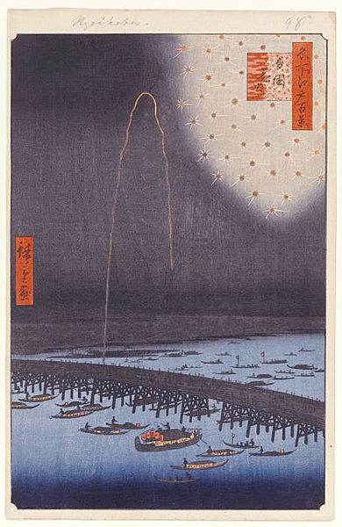

Utagawa (Andō) Hiroshige, Fireworks at Ryogoku Bidge (Ryogoku Hanabi), No. 98 from One Hundred Famous Views of Edo (Meisho Edo Hyakkei), 1858, colour woodcut, 36.2 x 23.5 cm (sheet), 34 x 22.5 cm (image), Brooklyn Museum, Gift of Anna Ferris (Accession No. 30.1478.98)
https://www.brooklynmuseum.org/opencollection/objects/121712/Fireworks_at_Ryogoku_Ryogoku_Hanabi_No._98_from_One_Hundred_Famous_Views_of_Edo

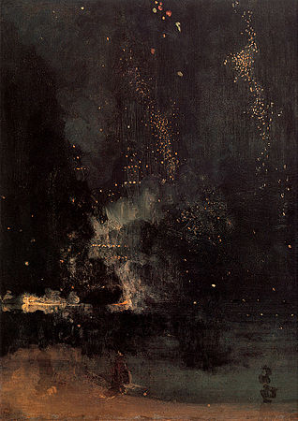

James Abbott McNeill Whistler, Nocturne in Black and Gold, The Falling Rocket, 1875, oil on panel, 60,2 x 46,7 cm, Detroit Institute of Arts, Gift of Dexter M. Ferry, Jr. (Accession No. 46.309)
http://www.dia.org/object-info/7d1a59d3-6163-440a-925a-b0978f1f8811.aspx

