Austrian Expressionism

Expressionism was one of the foremost modernist movements to emerge in Europe in the early years of the twentieth-century. It had a profound effect on the visual arts, as well as on music, dance, drama, literature, poetry, and cinema. Rather than depict physical reality, Expressionism developed as a reaction against the prevailing interest in positivism, naturalism, and Impressionism, as artists who were heavily influenced by the work of Edvard Munch and Vincent Van Gogh sought to explore subjective content, finding the visual means to fully evoke or express an emotion, mood or idea through their artwork.

Austrian Expressionism is primarily associated with the work of EGON SCHIELE and OSKAR KOKOSCHKA, and also includes the work of their contemporaries Max Oppenheimer, Richard Gerstl and Alfred Kubin. For Schiele and Kokoschka, portraiture and figural imagery, often favoring scenes of heightened sexual tension, were primary subjects as each sought to delve beneath the surface reality of physical appearance to uncover psychological or emotional insights in their subjects. Both artists reflect the importance at the time of the psychological theories of Sigmund Freud, particularly his On the Interpretation of Dreams, published in 1900. Like their German counterparts in DIE BRÜCKE group, both artists took inspiration in the authentic and natural behavior of children.

Both artists got their start in Vienna, thanks largely to the support of GUSTAV KLIMT, though their early works generated consternation and criticism when exhibited. By showing the untidy reality and complexity of the individual human psyche and the overriding forces of instinct, sexual desires, and physical or psychological illnesses that control and define a person, their works posed a direct challenge to the reserved nature of the Viennese, for whom outward appearances were central to the maintenance of societal expectations.

Portraits and Self-Portraits
Kokoschka encouraged his subjects to move about freely and behave naturally as he worked, without the use of preliminary sketches, to uncover the essence of a sitter. Portrait of Hans and Erika Tietze, 1909, depicts a married couple, both of who were respected art historians. Kokoschka incised directly onto the surface of the canvas to include force lines emanating from each figure, while adding linear motifs to surround them with a harmonic assortment of abstract colors and forms. Though individualized and separated through pose, they are united through the position of their hands, which creates an arching line across the foreground of the canvas to pull them together. Kokoschka was influenced by the development of x-ray technology at the time, a medical tool that similarly made the internal world outwardly visible.

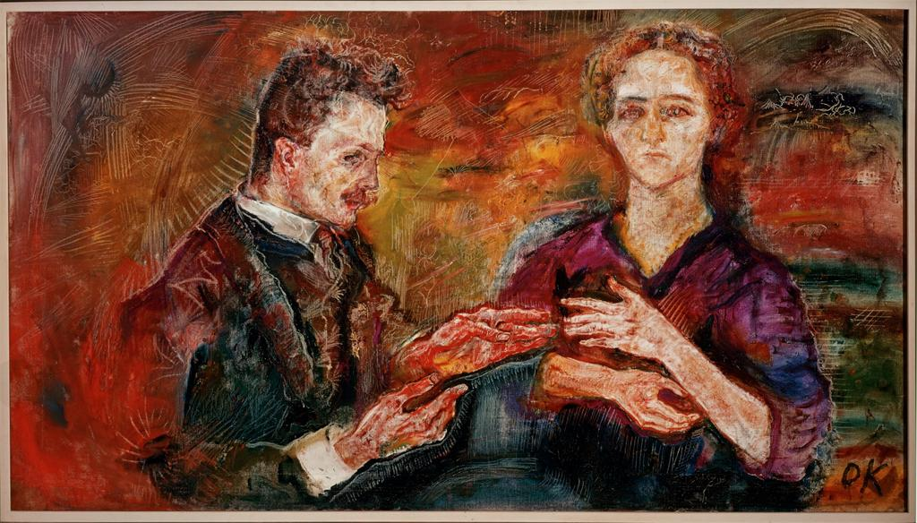

In Portrait of Paris von Gütersloh, 1918, Schiele’s friend and fellow artist is rendered in his distinctive, energetic line and the architectural structure of form found in his paintings. The sitter’s dominance within the vibrant orange background, punctuated with jolts of color in the blue tie and red socks, gives a sense of dynamism and intensity to the figure that corresponds to his creative identity. In Portrait of Johann Harms, 1916, Schiele elongates the form of his elderly father-in-law and includes a resigned gesture that conveys the awareness of deteriorating health and loss of physical vigor, which is further manifest in the somber, melancholy palette.

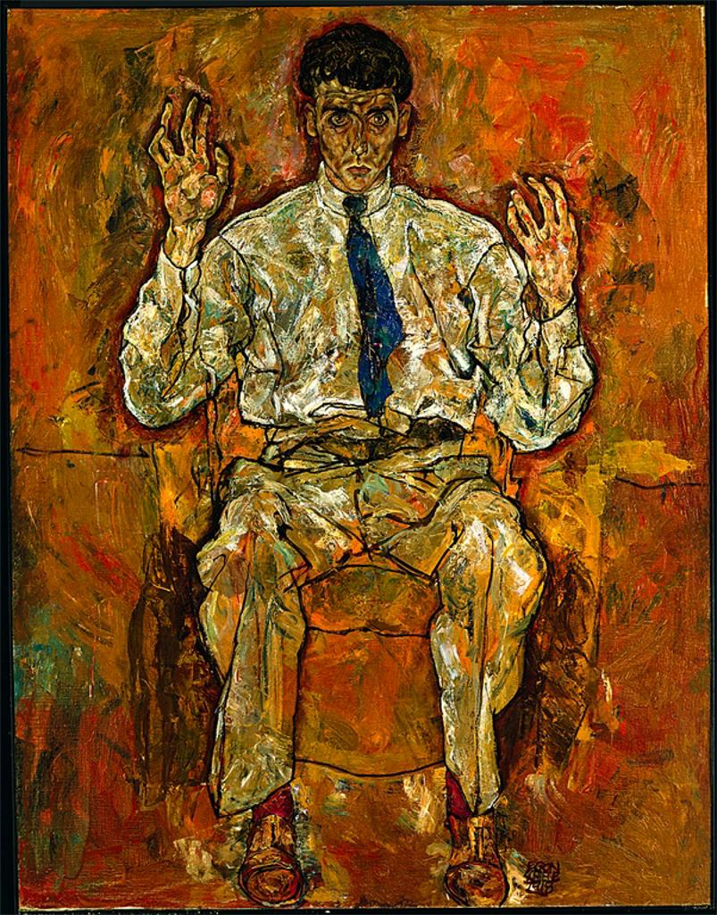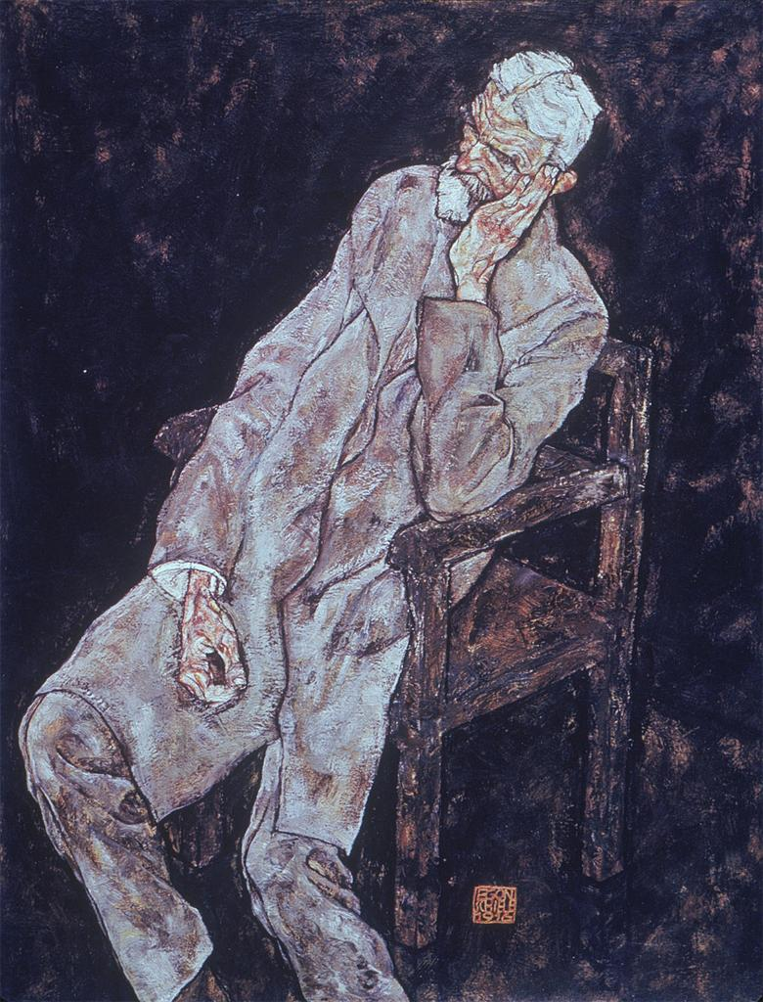

Schiele and Kokoschka were aligned in the usefulness of self-portraiture to study the power of pose, gesture, and facial expression, and throughout their works, the position of the hands is often central. This is seen in several examples, including Schiele’s Self-Portrait, 1910, in which he assumes a defiant and anti-authoritarian stance to signal his renegade arrival on an artistic scene that so prized the opposite type of portraiture, one that conveyed status and social position through objective details.

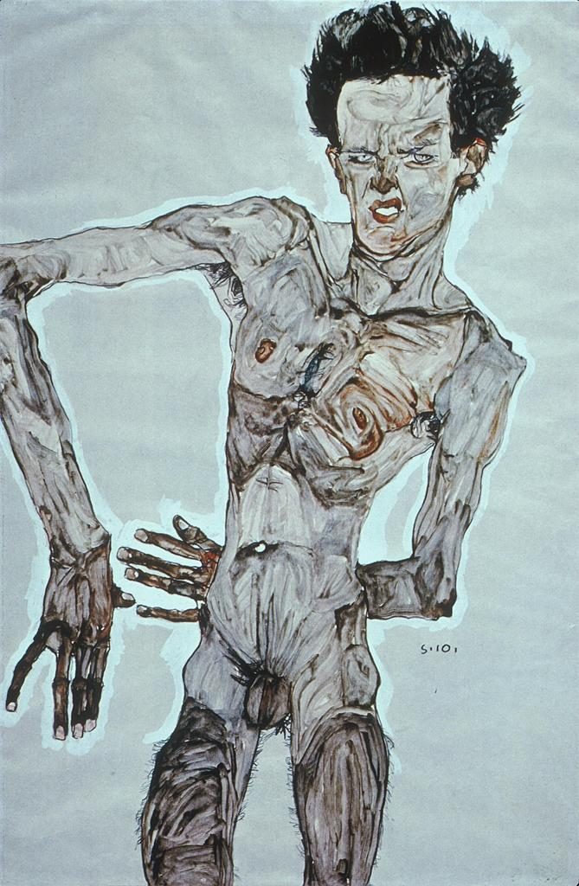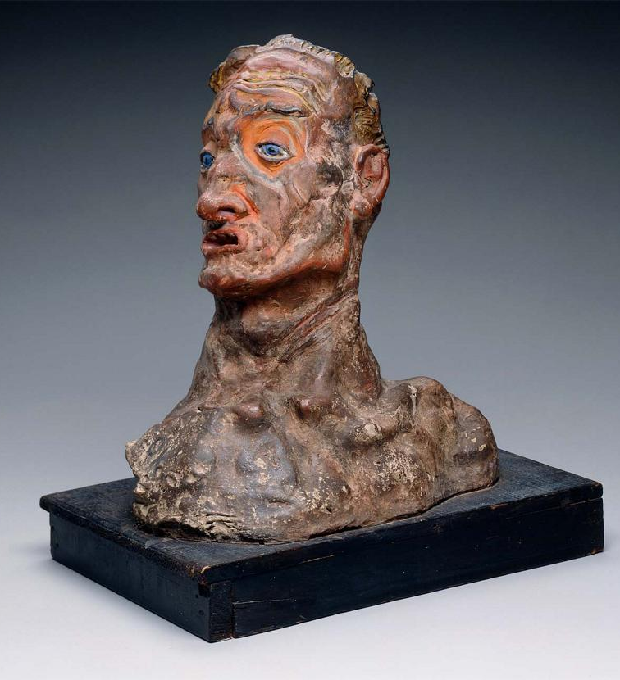

Kokoschka’s early Self-Portrait, 1909, a clay bust, shows the expressionist interest in surface texture and the intense handling of form, which are also key elements in Expressionist canvases. In one of his most famous works, Kokoschka is able to offer insight into his psychological state of mind during a defining love affair with Alma Mahler. In The Tempest (Bride of the Wind), 1914, the couple appears within an ethereal realm of color within an atmospheric landscape. But, the deterioration of their relationship is signaled by the cool blue tones and through the worrisome expression on the artist’s face, matched with the tension of his writhing hands.

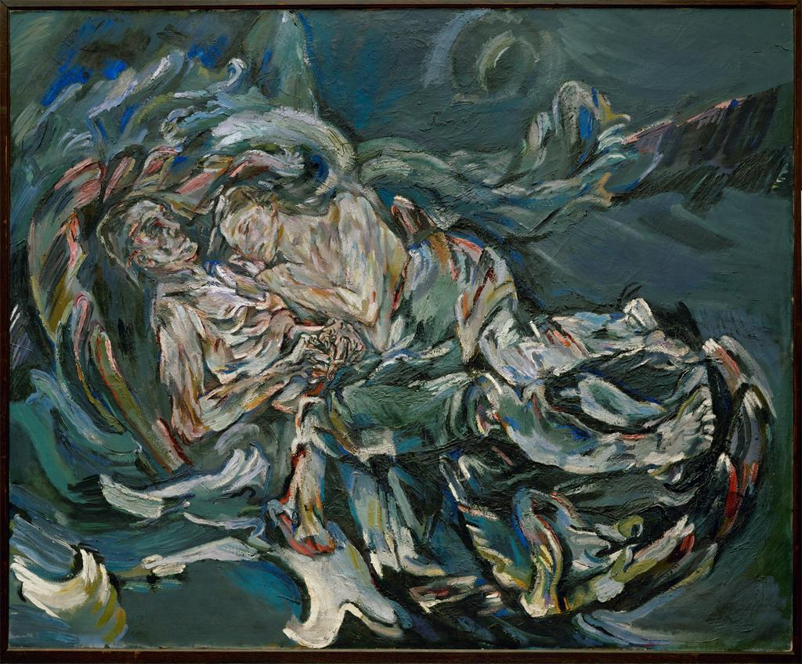

Other Art Forms
Kokoschka was the author of several dramatic plays that relied on non-linear narrative structure and aphoristic content, while Schiele wrote poetry using alliteration and rhythmic construction to heighten the sensual descriptiveness of his prose. This literary work is part of the larger reorganization and regeneration in languages of creative form within Expressionism. In Vienna, one of the most profound and influential mediums was music. Arnold Schoenberg, Anton Webern and Alban Berg experimented with atonal compositions, harmonic dissonance and strong subjective allusions, showing the capability of Expressionism to express deep meaning by transcending existing limitations.

References and further reading:

Vienna 1900: Klimt, Schiele, and their Times, A Total Work of Art, Barbara Steffen, editor. Basel: Fondation Beyeler and Hatje Cantz Verlag, 2011.

Vienna 1900 and the Heroes of Modernism. Christian Brandstätter, ed. London and New York: Thames & Hudson, Ltd. and Vendome Press, 2006.

Oskar Kokoschka. Klaus Albrecht Schroder and Johann Winkler, editors. Munich: Prestel 1991.

Oskar Kokoschka: Early Portraits from Vienna and Berlin, 1909-1914. Exh. cat. Tobias G. Natter, editor. Cologne: DuMont Verlag and the Neue Galerie New York, 2002.

Egon Schiele. Exh. cat. Klaus Albrecht Schröder. Vienna and Munich: Albertina and Prestel Verlag, 2005.

Egon Schiele: The Leopold Collection, Vienna, Magdalena Dabrowski, ed. (Munich and New York: Prestel, 2009).

Peter Vergo, Art in Vienna 1898-1918: Klimt, Kokoschka, Schiele and their Contemporaries. (London: Phaidon, 1981).

Van Gogh and Expressionism, Jill Lloyd, editor. Ostfildern and London: Hatje Cantz, 2006.

Vienna 1890-1920, Robert Waissenberger, editor. New York: Rizzoli, 1984.

