German Expressionism

The term German Expressionism refers to an aspect of international modernism that dominated the visual arts and architecture in that country toward the end of the Wilhelmine Empire through the early years of the Weimar Republic (from approximately 1906 to 1922). Artists associated with the term used a multiplicity of antinaturalist techniques to attack not only the conventions of nineteenth century academic art but also the conventions of a society they found repressive, materialistic, and corrupt. Experimenting with emotive colour, form, and composition, artists such as WASSILY KANDINSKY (fig. 1) and ERNST LUDWIG KIRCHNER (fig. 2) were determined to communicate utopian visions synthesized from an array of international, anti-establishment cultural and political ideologies such as theosophy, anarchism, and socialism.

As early as 1911, critics in Germany had begun to use the term Expressionist to refer to contemporaneous works of European art that turned away from naturalism and Impressionism. By the time of the 1912 Cologne Sonderbund exhibition, its director not only described their survey of the most recent developments of painting as Expressionismus but also emphasized the international number of artists from France, Austro-Hungary, Russia, Norway, in addition to Germany, who were simplifying and intensifying their colours and forms. Among the artists included in this exhibition were HENRI MATISSE of the Parisian Fauves, Kirchner and ERICH HECKEL of the Dresden/Berlin Brücke (Bridge), Kandinsky of the Munich Blaue Reiter (Blue Rider), and CESÁR KLEIN of the Berlin Neue Secession.

Provincial artists such as CARL VINNEN and the general public reacted negatively to the bright colors, flattened shapes, and distorted forms of Expressionism, continuing a long-standing aspect of German thought in which internationalist influences were seen as the direct cause of the decline of German art and culture. Supportive critics, however, cited earlier precedents such as oils by Grünewald and Michelangelo in addition to works by contemporary northern artists such as EDVARD MUNCH to justify the anti-naturalism of the new direction. The art historian WILHELM WORRINGER stressed the metaphysical values of the new artistic tendencies and urged the study of ‘primitive art’ to overcome the focus on the world of natural appearance perpetuated by the classical-Renaissance tradition of European art. Artists, aware that much of the public was bewildered by their work, felt compelled to explain their approach in essays, tracts, and manifestos. Periodicals such as Der Sturm (fig. 3) and Die Aktion reproduced numerous prints from Brücke, Blaue Reiter, and Neue Secession artists, as well as recognizing sculptors, architects, and poets as Expressionists. Even during the First World War, Der Sturm and its gallery continued to explain the new tendencies as international by promoting FUTURISM and CUBISM as part of Expressionism.

Because of the dominance of the state in artistic affairs during the Wilhelmine Empire, visual artists as well as architects such as BRUNO TAUT struggled to free themselves from national or state regulations that might determine the direction and content of their works. Social anarchism, with its promise of mutual help and a state that would wither away, set the frame for many Expressionists’ utopian and optimistic estimate of the possibilities of individual creativity. At the same time, most endeavoured to explore communal activities and to weigh their responsibility to the public.

After the First World War
The First World War became a catalyst for an even more activist stance among many Expressionists. With the collapse of Imperial rule in 1918 and the formation of the Weimar Republic, many artists who had been connected to Expressionist groups before the War, established new organizations such as the Arbeitsrat für Kunst (Work Council for Art) (fig. 4) and the Novembergruppe (November group) which initially supported free art education, public museums, and local participation in housing and other public projects. Now infused with French Cubism and Italian Futurism, Expressionism became a visual signifier for the new Republic with its opposition to the Imperial past and evocation of internationalist innovation. But the anti-naturalism that most Expressionists believed would stimulate change met with resistance from the workers they wishes to inspire. As the strikes and street battles of 1919 weakened the Republic, many artists and critics became disillusioned with the governing Social Democrats and turned dramatically against the CUBO-EXPRESSIONIST style manifested in election posters (fig. 5) and other visual images of the Republic commissioned by the majority party. Communists such as GEORGE GROSZ and JOHN HEARTFIELD distanced themselves from their Expressionist past and many of the original supporters of Expressionism, such as Worringer, wrote of its demise. Yet, during the 1920s, the urban middle class embraced the stylistic manifestations of Expressionism particularly in theater design and film and references to Expressionism survived in the visual manifestations of DADA and NEUE SACHLICHKEIT (New Objectivity).

During the 1930s, Expressionism was attacked by both the extreme right and left. The Marxist critic GEORG LUKÁCS severely critiqued Expressionism and modernism for its fragmented, abstracted forms and inability to communicate to the masses, and his 1934 essay set the tone for later criticisms of Expressionism during the 1980s. The National Socialist condemnation of Expressionism and modernism reached its apogee with the 1937-38 traveling exhibition of Entartete Kunst (Degenerate Art).

With the conclusion of the Second World War, Expressionism became resurrected in Germany and the United States as an antipode to the authoritarian realisms of both Soviet and National Socialist regimes. In the 1950s, art historians and critics began to publish studies of German Expressionism before the First World War, but scholars did not begin to explore the second generation of Expressionists until the 1970s and 1980s. Nonetheless, not until the end of the last century and the beginning of the twenty-first, have scholars asked why museums in the United States and England have favored Cubism over its modernist cousin, Expressionism, in exploring the trajectory of modern art.

References and further reading:

Barron, S. (1997) German Expressionism: Art and Society, New York: Rizzoli.

Benson, T. (2001) Expressionist Utopias: Paradise, Metropolis, Architectural Fantasy, Los Angeles: Los Angeles County Museum of Art.

(1989) German Expressionist Prints and Drawings, The Robert Gore Rifkind Center for German Expressionist Studies, 2 vols., Los Angeles: Los Angeles County Museum of Art.

Junge, H. (ed.) (1992) Avantgarde und Publikum: Zur Rezeption avantgardistisch Kunst in Deutschland 1905-1933, Cologne: Böhlau.

Long, R-C W. (ed.) (1993) German Expressionism: Documents from the End of the Wilhelmine Empire to the Rise of National Socialism, New York: G.K. Hall; paperback edition, Berkeley: University of California Press, 1995; esp. essays by R. Reiche and W.Worringer,16-18 and 9-13.

Raabe, P. (1964) Die Zeitschriften und Sammulungen des literarischen Expressionismus, Stuttgart: J. B. Metzlersche Verlag.

Raabe, P. (1972) Index Expressionismus, 18 vols., Neudeln, Liechtenstein: Kraus Thomson.

West, S. (2000) The Visual Arts in Germany 1890-1937: Utopia and Despair, New Brunswick, NJ: Rutgers University Press.

Weikop, C. (ed.) (2011) New Perspectives on Brücke Expressionism: Bridging History, Farnham, Surrey, UK: Ashgate; esp. essays by Long and Weikop, 11-30, 237-276.

Images:

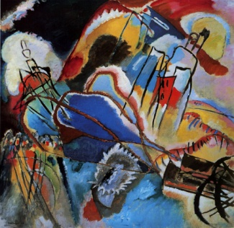
Fig. 1: Wassily Kandinsky, Improvisation 30, 1913, oil on canvas,The Art Institute of Chicago, Arthur Jerome Eddy Memorial Collection.

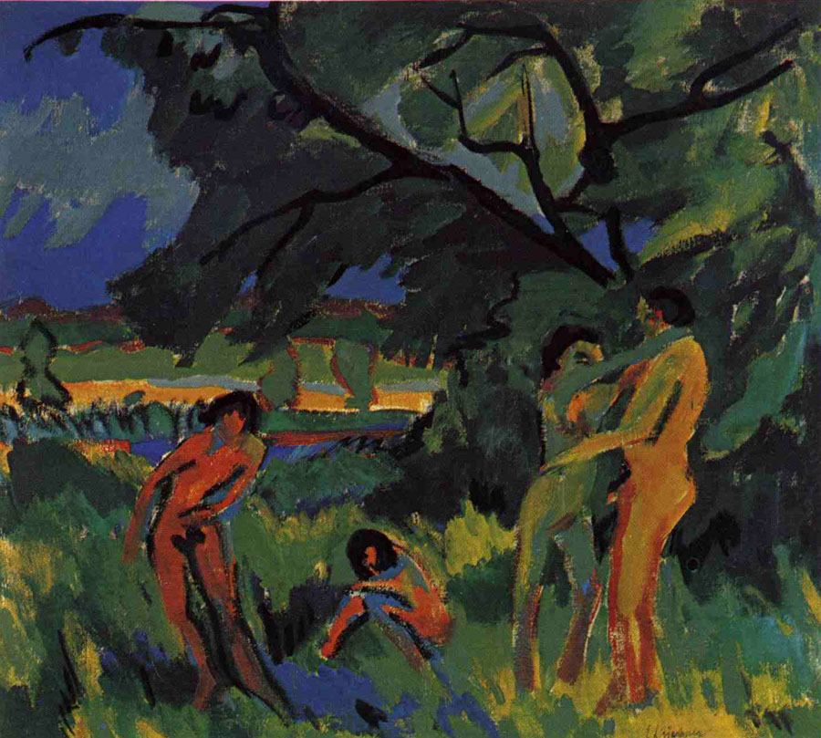
Fig. 2: E. L. Kirchner, Nudes in a Landscape, 1910, oil on canvas.

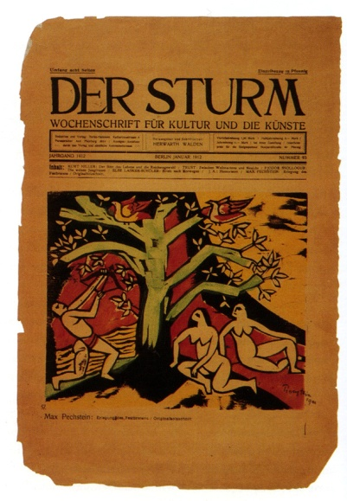
Fig.3: Max Pechstein, 1911, color woodcut, appearing in Der Sturm, January 1912.

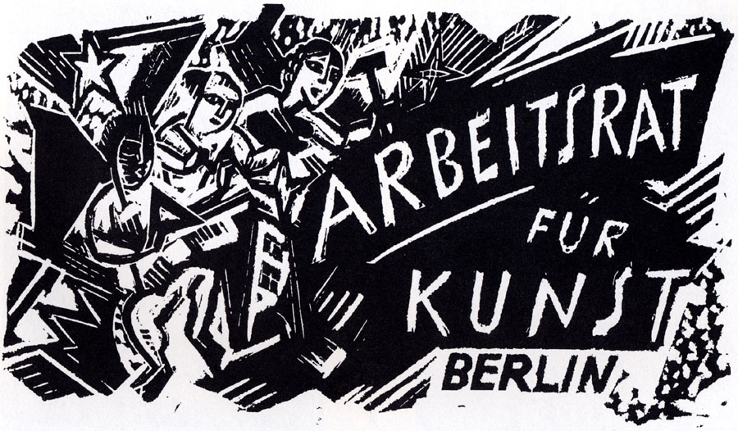
Fig. 4: Max Pechstein, Cover of leaflet for Arbeitsrat für Kunst, 1919

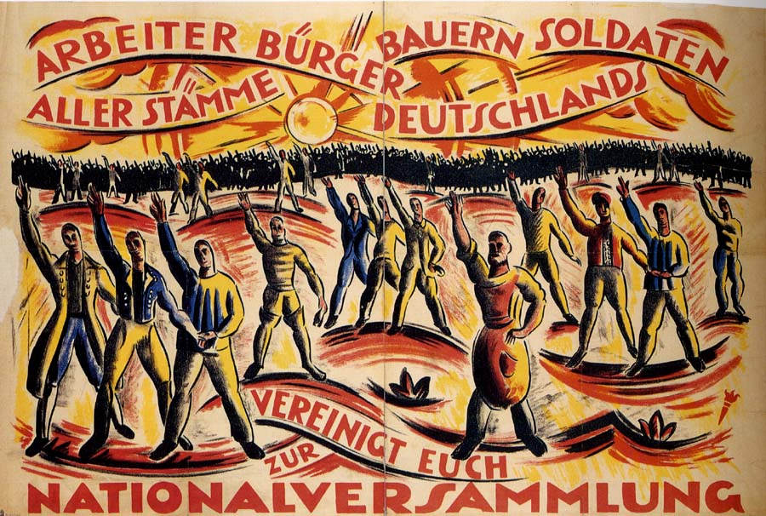
Fig. 5: Cesár Klein, Election Poster, 1919, color lithograph

