Exter, Alexandra Alexandrovna Grigorovich
Born 6 January 1882 in Bialostok, Belorussia, Imperial Russia
Died 17 March 1949 in Fontenay-aux-Roses, near Paris, France

First exhibiting in Kiev in The Link (1908), Alexandra Exter showed paintings of 1907 done in France and Switzerland in a Pointillist style. Passing through a short Cézannist period, she adopted structural principles of Cubism, 1911-1912, to then take up the colour ideas of the Parisian Simultaneists, Robert Delaunay, Sonia Delaunay and the Synchromists, 1913-1915. For them, colour is what the eye sees before it sees objects, making the world a fantastic display of shapes of moving colour between light and dark which they depicted in their paintings (R. Delaunay, Solar Disc, 1912, S. Delaunay, Le Bal Bullier, 1913). It was the city at night that Exter captured in a series of paintings that became increasingly non-objective as patches of colours began to dominate over the objects. Returning to Russia in 1914, she was associated with Cubo-Futurist painters – K. Malevich, L. Popova, et al. – and in 1916 she, like them and others, was using spinning discs to capture moving colour in light. Exter’s ‘Dynamism of Colour’ series (1916-1918) was entirely non-objective and was followed by her ‘Colour Constructions’ composed with beams of light from projectors onto a screen (1920-1924) and with the circular movement of machines, the ‘Dynamics of Colour’ series. Exploring colour and its laws was a main stream of modernism to which Alexandra Exter was a major contributor.
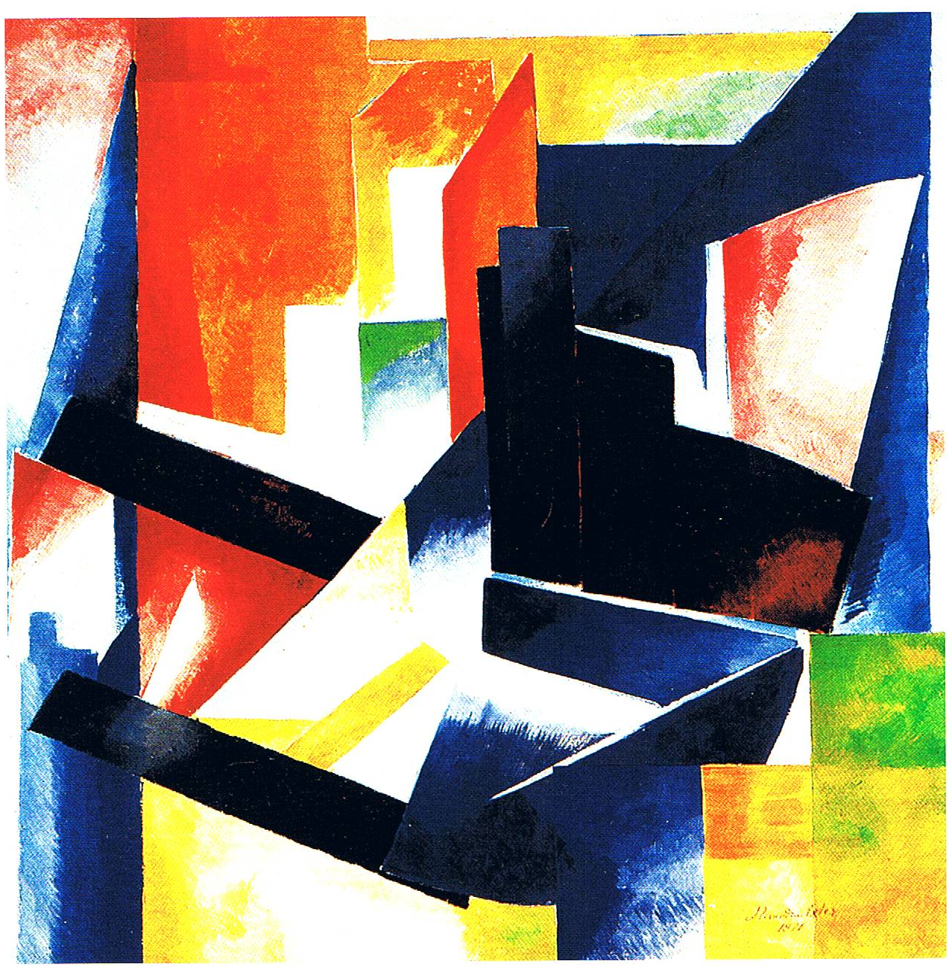
Colour Construction, 1921 Oil on canvas, 89 x 89 cm. State A. Radichev Museum of Art, Saratov

Very much a part of the modernist trends – Cubism, Simultaneism – in Paris, Exter brought the ideas inherent to them to her friends in Russia, thereby contributing to the rise of modernism and the Russian avant-garde. Due to the First World War and then the 1917 October Revolution, Exter was based in Russia and not only took part in exhibitions of non-objective art but became engaged in costume and set design for the theatre (Thamira Kitharides, 1916, Salome, 1917, Romeo and Juliet, 1921 for Alexander Tairoff and his Kamerny Theatre, Moscow), and for film (J. Protozanov’s, Aelita, 1924). Living in Kiev from 1917 to 1918, she was involved in arts programmes for the Bolshevik regime and in an official capacity she was responsible for installation of the Russian section at the Venice Biennale (1924) and the Paris Exposition des Arts Décoratifs et Industriels Modernes (1925), where she was awarded a gold medal for her theatre work. The political situation in Russia encouraged Exter to remain in Paris where she began to paint in a Purist style and taught composition and colour in the studio of Fernand Léger, the Académie Moderne (1925-1929) while also teaching theatre design in her own studio. In the 1930s she gave her talents to book design.

References and further reading:
Yakov Tugenhold, Alexandra Exter, Berlin: Saria, 1922 (in Russian, German, French).
Jean Chauvelin, Nadia Filatoff, with John Bowlt, Dmytro Horbachov, Alexandra Exter,
Paris: Max Milo Editions, 2003.
Gyorgy Kovalenko, Alexandra Exter, 2 vols., Moscow: Museum of Modern Art, 2010.
Patricia Railing, Alexandra Exter Paints, Forest Row: Artists Bookworks, 2011.

