3D SURFACE ANALYSIS

____________________________________________________

AUTHORS:-

|  |  |
| --- | --- |
| Name | ID No. |
| Shikari Ved Vishal Chandra | 1600337C203 |
| Shivam Agarwal | 1600338C203 |
| Shashank Mittal | 1600335C203 |
| Shiwang Jaiswal | 1600339C203 |
| Shashikant Chaudhary | 1600336C203 |

GROUP NUMBER: 5

INTRODUCTION –

INTRODUCTION TO OUR TOPIC:

According to the question, our team has been asked to find the critical points of the two variable function derived from a mobile number of one of our teammate and,were then asked to analyse the nature of the function which is nothing but a surface

At those critical points.

BACKGROUND INFORMATION

We know that:

* Critical point means: the points where the partial derivatives of the multivariable function are equal to zero or don’t exist.
* In mathematics, the second partial derivative test is a method in multivariable calculus used to determine if a critical point of a function is a local minimum, maximum or saddle point.
* 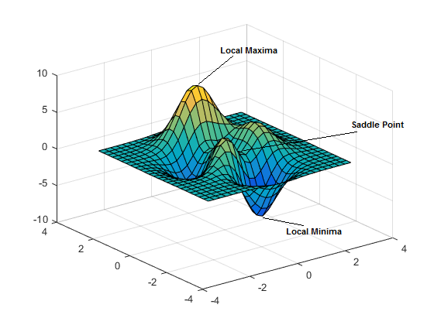In mathematical analysis, the maxima and minima of a function, known collectively as extrema, are the largest and smallest value of the function, either within a given range (the local or relative extrema) or on the entire domain of a function (the global or absolute extrema).
* Saddle Point-A point at which a function of two variables has partial derivatives equal to zero but at which the function has neither a maximum nor a minimum value.

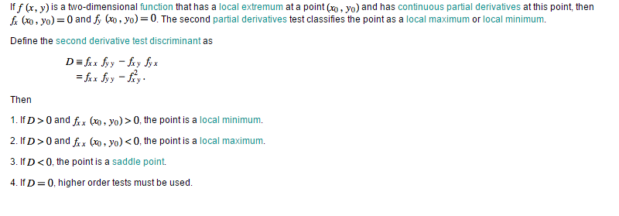

OBJECTIVES

* TO develop a mathematical understanding of a two variable function as a three dimensional surface.
* To plot and analyse the behaviour of the plotted surface.
* To find the critical points and analyse behaviour of the derived function at those critical points
* TO make a contour plot ie a 2D representation of our 3D surface.

Materials and Method

* GeoGebra tool (Graphing Software)-By using GeoGebra we have found the critical point by plotting the Fx =0 and Fy =0.
* After that we have used it for plotting the 3D surface by putting the equation in the input and column.
* And finally we plotted contour by putting various values of z in the equation in z= f(x,y).
* We analyse the behaviour of the surface at the critical points.
* By using second derivative test we determine whether the critical points are maxima, minima or saddle point.

Results and Discussions

Initially, the function which we formed by using the phone no**. 8142624452** is:

F(x, y) = 8x³ - x² y + 4x y² - 2y³ + 6x² - 2x y + 4y² - 4x + 5y – 2

After this we have found fx(partial derivative with respect to x)and fy (partial derivative with respect to y) and equated it equal to zero in order to find critical points .

Fx= 24x² - 2x y + 4y² + 12x - 2y – 4

Fy= -x² + 8x y - 6y² - 2x + 8y + 5

By equating the above expressions to zero and solving them we get our critical points.

Since we know that the solutions of 2 curves is nothing but the points where the graphs intersect,

We plot the curves in 2 d to get our critical points

Fx= 0 i.e. 24x² - 2x y + 4y² + 12x - 2y – 4=0

Fy=0 i.e. -x² + 8x y - 6y² - 2x + 8y + 5 =0

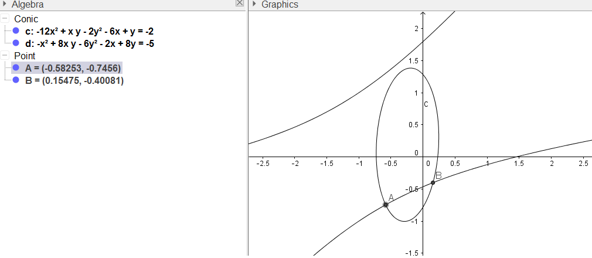

The Critical points found by solving the above equations are

A (-0.58253,-0.7456)

B (0.15475,-0.40081)

By using second Derivative test we find whether there is maxima, minima or saddle point at these critical points.

Fxx = 48x-2y+12

Fyy =  8x-12y+8

Fxy =  -2x+8y-2

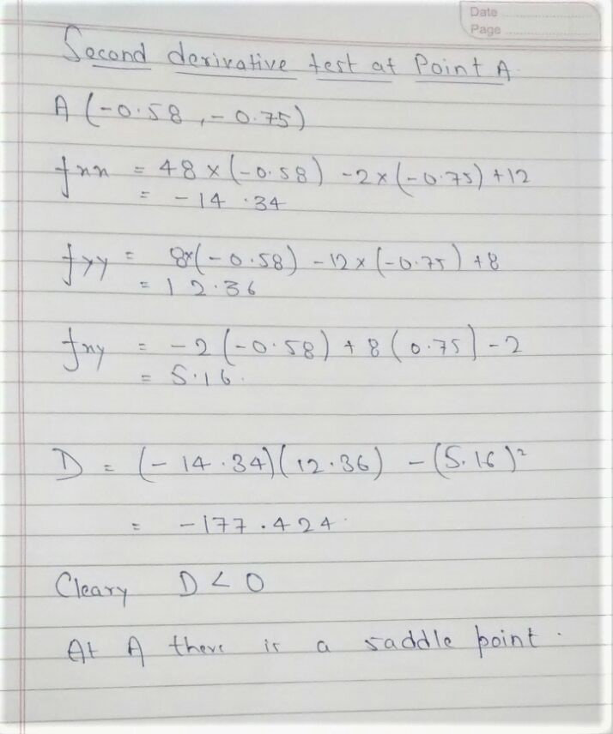

-The above figure is a second derivative test at the point “A”.

* RESULT Point A is a saddle point

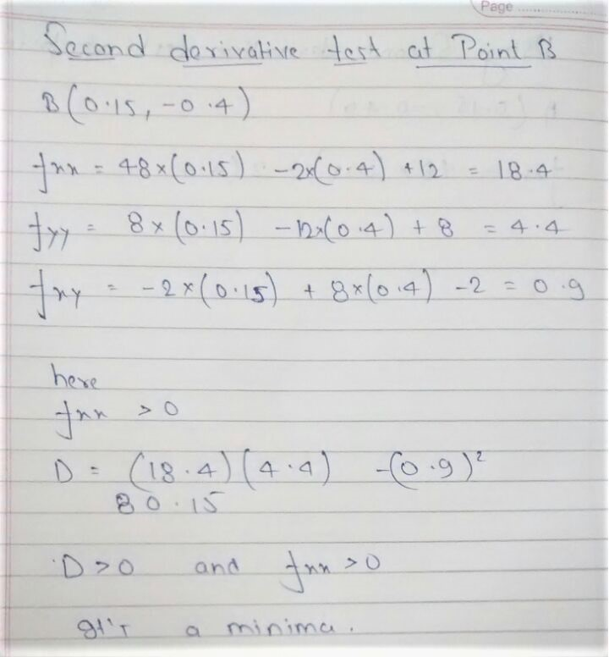

The above figure is a second derivative test at the point “B”.

* RESULT Point B is minima
* 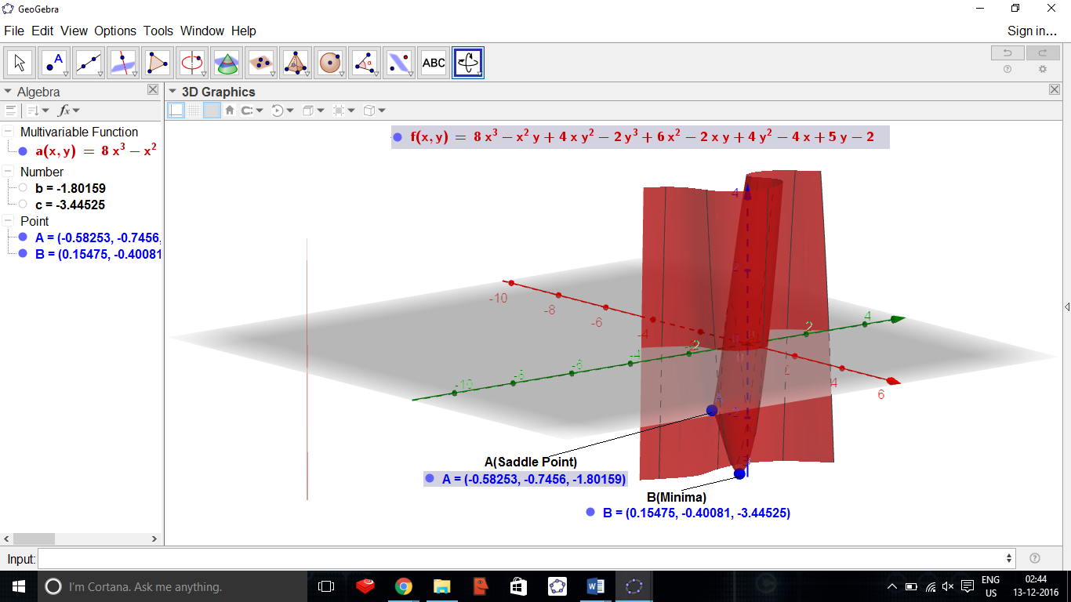By Using GeoGebra and plotting the above curve we get –
* The Point "A" in above figure is a saddle and point.
* The point “B” in above figure is minima.

Below are above graph taken in different angles

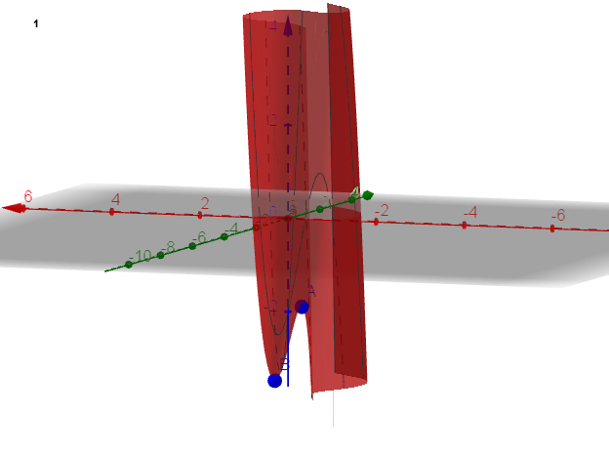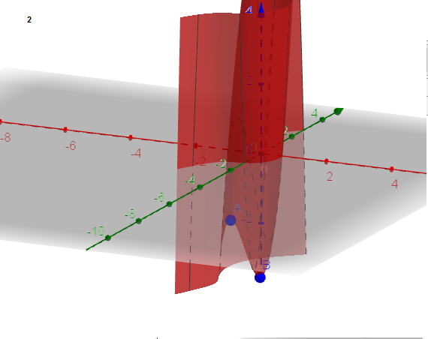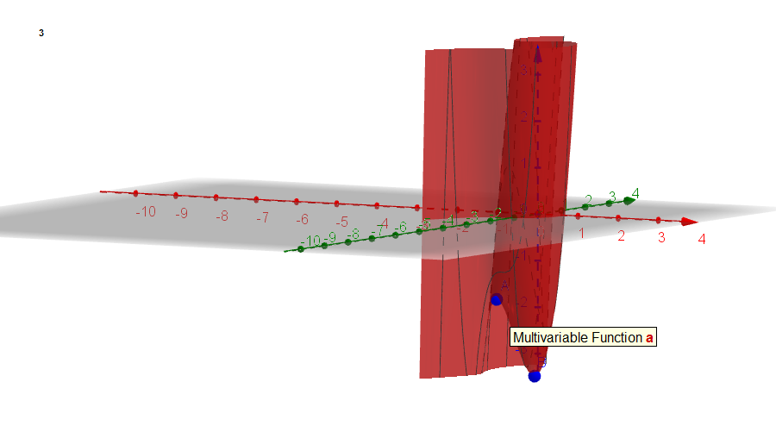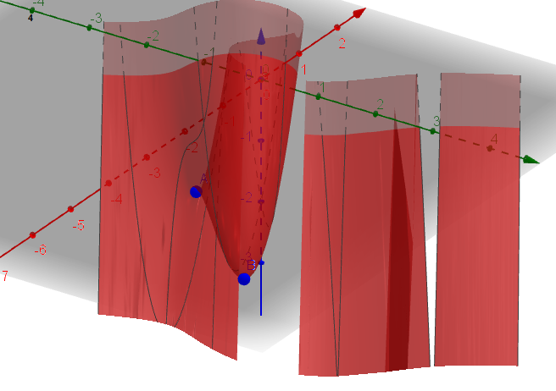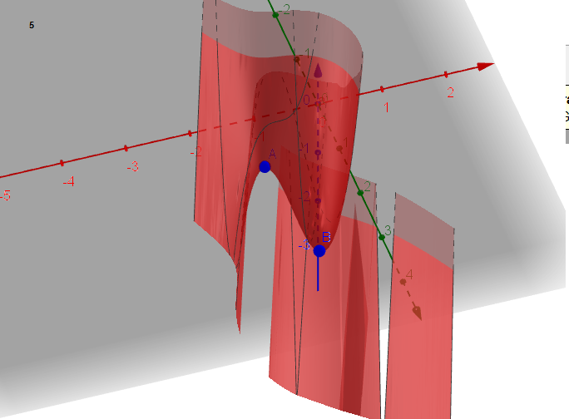

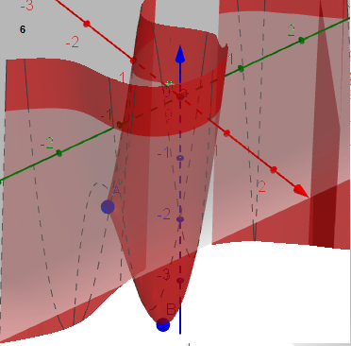

CONTOUR PLOT

A Contour plot means the set of equations obtained by substituting various integral values of z in the equation z=f(x,y) .ie. f(x,y)=a,b.c….. where a,b,c … are all contants.

* This is Contour plotting of the above curve at F(x,y)=(-10,-8,-6,-4,-2,0,2,4,6,8,9,10)

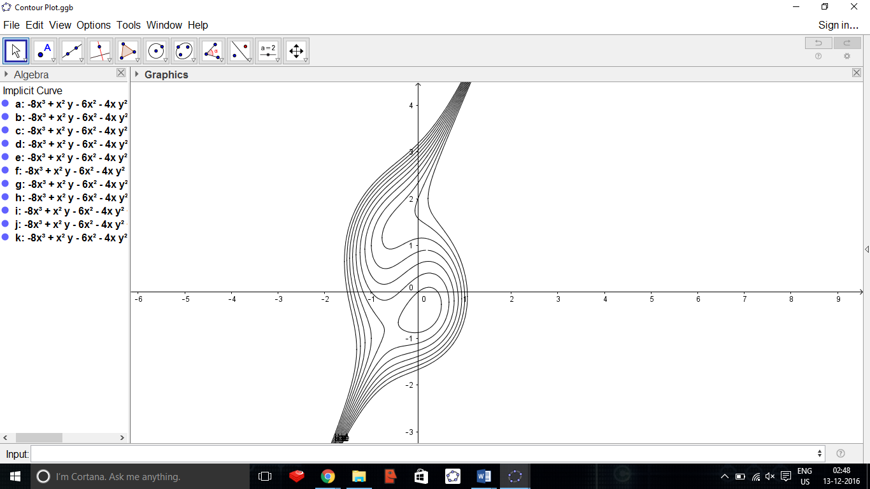

Conclusion:-

* By using the phone number 8142624452 we have formed a multi variable third degree equation.
* By finding its first order partial derivatives we have found its critical points.
* Using 2nd derivative test we found that it has 1 minima and 1 saddle point in our equation.
* The contour plot helps us conclude that from x= -1 to .5 and from y= -1 to 2,the slope our surface is blunt or not steep ,
* beyond x =-1 and x=.5, it goes steep

References:-

* <http://mathworld.wolfram.com/SecondDerivativeTest.html> Second derivative test condition.
* Thomas Calculus 14.7 – Extremum values and Saddle Points
* Class Notes

Acknowledgement:-

Working on this assignment was a source of immense knowledge to us.

It gave us a golden opportunity to test our mathematical skills and sharpen them up.

We would like to express our sincere gratitude to Professor Ziya Uddin for his guidance and support throughout the course.

In addition to all our group members, we thank to our friends Saksham and Suraj who helped us guiding in GeoGebra.