

STAR GAME

A Project report on Finite Linear Game using C language.

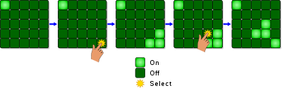

**Project Report by:-**

**Shashikant Chaudhary(1600336C203)**

ACKNOWLEDGEMENT

**Working on this assignment was a source of immense knowledge to us.**

**It gave us a golden opportunity to test our mathematical skills, programming skill and sharpen them up.**

**We would like to express our sincere gratitude to our Professor Dr Ranjib Banerjee for his guidance and support throughout the course.**

CONTENTS

Pg.no

1. SUMMARY 4

2. INTRODUCTION 4

3. HYPOTHESIS 5

4. PROCEDURE 6

5. RESULT 8

6. CONCLUSION 8

7. REFERENCES 8

# 

# 

# 

# SUMMARY

The aim of this project is to develop a Finite Linear Game using the concept of matrices on C platform.

A finite linear game is a problem that involves a situation where a physical system has only a finite number of states which can be altered by applying processes.

This game has 3x3 order matrix and each element of the matrix has finite state or values of ‘0’ (off) and ‘*’ (on) and these states can be change by using buttons on keyboard.

In this game when the user presses the button corresponding to a element in the matrix then that value and the values adjacent to it changes its state from ON to OFF or OFF to ON.

The challenge of this game is to change the states of all elements to ON i.e converting to (*) in limited chances.

The game uses concepts, like matrix addition and solution of linear equation, 2D arrays nested loops, if else condition etc.

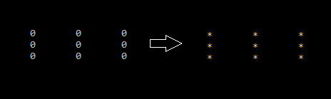

# 

# INTRODUCTION

The finite linear game .As the name of the game suggests that this game which we have made is based on matrices .The game uses the concept of matrices, matrix addition and programming skills .In this game we will have to try to make all the zeroes into stars.

Finite linear game is a computer or electronic game which works on the principle of linear transformation of matrices. There are many situations in which we must consider a physical system that has only a finite number of states. Sometimes these states can be altered by applying certain processes. Each of which produces finitely many outcomes. The finiteness of such situations is perfectly suited to analysis using modular arithmetic.

In this game we will try to convert all the zeroes into stars .The game has been designed in such a manner that it will test your IQ and mathematical knowledge .In this game when we press a button the zeroes adjacent to it will also be converted into stars .So, we have to convert all the zeroes into stars in as few button presses as possible.

This report will help you understand our project completely .Algorithm of the game will be explained in this report, use of mathematics in this game will be explained .The game will help us understand the use mathematics in programming.

# HYPOTHESIS

The aim is to turn ON all the elements. When the user presses button corresponding to any element then that element and its adjacent element changes its state from zero (0) to star (*) or star to zero.

So we thought if we add the matrix corresponding to the button and initial matrix then the odd values of elements correspond to ON state and even values of elements correspond to OFF state.

If the buttons are A1, A2……..A9 then the solution of the game will be .

aA1+bA2+cA3……….iA9=M (M is matrix having values of element ‘1’.).

a,b,c……..i are constants.

# 

# PROCEDURE

Initially we have taken a 3x3 order (A) matrix whose each element is 0.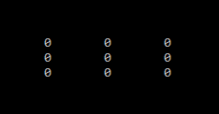3x3

After that we created nine different 3x3 order (A1-A9) matrices which serves as the switch for turning OFF or ON the elements in matrix i.e. change the elements to zero (0) or star (*) .These nine different matrices defines the buttons, and these matrices are in such a way that when the user presses the button corresponding to any element then that element and its adjacent elements becomes 1 and gets added to initial matrix.

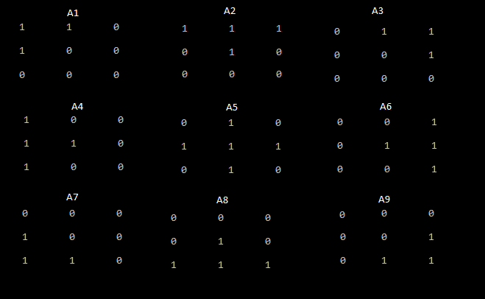

Whenever the user presses the button then the matrix corresponding to that button gets added to the initial matrix.

Suppose the user presses the A1 button then the matrix addition takes place i.e. A(sum)=A+A1 , then if the user again enters button An(n=1,2….9) then An gets added to the sum i.e. A(sum)’=A(sum)+An.

E.g. =A (sum) =A+A1+A1

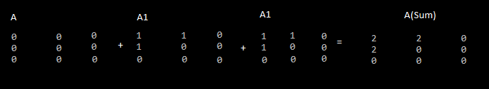

E.g. =A (sum) =A (sum)’+A2

A (sum) =Screenshot (11).png

Now the value of element is considered as ON and even value considered as OFF.

*Now our Aim was to convert the above thing into C Program*

ALGORITHM

Step 1: Start

Step 2: Declaring Variables for initial zero matrix, sum of the matrix and buttons using 2 dimensional array.

Step3: Display Initial matrix

Step4: Taking input from user.

Step 5: Run loop for multiple execution of the program.

Step 6: Using condition to check the input.

Step 7: Addition of initial matrix and input in variable ‘sum’.

Step 7: Printing the sum of matrix by changing odds to star (*) and evens to (0) zero.

Step 8: Again taking input and then Step 5 , Step 6 , Step 7 and Step 8.

Step 9: Changing all 0s to *.

Step 10: Stop.



# RESULTS

The solution of the game is aA1+bA2+cA3……….iA9=M (M is matrix having values of element ‘1’ or it is matrix having all values odd.) and a,b,c……..i are constants or number of times different buttons present.The game gets completes when the user converts all Zeroes to Star in limited number of steps.

# CONCLUSION

In this report, a design of finite linear game has been presented by converting the zeros to star. By further addition we can develop this project to a higher level by using LEDS and switches to play and complete the game (embedded C is needed to be used).

# REFERENCES

1. Linear Algebra A Modern Introduction by David Poole/Finite Linear Game/pg109
2. https://www.tutorialspoint.com/cprogramming/c_multi_dimensional_arrays.htm