

M.S.T University
Office Solution Development
Submitted to:
Tr.
Zaw Thein Htet
Student ID – 208233
NCC L4DC: M.S.T University


NCC Education
Level 4 Diploma in Computing
OSD
M.S.T University
A signed copy of this form must be submitted with every assignment.
If the statement is missing your work may not be marked.
Student Declaration
I confirm the following details:
Candidate Name: | Zaw Thein Htet
Candidate ID Number: | 208233
Unit: | OSD
Centre: | M.S.T University
Qualification: | Level 4 Diploma in Computing
Word Count: | 1600
I have read and understood both NCC Education’s Academic Misconduct Policy and the Referencing and Bibliographies document. To the best of my knowledge my work has been accurately referenced and all sources cited correctly.
I confirm that this is my own work and that I have not colluded or plagiarized any part of it.
Candidate Signature: | 
Date:

Centre Name : M.S.T University
Assignment Title : Office Solutions Development
Exam Cycle :
Candidate Name : Zaw Thein Htet
NCC Education ID No. : 208233
Submission Date :
Marker’s Comment :

Moderator’s Comment :

Mark: Moderated Mark: Final Mark:



Task 1
PlayTech Computer Sale Store
PlayTech is a premier destination for all your computer and technology needs. Our retail store is dedicated to supplying latest and most innovative products in the world of computing, ensuring that our customers stay ahead in the fast-paced digital age. Whether you're a tech enthusiast, a professional looking for high-performance systems, or a casual user in need of reliable computing solutions, we have something for everyone. At PlayTech we pride ourselves on delivering a seamless and enjoyable shopping experience. Our operations are meticulously designed to cater to every aspect of customer journey, from the moment they walk through our doors to after-sales support they receive. Formed in 2005 as retail arm of a local distribution and PC assembly company. Rebranded from TMC Computer to PlayTech in 2005 to reflect our hardcore gaming roots. PlayTech has been consistently turning out some of the highest spec and best priced gaming systems NZ has ever seen bringing high quality hardcore gaming PC's to NZ market. PlayTech has since become one of fastest growing IT hardware suppliers specializing in area of Gaming, Home Entertainment, Corporate and School PCs and equipment. Whatever your gaming requirements, buying direct from PlayTech enables you to obtain a higher specified PC and components for less. All of our systems are designed using latest components which our team assemble, test and tweak to directly tailor to your needs.
PlayTech Computer Sale store has expanded itself really wide as there are more demands for gaming PCs and business use computers. PlayTech has become so well known that even some youtubers themselves sponsor the business creating more customers and followers. As gaming industry has become widespread and businesses has become more competitive the demand for powerful computer is rising. PlayTech receives lots of customer physically and digitally. Not only PlayTech has regular sales but online shopping is also available to reach out to customers in other countries. There are different brands ranging from Asus, Dell, HP and Lenovo. PlayTech has 100 employees in its store tasked with different roles in the business. Our primary purpose at PlayTech is to empower our customers with best technology solutions available. We strive to enhance their digital experience by offering high-quality products, expert advice, and exceptional customer service. Our goal is to become a trusted partner in their tech journey, providing tools and support they need to achieve their personal and professional goals. By combining a passion for technology with a commitment to customer satisfaction, PlayTech aim to set a benchmark in the retail industry. We believe that by fostering a community of informed and satisfied customers, we can contribute to broader tech ecosystem and drive innovation forward helping them stay forefront of technology.
Outline key of PlayTech
PlayTech Computer Sale store strategy must involve sales inventory management, human resources, customer relationship management, and finance. Managing a computer sale retail store involves several key business processes, each supported by related information systems to ensure smooth and efficient operations.
Sales and Customer Service: Our knowledgeable sales staff is always on hand to assist customers in finding the perfect products to meet their needs. We provide personalized recommendations, product demonstrations, and detailed information to ensure informed purchasing decisions. We utilize a state-of-the-art Point of Sale (POS) system to streamline transactions, manage inventory in real-time, and provide quick and efficient service. Point of Sale (POS) Operations: Transaction processing, Payment processing (cash, credit, digital payments), Receipt generation. POS System: Hardware (registers, barcode scanners, receipt printers), Software for sales transactions and inventory updates.
POS System: Hardware and software for sales transactions and inventory updates. Point of Sale (POS) Operations: Processing sales transactions, Handling various payment methods (cash, credit, digital payments), generating receipts and managing returns.
Customer Relationship Management (CRM): Our CRM system helps us build lasting relationships with our customers by keeping track of their preferences, purchase history, and service records. This allows us to offer tailored promotions, loyalty rewards, and timely support. Customer Relationship Management (CRM): Customer data collection, Sales tracking and reporting, after-sales support and service. Order Management: Order processing, Special orders and pre-orders, Returns and exchanges. CRM System: Customer database, Sales tracking and analytics, Communication tools (email, SMS) Order Management System: Order tracking, Inventory allocation, Return and exchange processing. Customer Relationship Management (CRM): Collecting and managing customer data, tracking sales history and customer preferences, providing after-sales support and customer service. CRM System: Tools for managing customer data and interactions.
Inventory Management: Effective inventory management ensures that we always have the right products in stock. Our advanced inventory systems monitor stock levels, automate reordering, and provide detailed analytics to optimize our supply chain. Product Range: We offer a comprehensive selection of computers, laptops, peripherals, and accessories from leading brands. Our inventory includes everything from basic entry-level systems to high-end gaming rigs and professional workstations. Inventory Control: Stock level monitoring, Reordering and replenishment, Stocktaking and audits, Warehouse Management: Receiving and storage, Picking and packing, Distribution to sales floor, Supplier Management: Supplier communication and orders, Vendor performance tracking, Negotiation of terms and pricing. Related Information Systems: Inventory Management System: Real-time stock tracking, automated reorder alerts, Inventory reporting and analytics, Warehouse Management System (WMS): Inbound and outbound logistics, Space optimization, Order fulfillment tracking, Supplier Management System: Supplier database, Order processing, Performance metrics. Products and Services: Computers and Laptops: A diverse selection of desktops and laptops from leading brands. Custom-built PCs tailored to specific requirements, including gaming, professional, and educational uses.
Marketing and Promotions: We engage our customers through targeted marketing campaigns, seasonal promotions, and special events. Our efforts are designed to keep our audience informed about new product releases, exclusive offers, and in-store events. Competitive Pricing: Regular special offers and promotions. Price matching and discounts to ensure customers get the best deals. Marketing Campaigns: Campaign planning and execution, Utilizing digital marketing channels (email, social media) and traditional advertising, Print advertising. Promotions and Discounts: Managing seasonal sales, Loyalty programs, Special events. Market Research: Customer feedback, Competitive analysis, Sales data analysis racking and analyzing promotional effectiveness. Marketing Automation Software: Tools for managing and executing marketing campaigns, campaign management, Email marketing, social media scheduling Customer Analytics Tools: Data collection, Trend analysis, Customer segmentation, software for analyzing customer data and market trends. Loyalty Program Software: Points tracking, Rewards management, and customer engagement analytics. Tools for managing customer loyalty programs and rewards.
Order Management: Processing customer orders and special requests, managing online and in-store orders. Handling returns and exchanges efficiently. Related Information Systems: Order Management System: Software for tracking and managing orders.
Finance and Accounting: Accounts Receivable: Invoice generation, Payment collection, aging reports managing customer accounts and tracking receivables. Accounts Payable: Processing supplier invoices, Payment scheduling, Expense tracking and managing payables. Financial Reporting: Profit and loss statements, Balance sheets, Cash flow analysis/reports and forecasting. Accounting Software: Tools for managing financial transactions, General ledger, Accounts receivable/payable, financial reporting. Enterprise Resource Planning (ERP) System: Integrated system for comprehensive financial management, Budgeting and forecasting, Compliance and audit trails.
Human Resources Recruitment and Onboarding: Job postings, Application tracking, new hire orientation posting job openings and managing applications. Conducting interviews and onboarding new employees. Staff Management: Scheduling shifts and tracking attendance timekeeping, conducting performance evaluations, providing training and development opportunities, Payroll and Benefits: Payroll processing, Benefits administration, ensuring compliance with labor laws. Related Information Systems: Human Resources Management System (HRMS): Applicant tracking system (ATS) Employee database, Performance management tools. Tools for managing employee data, performance, and benefits. Time and Attendance System: Time clock integration, Shift scheduling, Overtime and leave tracking. Software for tracking employee hours and managing schedules.
Payroll System: Salary and wage calculations, Tax deductions and filings, Benefits administration. Tools for calculating and processing payroll and benefits.
IT Infrastructure System Maintenance: Hardware and software maintenance, Network management, Security protocols. Technical Support: Helpdesk services, Issue tracking and resolution, Employee training. Data Management: ensuring backup and recovery, managing data storage and data security. IT Service Management (ITSM) Tools: Incident management, Asset management, Change management Network Management Tools: Software for monitoring and managing network infrastructure, Configuration management, Security monitoring. Data Management Systems: Database management, Backup solutions, Data encryption and protection. Technical Support and Services: We offer a range of technical services, including computer setup, software installation, diagnostics, and repairs. Our skilled technicians are equipped to handle a wide variety of technical issues, ensuring that our customers' devices operate smoothly. Technical Support and Services: Expert consultation for choosing right technology solutions. Technical support for troubleshooting and repairs. Warranty and maintenance packages for ongoing support and peace of mind.
Compliance and Risk Management: Regulatory Compliance: Ensuring adherence to industry standards and regulations, managing data protection regulations and privacy compliance, Health and safety compliance. Risk Management: Risk assessment, Mitigation planning, Developing and implementing incident response plans.
By integrating these key business processes with appropriate information systems, a Computer Sale retail store can ensure efficient operations, improved customer satisfaction, and sustained growth.
All together total 100 staff in PlayTech Computer Sale store. Average salary per staff can vary widely based on role and experience. However, if we estimate a broad average across all roles, average salary might be approximately $38,000 - $45,000 per year. This estimation accounts for higher salaries of management and technical roles and lower salaries of entry-level positions. By structuring workforce in this way, a computer sale retail store can ensure efficient operations, excellent customer service, and robust technical support, ultimately leading to a successful and sustainable business.
Departments | Employees(Position) | Average Salary per Year
Management team | 3 staff: Store Manager-1  Assistant Manager-2 | Store Manager-$60,000 - $80,000  Assistant Manager-$45,000 - $60,000
Sales and Customer Service Team | 50 staff: Sales Associates-40  Customer Service Representatives-10 | Sales Associates- $30,000 - $40,000  Customer Service Representatives-$32,000 - $42,000
Technical Support Team | 15 staff: Technical Support Specialists-10  IT Support Technicians-5 | Technical Support Specialist- $35,000 - $50,000  IT Support Technicians- $40,000 - $55,000
Inventory and Logistics Team | 12 staff: Inventory Manager-2  Warehouse Staff-10 | Inventory Manager- $50,000 -$65,000  Warehouse Staff- $28,000 - $35,000
Marketing and Promotions Team | 4 Staff: Marketing Manager-1  Marketing Assistant-3 | Marketing Manager-$55,000 - $70,000  Marketing Assistant- $30,000 - $40,000
Administrative and Support Team | 7 Staff: HR Manager-1  HR Assistant-2  Accountant/Finance Manager-1  Finance Assistants-3 | HR Manager- $55,000 - $70,000  HR Assistant- $30,000 - $40,000  Accountant/Finance Manager- $55,000 - $70,000  Finance Assistant- $30,000 - $40,000
Compliance and Security Team | 5 Staff: Compliance Officer-1  Security Staff-4 | Compliance Officer- $50,000 - $65,000  Security Staff- $28,000 - $35,000

Departments | Software/Tools | Estimated Annual cost per user | Total Estimated Annual Cost
Sales and Customer Service | Point of Sale (POS) System. Square, Shopify POS, Lightspeed | $1,200 | $3,600
Management team | Customer Relationship Management (CRM) System. Salesforce, HubSpot, Zoho CRM. | $1,200 | $3,600
Inventory and Logistics Team | Inventory Management System  TradeGecko, Cin7, DEAR Systems | $2,400 | $5,000
Administrative and Support Team | Human Resources Management System (HRMS). BambooHR, Gusto, ADP | $1,500 | $5,000
Finance and Accounting | Payroll System- QuickBooks Payroll, Gusto, Paychex  Accounting Software- QuickBooks, Xero, FreshBooks. | $1,800 | $5,400
Marketing Team | Marketing Automation Software  Mailchimp, HubSpot, Marketo | $1,200 | $5,000
Technical Support Team  Compliance and Security Team | IT Infrastructure System Maintenance. ITSM software/tools. ServiceNow, Freshservice, Zendesk  Network Management Tools/Software- SolarWinds, PRTG, Cisco Meraki.  Compliance and Risk Management System- ComplySci, LogicGate, VComply. Resolver, RiskWatch, LogicManager.  Audit Management System- AuditBoard, Netwrix, Resolver | $6,400 | $19,000
Software tools in PlayTech store enhance customer satisfaction by automating processes. Using like this reduces human error, saves time and eliminates inefficiency. It helps boost productivity in store and add up to efficient workplace, better customer satisfaction and better operation in PlayTech store.
Task 2-End User Development
a)
b) While Microsoft Access is a popular and user-friendly database management system, it does have some limitations and drawbacks, particularly for larger or more complex applications.
Limited Scalability
Disadvantage: Access is not designed for large-scale databases. It can handle up to 2 GB of data and about 255 concurrent users, but performance can degrade as the database grows or if there are many simultaneous users. Mitigation: For growing businesses or applications requiring higher scalability, consider migrating to more robust database management systems like Microsoft SQL Server, MySQL, or PostgreSQL, which are better suited for handling larger volumes of data and more concurrent users.
Performance Issues
Disadvantage: Performance can suffer with complex queries, large datasets, or when multiple users are accessing the database simultaneously. Mitigation: Optimize the database by indexing frequently queried fields, normalizing the data to reduce redundancy, and splitting the database into a front-end (user interface) and back-end (data storage) to improve performance and manageability. For more advanced needs, upgrading to a client-server architecture using SQL Server or another RDBMS can significantly enhance performance.
Limited Web Integration
Disadvantage: Access is primarily a desktop database and does not offer robust tools for web-based applications or remote access. Mitigation: For web applications, consider using a web-friendly database management system such as MySQL, SQL Server, or a cloud-based solution like Amazon RDS or Azure SQL Database. These systems offer better support for web integration, remote access, and mobile devices.
File-Based Database
Disadvantage: As a file-based database, Access is more prone to corruption, especially with large files or improper shutdowns. It lacks the robustness of server-based databases. Mitigation: Regularly back up the database to prevent data loss and ensure data integrity. Implement proper shutdown procedures and consider using database repair tools when needed. For critical applications, transitioning to a server-based database like SQL Server can provide better reliability and data protection.
Security Limitations
Disadvantage: Access has limited security features compared to more advanced database systems. It lacks robust user authentication and role-based access control. Mitigation: Use the built-in user-level security features of Access to restrict access to sensitive data. For enhanced security, consider migrating to a database system with advanced security features like SQL Server, which offers encryption, robust authentication, and granular access controls.
Limited Support for Concurrent Users
Disadvantage: Access is not designed to handle a large number of concurrent users efficiently. It can lead to locking issues and slow performance. Mitigation: Limit the number of concurrent users and consider splitting the database into multiple smaller databases if necessary. For environments with many users, migrating to a multi-user database system like SQL Server, which is designed to handle numerous concurrent connections, would be a better solution.
Complex Deployment
Disadvantage: Deploying Access applications to multiple users can be complex, requiring each user to have Access installed or a runtime version. Mitigation: Use Access Runtime for users who do not need the full version of Access, simplifying deployment. For more seamless deployment and updates, consider using a web-based application with a database backend like SQL Server, which allows users to access the application through a web browser.
While Microsoft Access is a powerful tool for small to medium-sized applications, it has several limitations that can hinder performance, scalability, security, and usability in larger or more demanding environments. By understanding these limitations and implementing the suggested mitigations, such as optimizing the database, backing up regularly, and considering migration to more robust systems, businesses can reduce the impact of these disadvantages and ensure a more reliable and scalable database solution. Using a spreadsheet package like Microsoft Excel versus a database management system like Microsoft Access for developing a system comes with its own set of advantages and disadvantages.
Advantages of Using Microsoft Excel
Ease of Use: Advantage: Excel is highly intuitive and user-friendly, making it accessible even to those with minimal technical expertise. It’s easier for users’ to start with basic data entry, calculations, and simple data management tasks. Disadvantage: Access has a steeper learning curve and requires a basic understanding of database concepts, making it less approachable for beginners.
Flexibility and Versatility: Advantage: Excel is versatile and can handle a wide range of tasks from simple calculations to complex data analysis, charting, and visualization. It’s suitable for quick data manipulation and ad-hoc reporting. Disadvantage: Access is more rigid in structure, focusing on data management and relationships, which can be overkill for simple tasks.
Immediate Visual Feedback: Advantage: Excel provides immediate visual feedback through its grid layout, making it easy to see and modify data directly. Users can quickly create and customize charts and graphs. Disadvantage: Access requires running queries and forms to view and manipulate data, which can be less intuitive for visualizing information.
Integration with Other Office Tools: Advantage: Excel integrates seamlessly with other Microsoft Office applications like Word and PowerPoint, facilitating data sharing and presentation. Disadvantage: Access also integrates with Office tools but is primarily focused on data management and may require additional steps to export data for presentations.
Low Initial Setup: Advantage: Setting up a spreadsheet in Excel requires minimal initial configuration. Users can start entering and analyzing data immediately without the need for designing tables and relationships. Disadvantage: Access requires setting up tables, defining relationships, and creating forms and queries before data entry begins.
Disadvantages of Using Microsoft Excel
Scalability Issues: Disadvantage: Excel is not well-suited for handling large volumes of data. As data size grows, performance can degrade, and file size limitations can become problematic. Advantage: Access can manage larger datasets more efficiently and is designed to handle complex queries and large databases.
Data Integrity and Consistency: Disadvantage: Excel lacks robust mechanisms to enforce data integrity and prevent data duplication or inconsistencies. Users can easily make errors that affect data quality. Advantage: Access enforces data integrity through primary keys, relationships, and validation rules, ensuring consistent and reliable data management.
Multi-User Collaboration: Disadvantage: Excel is not ideal for multi-user environments. Simultaneous editing can lead to conflicts and data loss, and sharing files can be cumbersome. Advantage: Access supports multi-user access and concurrent data entry, making it better suited for collaborative environments.
Security: Disadvantage: Excel provides basic security features like password protection, but lacks advanced security controls for data access and permissions. Advantage: Access offers more robust security options, including user-level security, permissions, and encryption to protect sensitive data.
Advanced Data Management: Disadvantage: Excel’s flat-file structure limits its ability to handle complex data relationships and perform advanced data management tasks. Advantage: Access excels at managing relational data, enabling users to create complex queries, forms, and reports to analyze and manage data effectively.
Advantages of Using Microsoft Access
Structured Data Management: Advantage: Access is designed for structured data management, allowing users to define tables, relationships, and enforce data integrity rules. It’s ideal for applications requiring structured and relational data. Disadvantage: Excel’s flat-file structure does not support relational data management, making it less suitable for complex data relationships.
Query and Reporting Capabilities: Advantage: Access provides powerful query and reporting tools, enabling users to extract, analyze, and present data efficiently. It supports SQL and advanced query capabilities. Disadvantage: Excel’s query and reporting features are more limited than and not as robust as those offered by Access.
Form and Interface Design: Advantage: Access allows users to create custom forms and interfaces for data entry and navigation, enhancing user experience and data accuracy. Disadvantage: Excel lacks the ability to create custom forms and user interfaces, relying instead on its grid layout for data entry.
When to Use Excel: Simple data entry and analysis tasks. Quick data manipulation and ad-hoc reporting. When ease of use and immediate visual feedback are priorities. For single-user environments or small-scale projects.
When to Use Access: Managing larger datasets with complex relationships. Ensuring data integrity and consistency. Multi-user collaboration and data sharing. Advanced query, reporting, and form design needs.
Choosing between Excel and Access depends on the specific needs and complexity of the system being developed. For straightforward tasks and smaller datasets, Excel is a practical choice. For more complex, structured, and multi-user applications, Access provides the necessary tools and features to manage data effectively.
c) To ensure the success of an end-user development project, such as setting up a database system or a spreadsheet solution, it's essential to follow best practices that prioritize user needs, ease of use, and long-term maintainability.
Conduct Comprehensive Needs Analysis
Recommendation: Thoroughly understand the requirements of the end-users by conducting detailed needs analysis sessions. Engage with various stakeholders to gather their input and ensure that the system meets their expectations and workflows.
Implementation: Conduct interviews, surveys, and workshops with potential users to identify their needs, pain points, and preferences. Create user personas and scenarios to better understand how different users will interact with the system. Prioritize features and functionalities based on user feedback and business goals.
Design User-Friendly Interfaces
Recommendation: Focus on user experience (UX) and interface design to ensure the system is intuitive and easy to use for all users, regardless of their technical expertise.
Implementation: Use simple, clear, and consistent navigation structures. Design forms and data entry screens with user-friendly layouts and helpful prompts. Implement tooltips, help buttons, and documentation to assist users in navigating and using the system effectively.
Provide Comprehensive Training and Support
Recommendation: Offer thorough training sessions and ongoing support to ensure users are comfortable and proficient with the new system.
Implementation: Develop a training program that includes hands-on workshops, tutorials, and user manuals. Schedule regular training sessions, especially during the initial rollout phase, to address any questions or concerns. Establish a helpdesk or support team to provide ongoing assistance and troubleshooting for users.
Implement Data Integrity and Security Measures
Recommendation: Ensure data integrity and security to protect sensitive information and maintain trust in the system.
Implementation: Implement validation rules, constraints, and error-checking mechanisms to ensure data accuracy and consistency. Use encryption and access controls to protect sensitive data and restrict access to authorized users only. Regularly back up data and establish a disaster recovery plan to prevent data loss and ensure business continuity.
Encourage Feedback and Continuous Improvement
Recommendation: Foster a culture of continuous improvement by regularly soliciting feedback from users and making iterative enhancements to the system.
Implementation: Create feedback mechanisms, such as surveys, suggestion boxes, or regular meetings, to gather user input. Establish a process for prioritizing and implementing improvements based on user feedback. Conduct periodic reviews and updates to the system to ensure it continues to meet the evolving needs of the business and users.
Additional Recommendations: Plan for Scalability and Future Growth
Recommendation: Design the system with scalability in mind to accommodate future growth and changing business needs.
Implementation: Choose flexible and scalable software solutions that can grow with the business. Structure the database or spreadsheet system to allow for easy expansion and modification. Regularly review and assess the system's performance and scalability to address any emerging issues proactively.
Ensure Integration with Existing Systems
Recommendation: Integrate the new system seamlessly with existing software and workflows to enhance overall efficiency and data consistency.
Implementation: Identify key systems and processes that need to interface with the new solution. Use APIs or other integration tools to connect the new system with existing software applications. Test integrations thoroughly to ensure data flows smoothly between systems and any issues are promptly resolved.
Conduct Comprehensive Needs Analysis
Stage: Planning Support and Measures: Stakeholder Engagement, Organize meetings and workshops with end-users and stakeholders to understand their needs, workflows, and pain points. Create detailed user personas and use cases. Requirements Documentation: Develop comprehensive requirement documents based on the gathered information. Ensure all stakeholders review and approve these documents to avoid scope creep. Feasibility Study: Assess the feasibility of the project in terms of technical, financial, and operational aspects. Ensure that the project aligns with business goals.
Design User-Friendly Interfaces
Stage: Design Support and Measures, prototyping create wireframes and prototypes of the system’s user interface. Use tools like Figma or Sketch for visual representation. User Testing: Conduct usability testing sessions with actual end-users to gather feedback on the design. Iterate based on their input to improve the interface. Accessibility: Ensure that the design complies with accessibility standards to cater to all users, including those with disabilities.
Provide Comprehensive Training and Support
Stage: Implementation
Support and Measures: Training Programs: Develop and deliver training sessions tailored to different user roles. Use a mix of classroom training, online tutorials, and hands-on workshops. Documentation: Provide detailed user manuals, quick start guides, and FAQs. Ensure these resources are easily accessible. Support Channels: Set up multiple support channels, such as a helpdesk, email support, and live chat, to assist users with any issues they encounter.
Implement Data Integrity and Security Measures
Stage: Development
Support and Measures: Data Validation: Implement validation rules and constraints to ensure data accuracy and consistency. Use automated scripts to check data integrity. Security Protocols: Apply encryption, access control, and authentication mechanisms to protect sensitive data. Regularly update security protocols to address new threats. Regular Audits: Conduct periodic security audits and vulnerability assessments to identify and mitigate potential risks.
Encourage Feedback and Continuous Improvement
Stage: Maintenance
Support and Measures: Feedback Mechanisms: Establish regular feedback loops through surveys, suggestion boxes, and user forums. Encourage users to provide continuous feedback on the system’s performance. Iteration and Updates: Implement an agile approach to incorporate user feedback into regular updates and enhancements. Schedule regular release cycles for improvements and new features. Performance Monitoring: Continuously monitor system performance using analytics tools to identify areas for improvement and ensure the system remains efficient and user-friendly.
Additional Recommendations: Plan for Scalability and Future Growth
Stage: Design and Development
Support and Measures: Scalable Architecture: Design the system architecture with scalability in mind, using modular components that can be easily expanded or modified. Load Testing: Conduct load testing to ensure the system can handle increasing amounts of data and users without performance degradation. Future-Proofing: Stay informed about industry trends and emerging technologies to ensure the system can adapt to future needs.
Ensure Integration with Existing Systems
Stage: Development and Implementation
Support and Measures: API Integration: Develop APIs or use existing ones to ensure seamless integration with other systems and software used by the organization. Data Migration: Plan and execute a thorough data migration strategy to transfer data from legacy systems to the new system without loss or corruption. Compatibility Testing: Conduct extensive testing to ensure the new system works well with existing infrastructure and software, resolving any compatibility issues.
By following these recommendations, you can develop a robust and user-friendly system that meets the needs of end-users, ensures data integrity and security, and remains adaptable to future requirements, thereby ensuring the success of the end-user development project. To ensure the success of an end-user development project, it's crucial to provide support and implement measures throughout the different stages of the development life cycle. By following these recommendations and providing the necessary support and measures throughout the development life cycle, you can enhance the chances of a successful end-user development project. This approach ensures that the system meets user needs, remains secure and scalable, and continuously improves based on user feedback.
Task 3 Advanced features and functions of Microsoft Word
a) Staff sheet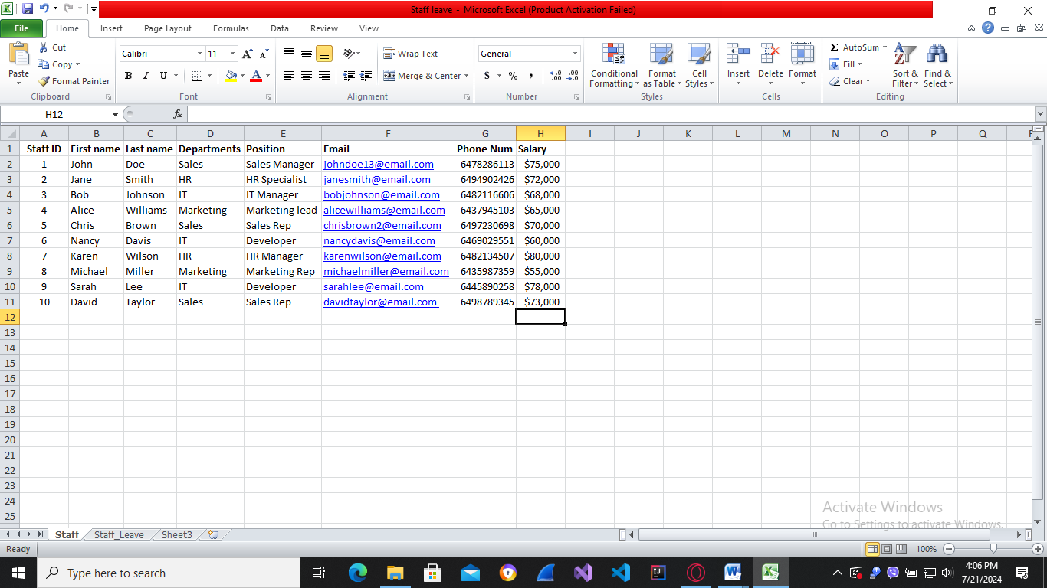
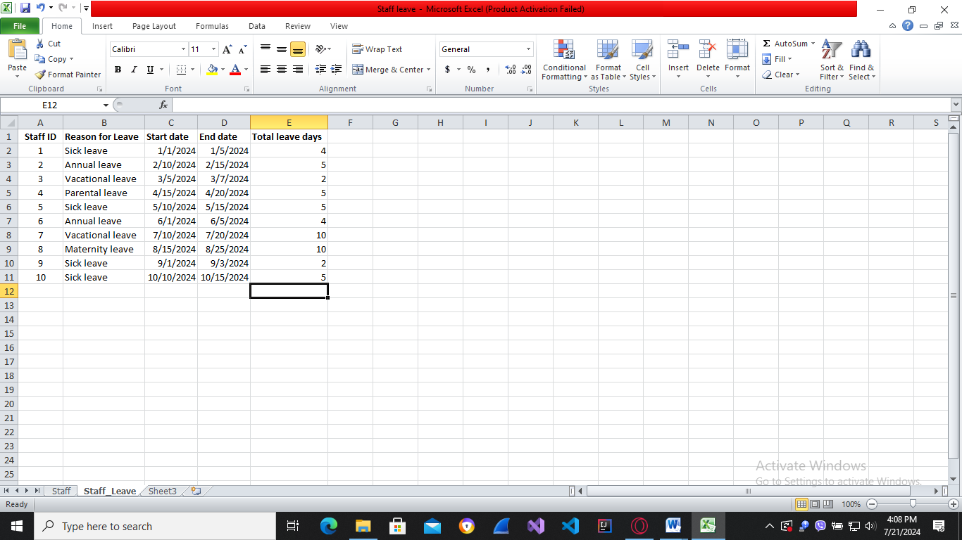
Staff leaves records
b) Mail Merge Instructions
- Open Microsoft Word and go to mailings tab in Microsoft Word.
- Click Start Mail Merge and choose step by step mail merge wizard.
- Select Letters under document type and click next: Starting document.
- Select Use current document for starting document and click next: Select recipients.
- Select Use an existing list for recipients and click Browse. Choose desired excel spreadsheet that you want to use then click next: Write your letter. (Make sure you have already created excel spreadsheet with correct data and information.)
- You can begin writing your template at this stage.
- Use Address block to mail merge recipients’ addresses.
- Greeting line permit you to write intro greeting speech and recipients’ names.
- Electronic postage is an add-in that permits you to print United States Postal Service acceded to electronic postage onto your mails.
- You can insert Match fields and modify elements from excel spreadsheet in More items.
Click next: Preview your letters to go to next page.
- At this stage, you can preview your final mail merged letters with each recipient and edit recipient list. Click next: Complete merge to go to final stage.
You have completed mail merge. You can print it or edit individual letters if you desire more modifications and adjustments.
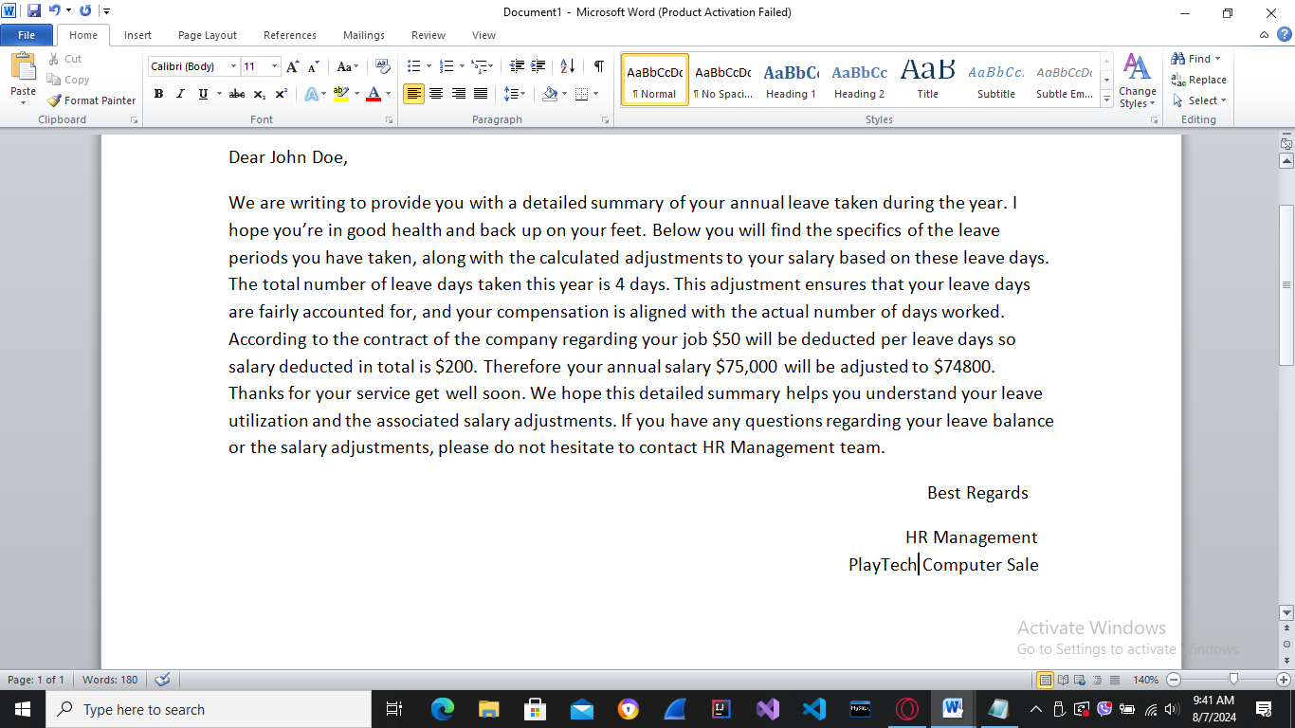
MailMerge Test 1

Mailmerge test 2
Test plan for mail merge
Test No | Test Description | Actual Result | Expected Result | Test Pass
1. | Inspect if recipients are duplicated in mail merge fields | Staffs aren’t duplicated | All staffs and their data are unique in mail merge fields | Yes
2. | Inspect if each staff and their respective leave days are matched | Each staff is correctly displayed with their respective total leave days. | Leave days and leave staffs are correctly paired | Yes
3. | Examine if deducted salaries are correctly calculated for every staff | To deduct salary is correctly calculated and shown for each staff | To deduct salary has correct values for every staff | Yes

Task 4 Advanced features and functions of Microsoft Excel
- 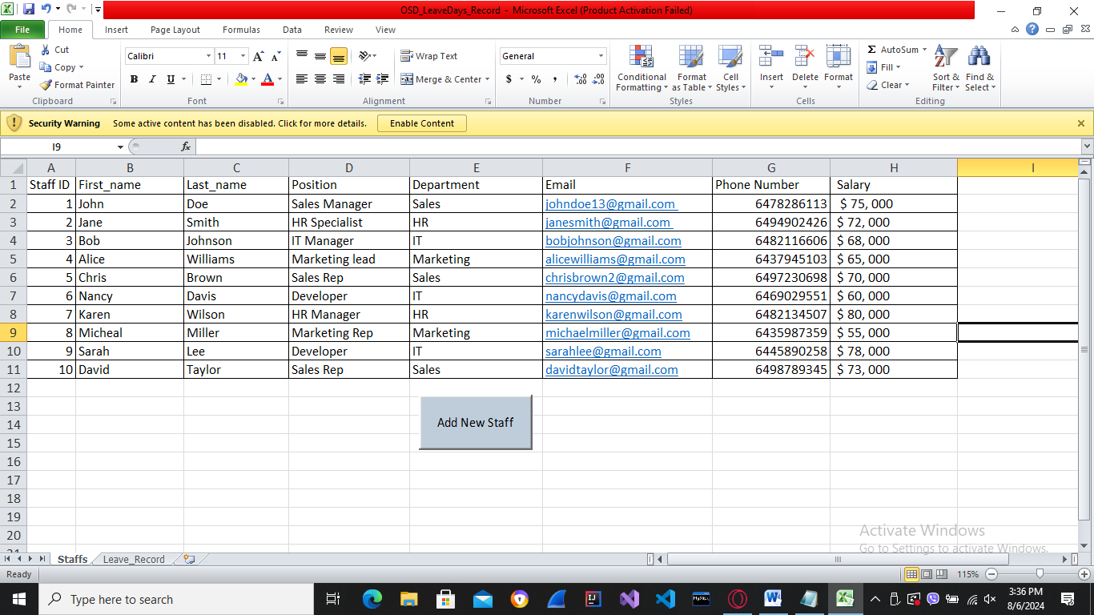

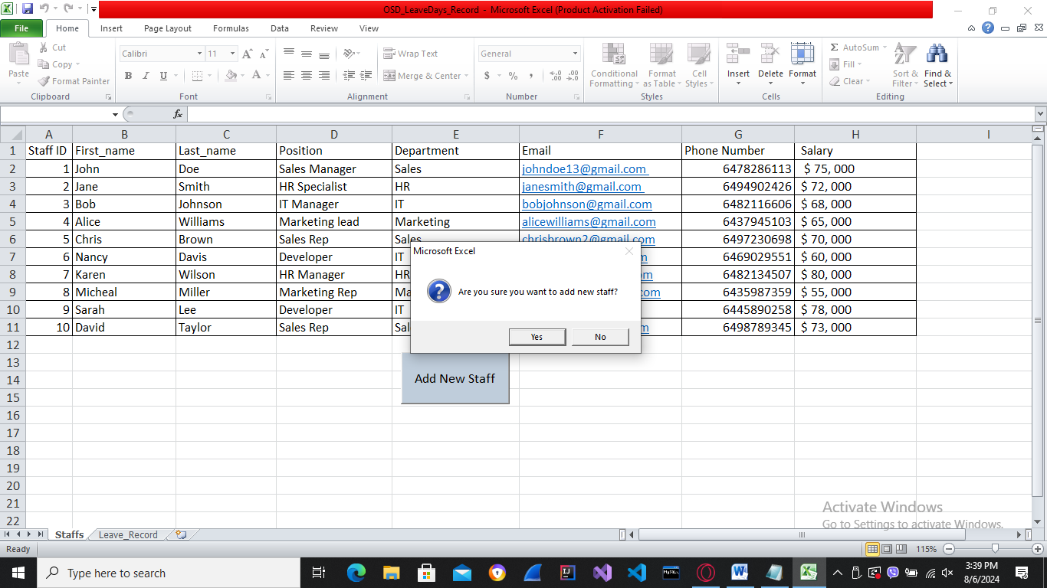
Press Add New Staff button to add new Staff and their information. Click Yes to confirm
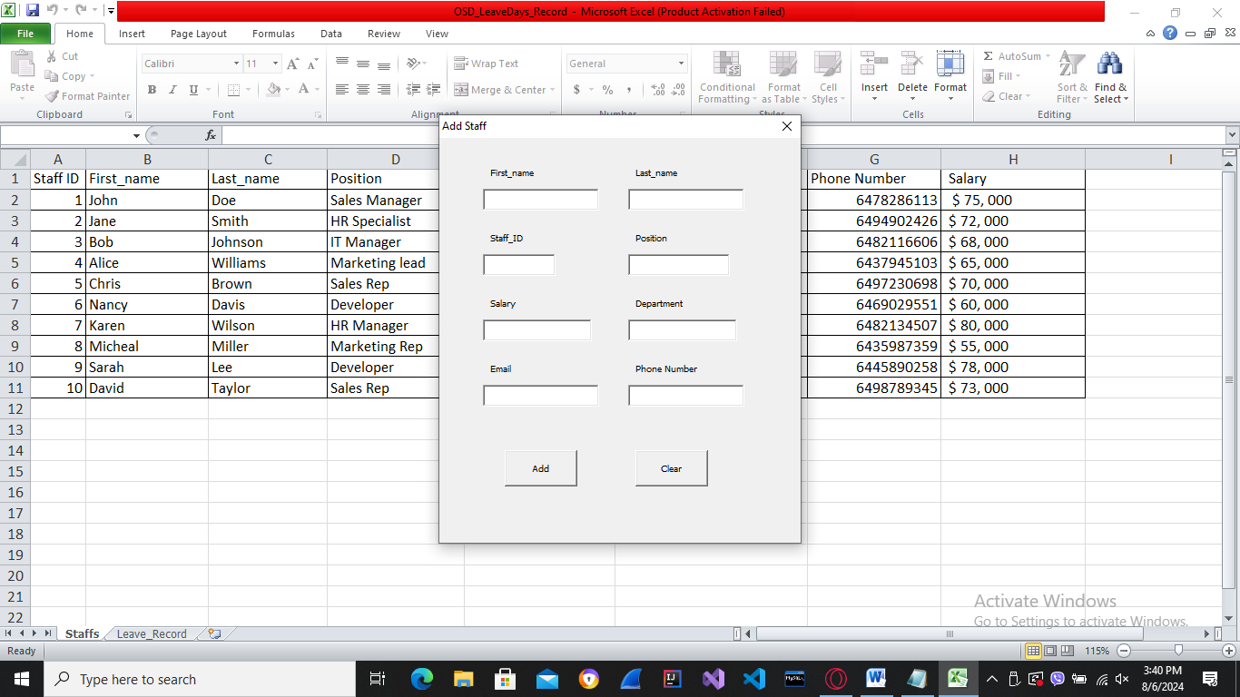
Insert data into those textboxes
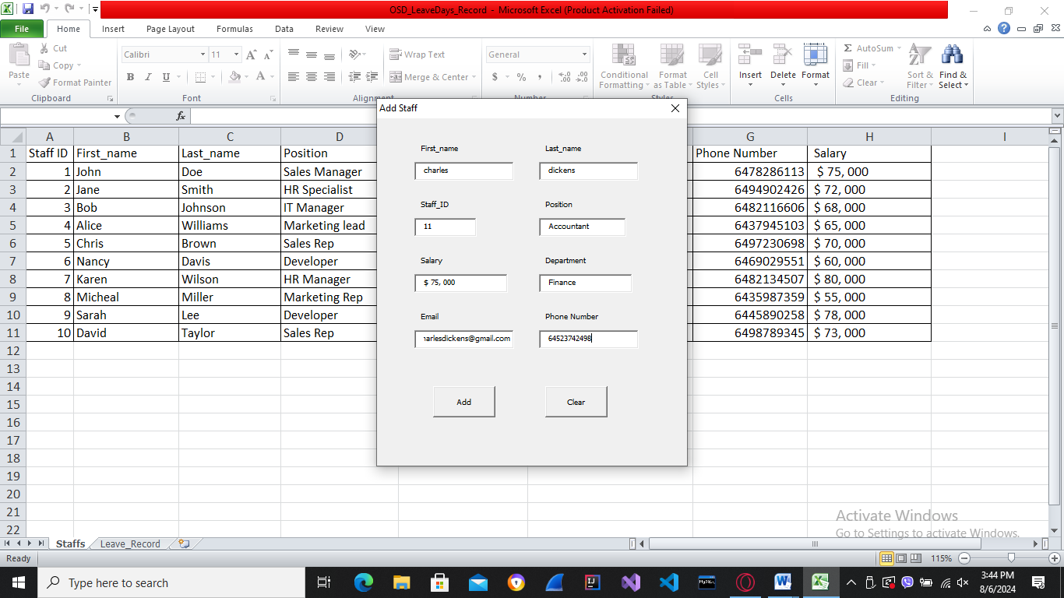
Click add to add the new staff into the table
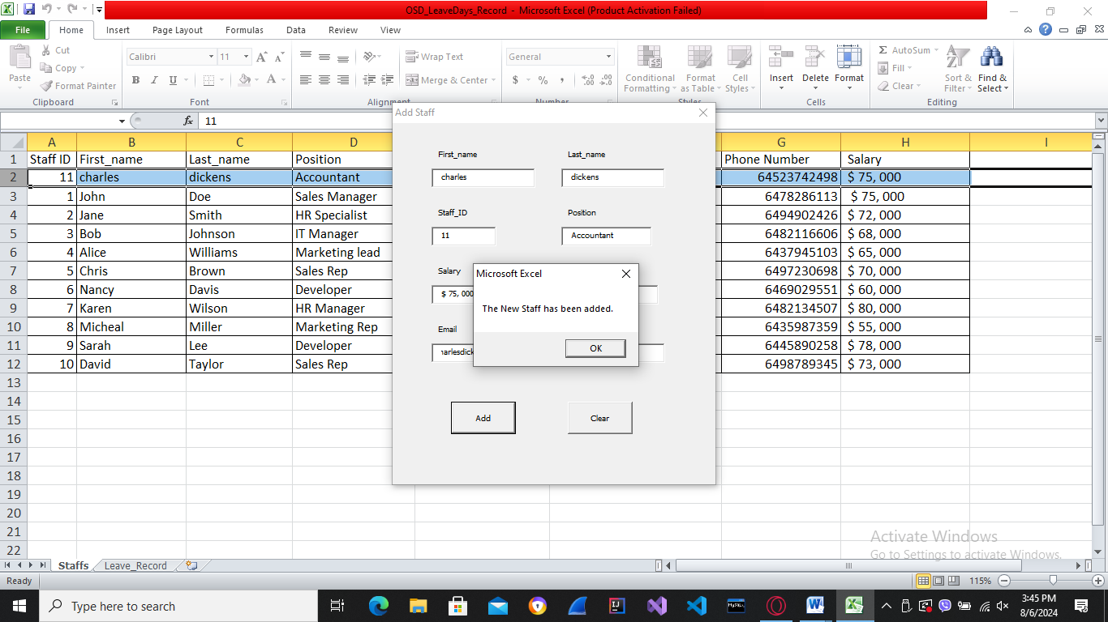
Click ok to confirm
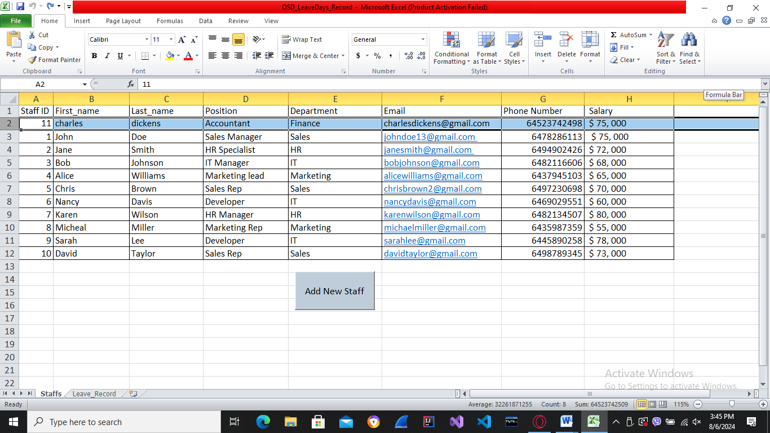
New staff added
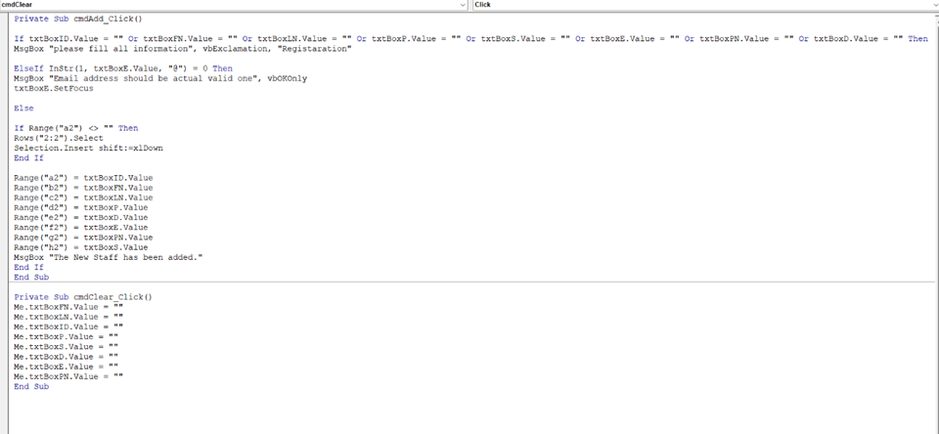
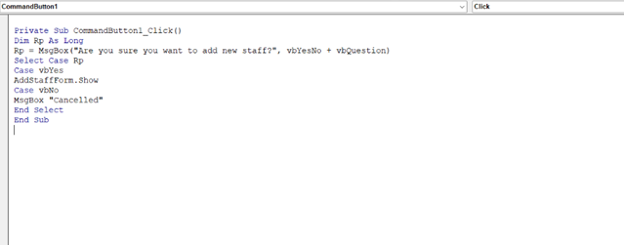
VB Code for adding staff and opening form
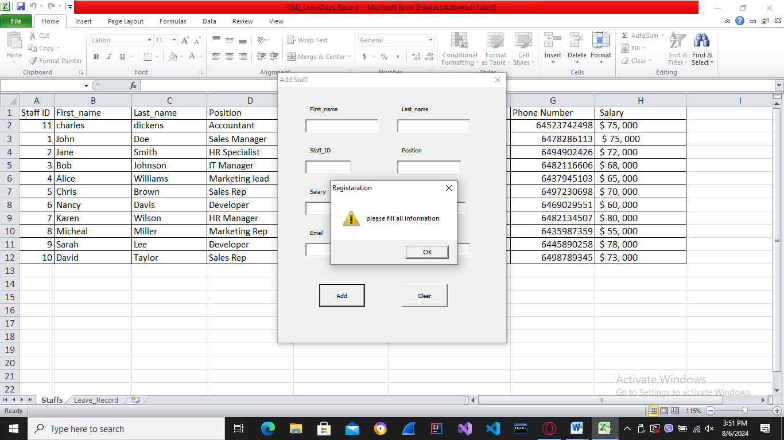
Validation, when empty textboxes
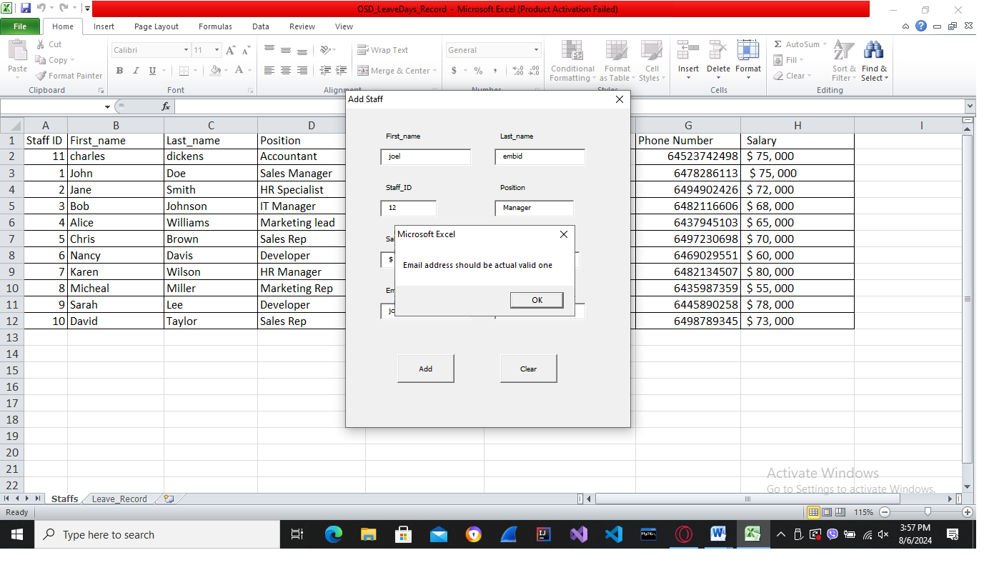
If email is invalid
b) When designing forms, whether in an Excel spreadsheet or any other context, it's crucial to consider basic design and usability principles to ensure that the form is user-friendly, efficient, and effective.
Clarity and Simplicity
Clear Labels: Each column header (e.g., "Staff ID", "First Name", "Last Name") is clearly labeled to ensure users immediately understand what data should be entered in each column. Simple Layout: The form is designed with a straightforward grid layout, which is familiar to most users and easy to navigate.
Consistency
Consistent Formatting: The format of dates, text, and numerical values is consistent throughout the form to avoid confusion. For example, all dates follow the "YYYY-MM-DD" format. Uniform Structure Both the "Staff" and "Staff Leave" sheets follow a similar structure, with the most critical identifiers (e.g. "Staff ID") placed in the same location to ensure consistency across different forms.
Ease of Data Entry
Pre-defined Fields: Each field has a specific purpose, reducing the chances of incorrect data entry. For example, "Leave Type" uses predefined types like "Annual Leave", "Sick Leave", etc. Data Validation: Where possible, data validation rules can be added to ensure that entries meet specific criteria (e.g. dates must be in a valid date format, email addresses must contain an "@" symbol).
Error Prevention
Input Constraints: Constraints are set to prevent users from entering invalid data, such as limiting the "Staff ID" to numerical values only. Calculated Fields: The "Number of Days" field in the "Staff Leave" sheet is a calculated field, reducing the risk of manual calculation errors and ensuring accuracy.
Accessibility
Readable Fonts: The use of standard, readable fonts (like Arial or Calibri) ensures that text is easy to read for all users. Appropriate Colors: The design avoids using colors that can be difficult to distinguish for colorblind users. High contrast between text and background ensures readability.
Logical Flow
Logical Grouping: Related fields are grouped logically. For example, all personal information fields (e.g., "First Name", "Last Name") are grouped together. Sequential Order: Fields are arranged in a logical order that mirrors the way users think about the data, from general information (e.g., "Staff ID") to specific details (e.g. "Email").
User Feedback
Immediate Feedback: Calculated fields, like "Number of Days" in the "Staff Leave" sheet, provide immediate feedback to users, helping them understand the result of their data entries. Error Messages: If implementing data validation, clear and instructive error messages should be provided to guide users on how to correct their entries.
Efficiency
Auto fill and Drop-downs: Where applicable, features like auto fill and drop-down menus can be used to speed up data entry and reduce errors. Shortcuts and Formulas: Leveraging Excel’s formulas and shortcuts can enhance efficiency for power users.
Scalability
Expandable Layout: The form design allows for easy addition of new records without disrupting the existing structure. Users can add new rows for additional staff or leave periods without needing to modify the form layout.
Integration Readiness
Unique Identifiers: The inclusion of unique identifiers like "Staff ID" ensures that data can be easily merged and integrated with other systems, such as Mail Merge tools in Microsoft Word.
By adhering to these principles, the form design in Excel not only facilitates easy and accurate data entry but also enhances the overall user experience, making the system more reliable and efficient for end-users. Using macros to create interactive forms in Excel can offer a variety of benefits and challenges.
Merits of Using Macros for Interactive Forms
Automation of Repetitive Tasks
Merit: Macros can automate repetitive tasks, such as data entry, validation, and processing, saving time and reducing the risk of manual errors. Example: A macro can be programmed to automatically format newly entered data, check for duplicates, or generate summary reports.
Enhanced Functionality Merit: Macros can extend the functionality of Excel beyond its built-in capabilities, allowing for custom forms, dynamic data handling, and complex calculations. Example: You can create buttons that trigger specific actions, such as submitting data, clearing fields, or navigating between different parts of the form.
Improved User Experience Merit: Interactive forms with macros can provide a more intuitive and user-friendly experience. Features like automated prompts, conditional formatting, and error messages can guide users through the form. Example: A macro can display a message box if a required field is left blank or if invalid data is entered.
Consistency and Accuracy Merit: Macros ensure that data is processed consistently according to predefined rules, which helps maintain data integrity and accuracy. Example: A macro can enforce specific data entry formats, such as date formats or numerical ranges, ensuring consistency across the dataset.
Time Efficiency Merit: By automating complex or time-consuming tasks, macros can significantly improve efficiency and productivity. Example: Macros can automate the generation of reports or summaries based on the entered data, which would otherwise take a considerable amount of time if done manually.
Demerits of Using Macros for Interactive Forms
Complexity in Development and Maintenance Demerit: Developing and maintaining macros can be complex, especially for users who are not familiar with VBA (Visual Basic for Applications). This can lead to a reliance on specialized knowledge. Example: Creating a macro to handle complex validation rules or dynamic form behavior requires coding skills, which might not be available in all organizations.
Security Risks Demerit: Macros can pose security risks, as malicious macros can be used to execute harmful code. Users need to be cautious when enabling macros, especially from untrusted sources. Example: Opening a workbook with macros from an unknown source can expose the system to viruses or malicious scripts.
Compatibility Issues Demerit: Macros may not be compatible with all versions of Excel or other spreadsheet applications, leading to potential issues when sharing files. Example: Macros created in a newer version of Excel might not work correctly in older versions, or they might not function at all in alternative spreadsheet software like Google Sheets.
Performance Concerns Demerit: Macros can slow down the performance of Excel, especially if they involve complex calculations or are poorly optimized. Example: A macro that processes large datasets or performs extensive computations can cause Excel to become sluggish or unresponsive.
Debugging and Error Handling Demerit: Debugging macros can be challenging, particularly for those who are not experienced with VBA. Errors in macros can lead to unexpected results or application crashes. Example: A small mistake in the macro code can result in data corruption or loss, and troubleshooting such issues can be time-consuming.
Balancing the Merits and Demerits
To effectively use macros for interactive forms while mitigating the associated risks, consider the following strategies:
Training and Documentation-provide training for users on how to create, use, and troubleshoot macros. Maintain thorough documentation for all macros to facilitate maintenance and updates.
Security Best Practices-implement security best practices, such as digitally signing macros, using trusted sources, and educating users about the risks of enabling macros from unknown sources.
Testing and Validation-rigorously test macros in different scenarios to ensure they work as intended and do not introduce errors or performance issues. Validate the results to ensure accuracy.
Optimization-optimize macros for performance by minimizing the use of resource-intensive operations and avoiding unnecessary loops or calculations.
Compatibility Considerations-ensure those macros are compatible with the versions of Excel used by your organization. If necessary, provide guidelines for users on how to enable and use macros in different environments.
By carefully balancing the advantages and disadvantages, you can leverage macros to enhance the functionality and usability of interactive forms in Excel while minimizing potential risks and challenges.

