Feedforward Neural Network for Aircraft Pitch Prediction

1. Overview / Description
This project builds a feedforward neural network (FFNN) to predict aircraft pitch using flight dynamics data. The dataset includes input features like altitude, indicated airspeed, and roll. The model’s objective is to learn the relationship between these inputs and the pitch using both single and multi-layer neural network architectures.

2. Methodology / Strategy
The modeling pipeline consisted of:
- Feature selection: altitude, indicated_airspeed, roll
- Z-score normalization for both input features and target (pitch)
- Two-layer FFNN architecture using numpy
- Activation functions tested: ReLU, Tanh, Sigmoid
- Training with both batch and stochastic gradient descent
- Evaluation using MSE, RMSE, MAE, and R² Score

3. Implementation
Implementation was done using Python in Google Colab. The model is built from scratch using NumPy. The neural network class includes forward and backward propagation, early stopping, and saving parameters. Multiple learning strategies, activations, and hidden layer sizes were supported and tested.

4. Results
Final R² Score: 44.73%
Best results from Tanh activation using stochastic gradient descent with 2 hidden layers (32, 16).
Metrics:
- Tanh (MSE=0.4812, Iteration=66)
- ReLU (MSE=0.5238, Iteration=94)
- Sigmoid (MSE=0.5174, Iteration=418)
- RMSE: 2.486
- MAE: 1.475
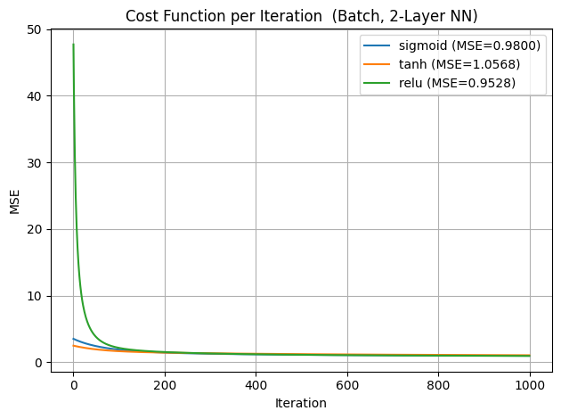
Figure 1: Batch Training MSE per Iteration
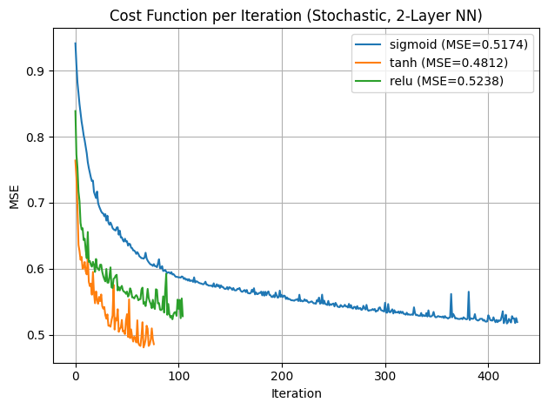
Figure 2: Stochastic Training MSE per Iteration
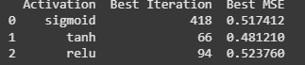
Figure 3: MSE Summary Table
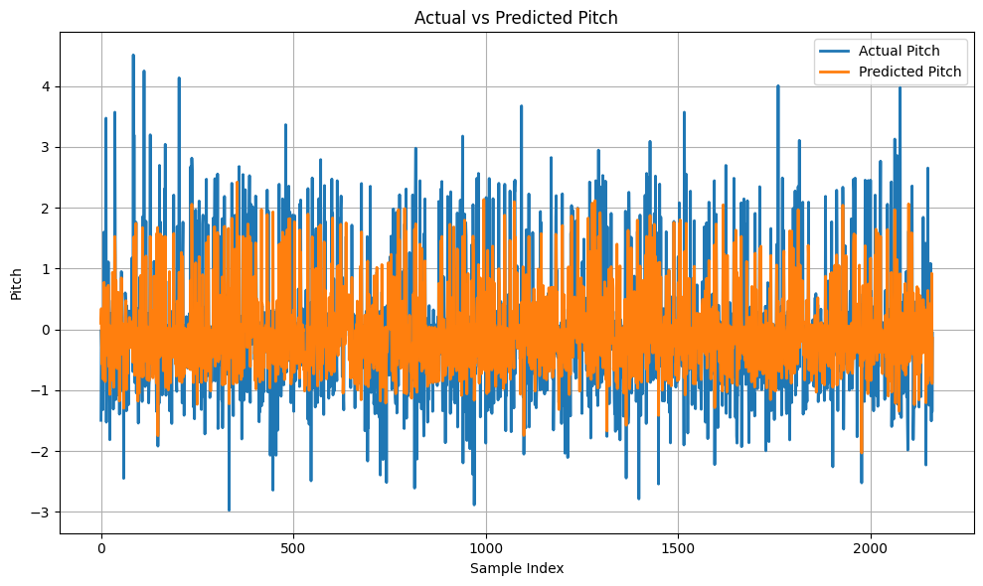
Figure 4: Actual vs Predicted Pitch (Line Graph)

Figure 5: R² Score Display

5. Discussion
Stochastic gradient descent led to faster convergence with better performance (lower MSE) compared to batch training. Tanh activation was most effective in learning the pitch patterns, while ReLU showed more oscillation in stochastic mode. The model captures general trends well, but shows underfitting on outlier pitch values.

6. Conclusion
A 2-layer FFNN using Tanh and stochastic learning gave the best performance. Future improvements could include deeper architectures, alternative optimizers like Adam, and richer features from flight logs. Despite moderate accuracy (R² ≈ 45%), the model demonstrates the feasibility of neural network-based pitch prediction.

7. References
- DATA 527 Lecture Slides
- Scikit-learn Documentation
- NumPy & Matplotlib Libraries
- Predictive Modeling Course Textbook

