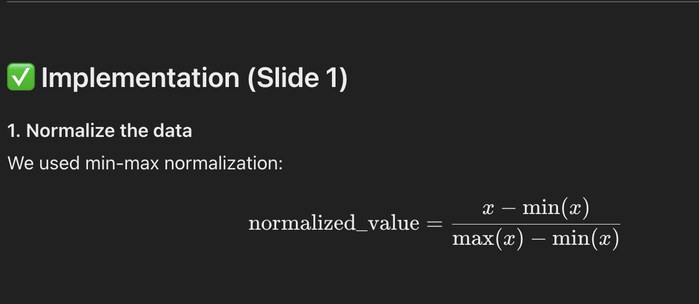
First, we started by normalizing our data using min-max scaling. This ensures that all variables are on the same scale, which is important for gradient descent to work properly.

2. Compute Mean Squared Error (MSE)
def compute_mse(X, y, theta):
predictions = X.dot(theta)
mse = np.mean((predictions - y) ** 2)
return mse
This function calculates the average squared difference between actual and predicted values. it helps us track how well the model is learning.

3. Gradient Descent Function Setup:
def gradient_descent(X, y, learning_rate, num_iterations):
m, n = X.shape
theta = np.zeros(n)

4. Gradient Descent Loop:
for i in range(num_iterations):
predictions = X.dot(theta)
errors = predictions - y
gradients = (2/m) * X.T.dot(errors)
theta -= learning_rate * gradients
mse = compute_mse(X, y, theta)

We then defined our gradient descent function, starting by initializing our parameter values to zero.
In the gradient descent loop, for each iteration, we computed predictions, calculated the error between predicted and actual values, computed the gradients, and updated our parameters using the learning rate. At every step, we also recorded the MSE so we could track the model's improvement.
5. Model Training Call:
theta, mse_log = gradient_descent(X, y, learning_rate, num_iterations)
After running this, theta holds our optimized model parameters and mse_log tracks how error decreases over iterations.

- With 1,000 iterations and a learning rate of 0.01, we achieved our best R² value of around 0.62, indicating a strong model fit.
- 1000 iterations and 0.001 learning rate, R² 0.35; This relatively low R² indicates that the model was not able to explain much of the variance in the data.
- Lower learning rates resulted in slower convergence and poorer model accuracy.
- This showed us that tuning hyperparameters like learning rate and iterations is critical.

