UNITY 3D · VIRTUAL ENVIRONMENTS
Virtual Computing Laboratory
An interactive, explorable 3D environment built from an imported
architectural model in Unity
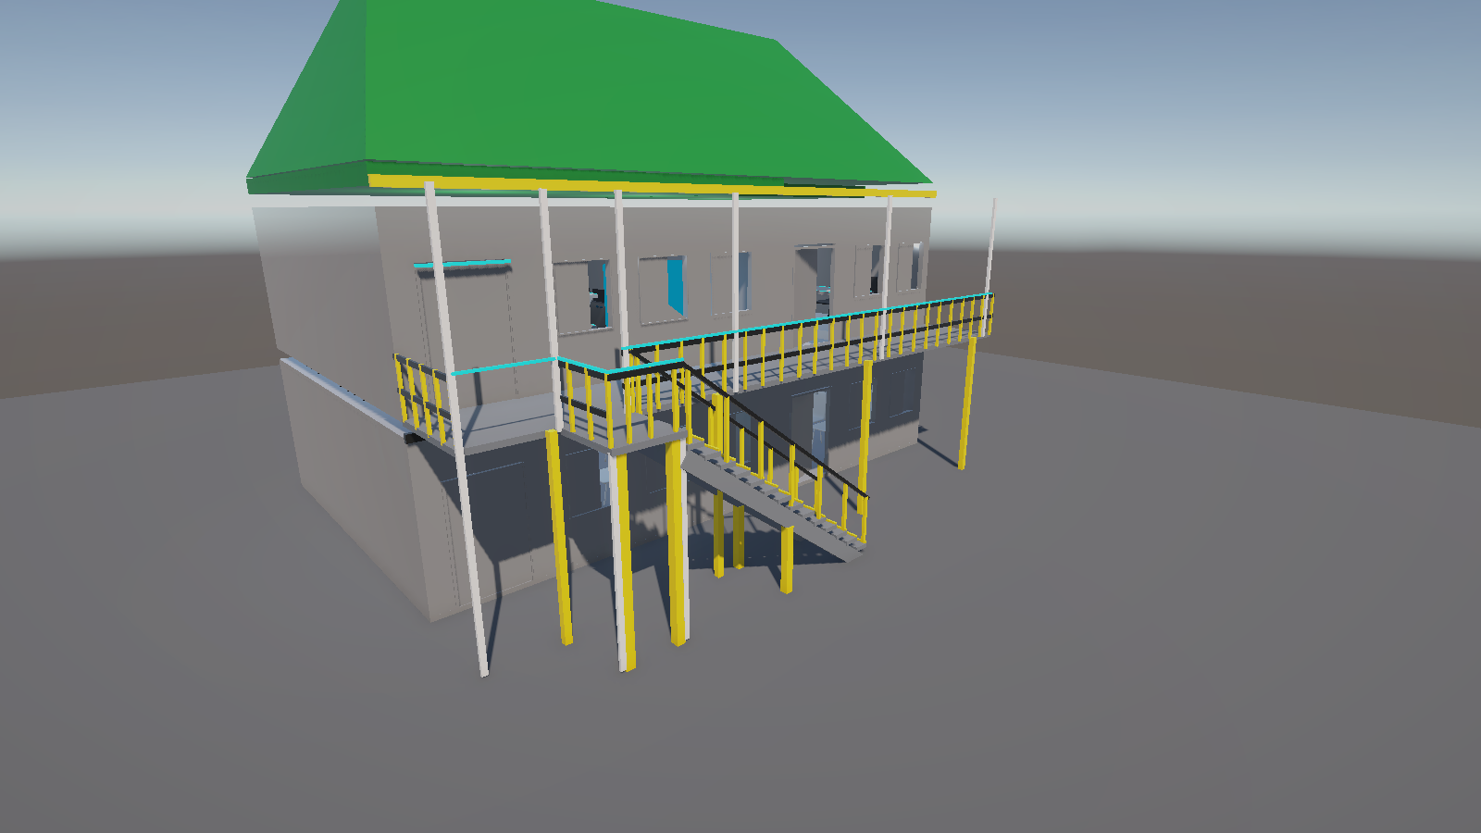
Project preview: the imported two-storey building from the south-east, showing the green roof, straight external stair, balcony and upper-floor laboratory.

STUDENT | ______________________________
MODULE | Virtual Environments
DATE | 26 October 2026
SCENE | Assets/Scenes/SampleScene.unity

Contents
1. Introduction
2. Environment overview
3. Scene construction
4. Collision design
5. Interaction systems
6. Controls
7. Testing and verification
8. Challenges and solutions
9. Conclusion
A. Appendix A — Project structure and scripts

1. Introduction
This report documents the construction of an interactive virtual computing laboratory in Unity 6. The starting point was a two-storey architectural model exported from 3ds Max as three FBX modules. The model was retained as the centrepiece of the scene; only the supplementary geometry needed to make it playable (the straight external stair, balcony floor, invisible collision volumes and interaction anchors) was added. The result is a third-person experience in which the player can walk through the upper-floor computer lab, open and close the balcony door with an F-key prompt, use a workstation and reach the exterior via the new stair.
Imported model preserved. The building shell, doors and balcony railings come from the 3ds Max export; the lab surfaces follow a reference-led green, off-white, slate and charcoal palette.
Interactive systems. Character controller, orbit camera, F-key balcony door, workstation interaction, straight external stair and animated ceiling fan.
Verified in Play Mode. Movement, stair ascent/descent, collision, door opening/closing, workstation proximity/active state, display pulse and animation were tested in the Unity Editor.

The scene is intentionally compact and self-contained so that it can be opened and played without additional packages or external assets. All gameplay scripts use the new Input System package that is already configured in the project.

1.1 Objectives
- Import the supplied building and place it at a realistic, usable scale without replacing it with primitives.
- Provide a walkable laboratory with reliable collision and a third-person camera.
- Add an interactive animated balcony door and retain the continuously animated ceiling fan.
- Add a proximity-based interactive workstation with on-screen feedback.
- Organise the hierarchy, apply lighting and post-processing, and verify the result in Play Mode.

2. Environment overview
The building is a two-storey structure with an open ground floor and a computer laboratory on the upper floor. Ten workstation desks with twenty chairs are arranged in two rows of four, with two additional desks against the east wall. The front facade contains a double doorway onto a balcony; one leaf (PivotDoor001) is driven by DoorController and is opened or closed with an F-key prompt. A roof mass caps the building and a parapet surrounds the roof terrace. A single straight external flight descends west from a compact landing at the balcony's stair entrance, with slate treads, safety-yellow posts and black handrails. The cover image shows the completed building from the south-east.

2.1 Key dimensions
Item | Value | Notes
Source model | 3 FBX modules | bottom.fbx (ground floor), top.fbx (upper storey, 10 workstations, doors), roof.fbx
Model scale | 10 units | Uniform scale on the building root; door leaf ≈ 2.1 m high
Storey height | ≈ 3.2 m | Upper lab floor at y = 3.0 m; balcony at y = 3.3 m
Laboratory | ≈ 13.2 m × 8.0 m | 10 workstation desks and 20 chairs; two rows of four plus two east-wall desks.
Roof | y = 6.50–10.45 m | Roof mass and parapet; green fascia at the lower edge.
Player spawn | (0.2, 3.02, 0.1) | Upper lab, facing the interior.
External stair | 14 treads in 1 straight flight, 1.30 m wide | 15 risers at 0.22 m rise and 0.30 m run; compact landing at the stair entrance; yellow posts and black handrails.

The ground floor is fully modelled but has no internal stair or lift in the source file, so it is treated as visual context rather than a playable level. The playable experience begins on the upper floor, where the laboratory and balcony are located. The straight external stair added at the balcony's west-facing stair entrance provides a visible route between the balcony and the exterior ground.

3. Scene construction

3.1 Import and scale calibration
The three FBX modules were imported under Assets/Building and parented to an empty Building object at the world origin. A uniform scale of 10 was applied to the root. The value was calibrated from the door leaf: at scale 10 its height is approximately 2.1 m, which is consistent with a real door, and the resulting storey height is approximately 3.2 m. A uniform scale also avoids the shearing and distortion that would occur if each imported transform were scaled non-uniformly.
The workstation desks sit at y ≈ 3.02 m, approximately 2 cm above the collision floor, and the door threshold is at y ≈ 3.29 m. The 0.30 m step from the laboratory to the balcony is intentional: the balcony floor was raised to 3.3 m to align with the bottom of the door leaves and the railings in the source model.

3.2 Scene hierarchy
The scene is grouped by responsibility so that it remains readable in the Hierarchy window:
Group | Contents | Purpose
Main Camera | Camera + ThirdPersonCamera | Follows the player; orbit and collision
Global Volume | SampleSceneProfile | Tonemapping, bloom and vignette
Environment / Building | GroundFloor, UpperFloor, Roof | The imported 3ds Max modules
Environment / Balcony | 2 floor slabs, 8 colliders | Supplementary floor and six rail colliders.
Environment / BuildingCollision | 8 box colliders | Clean, invisible collision shell.
Gameplay / Doors | LabDoorTrigger, DoorController | F-key balcony door.
Gameplay / InteractionObjects | Workstation, WorkstationDisplay | E interaction and cyan display.
Gameplay / AnimatedObjects | CeilingFan (Hub, Rod, FanBlades) | Continuous rotation.
Gameplay / Player | Body, Visor | Third-person avatar
Lighting | Directional Light, LabLight1–3, display accent | Cool-white sun and interior fill, plus cyan display pool.
Environment / ExteriorStairs | 54 renderers, 42 colliders | Straight stair: 14 treads, single flight, yellow posts, black handrails and 28 invisible side guards.
Environment / ExteriorGround | Exterior ground plane | Ground-floor context.
Environment / LabAccents | 24 accent renderers + display light | Cyan accent strips and display pool.
Environment / ExteriorDetails | 6 renderers | Roof fascia, facade divider and four balcony supports.

3.3 Materials and supplementary geometry
The building shell and laboratory furniture were re-materialed with a palette drawn from the 3ds reference: green roof, off-white walls, slate exterior decks and stairs, yellow rail posts and black handrails. Imported door, window and selected fixture materials are retained. The final look uses the following palette and supporting materials:
- LabWall / LabDesk / LabChair — off-white walls, light-grey desk tops and black chairs.
- RoofGreen / BalconyFloor / StairSlate — green roof, slate balcony deck and slate stair treads and stringers.
- SafetyYellow / CharcoalTrim / ExteriorGround — safety-yellow vertical posts and balcony supports, black handrails and trim, and medium-grey exterior ground.
- AccentCyan / LabDisplay / PlayerBody / PlayerAccent — cyan accent strips and wall display, plus the avatar body and visor.
The balcony floor is built from two thin boxes (13.2 m × 1.9 m and 1.22 m × 1.30 m) that follow the footprint of the railings, plus eight box colliders for the two floor slabs and six railing runs. The workstation display is a 2.8 m × 1.6 m quad on a clear section of the front wall, facing the room. It is double-sided and uses a URP Unlit cyan material so that it remains legible in the interior lighting; the screen renderer is also tinted at runtime by WorkstationInteraction. A thin yellow roof fascia, a black facade divider and four yellow balcony supports complete the exterior composition. The compact stairhead landing occupies the front opening, and the straight stair is built as one connected assembly that descends west along the facade.
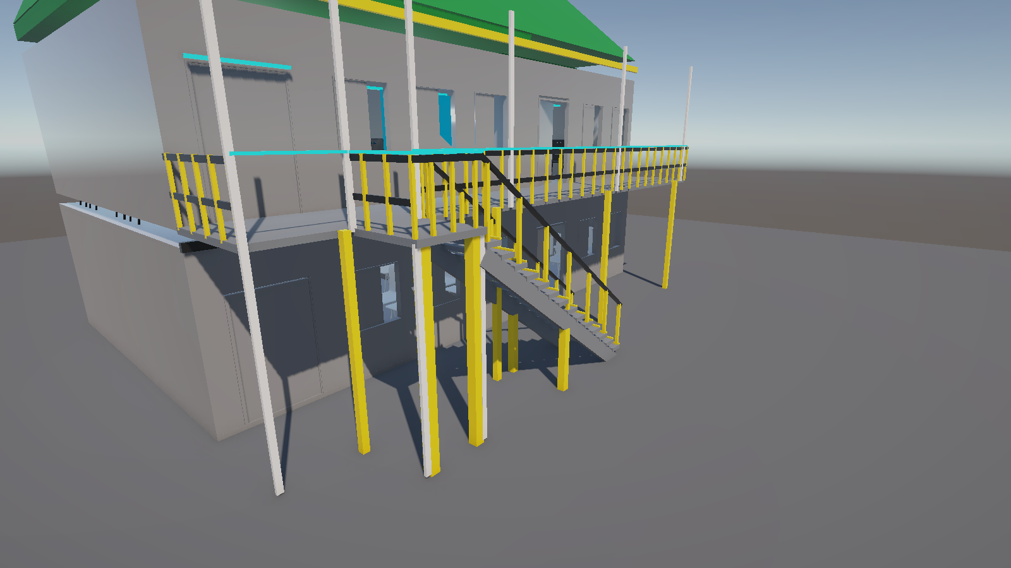
Figure 1. Straight external staircase and front entrance. The stair descends west from the compact balcony landing in a single straight flight, with slate treads, yellow posts and black handrails.

3.4 Lighting and post-processing
The laboratory is lit by a cool-white directional sun (intensity 2.4, soft shadows, Euler 50°/210°/0°) and three cool point lights (intensity 5.5, range 11 m) positioned along the ceiling. The directional light provides the exterior key light and the point lights lift the interior without requiring baked lightmaps. A display accent light adds a cyan pool above the workstation display. A global Volume applies Neutral tonemapping, bloom (intensity 0.25, threshold 1.0) and a subtle vignette (0.2) to soften the contrast and focus attention on the room. Post-processing is enabled on the Main Camera.
The two screenshots below show the laboratory from the front-wall entrance area and from the rear corner.
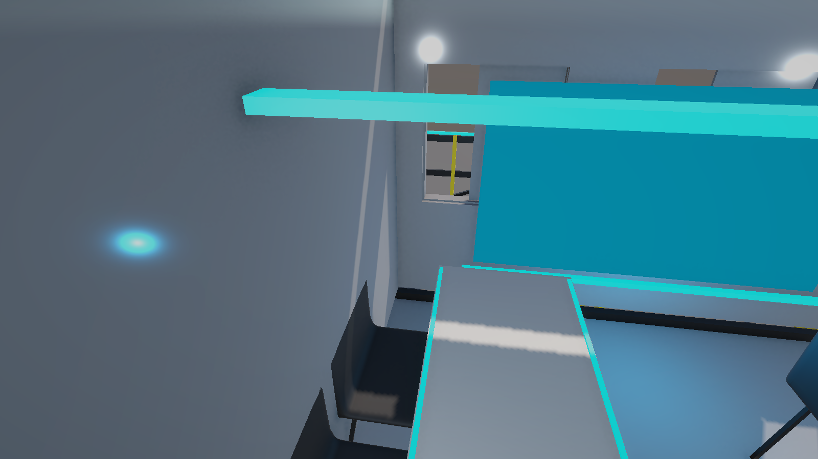
Figure 2. Interior view from the front-wall entrance area: off-white walls, light-grey desk tops, black chairs, workstation rows, cyan ceiling accents and the wall display.
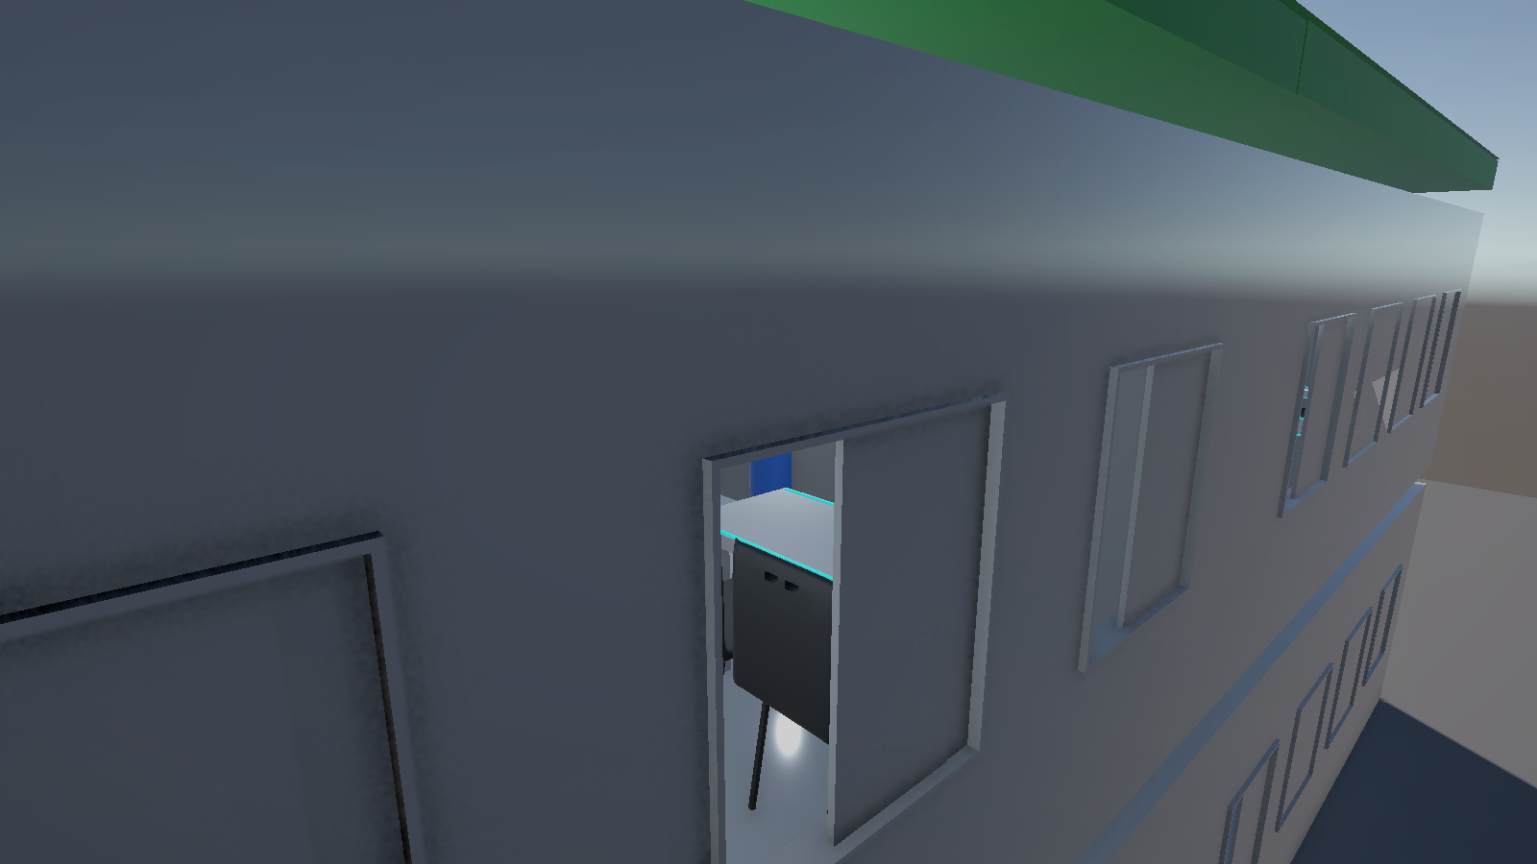
Figure 3. Wide interior view showing the complete workstation layout and the balcony doorway on the right.

4. Collision design
Collision was the most important technical issue in the project. The imported meshes use non-uniform and rotated lossy scales, and several pivots are far from the geometry. MeshColliders generated from those renderers produced phantom surfaces in mid-air and repeated console warnings about Physics.ClosestPoint. They were therefore removed from the imported building objects.
Clean collision was rebuilt with box colliders on an invisible BuildingCollision group:
- Laboratory floor — top face exactly at y = 3.0 m, matching the visible floor.
- Perimeter walls — four boxes enclosing the lab; the front wall is split into two segments around the 1.4 m doorway.
- Door header — a box above the opening so the player cannot walk through the wall above the door.
- Ground — a large box at y = 0 for the exterior/ground-floor context.
- Furniture — a fitted BoxCollider on each of the 10 workstation desks and 20 chairs, generated from their local mesh bounds.
- Door and balcony - a collider on the moving door leaf, two balcony floor colliders and six rail colliders (eight in total). The straight external stair has 14 open tread colliders plus 28 invisible side-guard colliders (42 total).
The CharacterController has a radius of 0.35 m, a height of 1.8 m, a centre at (0, 0.9, 0) and a step offset of 0.35 m. The step offset is deliberately larger than the 0.30 m balcony step and the 0.22 m stair rise, so the player can walk onto the balcony and climb the stair without jumping. The controller also uses a small grounded stick force to keep contact on the small height changes at the door threshold.

5. Interaction systems

5.1 Third-person character controller
ThirdPersonController moves a CharacterController using camera-relative WASD input from the new Input System. Movement speed is 4.5 m/s, gravity is −22 m/s², and the character smoothly turns toward the movement direction with a 0.08 s smoothing time. The controller reads Keyboard.current directly, which is required because the project is configured for the new Input System only.
The avatar is a simple capsule with a visor (Body and Visor children), coloured with the PlayerBody and PlayerAccent materials. The capsule is a visual proxy only; all movement and collision are handled by the CharacterController on the root.

5.2 Orbit camera
ThirdPersonCamera follows a pivot 1.55 m above the player at a distance of 4.5 m. The mouse orbits the camera with a pitch clamp of −15° to 65°, and the camera is smoothed toward its desired position. A sphere cast (radius 0.25 m) pulls the camera in when a wall or desk would otherwise occlude the player. The cursor is locked on start, Escape releases it, and a left click locks it again. The camera field of view is 60°.

5.3 Interactive balcony door
LabDoorTrigger is the door-interaction anchor at the upper-floor doorway. DoorController measures the distance to the player; within 2.6 m it displays a centred [F] prompt and toggles the hinge (PivotDoor001) with a SmoothStep interpolation. The closed hinge rotation is 180° and the open angle is −100°, producing a final local Y rotation of 80°, so the leaf swings outward onto the balcony. The animation lasts 1.0 s. Pressing F again closes the door; the collider on the leaf moves with it.
The door was verified in Play Mode with the player at (4.8, 3.02, 2.8): playerInRange was true, the hinge reached 80°, and the on-screen prompt switched to “[F] Close door”. The door returned to 180° and closed after the test. Figure 4 shows the open doorway.
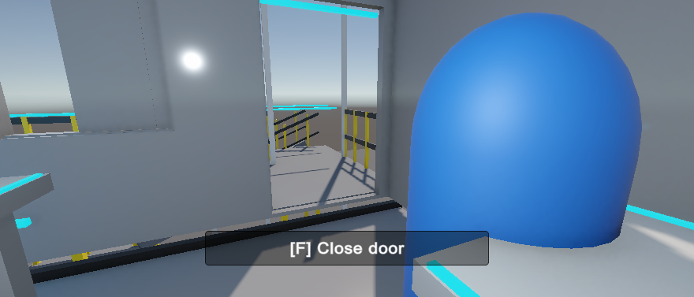
Figure 4. Play Mode: the balcony door held open after pressing F, with the [F] Close door prompt visible.

5.4 Interactive workstation
WorkstationInteraction is attached to the workstation anchor near the player's spawn. It measures the distance to the object tagged Player and, within 2.5 m, displays a centred on-screen prompt built with OnGUI: “[E] Use computer (available)”. Pressing E toggles a session state. While a session is active the prompt changes to “in use”, a confirmation message appears for three seconds, and the assigned workstation display is pulsed between a dark idle cyan and a bright active cyan using a MaterialPropertyBlock. The large wall display provides a clear visual anchor for the interaction.
The interaction was verified by placing the player within range (playerInRange = true) and confirming that sessionActive became true, the prompt switched to the active state and the wall display showed the active pulse. Figure 5 shows the prompt during Play Mode.
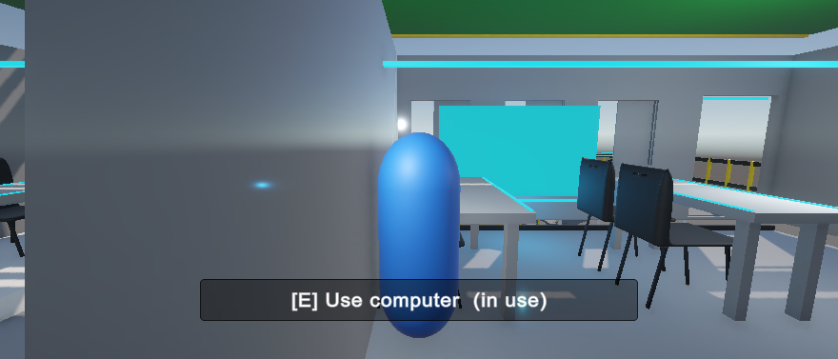
Figure 5. Play Mode: workstation prompt with the active session message visible above it and the cyan wall display pulsing.

5.5 Animated ceiling fan
AnimatedFan rotates the FanBlades transform around its local Y axis at 240° per second. It is a deliberately simple, continuous animation that adds life to the room without requiring an Animator Controller, and it demonstrates that the scene contains both triggered animation (the door) and ambient animation (the fan). The fan hangs from the ceiling at approximately y = 5.45 m.

6. Controls
Input | Action
W / A / S / D | Move relative to the camera
Mouse | Orbit the third-person camera
Left click | Lock the cursor (when released)
Esc | Release the cursor
E | Use / stop using the nearby workstation
F near balcony door | Open / close the balcony door
Walk onto external stair | Climb / descend between the balcony and the exterior ground.

7. Testing and verification
The scene was tested in Play Mode in the Unity Editor. The checks below combine direct state inspection through the editor bridge with in-game observation. The final console read contained no errors or warnings.
Test | Method | Observed result | Status
Scale | Measured the door leaf and storey in world units | Door ≈ 2.1 m; storey ≈ 3.2 m | Pass
Spawn / grounding | Read the player and CharacterController state | Player at (0.2, 3.02, 0.1), grounded = true | Pass
Camera follow | Compared camera position with the player over several frames | Camera followed at ≈ 4.5 m behind and above | Pass
Walking and collision | Walked the character through the lab and onto the balcony | Player crossed the doorway and stood on the balcony floor at y = 3.38 m | Pass
Door opening | Stood within 2.6 m and pressed F | playerInRange = true; hinge 180°→80°; prompt switched to [F] Close door | Pass
Door closing | Pressed F again / left the range | Hinge returned to 180°; door closed | Pass
Workstation proximity | Read playerInRange at the spawn | playerInRange = true within 2.5 m | Pass
Workstation toggle | Sent an E event through the Input System | sessionActive = true; prompt switched to 'in use'; display pulse confirmed | Pass
Ceiling fan | Observed FanBlades local Y rotation over time | Continuous rotation at 240°/s | Pass
Console | Read errors and warnings after the final fixes | 0 entries | Pass
External stair walkability | Ascended and descended the straight flight in Play Mode | Descended from (5.35, 3.36, 6.45) to (0.10, 0.124, 6.45); ascended back to (5.02, 3.38, 6.45); grounded throughout; treads and side guards tested | Pass
Reference palette | Reviewed material assignments and final captures | Green roof on 3 renderers; 72 yellow elements and 10 charcoal trim pieces; 16 slate stair renderers; 10 desks | Pass
Wall display visibility | Confirmed double-sided material and assigned screenRenderer | Display visible; active pulse confirmed | Pass

A note on automated input: the Input System only receives operating-system key events while the Unity Editor has focus. For the automated checks Application.runInBackground was enabled and player and session state were inspected through the editor bridge. This is a testing detail only; playing the scene normally in the Editor requires no special setup.

8. Challenges and solutions

8.1 Phantom collision from imported mesh colliders
The imported meshes carry non-uniform, rotated lossy scales, and some pivots are far from their geometry. MeshColliders built from these renderers produced invisible collision surfaces in the middle of the room and repeated ClosestPoint warnings. The solution was to remove those MeshColliders and build a clean box-collider shell on a dedicated BuildingCollision group. The visual model is untouched, and collision is now predictable.

8.2 Missing balcony floor
The source model contains balcony railings and door leaves but no floor slab or usable external route. Two thin floor boxes were added at y = 3.3 m to match the door threshold, together with invisible rail colliders. A compact stairhead landing (1.22 m × 1.30 m) was placed in the existing front opening, and a straight external stair was then built from primitives: 14 open slate treads at 0.22 m rise and 0.30 m run in a single 1.30 m wide flight descending west along the facade. Fifteen risers connect the balcony at y = 3.30 m to the exterior ground. Yellow posts, black handrails, two stringers and four supports complete one connected assembly, and 28 invisible side-guard colliders keep the player on the treads. Unity does not allow children of imported prefab instances to be reparented, so the stair parts were aligned in world space and kept outside the prefab hierarchy. The stair was tested in both directions in Play Mode; descent ended at y = 0.124 and ascent returned to y = 3.38, grounded throughout. The 0.30 m balcony step remains comfortably within the controller's 0.35 m step offset.

8.3 Scale and input configuration
The 3ds Max export had no explicit unit metadata, so the scale was calibrated against the door and the storey height rather than guessed. The project is also configured to use the new Input System only; all player and camera input therefore uses Keyboard.current and Mouse.current. Using the legacy Input class would throw at runtime in this configuration.

8.4 Editor focus during automated tests
When the Unity Editor loses focus, Play Mode can stop advancing frames and the Input System stops receiving hardware input. This initially made the door and workstation appear unresponsive during automated testing. Enabling Application.runInBackground resolved it; it does not affect normal play in a focused editor or a built player.

9. Conclusion
The project delivers a complete, playable virtual computing laboratory built around the supplied 3D model. The imported building now has a reference-led green roof, off-white walls, slate exterior surfaces, yellow rail posts and black handrails, and contains ten workstations with twenty chairs, a cyan wall display and a straight external stair. The player can walk through the space with a responsive third-person controller, open and close the balcony door with F, climb between the balcony and the exterior ground, and start or stop a workstation session with E. Two forms of animation are present: the interactive balcony door and the continuously rotating ceiling fan.
All core requirements were verified in Play Mode, and the final scene contains no console errors or warnings. The main technical risk — unreliable collision from the imported meshes — was resolved with a purpose-built box-collider shell, which also makes the scene easier to extend.
Future work could add a ground-floor fit-out and lift, audio ambience, a start menu and settings panel, additional interactable workstations, and static batching or occlusion culling for the large furniture set.

Appendix A — Project structure and scripts

A.1 Project structure
- Assets/Building/ — bottom.fbx, top.fbx and roof.fbx, the imported 3ds Max modules.
- Assets/Materials/ — LabWall, LabDesk, LabChair, RoofGreen, StairSlate, SafetyYellow, CharcoalTrim, BalconyFloor, ExteriorGround, AccentCyan, LabDisplay, PlayerAccent, PlayerBody and FanMaterial.
- Assets/Scenes/SampleScene.unity — the complete playable scene.
- Assets/Scripts/ — the five runtime scripts listed below.
- Assets/Screenshots/ — the final exterior, stair, interior and Play Mode images used in this report.

A.2 Runtime scripts
Script | Responsibility
ThirdPersonController.cs | Camera-relative WASD movement, smooth turning, gravity and grounding on a CharacterController.
ThirdPersonCamera.cs | Mouse orbit, pitch clamping, cursor lock and sphere-cast collision avoidance.
DoorController.cs | F-key proximity detection and SmoothStep hinge rotation for the balcony door.
WorkstationInteraction.cs | Proximity detection, the [E] prompt, session toggle and monitor colour pulse.
AnimatedFan.cs | Continuous local-axis rotation for the ceiling fan blades.

A.3 Screenshot index
File | View
exterior_reference.png | Exterior from the south-east with green roof and straight stair.
stairs_reference.png | The straight external stair and compact stairhead landing at the balcony opening.
lab_entrance_reference.png | Off-white front wall, cyan display and light-grey/black workstation rows.
lab_interior_reference.png | Wide view of the complete workstation layout.
lab_door_open_reference.png | Play Mode: balcony door open with [F] Close door prompt.
lab_workstation_prompt_reference.png | Play Mode: workstation prompt, active session and pulsing display.

