THE COPPERBELT UNIVERSITY
SCHOOL OF INFORMATION AND COMMUNICATION TECHNOLOGY
COMPUTER SCIENCE DEPARTMENT | CS 400: PROJECT SEMINARS
CHAPTER 5
IMPLEMENTATION
A Sentiment Analysis Prototype for Zambian Green Energy Discourse on Social Media
Submitted by
Mulenga Musamba | Student ID: 22110887
Supervisor: Dr. George Mufungulwa
August 2026

Chapter Contents
Section | Title
5.1 | Introduction
5.2 | System Implementation
5.2.1 | Development and Deployment Setup
5.2.2 | Software and Hardware
5.2.3 | Implemented Architecture and Components
5.2.4 | Algorithms and Functional Implementation
5.2.5 | Installation, Deployment and Operation
5.2.6 | Training, Project, Risk and Configuration Management
5.2.7 | Troubleshooting and Further Work
5.3 | Coding
5.4 | Results
5.5 | Conclusion

Scope note: This chapter documents the prototype as implemented and tested. Features described only in the earlier design, such as a database-backed production deployment and formal multi-user load testing, are identified as future work rather than reported as completed.

5.1 Introduction
This chapter explains how the approved system design was converted into a working prototype for analysing public Facebook comments about green energy and electricity services in Zambia. The implemented system accepts a public Facebook post URL, obtains or reuses its top-level comments, applies relevance, sentiment, emotion and topic analysis, and presents URL-specific findings through a Streamlit dashboard.
Implementation was iterative. Error analysis led to local language and domain corrections, preservation of readable text for negation-sensitive analysis, cache-first collection to reduce external API cost, and defensive filtering of replies and profile mentions. The chapter also records installation, testing, deployment, project controls, troubleshooting and limitations so that the prototype can be reproduced and defended without overstating its maturity.
Implemented objective: Transform one user-supplied public Facebook URL into auditable sentiment, emotion, topic, trend and policy-oriented results while keeping research datasets and developer controls outside the end-user dashboard.

5.2 System Implementation

5.2.1 Development and Deployment Setup
The prototype was developed and tested on Windows 11 using Python 3.13.1, Git 2.53.0 and a local Streamlit server. Source code is organised by responsibility under src/, while scripts/, tests/, data/ and docs/ contain repeatable operations, automated checks, data artifacts and project documentation respectively. The same Python application serves both development and local demonstration deployment.
Environment | Verified configuration
Operating system | Windows 11 Pro, version 10.0.22621
Processor | Intel Core i3-8145U at 2.10 GHz
Memory | 7.4 GB usable RAM
Programming runtime | Python 3.13.1
Version control | Git 2.53.0; GitHub remote repository
Application server | Streamlit local web server on port 8501
External service | Apify Facebook comments actor for unseen public URLs
Persistence | CSV/JSON audit files and Joblib model artifacts

A relational DBMS was considered in the design, but the implemented prototype deliberately uses file-based persistence. This keeps the research workflow transparent and portable; a database becomes appropriate when authentication, concurrent users, retention rules or centrally managed deployment are added.

5.2.2 Software and Hardware
Software/component | Purpose in the implementation
Streamlit | End-user URL input and Overview, Trends, Topics and Report views
Apify Client | Collection of publicly accessible comments for previously unseen URLs
pandas | Tabular cleaning, deduplication, persistence and aggregation
NLTK / VADER | Transparent social-media polarity scoring
NRCLex and local lexicons | Emotion scoring and Zambia-specific language adaptation
scikit-learn / Joblib | TF-IDF features, Naive Bayes, Logistic Regression, SVM and model storage
Matplotlib | Charts used in evaluation and downloadable outputs
pytest | Automated unit and integration regression testing

The verified development laptop is sufficient for the classical machine-learning pipeline and local dashboard. At least 8 GB RAM, a modern dual-core processor, Python 3.11 or newer, reliable internet for first-time collection, and free disk space for model and CSV artifacts are recommended. Transformer models are optional and require substantially more memory and processing time.

5.2.3 Implemented Architecture and Components
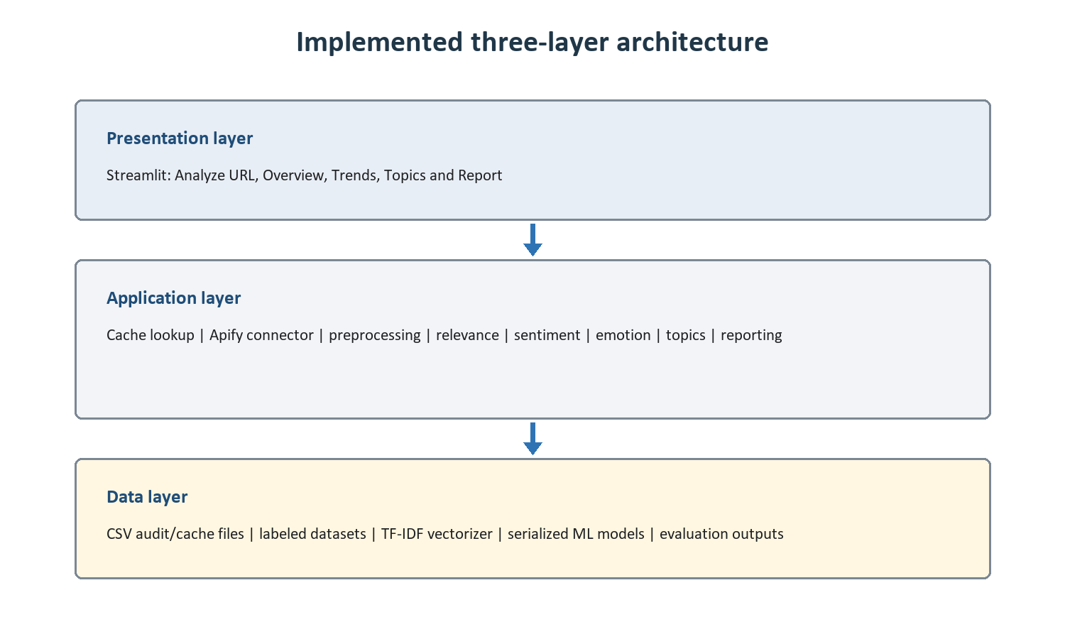
Figure 5.1. Implemented three-layer architecture of the prototype.
The presentation layer contains the end-user dashboard. The application layer coordinates URL validation, cache lookup, collection, text preparation, relevance detection, sentiment and emotion scoring, topic aggregation, temporal analysis and report generation. The data layer stores raw post caches, processed and labeled CSV files, evaluation outputs, lexicons and serialized TF-IDF/model artifacts.
Deliverable | Implemented component | Status
URL-based collection | src/data_collection and src/dashboard/live_analysis.py | Implemented
Sentiment and sarcasm | src/sentiment with VADER and local correction rules | Implemented
Emotion detection | NRC plus local emotion lexicon | Implemented
Classical ML models | Naive Bayes, Logistic Regression and SVM | Implemented
End-user dashboard | Analyze URL, Overview, Trends, Topics and Report | Implemented
Developer annotation dashboard | Manual gold-label review workflow | Future work
Production database | Central multi-user persistence and access control | Future work

5.2.4 Algorithms and Functional Implementation
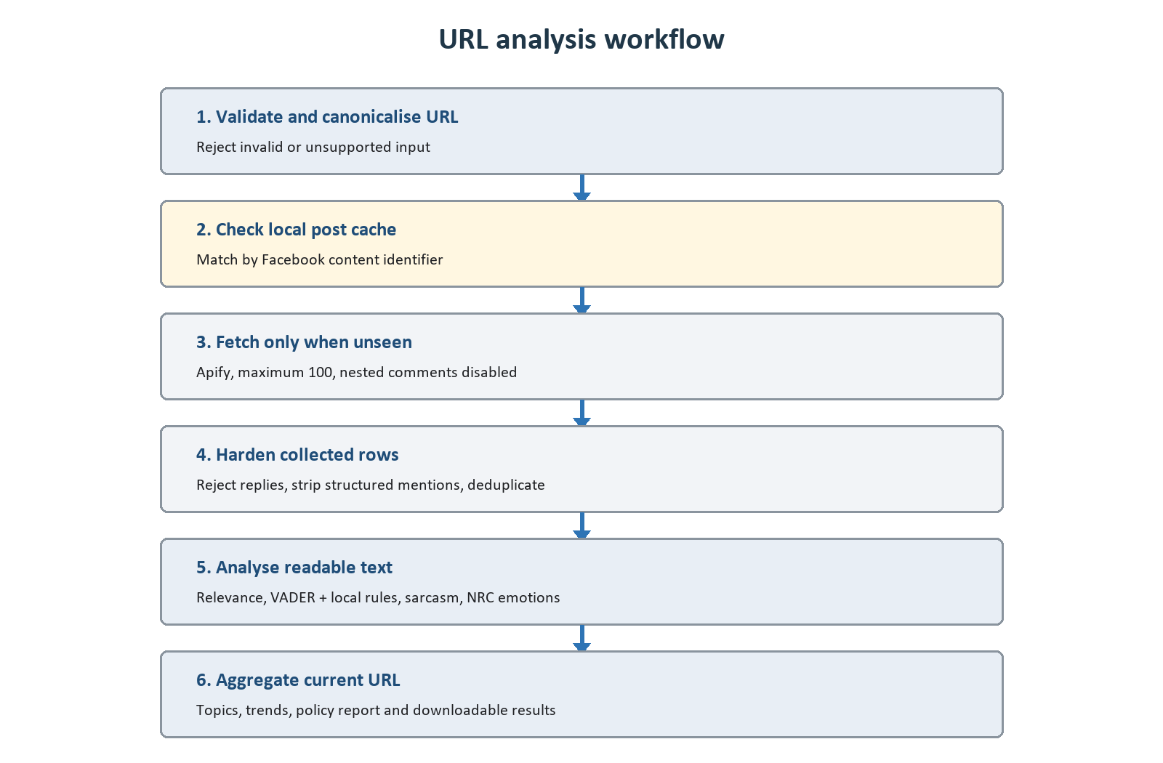
Figure 5.2. Cache-first URL analysis and reporting workflow.
The URL is canonicalised to remove non-essential query parameters and identify the Facebook post or video. A matching local cache is loaded before any external request. Consequently, repeated analysis remains available when Apify credit or network access is unavailable. For an unseen URL, collection is capped at 100 comments to control cost.
The collector requests top-level comments by setting includeNestedComments to false. Defensive schema checks also reject rows containing reply depth, parent-comment identifiers or reply flags. Structured mention names are removed and duplicate comment identifiers/text pairs are discarded before analysis.
Two text representations are retained. Readable text preserves punctuation, contractions and negation for VADER, sarcasm, emotion and relevance rules. Processed text supports TF-IDF machine-learning features. This separation fixed a class of errors in which cleaning removed the grammatical context needed to interpret complaints.
Stage | Algorithm or rule | Output
Relevance | Zambian energy vocabulary and contextual inclusion rules | Relevant/off-topic flag
Sentiment | VADER compound thresholds with local phrase correction | Negative, neutral or positive
Sarcasm | Auditable cue and polarity-conflict heuristics | Sarcasm flag and adjustment
Emotion | NRC categories plus Zambia-specific emotion phrases | Leading emotion and scores
Machine learning | Word/character TF-IDF with NB, LR and linear SVM | Comparable baseline predictions
Topics | Transparent domain keyword taxonomy | Topic labels, counts and examples
Reporting | Evidence thresholds over topic, sentiment, emotion and time | Stakeholder findings and policy considerations

Latest quality correction: The phrase 'not making sense' was added as a negative local correction. The reviewed business-impact complaint now changes from VADER raw +0.2375 (positive) to corrected -0.5625 (negative), and an exact regression test protects this behaviour.

5.2.5 Installation, Deployment and Operation
The local installation and demonstration procedure is:
- Clone the Git repository and open a terminal in the project root.
- Create and activate a Python virtual environment.
- Install dependencies with: python -m pip install -r requirements.txt.
- Create a .env file containing APIFY_API_TOKEN and, when required, the configured actor identifier. Secrets are excluded from version control.
- Run automated verification with: python -m pytest -q.
- Start the dashboard with: python -m streamlit run src/dashboard/app.py.
- Open http://localhost:8501, paste a public Facebook post URL, choose a limit of 100 or less, and select Analyze public comments.
No legacy organisational system is replaced by this prototype, so direct cutover and transactional data migration are not applicable. Research CSV files were normalised into the project schema, then training/test partitions and model artifacts were regenerated. Deployment is currently local and single-instance; GitHub provides code distribution and configuration history.

User Training
End-user training is intentionally brief because the dashboard begins with the URL task. A demonstration should cover public-URL selection, the comment cap, cache messages, the meaning of sentiment/emotion/topic summaries, report download, and the warning that Facebook comments are not a representative survey. Users should validate high-impact findings against example comments and operational evidence.
Training topic | Expected user outcome
URL selection | Recognise a publicly accessible Facebook post or video URL
Result interpretation | Distinguish volume, polarity, emotion, topic and trend evidence
Cache behaviour | Understand that saved comments can be analysed without new Apify usage
Ethical use | Avoid identifying authors or treating results as population-wide opinion
Reporting | Download and present a URL-specific report with its limitations

5.2.6 Project, Risk and Configuration Management
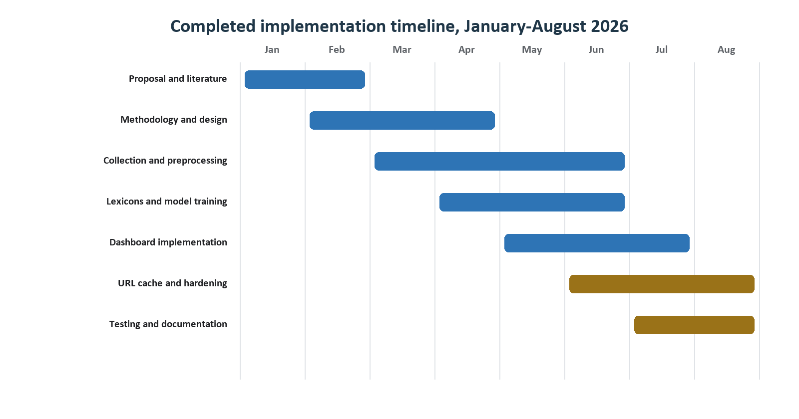
Figure 5.3. Completed implementation timeline.
The project followed incremental delivery: requirements and literature informed the methodology and design; collection and preprocessing enabled lexicon/model work; dashboard integration exposed data-quality issues; testing and documentation consolidated the prototype. Git commits and generated artifacts provide a traceable implementation history.
Risk | Implemented control | Residual limitation
Apify credit or outage | Cache-first lookup; maximum 100 comments | Unseen URLs still require the external service
Replies/names entering data | Disable nested comments; reject parent-linked rows; strip mentions | Scraper schemas can change
Incorrect sentiment | Local lexicons, readable-text scoring and regression tests | Sarcasm and code-switching remain difficult
Privacy and misuse | Public comments only; no profile names in analysis outputs | Platform and research ethics still require review
Model overstatement | Held-out metrics and explicit prototype limitations | No independently human-labeled gold standard yet
Configuration leakage | .env secrets excluded; dependencies recorded | Deployment secret management is not centralised

Configuration management uses Git for source history, requirements.txt for Python dependencies, .env for local secrets, Joblib for model/vectorizer versions and dated CSV/JSON files for collection and evaluation evidence. Generated raw and result files are retained as an audit trail; future production deployment should add artifact version identifiers, retention policies and automated release tagging.

5.2.7 Troubleshooting and Further Work
Symptom | Likely cause and response
Apify usage exceeded | Use a previously cached URL; add credit only when a genuinely unseen URL must be collected
No comments returned | Confirm that the post is public, the URL is supported and comments are visible
Too few relevant comments | The discussion may be off-topic; inspect the relevance examples rather than forcing inclusion
Unexpected sentiment | Inspect raw score, matched local phrase and readable text; add a tested correction only when the linguistic pattern generalises
Dashboard does not start | Activate the environment, install requirements and verify that port 8501 is available
Trend view is empty | Valid timestamps and more than one time period are required

- Build a separate manual review and annotation dashboard for authorised researchers and developers.
- Create a human-labeled Zambian gold-standard dataset and report inter-annotator agreement.
- Add a production database, authentication, retention controls and formal concurrent-user testing.
- Evaluate Africa-focused or fine-tuned transformer models against the transparent baselines.
- Add model/version provenance and drift monitoring to every downloaded stakeholder report.

5.3 Coding
Python was selected because its data-processing and natural-language libraries support reproducible experimentation, while Streamlit provides a compact web interface without duplicating analysis logic in a second language. The modular package structure allows collection, sentiment, insights and dashboard behaviour to be tested independently.

5.3.1 Cache-first URL execution
cached = load_cached_comments(source_url, max_comments=max_comments)
if cached:
comments = cached.comments
collection_source = "local_cache"
else:
comments = fetch_comments(source_url, max_comments=max_comments)
save_post_cache(comments, source_url=source_url)

5.3.2 Top-level comment protection
run_input = {
"startUrls": [{"url": source_url}],
"maxComments": min(max_comments, 100),
"includeNestedComments": False,
}
if _is_reply_item(item):
return None

5.3.3 Local sentiment correction
local = apply_local_correction(text, raw_compound, raw_label)
final_compound = local["compound"]
final_label = local["label"]
# Example: 'not making sense' applies a negative domain correction.
Complete source listings remain in the repository. The fragments above demonstrate the three implementation decisions most important to reliability and cost: local reuse before external collection, reply exclusion at both request and row level, and auditable local correction after a transparent base score.

5.4 Results
Verification combined automated tests, held-out model evaluation, manual error analysis and an end-to-end dashboard run using a cached Facebook URL. The full automated suite completed successfully with 66 passing tests. The cached demonstration loaded 20 stored top-level comments without consuming Apify tokens; nine were classified as energy-relevant and all nine were negative for that particular post.
Evidence | Verified result
Automated regression suite | 66 tests passed
Relevant labeled dataset | 2,813 comments: 1,011 negative, 904 neutral, 898 positive
Naive Bayes | 55.1% accuracy; 53.7% weighted F1
Logistic Regression | 58.3% accuracy; 58.0% weighted F1
Support Vector Machine | 58.4% accuracy; 58.3% weighted F1
Reviewed complaint | Raw +0.2375 positive; corrected -0.5625 negative

Interpretation: SVM is the strongest of the three classical baselines, but the 58.4% accuracy and 58.3% weighted F1 are moderate. These are prototype results on noisy, code-switched social-media text with weak supervision; they are not evidence of production-grade accuracy.
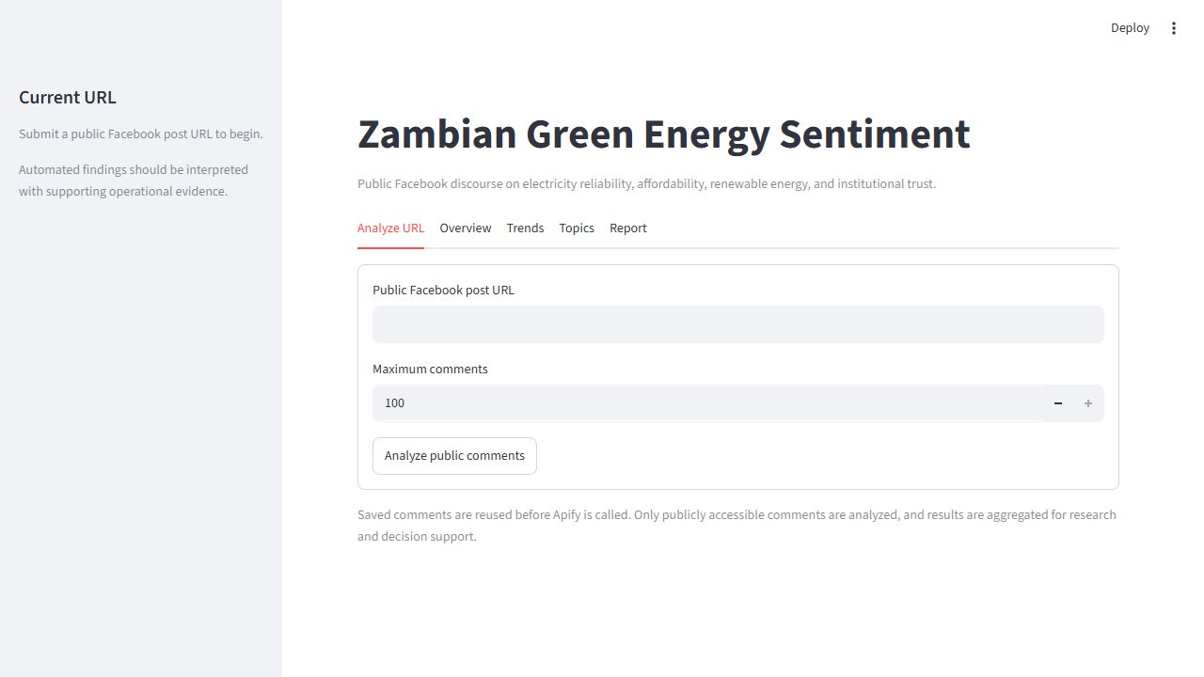
Figure 5.4. The end-user dashboard begins with the public Facebook URL workflow.
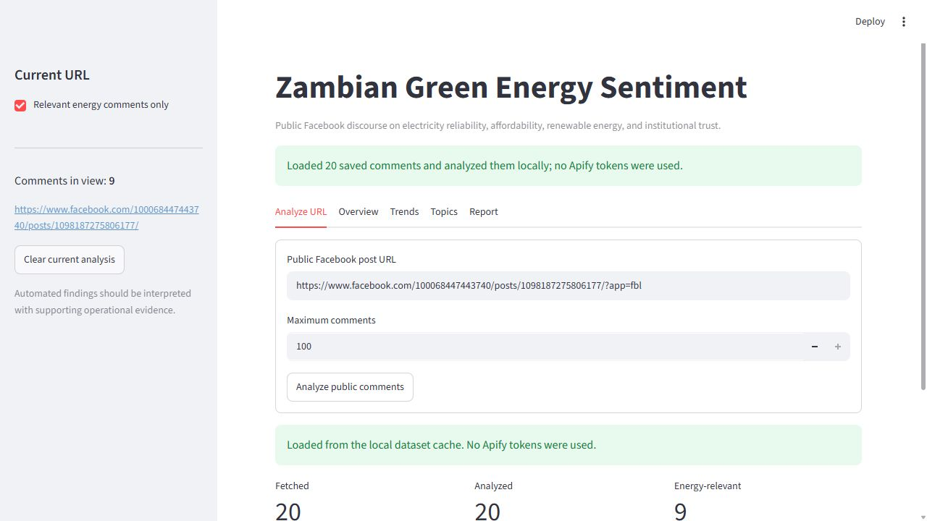
Figure 5.5. A saved post was loaded locally, avoiding new Apify usage.
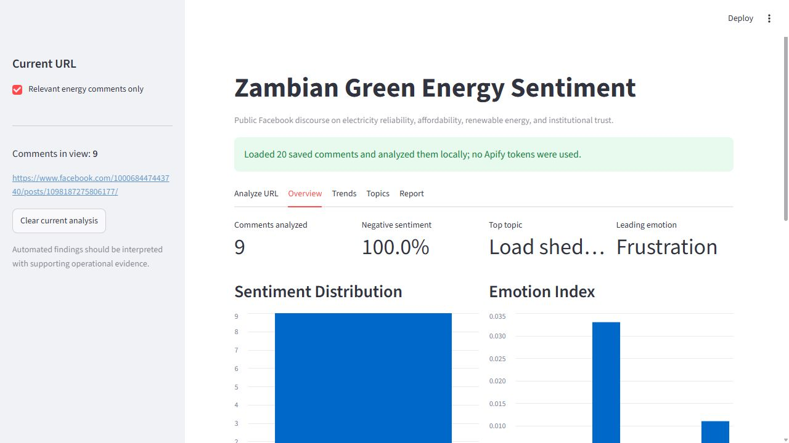
Figure 5.6. URL-specific overview for the cached demonstration post.
The screenshots demonstrate the implemented user journey rather than the research corpus. Results are replaced when another URL is analysed. The overview combines distribution, topic and emotion evidence, while the report tab converts the same URL-specific evidence into cautious stakeholder findings and future policy considerations.

5.5 Conclusion
The implementation converts the three-layer design into a functioning, testable prototype. It provides URL-based public comment collection, cache-first reuse, top-level-comment hardening, readable-text sentiment and emotion analysis, three classical machine-learning baselines, transparent topic aggregation, trends and an end-user stakeholder report.
The work also demonstrates the value of iterative validation. Manual review exposed misleading positive classifications caused by contextual words and lost negation. Local phrase correction, text-representation separation and regression tests improved the system while preserving an auditable raw score. The prototype is suitable for exploratory research and decision support, but policy use must remain supported by human review and independent evidence.
The next priority is a developer-only annotation dashboard and a human-labeled Zambian evaluation set. Production deployment should then add central persistence, authentication, stronger configuration management, concurrency testing and model monitoring. These extensions build on the current end-user dashboard without changing its focused URL-to-results workflow.

Implementation Evidence
Artifact | Project location
Dashboard | src/dashboard/app.py
Live URL pipeline | src/dashboard/live_analysis.py
Collector hardening | src/data_collection/apify_client.py
Local sentiment lexicon | data/lexicons/local_sentiment_lexicon.csv
Automated tests | tests/
Model evaluation | data/results/evaluation_summary.csv
User and defence documentation | docs/

Document generated from the verified project state on 09 August 2026.

