Recursion Assignment

Write the following functions both iteratively and recursively. Note that for each question you will have to write 2 functions: f1_I, and f1_R. Each question will correspond to a single program. Name the programs recursion_Q##. Where ## represents the question number. For example, the answer to question 5 would be called recursion_Q05. This file would contain two functions: f5_I and f5_R along with a bit of code in main to allow for testing.

- Write a function to compute the n^{th} term in the following sequence of numbers: 17, 26, 35, 44, 53, … Return the term.
- A sequence is defined by the following recurrence relation: 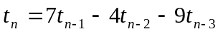and the base case: 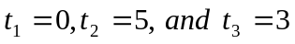. Write a function to determine given .
- A sequence is defined by the following recurrence relation: 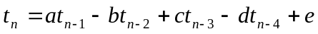and the base case: 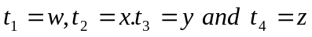. Write a function to determine the n^{th} term in such a sequence.
- Write a function to compute 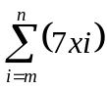 where n >= m, x ,m ,n are all integers. Return the sum.
- Write a function to count the number of multiples of m between a and b in an array of integers A. Where b >=a, and a, b, and m are all whole numbers. NOTE that the multiples are between the whole numbers a and b … a and b are not indices in the array.
- An array contains positive integers but the last element is negative. The last element of the array is called a sentinel and is used to indicate the end of the array … kind of like the NULL terminator in a string. Write a function to compute the sum of the multiples of m in the array.
- Write a function that takes a string and evaluates it according to the rule that all letter chars get 10 points, all number chars get 5 points, all spaces get 20 points and all other characters get 1 point except for the addition sign which gets 0 points. Return the value of the string.
- Write a function to determine if a string is a palindrome. A palindrome is a word that is still the same word when spelled backwards. Here are some palindromes: abba, dud, C, 845q2t2q548. The empty string is also a palindrome. Return 1 if the string is a palindrome and 0 if it is not.
- Write a function that counts all of the characters, c, in the string s. Return the count of the character c in the string s.
- Write a function to delete the first occurrence of the character c in the string s.
- Write a function to delete all instances of the character c that occur in the string s.
- Write a function that inserts a number, n, into the correct position in an array of sorted integers A. Assume that the array is sorted in increasing order.
- Write a function that determines the square root of a real number r. Assume that r will be greater than or equal to 1.
- Write a function that finds an element key in an array of sorted integers A. If key is found then return the index of key in the array otherwise return -1 to indicate that it was not found. Assume that there are no duplicate elements in the array. Use a linear search.
- Repeat the previous question using a binary search.

