

Digital Technology

By Alexander Perkins



Table of Contents

Explore 2

Summary 2

Brainstorming Mind Map 2

Criteria 2

Research 2

Develop 3

Rules 3

Algorithm 3

Storyboards 3

Generate 4

Assets 4

Screenshots of code 4

Evaluate 5

Bibliography 6

# Explore

## Summary

My task is to create a python game using python with pygame. The goal of this game is to take the player on a journey, which can be any journey whether that be to travel the world or just to get home, but this journey should keep the reader entertained and should be engaging.

## Brainstorming Mind Map

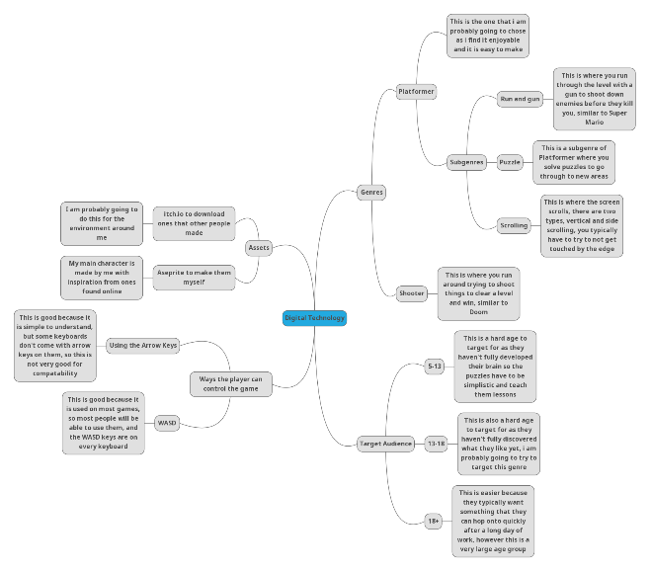

## Criteria

I am going to develop some criteria to ensure that my game has a certain level of entertainment and look to it, these criteria are going to be:

|  |  |  |
| --- | --- | --- |
| Must Have | Should Have | Must Not Have |
| The player must be able to control the character for at least 70% of the game | The game should have good assets (art) | The game must not have many game breaking bugs (This would ruin the players immersion and experience) |
| The game must have the theme of Journey | The game should be intuitive and easy to use with little to no text | The game must not include anything that would break the players immersion |
| The game must include challenges that the player must overcome | Should be targeted to an audience between 18-22 | Must not let the player leave before having solved all puzzles in the level |

## Research

Through my research I have found that there are multiple different genres of games (Contributors, List of Video Game Genres, 2025), I have chosen to make a platformer game, specifically the subgenres of run-and-gun, and puzzle platformers (Contributors, Platformer, 2025). This genre has been picked as it is a simple game that can be very fun, take, for example, Ori and the Will of the Wisps, this is an Action/adventure platformer (Ori and the Will of the Wisps, n/d) that is a very fun and easy to play game that has kept me entertained for hours, some of the puzzles are hard but once you get them you get an amazing feeling. Through my research I have found that people aged 13-22 make up 66.7% of the people who like 2D Platformers and 72.73% of people rate Platformers a 4 or a 5 with an average rating of 4.05 (Demographics of Players of Platformer Games (2D and 3D), 2023).

# Develop

## Rules

The rules for my game are that

1. The player must kill all enemies and solve all puzzles in a level before moving on
2. The player can move left and right, jump and can fall down, which will return them to the last checkpoint.
3. Checkpoints are taken once per level when you enter it
4. The score is calculated based on how long you took per level to solve it

## Algorithm

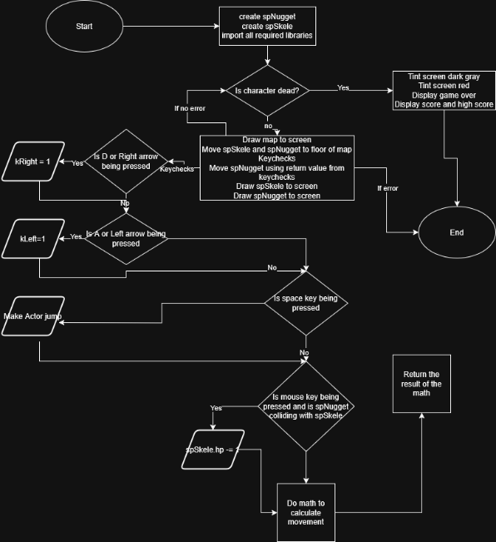

## Storyboards

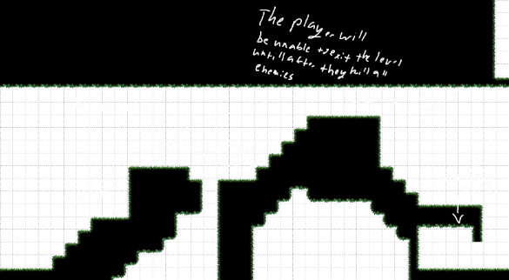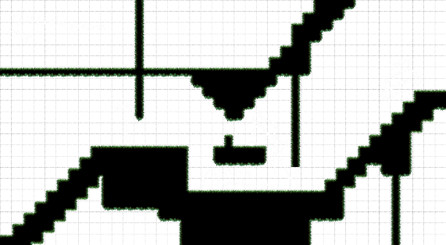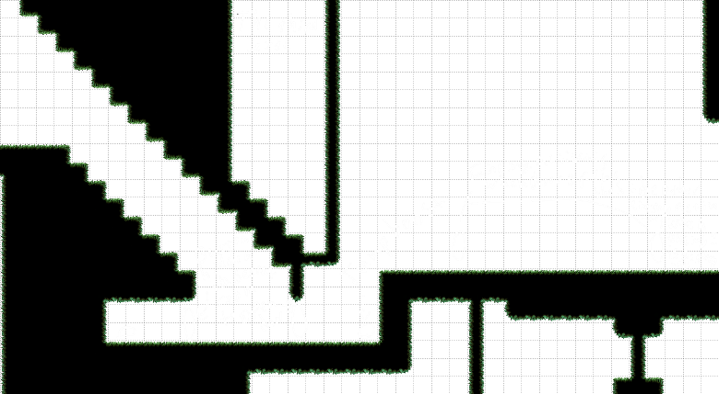

All maps have been made in a program called [Tiled](https://github.com/mapeditor/tiled)

# Generate

[Link to the code](https://github.com/Ghostboo124/school-game-t1/tree/main/assesment/code)

## Assets

I will be gathering my assets from itch.io, which is a website for distributing games and assets for game developers, and I will be making some of my own assets in a program called Aseprite All assets used are in the link to the code. The following are links to assets used, all are free to use.  
<https://tallbeard.itch.io/music-loop-bundle>   
<https://maaot.itch.io/mossy-cavern>   
<https://brullov.itch.io/oak-woods>

## Screenshots of code



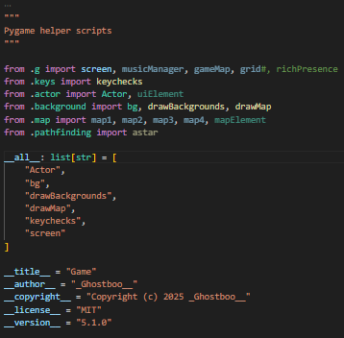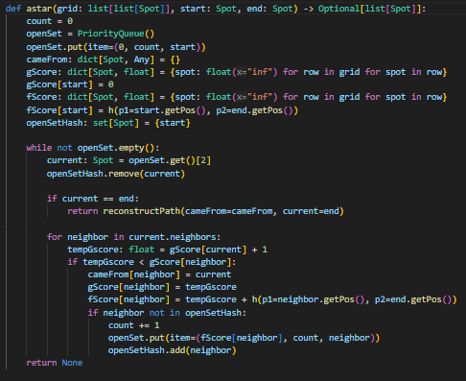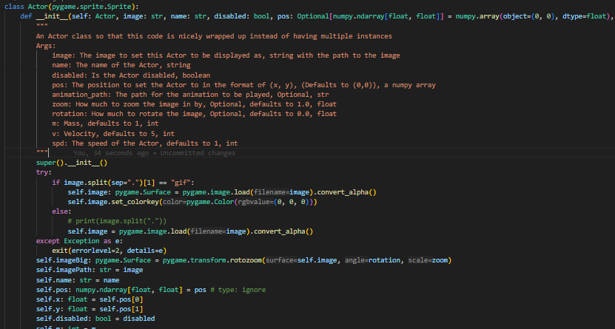EOP



# Evaluate

## Criteria

|  |  |  |
| --- | --- | --- |
| Must Have | Should Have | Must Not Have |
| The player must be able to control the character for at least 70% of the game | The game should have good assets (art) | The game must not have many game breaking bugs (This would ruin the players immersion and experience) |
| The game must have the theme of Journey | The game should be intuitive and easy to use with little to no text | The game must not include anything that would break the players immersion |
| The game must include challenges that the player must overcome | Should be targeted to an audience between 18-22 | Must not let the player leave before having solved all puzzles in the level |

The success criteria was mostly met, as the player was able to control the character for 100% of the game unless dead, the game had the theme of journey as the player completed a journey from the first level to the last level, the player was provided with challenges that they had to overcome, specifically killing enemies and solving puzzles. The game’s assets however could have been better, more specifically the moving background should have only moved when the player moved and the map didn’t extend to the bottom of the screen, the game was intuitive and easy to use with no text included in the game. The game was targeted to an audience between 18 and 22 years old, but no one play tested it so I can not be sure if they enjoyed playing it. This game however did have some major bugs, but the game was still somewhat playable, the game as stated before had some major bugs, that ruined the players immersion. And the game did not let the player leave before having solved all puzzles in the level.

# Bibliography

Contributors, W. (2025, Feburary 28). *List of Video Game Genres*. Retrieved from Wikipedia: https://en.wikipedia.org/w/index.php?title=List_of_video_game_genres&oldid=1278155815

Contributors, W. (2025, Feburary 3). *Platformer*, 1273694931. Retrieved March 13, 2025, from Wikipedia: https://en.wikipedia.org/w/index.php?title=Platformer&oldid=1273694931

*Demographics of Players of Platformer Games (2D and 3D)*. (2023, May 10). Retrieved from Google Docs: https://docs.google.com/document/d/1ITon0uDifax7GwKpPF3QR71_CvxiwYgjLtr1p9rse3c/edit?pli=1&tab=t.0  
Date found at:  
https://gamedev.net/blogs/entry/2276048-demographics-of-players-of-platformer-games-2d-and-3d/

*Ori and the Will of the Wisps*. (n/d). Retrieved from Ori and the Blind Forest: https://oriandtheblindforest.fandom.com/wiki/Ori_and_the_Will_of_the_Wisps