Preamble:

We set out to facilitate easy access to healthcare through our digital intermediation.

The current situation makes access to specialists healthcare tedious and the waiting period longer due to dearth of qualified resources

Value Proposition:

Our value proposition is to provide a digital platform for interaction between the patients and the providers and streamline the access and engagement in a seamless manner to engender quality benefaction for all participants.

An example use case:

A patient want a dental care/service

Locates a Clinic after tedious search and referrals

After the initial assessment, he has to wait until a specialist is located and appointment booked.

He is in the queue for consultation and attention which could lead to procedures that requires further booking and waiting periods

Task:

Design a working model as a digital platform to address this challenge in a win-win situation for all stakeholders.

Please build

1 Ready to deploy MVP with codes

2. The database schema for this model

3. ⁠The pitch check for investors / hospitals and

CareBridge – Digital Healthcare Access & Specialist Coordination Platform
PRODUCT DESIGN • DEPLOYABLE MVP • DATABASE • INVESTOR & HOSPITAL PITCH
The proposed solution is to build CareBridge, a digital healthcare coordination and intermediation platform that connects patients, primary healthcare providers, specialists, diagnostic centres and hospitals in one coordinated ecosystem.
The important distinction is that CareBridge should not simply be another online hospital directory or appointment-booking application.
It should manage the patient's healthcare journey from the initial request to specialist consultation, diagnostics, treatment, procedures and post-treatment follow-up.
This carries forward the agreed CareBridge direction: a Lagos, Nigeria launch, with a dental-care pilot that can subsequently expand to other medical specialties, supported by web, Android/iOS and provider API integrations.

1. The business problem and proposed solution

The current patient experience

Today's fragmented healthcare journey
- Patient experiences a health problem and searches for a clinic.
- Patient contacts several clinics to establish availability.
- Clinic conducts an initial assessment.
- Patient waits while a suitable specialist is identified.
- Specialist appointment is arranged, often after additional delays.
- Diagnostics or procedures require separate bookings.
- Patient struggles to coordinate follow-up care.
Fragmented, slow and difficult to coordinate

The CareBridge experience
- Patient submits a healthcare request through CareBridge.
- Platform identifies suitable, verified healthcare providers.
- Providers receive the request and accept or decline referrals.
- Patient sees genuine available appointment slots.
- Specialist consultations and required diagnostics are coordinated.
- Treatment and procedure appointments are scheduled.
- Patient receives reminders, progress updates and follow-up support.
One coordinated healthcare journey

The central proposition
CareBridge becomes the coordination layer between healthcare demand and available healthcare capacity.
It does not need to own hospitals, clinics or diagnostic facilities. Instead, it makes their existing capacity more accessible and easier to utilise.
The platform should optimise five things:
- Access – connect patients to the right healthcare professionals.
- Availability – identify actual appointment capacity rather than merely listing providers.
- Coordination – manage referrals, consultations, diagnostics and procedures.
- Transparency – provide visibility into estimated costs, appointments and service progress.
- Continuity – ensure that patients are not abandoned after an initial consultation.

2. The operating model

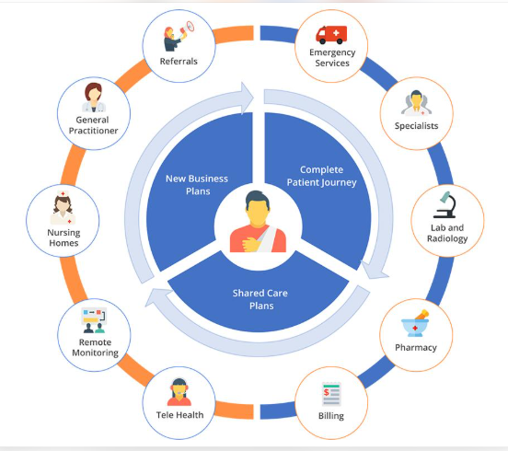
Shras - IT Solutions Pvt Ltd
shrasits.com
The platform will have six principal participant groups.
Stakeholder | Role and value received
Patients | Convenient access, shorter coordination time, transparent options
Clinics | Patient acquisition, better scheduling and referral management
Specialists | Qualified referrals, improved utilisation and predictable appointments
Hospitals | Additional patient flow and improved capacity utilisation
Diagnostic centres | More organised test requests and bookings
CareBridge | Intermediation revenue, subscriptions and coordination fees

The dental-care pilot
The first deployment should focus on dental services because the treatment journey naturally involves multiple providers and stages.
For example:
A patient requires a root canal treatment.

Dental Cleanings and Exams in Winter Springs, FL | Sunrays Smiles Dental Care
sunraysdentalcare.com
The proposed journey:
- Patient selects Dental Care.
- Patient describes the problem, uploads relevant images if desired and selects a preferred location.
- CareBridge identifies verified dental clinics.
- A clinic accepts the request and performs an initial assessment.
- The clinic determines whether a general dentist or specialist endodontist is required.
- CareBridge identifies an available specialist and coordinates the referral.
- Patient receives appointment options and estimated charges.
- The specialist conducts the consultation and recommends treatment.
- Where necessary, diagnostics and the root canal procedure are booked.
- CareBridge tracks completion and arranges follow-up.
Important: Clinical decisions, diagnosis and treatment recommendations remain the responsibility of licensed healthcare professionals. CareBridge facilitates access and coordination; it does not replace medical judgement.

3. System architecture
The recommended architecture separates the patient-facing application, provider operations and the central coordination engine.
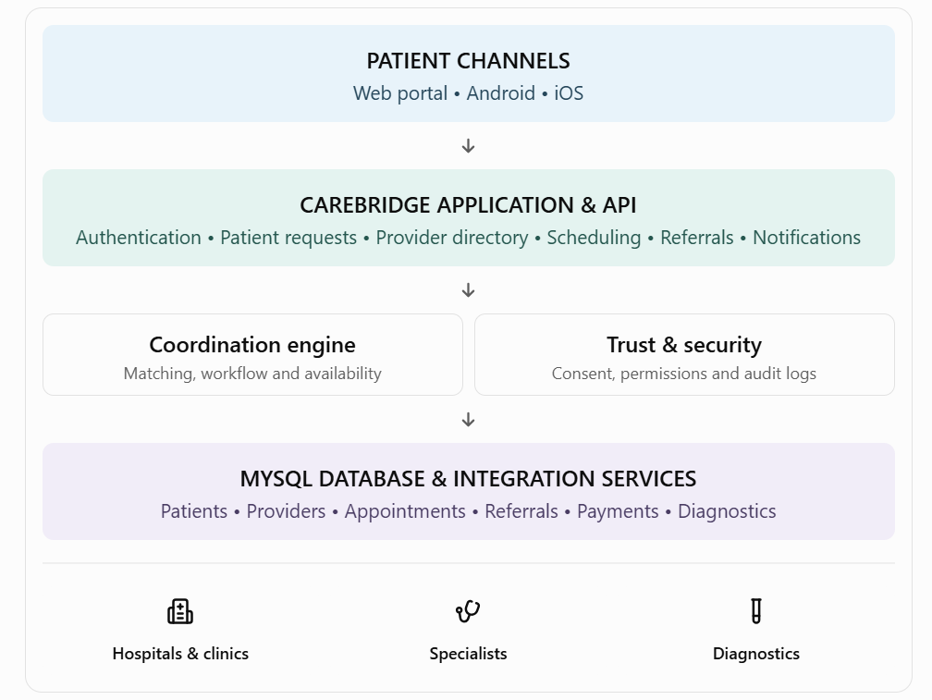
PATIENT CHANNELS
Web portal • Android • iOS
CAREBRIDGE APPLICATION & API
Authentication • Patient requests • Provider directory • Scheduling • Referrals • Notifications
Coordination engine
Matching, workflow and availability
Trust & security
Consent, permissions and audit logs
MYSQL DATABASE & INTEGRATION SERVICES
Patients • Providers • Appointments • Referrals • Payments • Diagnostics
Hospitals & clinics
Specialists
Diagnostics

Recommended technology stack
Component | Technology
Backend | Node.js + Express
Database | MySQL 8
Web application | React
Mobile applications | React Native / Expo
Authentication | JWT, MFA and OTP
Notifications | SMS, email and push
Payments | Nigerian payment gateway integration
Hosting | Secure cloud infrastructure
Provider integration | REST APIs
I have chosen Node.js and MySQL for the initial implementation, making the backend straightforward to extend and maintain.

4. Ready-to-deploy MVP source code
Source package created
I have prepared a runnable backend MVP package containing:
CareBridge MVP Source Code
Node.js • Express • MySQL • Docker
Download CareBridge MVP source code
Included modules
- User registration and authentication.
- Patient care requests.
- Verified provider directory.
- Provider request queue.
- Provider offers and acceptance/decline.
- Appointment booking with overlapping-slot checks.
- Patient appointment history.
- Basic administrative metrics.
- Database schema and Docker deployment configuration.
- Installation and API documentation.

How to deploy
- Install Docker and Docker Compose on the server.
- Extract the downloaded source package.
- Copy .env.example to .env.
- Configure database credentials and a strong JWT secret.
- Add a strong MYSQL_ROOT_PASSWORD to .env.
- Run:
docker compose up --build -d
7. Test the API:
http://YOUR_SERVER_IP:4000/health
Expected response:
{
"status": "ok",
"service": "CareBridge API"
}
The package is a deployable API foundation, not yet the complete production system. It does not include the React patient interface, provider portal or mobile applications. Those are the next implementation layer.

5. Database schema
The database is designed around the healthcare journey rather than just patient and hospital registration.
The SQL file is included in the downloadable source package under db/schema.sql.

Principal database tables
Table | Purpose
users | Patient, provider staff and administrator accounts
providers | Hospitals, clinics, specialists and diagnostic centres
provider_users | Staff membership and provider access
care_requests | Patient healthcare requests
provider_offers | Provider matching and responses
appointments | Consultation and treatment scheduling
clinical_referrals | Specialist referral management
service_estimates | Estimated treatment and service charges
payments | Financial transactions
patient_consents | Privacy and information-sharing permissions
notifications | SMS, email and application notifications
audit_logs | User activity and system accountability

Core relationship model

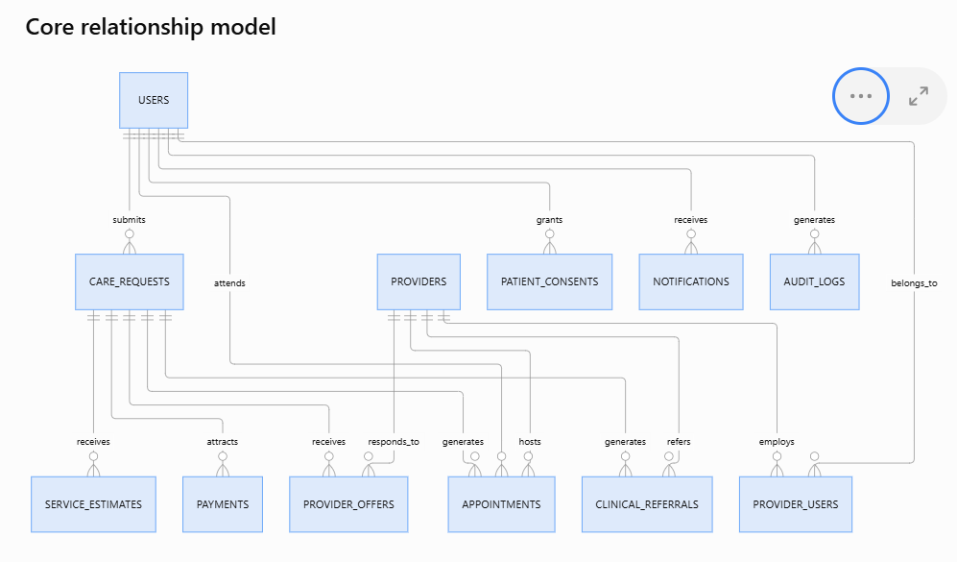

An important design decision
CareBridge must distinguish between:
- A patient request.
- A provider accepting a request.
- A clinical referral.
- An appointment.
- A completed treatment.
These are separate events and must not be treated as the same transaction.
For example, a clinic accepting a patient request does not automatically mean that a specialist appointment has been confirmed.
This separation is essential for accurate reporting, accountability and future expansion.

6. User roles and operational workflows
The MVP should support the following roles.
Role | Principal permissions
Patient | Create requests, select providers, book and track appointments
Clinic administrator | Manage clinic profile, staff and appointments
General dentist | Assess patients and initiate referrals
Specialist | Accept referrals, manage consultations and treatment
Diagnostic centre | Manage investigations and appointments
CareBridge operator | Coordinate requests, resolve bottlenecks and monitor service levels
System administrator | Manage users, verification, access and configuration

The matching engine
This is arguably the most important component of CareBridge.
It should not simply recommend the nearest clinic.
The matching algorithm should consider:
- Clinical specialty required.
- Provider verification and licensing.
- Actual appointment availability.
- Geographic proximity.
- Services and equipment available.
- Estimated service costs.
- Provider acceptance and historical service performance.
An example matching score could be:
Matching criterion | Weight
Specialty suitability | 30%
Appointment availability | 25%
Provider verification | 20%
Location | 10%
Service cost suitability | 10%
Historical service performance | 5%
These weights are illustrative and should be validated during the pilot.
Clinical suitability and provider verification must be mandatory eligibility conditions, not criteria that can be overridden by a high commercial score.

7. Revenue model: How everybody wins
CareBridge needs to create measurable economic value for each participant.

Proposed revenue streams
Revenue source | Description
Provider subscriptions | Monthly subscriptions for access to platform tools
Coordination fees | Disclosed fees for completed coordination services
Enterprise subscriptions | Hospital group and institutional arrangements
Integration fees | API integration and workflow customisation
Premium operational services | Reporting, scheduling and capacity management
I recommend that CareBridge initially avoid relying entirely on commissions from medical procedures.
A subscription and transparent coordination-fee model provides more predictable revenue and reduces the incentive to influence clinical decisions.

Illustrative commercial scenario
The following is a planning example, not a market forecast.
Assume:
- 20 participating healthcare facilities.
- 15 completed patient journeys per facility per month.
- Average coordination revenue of ₦3,000 per completed journey.
- 20 facilities paying ₦50,000 monthly subscription.
Revenue source | Monthly revenue
Coordination: 300 journeys × ₦3,000 | ₦900,000
Subscriptions: 20 × ₦50,000 | ₦1,000,000
Total | ₦1,900,000

₦1.9m
Illustrative monthly gross platform revenue
This excludes salaries, hosting, customer acquisition, support, taxes and other operating expenses.
The business case should ultimately be established using real pilot data.

8. Investor and hospital pitch
12-slide presentation created
I have prepared an editable PowerPoint presentation for investor and hospital discussions.
CareBridge Investor & Hospital Pitch
12 slides • Editable PowerPoint
Download the CareBridge pitch presentation

Recommended investor positioning
CareBridge is building the digital infrastructure that connects fragmented healthcare services into one coordinated patient journey.
The investment proposition is not simply to build another healthcare application.
It is to build a platform that makes existing healthcare resources easier to discover, access, coordinate and utilise.

What investors should understand
- The problem is structural: healthcare demand and healthcare capacity are poorly coordinated.
- The opportunity is scalable: start with dentistry, then expand into other specialties.
- The model is asset-light: CareBridge partners with existing facilities.
- The platform has recurring revenue opportunities.
- The data generated can improve capacity planning, patient access and service delivery, subject to appropriate privacy controls.

What hospitals should understand
CareBridge is a partner, not a competitor.
It can help hospitals:
- Attract additional patients.
- Improve specialist appointment utilisation.
- Receive structured referrals.
- Reduce administrative coordination.
- Improve patient retention and follow-up.
- Obtain better visibility into demand for their services.

9. Security, privacy and regulatory requirements
Because CareBridge will handle sensitive health information in Nigeria, security cannot be postponed until after launch.
The implementation must account for:
- Nigeria Data Protection Act 2023 and applicable NDPC requirements.
- Appropriate patient consent and data-sharing permissions.
- Verification of healthcare facilities and practitioners, including relevant professional registration.
- Role-based access control.
- Encryption in transit and at rest.
- Audit trails for access to patient information.
- Secure storage of clinical documents and images.
- Data retention and deletion policies.
- Incident response and disaster recovery.
- Appropriate agreements between CareBridge and participating healthcare providers.
Clinical records should not be exposed through the ordinary provider directory or general patient-facing APIs.
The initial code provides basic authentication and audit logging, but production deployment will require stronger identity verification, granular provider-level authorisation, encrypted clinical document management, security testing and independent compliance review.
Emergency cases must also be directed to appropriate emergency services rather than left in a routine referral queue.

10. Implementation roadmap
I recommend a controlled 90-day technical and operational pilot, followed by a scale-up decision.

90-day CareBridge pilot
- Days 1–30: Product foundation
  - Complete backend and patient web interface.
  - Build provider registration and verification.
  - Establish the initial provider network.
  - Configure dental services and specialties.
  - Implement consent and access controls.
- Days 31–60: Operational integration
  - Provider dashboard.
  - Appointment availability and calendar.
  - Referral acceptance.
  - Specialist and diagnostic scheduling.
  - SMS and email notifications.
  - Patient journey tracking.
- Days 61–90: Controlled pilot
  - Onboard selected clinics and specialists.
  - Run real patient journeys with appropriate clinical oversight.
  - Measure appointment delays and referral completion.
  - Collect patient and provider feedback.
  - Review revenue and operational costs.

Pilot performance indicators
I would establish the following targets for discussion with pilot partners, rather than treating them as guaranteed results.
KPI | Initial target
Provider request acknowledgement | Within 2 working hours
Provider verification | 100% before activation
Referral response | Within 1 working day
Appointment confirmation | Within 24 hours of accepted offer
Patient journey tracking | 100% of active requests
Patient satisfaction | At least 85%
Appointment completion | At least 80%

11. My recommendations before commercial launch
There are five capabilities I consider essential to making CareBridge a genuine healthcare coordination business rather than simply a booking application.
- Real-time provider capacity: Providers must maintain genuine available appointment slots, with synchronisation to their existing systems where possible.
- Referral orchestration: A clinic must be able to refer a patient to an identified specialist, receive acceptance and track the outcome.
- Patient journey management: Patients must see what has happened, what is pending and what they need to do next.
- Provider performance analytics: Hospitals should be able to measure referrals, appointment utilisation, cancellations and completed journeys.
- Clinical governance: CareBridge should have a clearly defined clinical governance framework and a qualified clinical advisory group.

12. The next development milestone
I recommend that we now move from the backend foundation to the complete operational product.

CareBridge – Complete MVP Build
Recommended next milestone
Deliverables
- Patient-facing React web application.
- Hospital and clinic management portal.
- Specialist dashboard.
- CareBridge administrator dashboard.
- Appointment and availability engine.
- Automated specialist referral workflow.
- Diagnostic and procedure scheduling.
- Patient notifications.
- Payment integration.
- Reporting and management dashboard.
- Deployment and operational documentation.
Recommended launch configuration
Item | Decision
Brand | CareBridge
Market | Lagos, Nigeria
Initial specialty | Dentistry
Backend | Node.js
Database | MySQL
Web | React
Mobile | React Native
Business model | B2B2C
Expansion | All major medical specialties
My strategic recommendation: Build CareBridge around the concept of managed access to healthcare, not merely access to healthcare providers. The real competitive advantage will be the ability to coordinate the entire patient journey across independent healthcare organisations.
That is where the greatest value lies for patients, hospitals, specialists and investors.

