The 3 AM Frustration That Led to Two Open-Source Financial Protocols ⚡

Six months ago, I was staring at a screen at 3 AM alongside a cold cup of coffee, trying to reconcile a freelance invoice against a chaotic spreadsheet.
I was frustrated. Not just because I hated accounting, but because as engineers, we build the future of the internet, yet our own professional tools feel like they're stuck in 2005. The interfaces were clunky, the data was chaotic, and the actual settlement of funds took days.
I promised myself I wouldn't use those tools anymore. I was going to build my own.
That was the night the "Ghostie Protocol" was born. What started as a late-night thought experiment spiraled into an obsession with design engineering and high-agency architecture.
Today, that obsession has become two distinct, fully realized platforms.



Chapter 1: Taming the Chaos (The LedgerSnap Build)

I started with the foundation: visualizing the data. I realized that if you treat financial data like a math problem, it’s boring. But if you treat it like a story, it becomes powerful.
I built LedgerSnap, an archival tracker engineered on React and Vite. I threw away standard dashboard grids and implemented a "No-Line" design philosophy. No rigid boxes. No unnecessary borders. Using a bespoke HCT (Hue, Chroma, Tone) color system and Framer Motion spring physics, the numbers didn't just sit on the screen—they lived there.
Suddenly, looking at outflows wasn't stressful. It was clear. But there was still a massive piece missing.

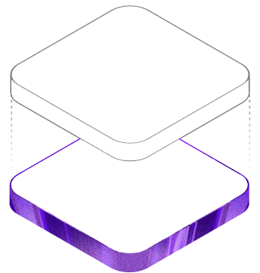

Chapter 2: The Finality Problem (The Vertex Pivot)

LedgerSnap was great for tracking capital, but I still had to route it. When a client agreed to a scope of work, moving from "we have a deal" to "the funds have arrived" was a fragmented nightmare.
I didn't just want a payment gateway; I wanted Surgical Finality.
I needed a network that was fast, cheap, and institutional-grade. That led me straight to the Solana Virtual Machine (SVM). I spun up Next.js 16 and Supabase, and began architecting Vertex Pay.
Building Vertex tested everything I knew about security. I had to ensure absolute trust—meaning the client's Web3 wallet connection had to operate entirely parallel to the database session, locked down by Row Level Security (RLS).
I spent weeks getting the Z-axis depth and glassmorphism just right so the UI felt like a high-end financial cockpit, radiating trust and absolute authority. When the first invoice transitioned flawlessly into an immutable, on-chain hash... that was the "Aha" moment. The gap was finally bridged.

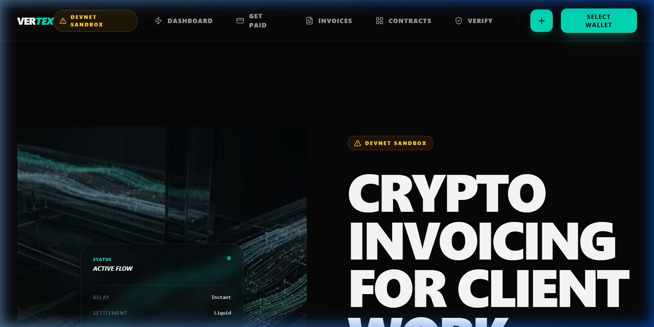

The Epilogue: Design is Function

If this journey taught me anything, it’s that in 2026, Design Engineering isn't about making things "look pretty." It is a core security feature.
When an interface responds with buttery smooth 300ms transitions, when the typography scales fluidly without breaking the viewport, when a transaction settles instantly—you don't just build an app. You build trust.
Neither LedgerSnap nor Vertex are just portfolio pieces. They are the standard for how I believe software should be built.

You can explore the live environments here:
🔗 Vertex (Surgical Settlement): https://vertex-pay.vercel.app
🔗 LedgerSnap (Financial Architect): https://ledgersnap-one.vercel.app

To every founder, designer, and dev out there obsessing over that 1% of polish while the rest of the world tells you to "just ship it"—keep obsessing. It's the only thing that matters.
Let me know what you think of the flow, and drop your questions about Web3 or React architecture below! 👇

#Storytelling #BuildInPublic #SoftwareEngineering #NextJS #Solana #ReactJS #Web3 #DesignEngineering #FinTech #DeveloperJourney

