Client Wealth Audit Portal
Technical and Operational Documentation
Author: Sharad Mayank Sinha
Date: July 2026

Table of Contents

1. Executive Summary
The Client Wealth Audit Portal is a secure Enhanced Customer Due Diligence (ECDD) application designed for relationship managers to verify UHNWI Source of Wealth (SOW) portfolios. It models, verifies, and audits capital inflows against regulatory compliance frameworks (Wolfsberg and MAS guidelines).

2. Operational Portal Overview

2.1 Secure Gateway Authentication
Controls system access and enforces separation of duties between relationship managers and administrators via a salted SHA-256 hashed gateway.
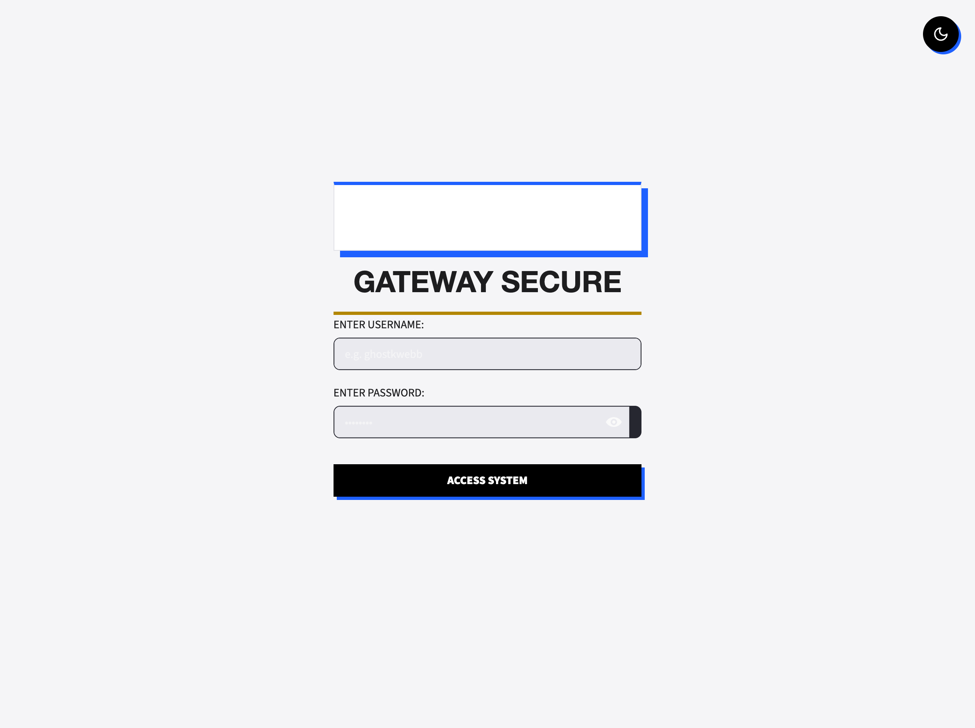
Figure 2.1: Portal gateway authentication interface.
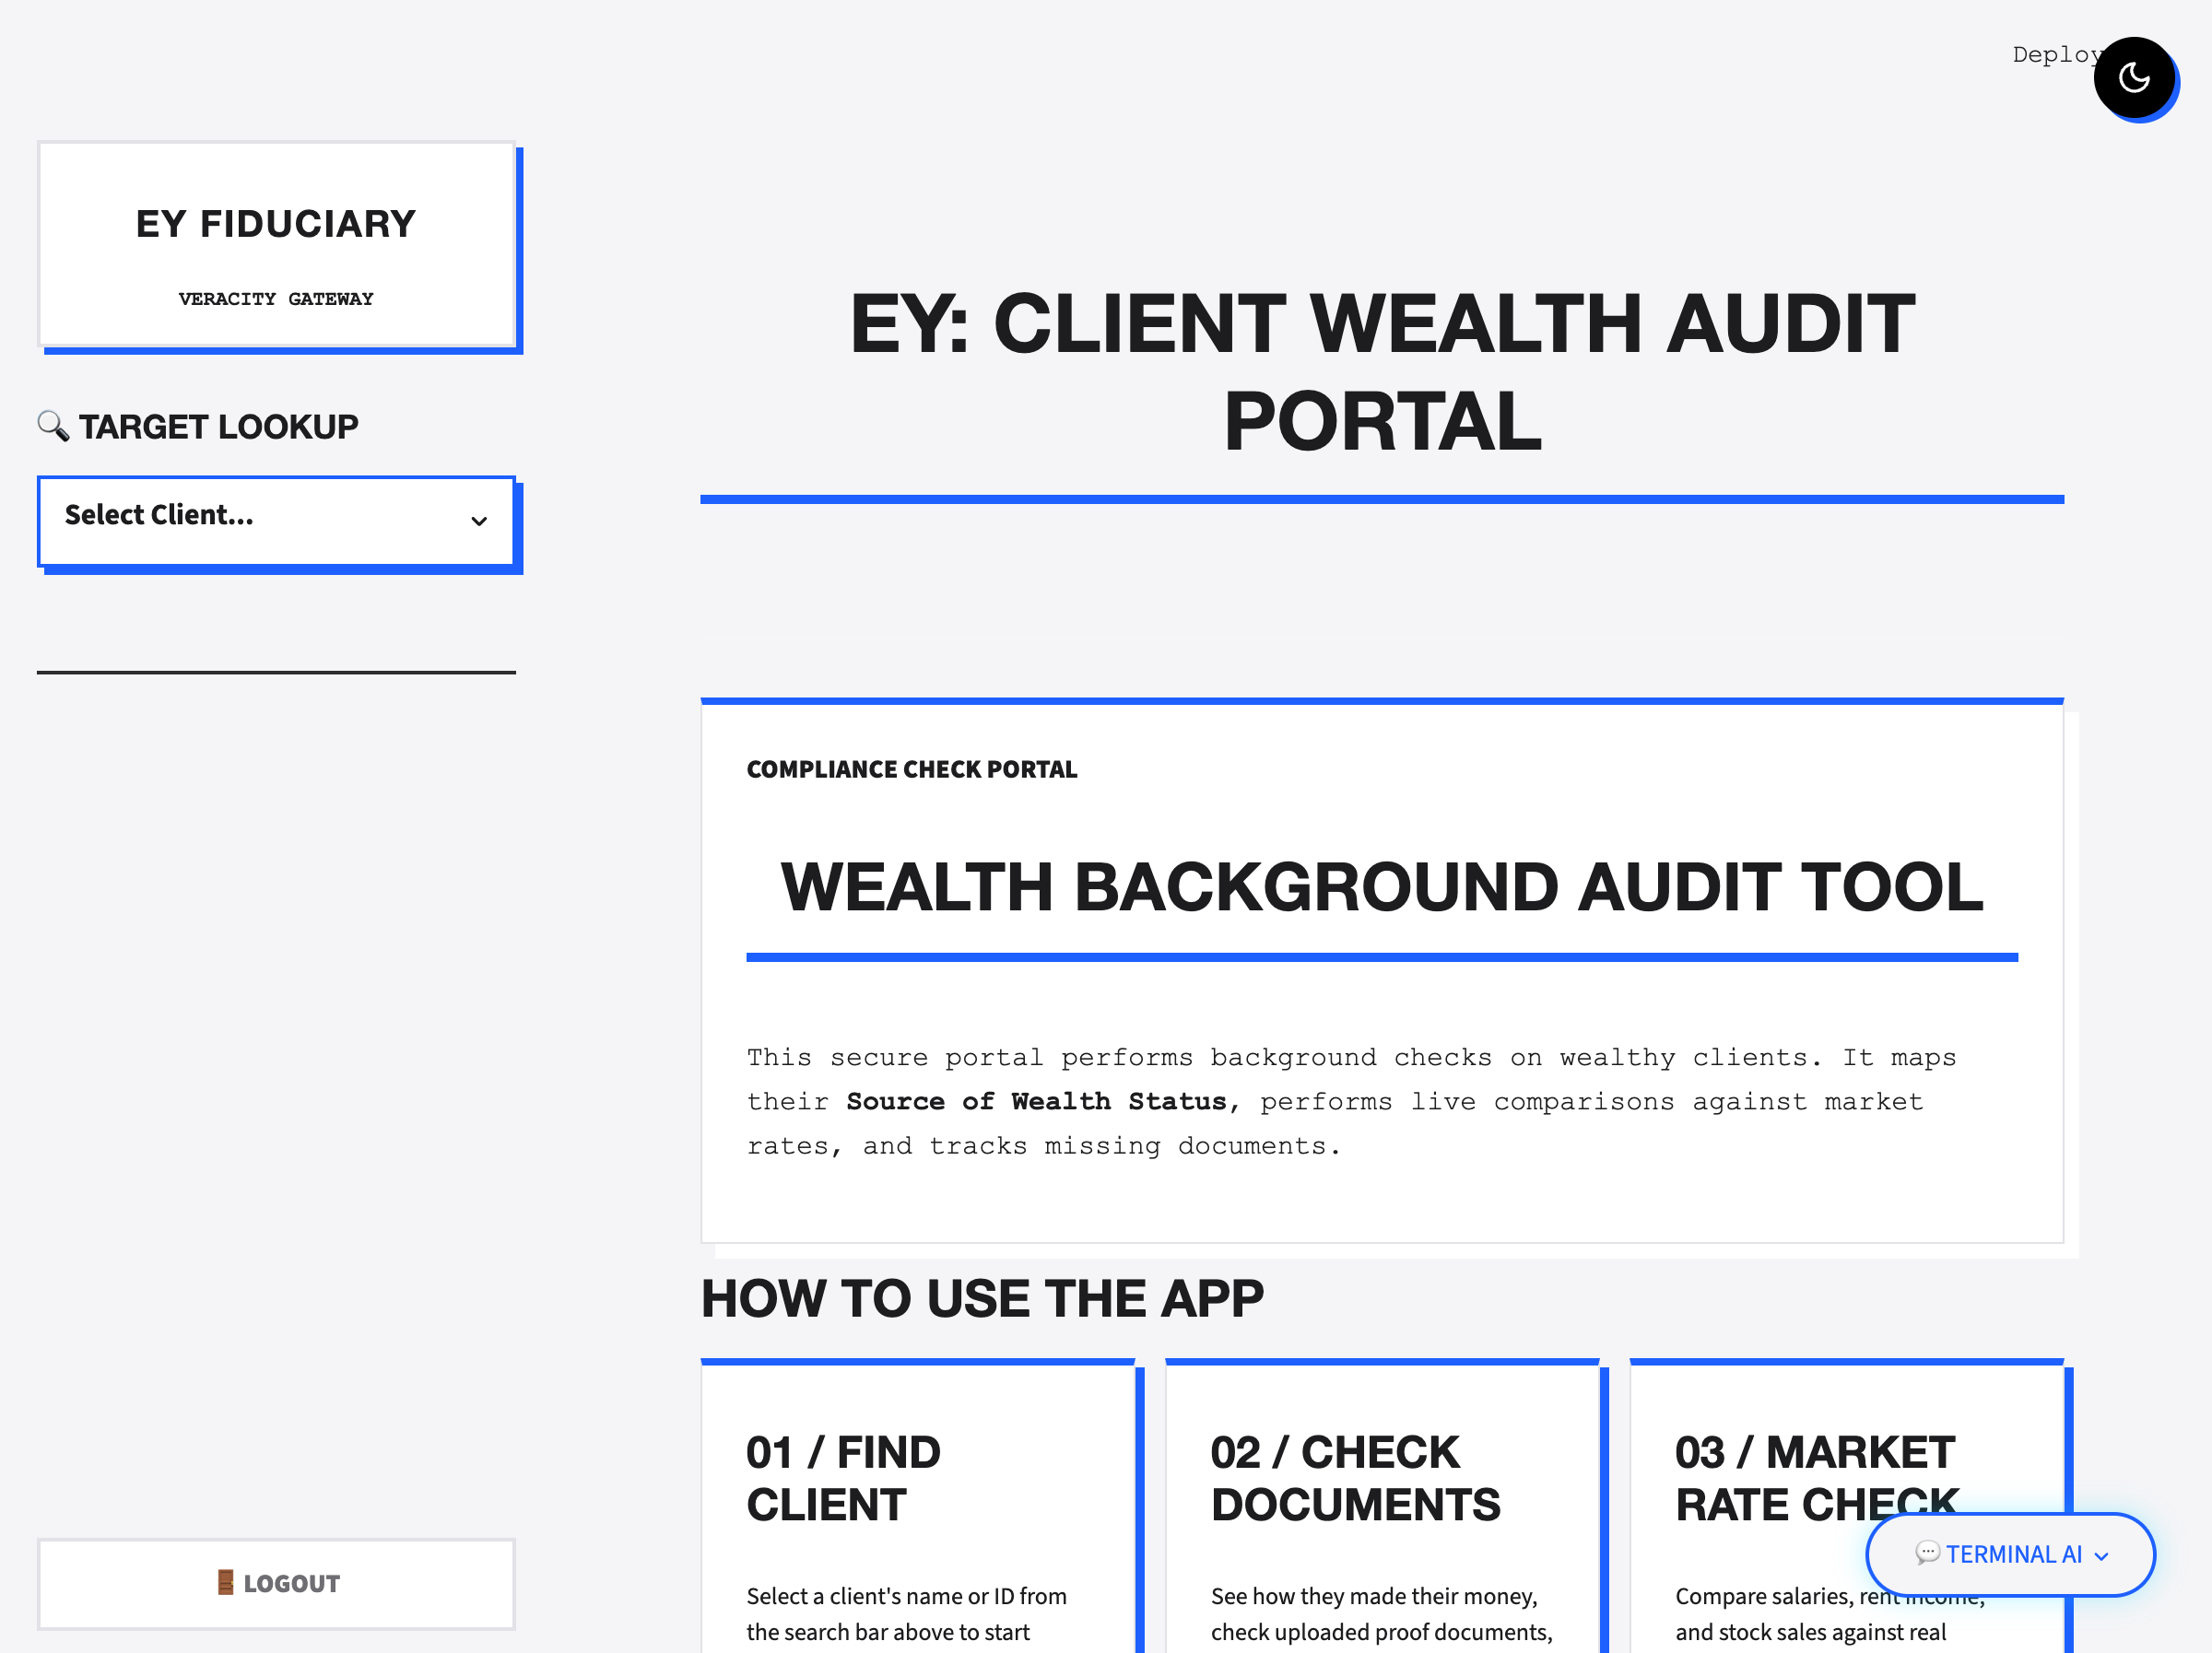
Figure 2.2: Post-authentication gateway dashboard landing screen.

2.2 Client Profile Summary
Enables targeted profile lookups, displaying nationality, account history tenure, active wealth streams, and net worth estimations.
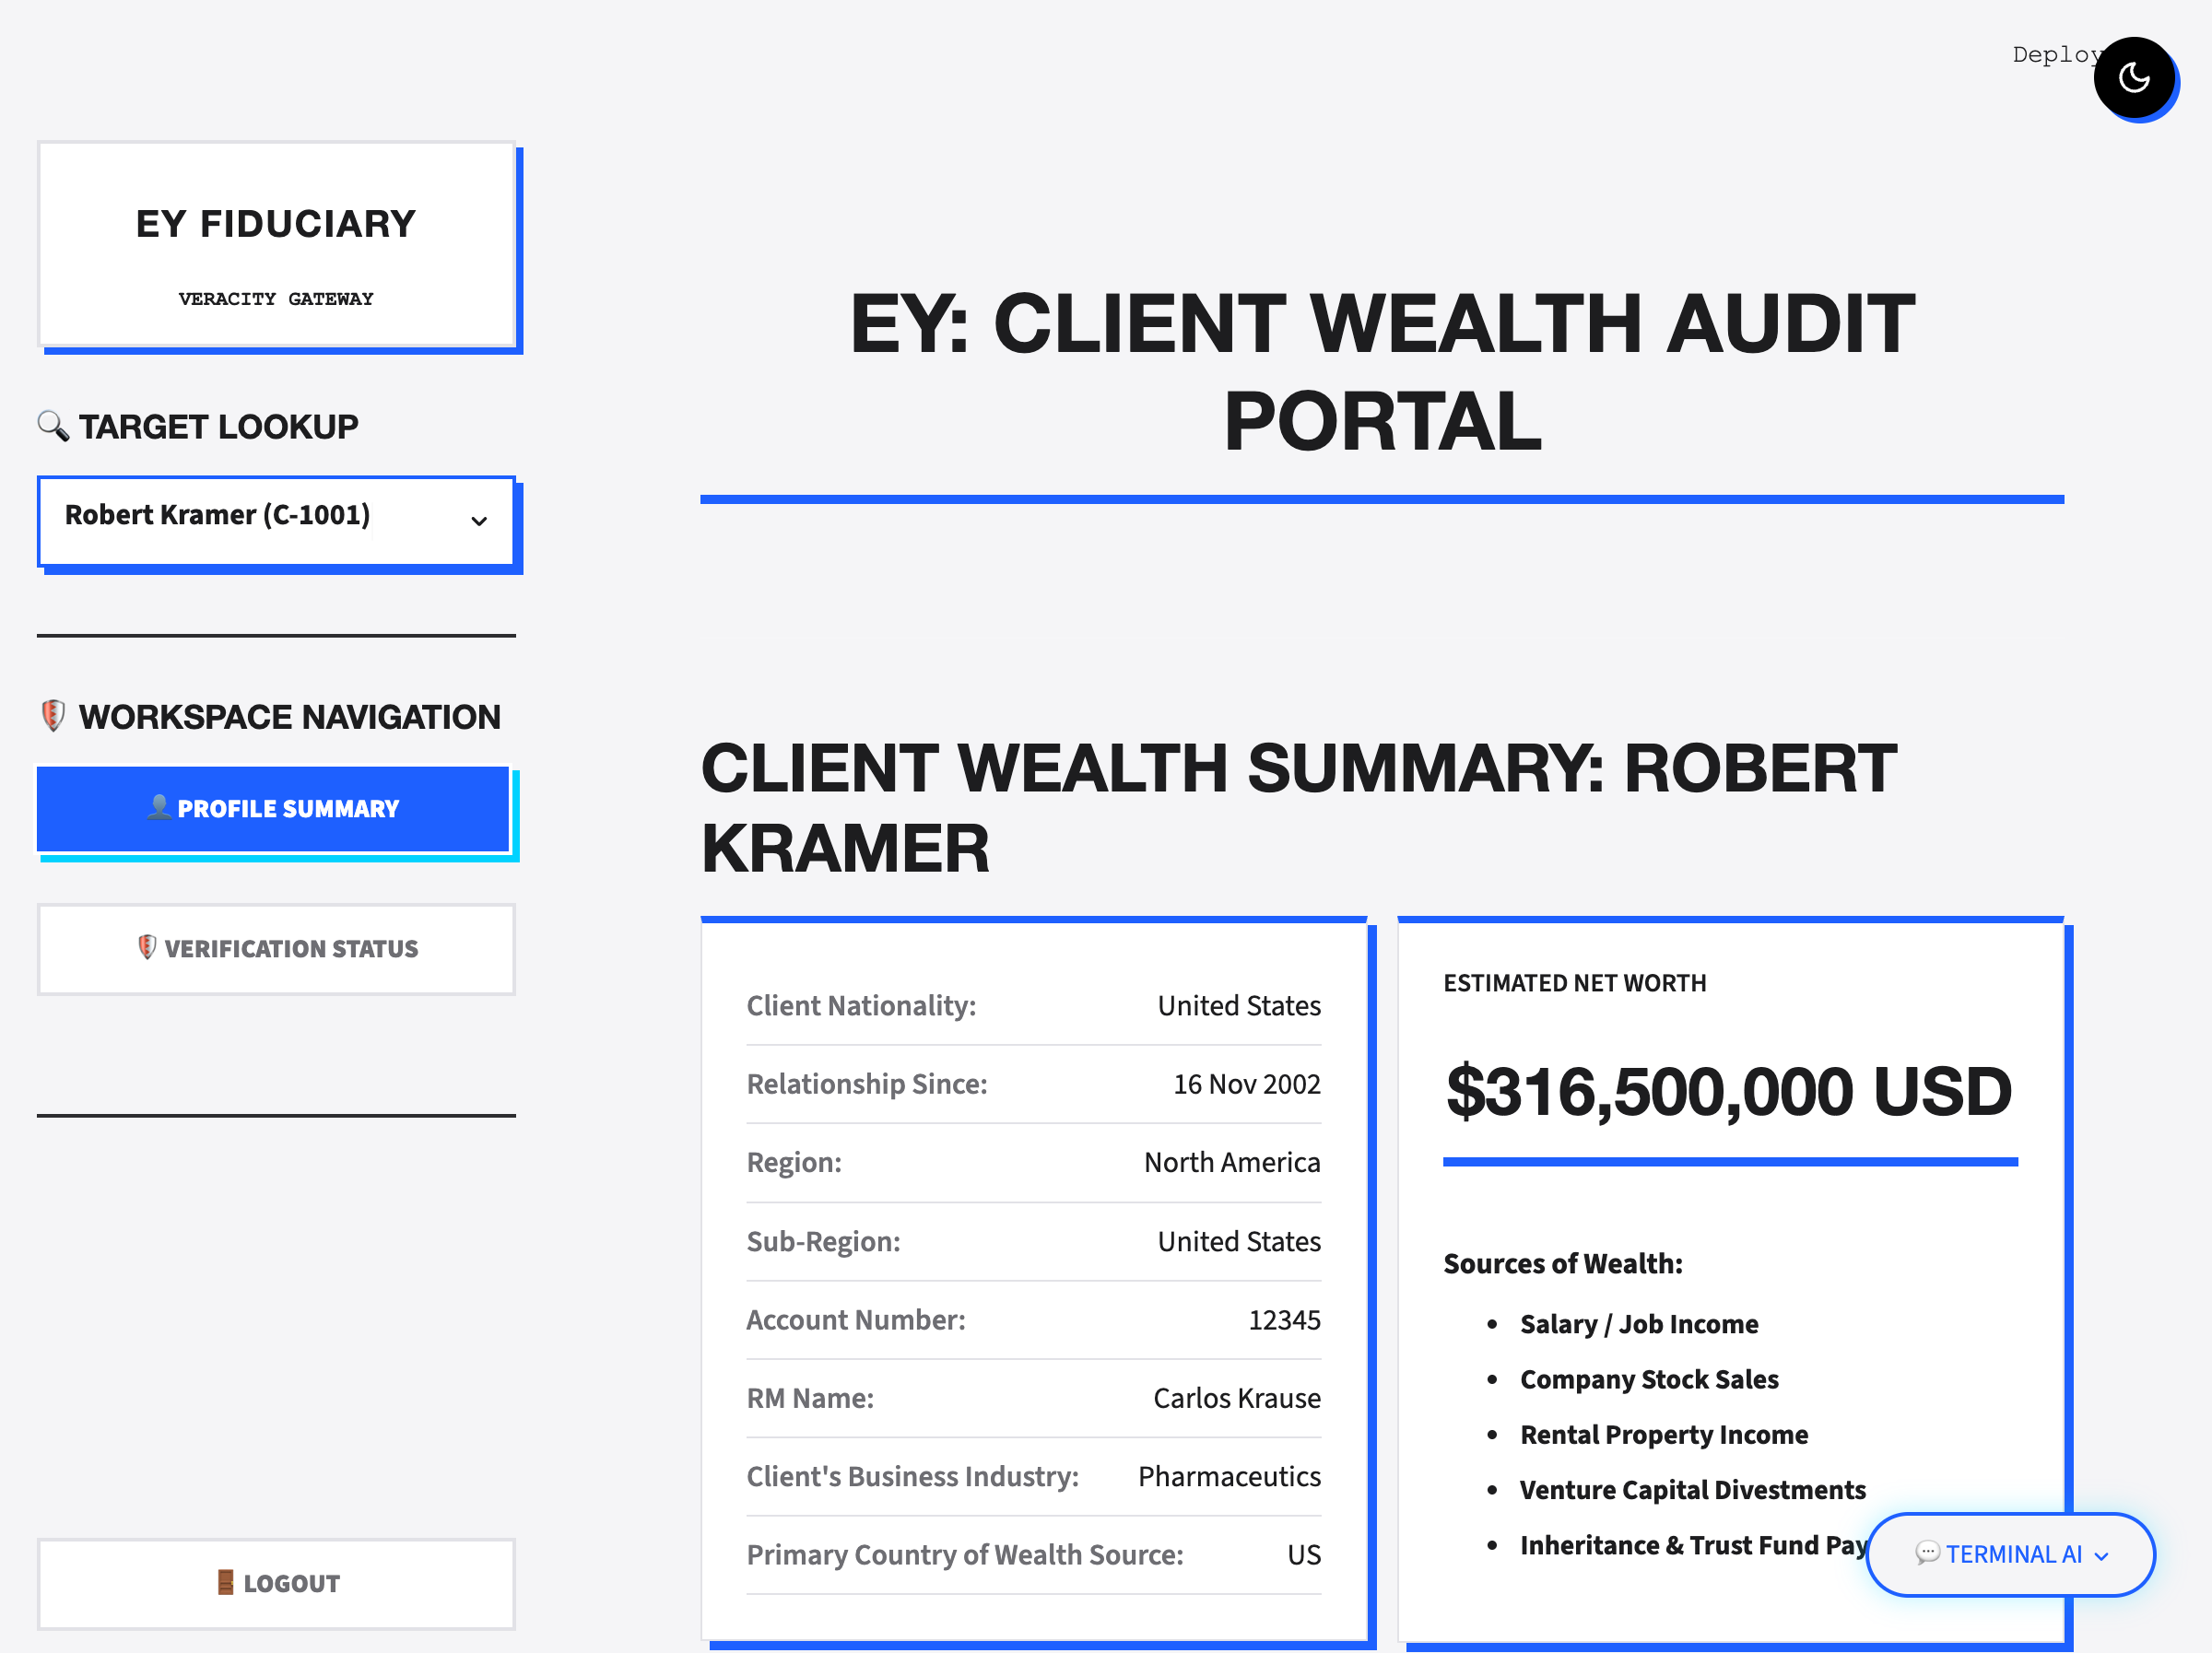
Figure 2.3: Audited Client Profile Summary dashboard.

2.3 SOW Compliance Matrix & Ledger
Tracks document availability (Fully Available, Partially Available, Not Available, N/A) and lists timeline details across a 60-month tabbed grid for ledger verification.
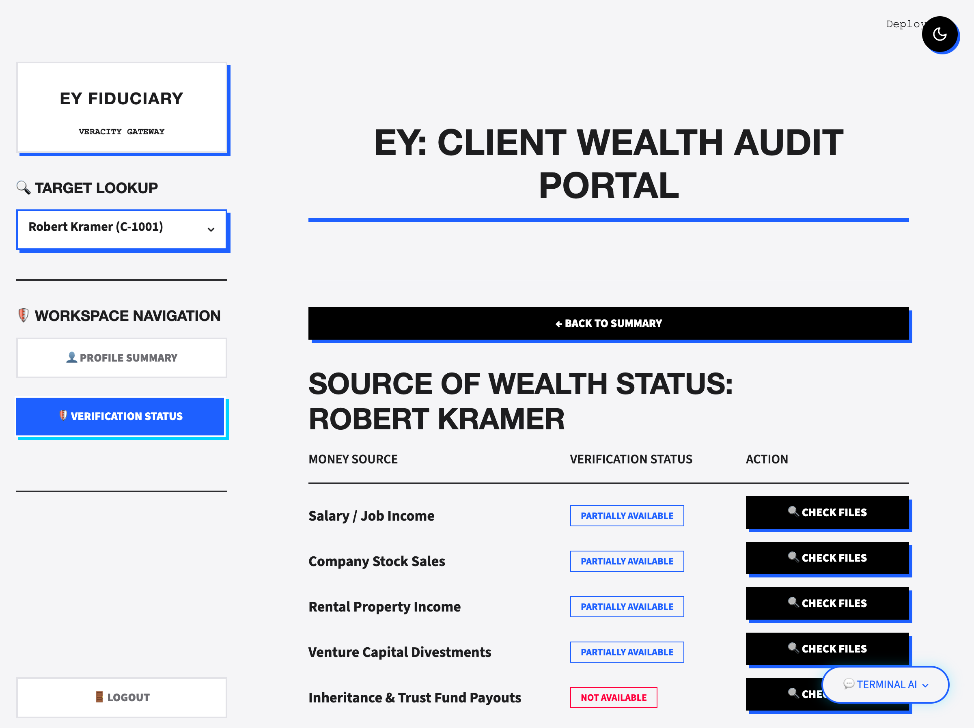
Figure 2.4: Compliance checklist matrix.
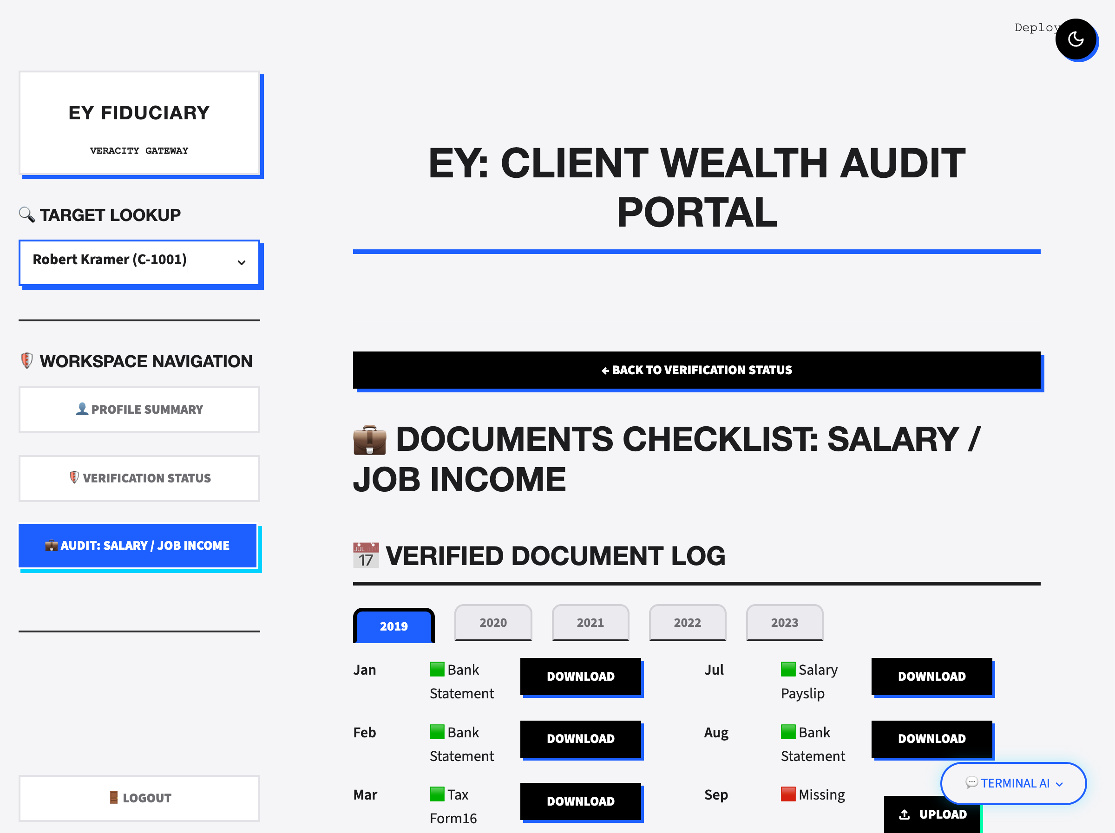
Figure 2.5: Yearly timeline ledger compartment.

2.4 Salary & Job Income Plausibility Calibration
Salary verification runs a month-over-month historical alignment mapping. For each audited month in the 60-month grid, the engine cross-references the reported company and role active at that date against client career segments. To establish baseline rates, the system scrapes regional salary ranges (e.g. Glassdoor, LinkedIn, AmbitionBox) via SerpAPI. RMs can toggle these scraped sources in the UI, updating the Plotly baseline overlay. Missing months (red slots) display the expected salary benchmark value (marked with 'x' indicators) directly on the trend chart.
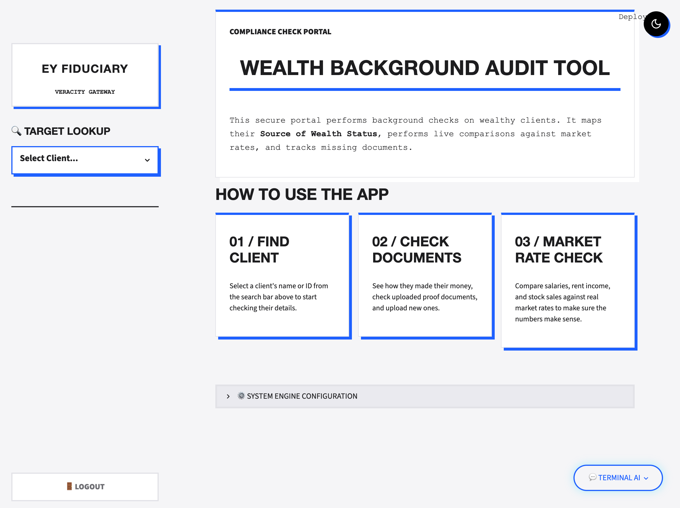
Figure 2.6: Salary market calibration and expected baseline trendline.

2.5 Rental Property Yield & Conformance Modeling
Rental income plausibility is checked using a multi-factor mathematical formula applied to the client's property metadata (area, base rate, tier, property type, and density factor):
Typical Monthly Rent = Area (sq ft) * Base Rate * Loc_Mult * Type_Mult * Density_Mult
Where multipliers are configured based on tier (Tier 1 Metro = 1.4, Tier 2 City = 1.0, Tier 3 City = 0.7), classification (Prime Commercial = 1.3, SEZ Office = 1.1, Suburban Residential = 0.8), and population density demand (High = 1.2, Medium = 1.0, Low = 0.8).
To calibrate this calculated base, the portal scrapes online property indices (99acres, MagicBricks, Housing.com) via SerpAPI. The average actual documented rent is divided by the calculated base to produce a conformance ratio. If the ratio is within 0.75 and 1.25, the yield is marked as matching standard rates. Values exceeding 1.25 are flagged as unusually high (red status warning). Additionally, the expected rent baseline compounds a 10% annual escalation raise every 12 months.

2.6 Income Volatility & Anomaly Profiling
Calculates Month-over-Month (MoM) cash flow changes. Visualized using a Plotly bar chart, this profiler automatically flags transactions that deviate from the rolling standard deviation limits (+/- 2σ) as high-risk anomalies requiring RM review.
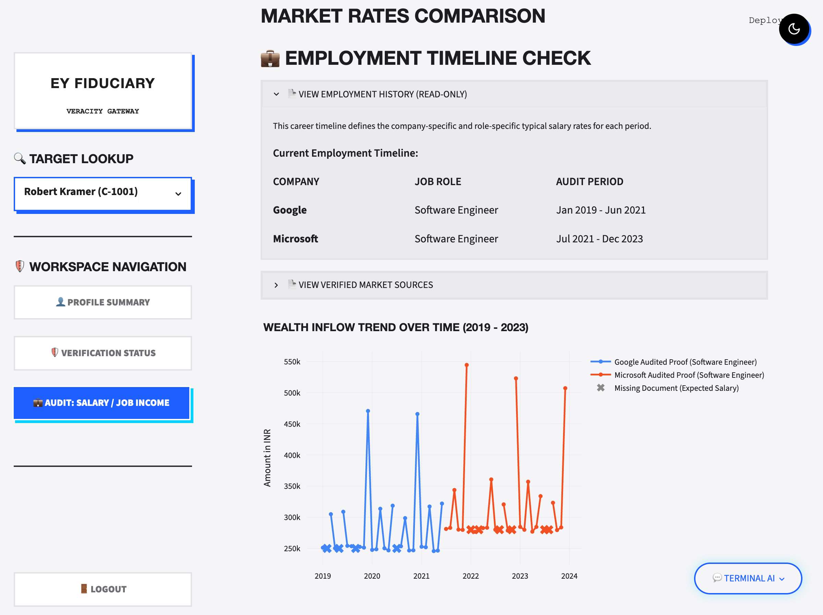
Figure 2.7: Volatility indexing and MoM cash flow limits.

3. System Architecture & Modules
Architecture Summary: The application is structured as a Streamlit-based dashboard integrating several core libraries:
• - Streamlit: Controls routing, layout views, and styling properties.
• - Pandas: Handles the database session state and outputs CSV/Excel logs.
• - Plotly: Generates the responsive timeline and volatility anomaly charts.
• - pdfplumber & LLM: Match uploaded PDF invoices and parse document text.
• - LangChain Agent: Queries client datasets using natural language inside the AI chatbot.

