Assignment 4

61075029H Jun Yu SHEN 沈峻宇

1. Temporal Differences TD(0):

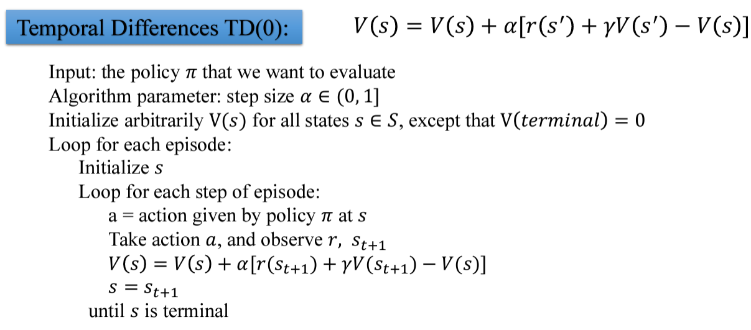

Result:

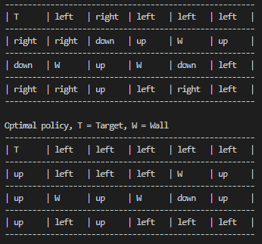

1. Code:

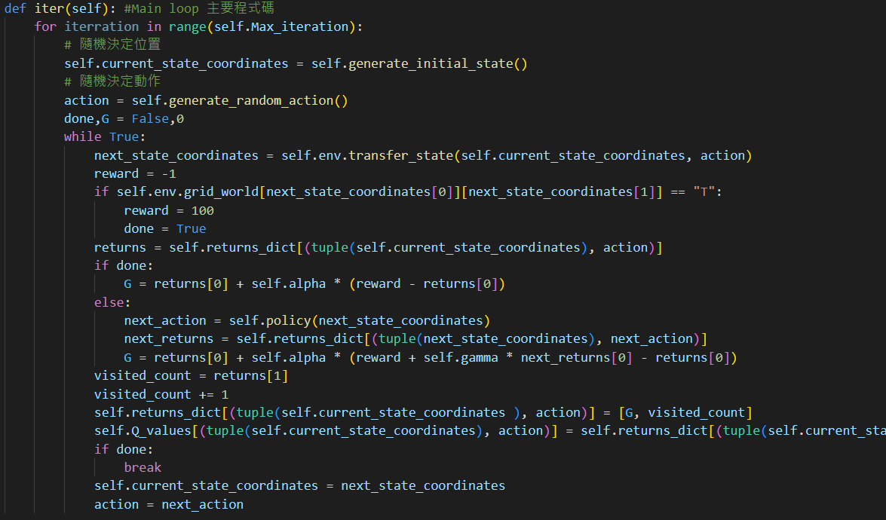

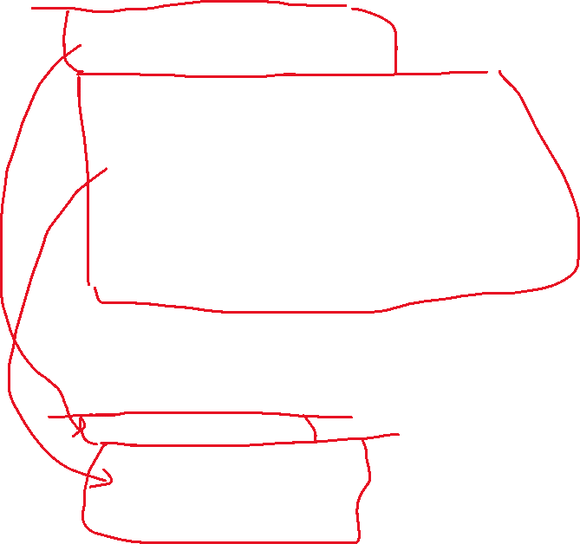

I have modified this section.





Almost all of the calculations in the program are done here. Only this part was modified and it was done