Assignment 7

61075029H Jun Yu SHEN 沈峻宇

1. After making a Custom environment, add your desired obstacles and change the reward function of the "GridWorld environment" and apply Q-Learning to solve the problem.

In this operation there is a new obstacle if the agent touches the obstacle will get a little penalty and the size of the terrain is set to the default 10 \* 10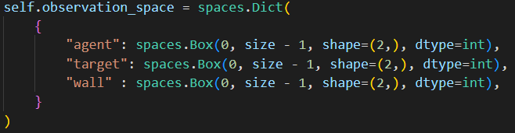

The bonus method in the example program has been modified a little bit. The original bonus will be given only when the end point is reached, but I have added that if the end point is not reached each time, the distance to the end point will be calculated and the penalty will be given.

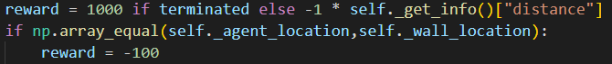

Result:

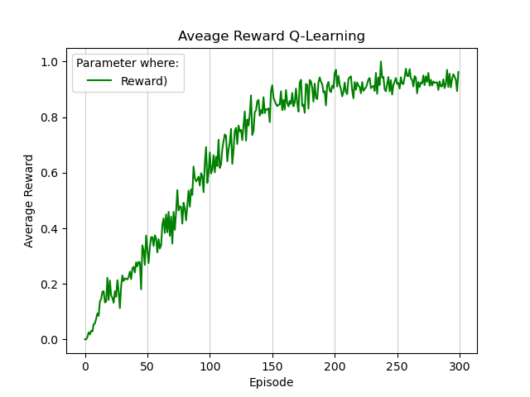

At the end there is also a good reward.