Technical & Executive Submission Dossier: City Bike-Sharing Demand Analytics & Operations Prototype
Prepared for: HR & Technical Interview Panel
Dataset: Official UCI Bike Sharing Dataset (Capital Bikeshare, Washington, D.C., 2011–2012)
Deliverables Covered: End-to-End Data Quality & Feature Engineering • Statistical Hypothesis Testing • Time-Aware ML Demand Estimation • Interactive Natural-Language Operations Prototype • Conditional Anomaly Detection

1. Executive Answer to the Core Business Question
Business Problem Statement:
*"Riders frequently complain about the unavailability of bikes, while several bikes remain unused across the city. Do we need to buy additional bikes, or can demand be addressed through better resource allocation and planning?"*

Data-Grounded Verdict: **Primarily a Resource Allocation & Dynamic Scheduling Problem — Combined with Targeted Fleet Expansion for Secular Growth**
Our empirical investigation of 17,379 hourly records (`3,292,679` total rentals across 731 days) reveals that simultaneous rider complaints ("no bikes available") and idle inventory ("unused bikes across the city") are driven by extreme temporal concentration rather than a high 24-hour average utilization rate:
- Extreme Temporal Peaking (The Root Cause of Stockouts + Idle Bikes):
- Across the entire two-year dataset, the mean hourly demand is only `189.5` rentals/hour (median `142.0`/hour), whereas the 99th-percentile peak reaches `782`–`977` rentals/hour.
- On working days (`n = 500` days), 51.3% of all daily rentals occur inside just 5 commuting hours (07:00–08:59 and 16:00–18:59). Demand spikes to `477` rentals/hour at `08:00` (90th percentile `692`/hr) and `525` rentals/hour at `17:00` (90th percentile `782`/hr), then drops by more than 60% during midday (`10:00–15:00`) and over 95% overnight (`00:00–05:00`).
- On non-working days (`n = 231` days), the temporal profile flips completely: morning commute demand collapses (`106` rentals/hr at `08:00`), and demand shifts to a broad midday recreational plateau (`12:00–16:00`, averaging `359–373` rentals/hr, 90th percentile `590–605`/hr).
- Implication: Buying more bikes without changing operations will simply leave *more* bikes sitting idle during the 19 non-peak hours of every working day. The primary lever is predictive pre-positioning and inter-peak rebalancing before 07:00 and between 10:00–15:30 on working days, and shifting staff to midday leisure corridors on weekends.
- Secular System Growth (+64.9% YoY) Requires Planned Capacity Scaling:
- Total annual ridership grew +64.9% from `1,243,103` rentals in 2011 (3,405.8/day) to `2,049,576` rentals in 2012 (5,599.9/day), with registered subscribers driving 81.2% of volume.
- Therefore, while daily stockouts are solved by time- and weather-aware reallocation, long-term capacity planning must account for the +64.9% secular shift in peak-hour demand (08:00 and 17:00–18:00).
- Critical Distinction Between "Rental Demand (`cnt`)" and "Physical Station Fleet Size":
- This dataset records system-wide hourly checkouts (`cnt`), not station-level origin–destination flows, trip durations, or dock capacities.
- Our machine-learning model predicts expected system-wide hourly rental demand with MAE = `43.54` rentals/hr and R² = `0.904` (cutting baseline error by 59.4%), and our prototype pairs this statistical prediction with an explicit, user-configurable Operational Safety Buffer (default `+15%`) so operations managers can translate expected checkouts into actionable shift targets without confusing operational buffers with model outputs.

2. Solution Architecture & Tech Stack

2.1 End-to-End Architecture
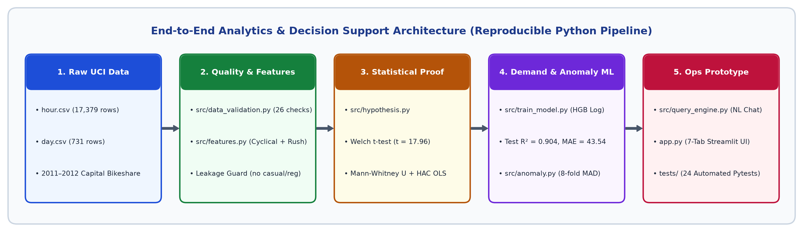
Figure: End-to-End Analytics and Decision Support Architecture

2.2 Technology Stack & Engineering Standards
Layer | Technology / Library | Purpose & Engineering Rationale
Language & Runtime | Python 3.14 (.venv) | Reproducible, isolated virtual environment with pinned dependencies in requirements.txt.
Data Processing | pandas, numpy | Vectorized schema validation, timestamp gap analysis, cross-table reconciliation, and cyclical feature engineering.
Statistical Inference | scipy.stats, statsmodels | Welch's unequal-variance t-test, Mann-Whitney U test, Levene's variance test, Shapiro-Wilk test, 10,000-draw bootstrap CIs, and Ordinary Least Squares with Newey-West HAC (7-lag) standard errors to handle serial correlation.
Machine Learning | scikit-learn, joblib | TransformedTargetRegressor (log(1 + y) forward / exp(ŷ) - 1 inverse), HistGradientBoostingRegressor (squared-error & Poisson loss), RandomForestRegressor, expanding-window chronological CV, and permutation importance.
Visualization | matplotlib, plotly | Publication-grade static diagnostic figures (outputs/figures/*.png) and interactive Plotly charts inside Streamlit.
Interactive Prototype | streamlit | 7-tab operations dashboard with real-time what-if sliders, safety buffer controls, and conversational chat UI.
Natural-Language Engine | Regex Intent/Entity Parser (re) + Optional OpenAI-compatible API | Works 100% offline without an API key; guarantees zero hallucinated numbers by routing every query to deterministic pandas / model calculations.
Quality Assurance | pytest, streamlit.testing.v1.AppTest | 24 automated unit and integration tests verifying data integrity, leakage prevention, chronological splits, nonnegative predictions, NL intents, and headless UI execution.

3. Deliverable 1: Data Quality Checks & Feature Engineering
Implementation: src/data_validation.py, src/features.py, reports/data_quality_report.md

3.1 Comprehensive Audit of the Raw Dataset
Before building any model, we ran 26 automated programmatic checks across hour.csv and day.csv:
Check Category | Verification Performed | Empirical Result | Engineering Decision
Dimensions & Schema | Exact row and column counts vs. UCI specification | hour.csv: 17,379 × 17; day.csv: 731 × 16 | PASS — Verified via SHA-256 and row counts.
Missing & Duplicate Records | Cell-level NaN, duplicate rows, duplicate instant, duplicate (dteday, hr) | 0 missing cells, 0 duplicate rows, 0 duplicate keys | PASS — Strictly monotonic timestamps.
Component Identity | Check cnt == casual + registered on every row | 0 mismatches across all 17,379 hourly and 731 daily rows | PASS — casual and registered are exact additive components of cnt.
Cross-Dataset Reconciliation | Sum casual, registered, cnt in hour.csv by dteday and compare to day.csv | 0 dates disagree (max absolute difference = 0) | PASS — day.csv is the exact daily sum of hour.csv.
Hourly Sequence Completeness | Compare observed timestamps against full 731 × 24 = 17,544 hourly grid | 165 absent hours across 76 calendar dates (655 days have 24 hrs; 62 have 23 hrs; 14 have ≤ 22 hrs) | DOCUMENTED, NOT IMPUTED — Absent hours correspond to zero-checkout overnight hours or storm shutdowns (e.g., 23 missing hours on 2012-10-29 during Hurricane Sandy).
Season Coding Audit | Cross-tabulate season (1..4) against calendar dates | Transitions occur on astronomical equinoxes/solstices (Mar 21, Jun 21, Sep 23, Dec 21) | CRITICAL INSIGHT — Code 1 (labeled springer in README) spans ~Dec 21–Mar 20. Dashboard provides an explicit toggle between Official README and Astronomical Calendar labels.
Physical Sensor Checks | Inspect temp, atemp, hum, windspeed ranges ([0, 1]) | 22 rows on `2011-03-10` have `hum == 0.0`; 2,180 rows have windspeed == 0.0 | FLAGGED — 0% humidity on a rainy day (weathersit = 3) is a sensor dropout; retained with documentation.
Distributional Outliers | Global IQR fence (cnt > 642.5) and conditional robust z-score (∣z_robust∣ > 3.5 within hr × workingday) | 505 global IQR outliers; 438 conditional outliers | RETAINED — Unlike the reference R report that erased extremes via tsclean(), we preserve real rush-hour peaks and storm drops.

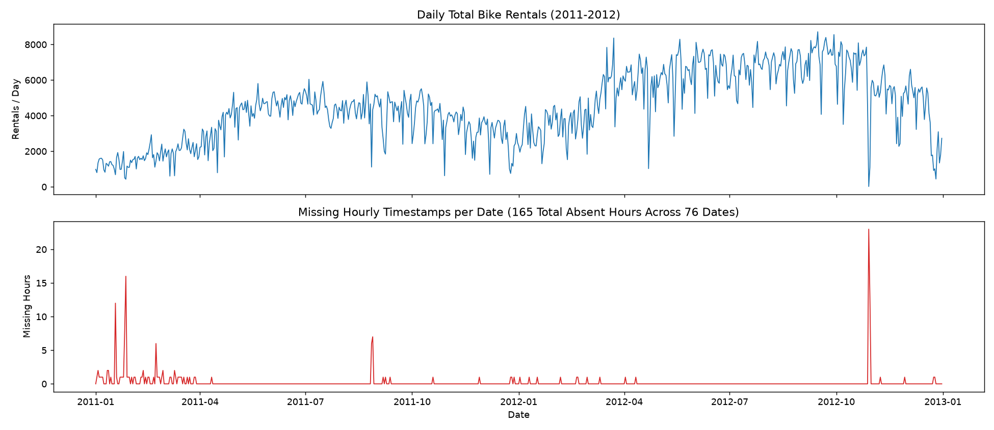
Figure: Daily Rentals and Missing Hourly Timestamps

3.2 Feature Engineering & Target Leakage Prevention
Every feature engineered in src/features.py is a deterministic function of calendar and weather inputs—meaning zero target statistics leak across time and the exact same function transforms training batches, test batches, and single what-if scenarios in the Streamlit app:
- Physical De-Normalization (for human interpretability):
- temp_c = 41.0 × temp (°C), atemp_c = 50.0 × atemp (°C), hum_pct = 100.0 × hum (%), windspeed_kmh = 67.0 × windspeed (km/h).
- Cyclical Fourier Encodings (preserving circular continuity at midnight, week wrap-around, and Dec → Jan):
- Hour of Day (24-hr cycle): hr_sin = sin(2π · hr / 24) and hr_cos = cos(2π · hr / 24)
- Day of Week (7-day cycle): weekday_sin = sin(2π · weekday / 7) and weekday_cos = cos(2π · weekday / 7)
- Month of Year (12-month cycle): mnth_sin = sin(2π · (mnth - 1) / 12) and mnth_cos = cos(2π · (mnth - 1) / 12)
- Behavioral Regime & Weather Interaction Indicators:
- is_weekend: 1 if weekday ∈ {0, 6} (Sunday/Saturday), 0 otherwise.
- is_commute_hour: 1 if hr ∈ {7, 8, 16, 17, 18}, 0 otherwise.
- workday_commute = is_commute_hour × workingday: Captures the sharp bimodal rush-hour regime specific to working days.
- Hard Guard Against Target Leakage:
- casual and registered sum identically to cnt (cnt = casual + registered). Including either would constitute 100% target leakage.
- instant is an arbitrary row counter that proxies time linearly.
- assert_no_leakage() raises a ValueError if any of ("casual", "registered", "cnt", "instant") ever appears in the predictor list, and is verified by unit tests.
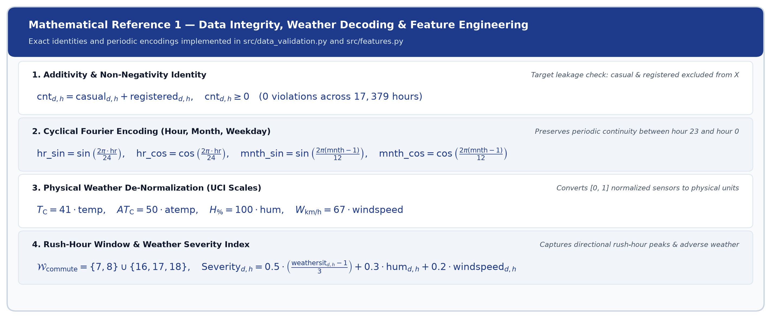
Figure: Mathematical Reference 1 — Data Integrity, Weather Decoding and Feature Engineering
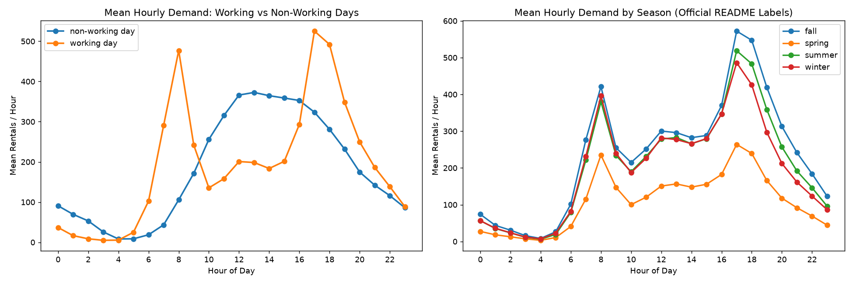
Figure: Hourly, Seasonal, Weather, and Temperature Demand Patterns
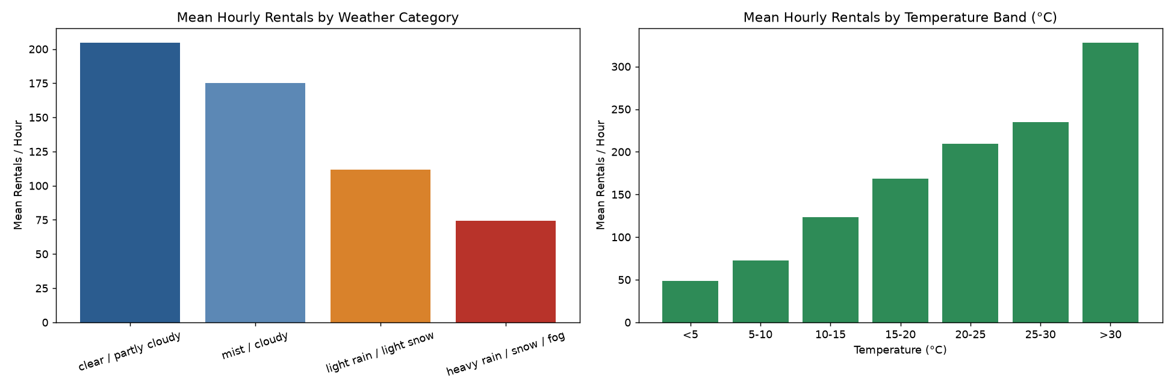
Figure: Weather Situation and Temperature Band Profiles

4. Deliverable 2: Hypothesis Formulation & Statistical Testing
Implementation: src/hypothesis.py, reports/hypothesis_results.md

4.1 Pre-Registered Experimental Design
To test whether weekday commuter peaks are structurally different from weekend/holiday demand during rush hours, we fixed the experimental design in src/config.py prior to testing:
- Research Question: Is bike demand during commuting hours higher on working days than on non-working days?
- Predefined Commuting Windows: Morning hr ∈ {7, 8} (07:00–08:59) and Evening hr ∈ {16, 17, 18} (16:00–18:59).
- Unit of Analysis: One calendar date (N = 731 days), where the daily commuting-window outcome is Y_d = Σ cnt_{d,h} summed over h ∈ {7, 8, 16, 17, 18}. Aggregating to the daily level avoids pseudoreplication across hours within the same day.
- Null Hypothesis (H₀): μ_working = μ_non-working (mean daily commuting-window demand is equal on working and non-working days).
- Alternative Hypothesis (H₁, one-sided): μ_working > μ_non-working at significance level α = 0.05.
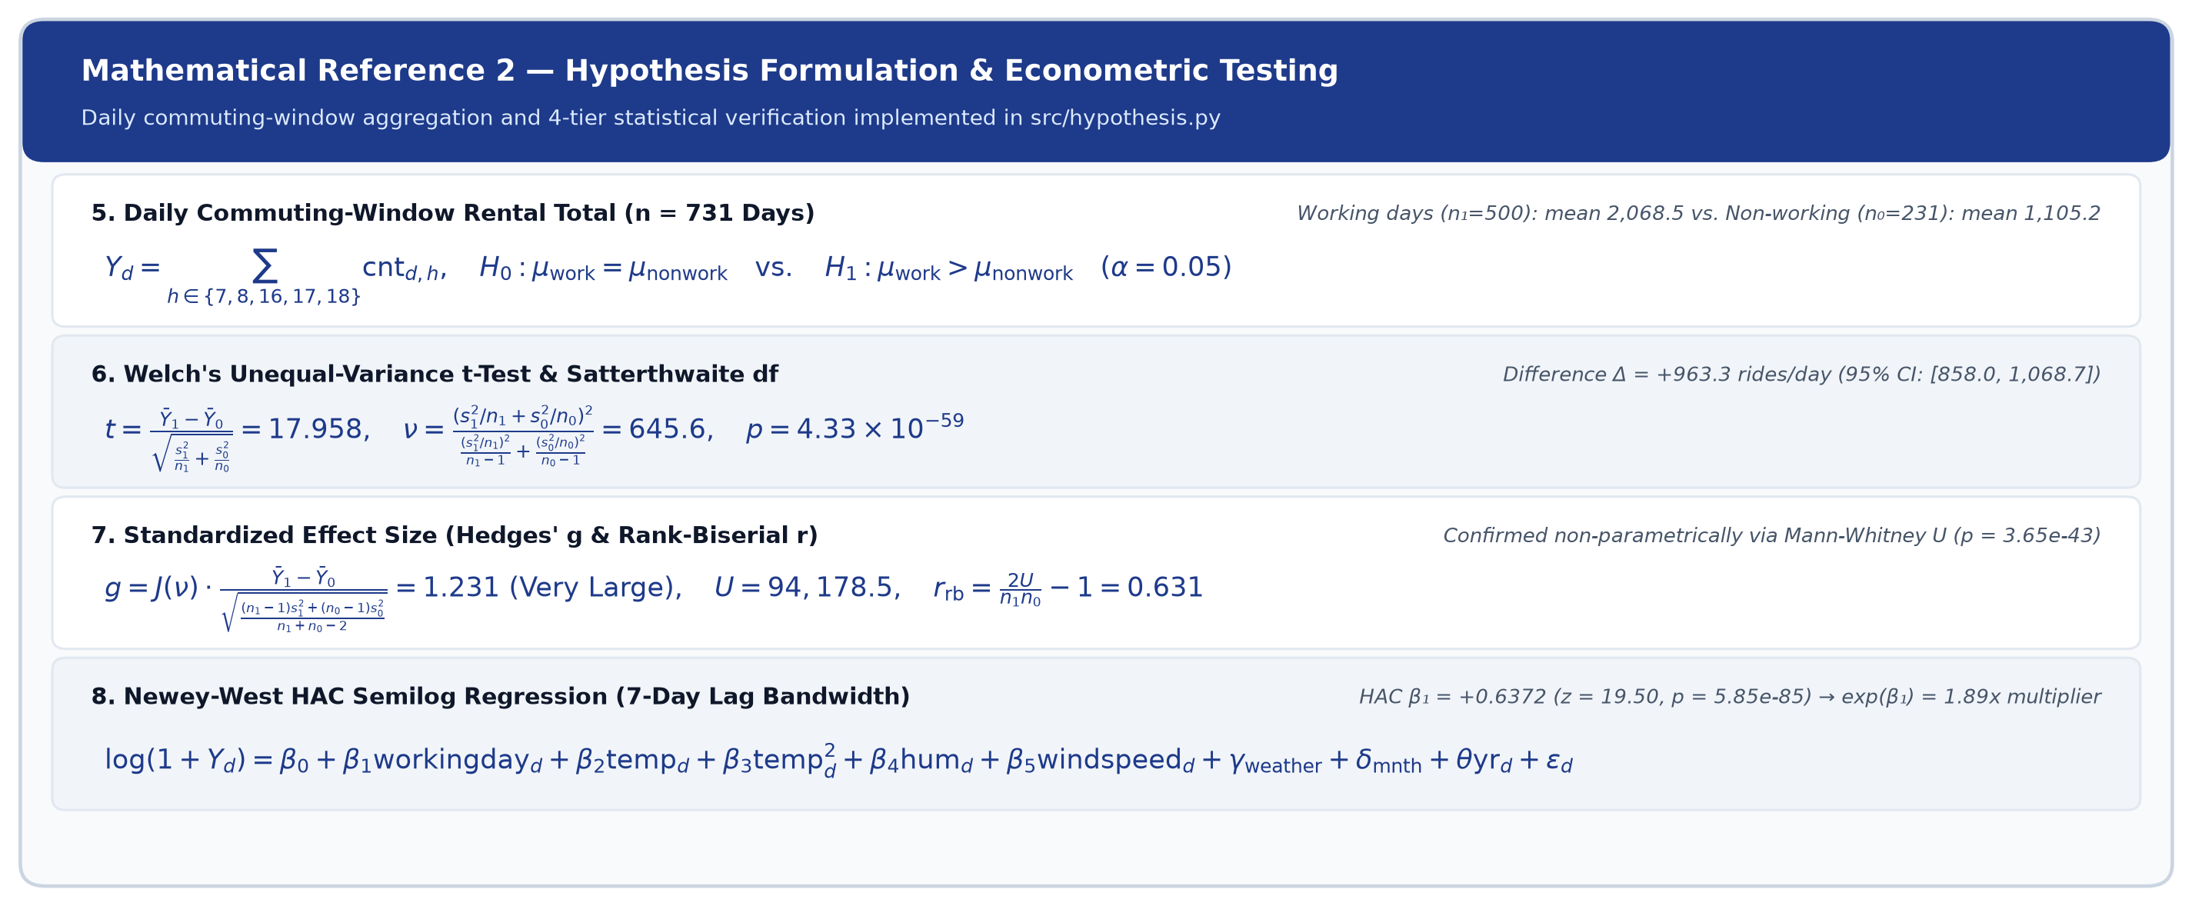
Figure: Mathematical Reference 2 — Hypothesis Formulation and Econometric Testing

4.2 Statistical Test Results & Robustness Checks
Analysis / Subset | n_work / n_non-work | Working Mean (Median) | Non-Working Mean (Median) | Mean Diff (95% Welch CI) | Welch t (df) | One-Sided p-Value | Effect Size (Hedges' g)
Primary (All 731 Days) | 500 / 231 | 2,068.5 (2,078.0) | 1,105.2 (1,096.0) | +963.3 ([858.0, 1,068.7]) | 17.96 (645.6) | `4.33 × 10⁻⁵⁹` | 1.23
Complete 5-Hr Windows Only | 495 / 230 | 2,087.3 (2,093.0) | 1,109.4 (1,100.0) | +977.9 ([873.4, 1,082.4]) | 18.38 (636.2) | `3.89 × 10⁻⁶¹` | 1.27
2011 Only (`yr = 0`) | 250 / 115 | 1,535.6 (1,739.0) | 858.6 (880.0) | +677.0 ([570.6, 783.4]) | 12.52 (302.6) | `1.48 × 10⁻²⁹` | 1.24
2012 Only (`yr = 1`) | 250 / 116 | 2,601.4 (2,702.0) | 1,349.6 (1,471.0) | +1,251.8 ([1,108.8, 1,394.8]) | 17.23 (282.1) | `2.87 × 10⁻⁴⁶` | 1.77
Weekends Only (Excl. 21 Holidays) | 500 / 210 | 2,068.5 (2,078.0) | 1,107.0 (1,100.0) | +961.5 ([855.2, 1,067.8]) | 17.76 (597.1) | `2.72 × 10⁻⁵⁷` | 1.23

- Nonparametric Confirmation: Mann-Whitney U = 94,178.5, one-sided p = 3.65 × 10⁻⁴³, rank-biserial correlation r_rb = 0.631; 10,000-draw bootstrap 95% CI for the mean difference is [857.3, 1,069.2].
- Accounting for Serial Dependence & Weather Confounding:
- Group-demeaned daily residuals exhibit lag-1 autocorrelation r₁ = 0.79 (Durbin-Watson = 0.41) because ridership evolves smoothly across seasons and weather spells.
- We therefore estimated an Ordinary Least Squares model with Newey-West HAC standard errors (`maxlags = 7`) controlling for quadratic temperature, humidity, wind speed, worst daily weather code, month fixed effects, and year:
- Regression Specification: log(1 + Y_d) = β₀ + β₁·workingday_d + β₂·temp_d + β₃·temp_d² + β₄·hum_d + β₅·windspeed_d + γ_weathersit + δ_mnth + θ·yr_d + ε_d
- Even after controlling for all weather and calendar confounders (R² = 0.682), working days carry `exp(β̂₁) = 1.89×` (95% CI [1.77×, 2.02×], HAC z = 19.50, one-sided p = 5.85 × 10⁻⁸⁵) the commuting-window demand of non-working days (linear-scale adjusted difference +927.9 rentals/day, 95% CI [848.0, 1,007.9]).
- Secondary Weather Hypothesis (H₂): Days experiencing any precipitation (weathersit ≥ 3, n = 300) average 4,014 rentals/day vs. 4,846 rentals/day on dry/mist days (n = 431): Welch one-sided p = 3.02 × 10⁻⁹, Mann-Whitney p = 1.24 × 10⁻⁸, with an average within-season-year drop of -829 rentals/day.
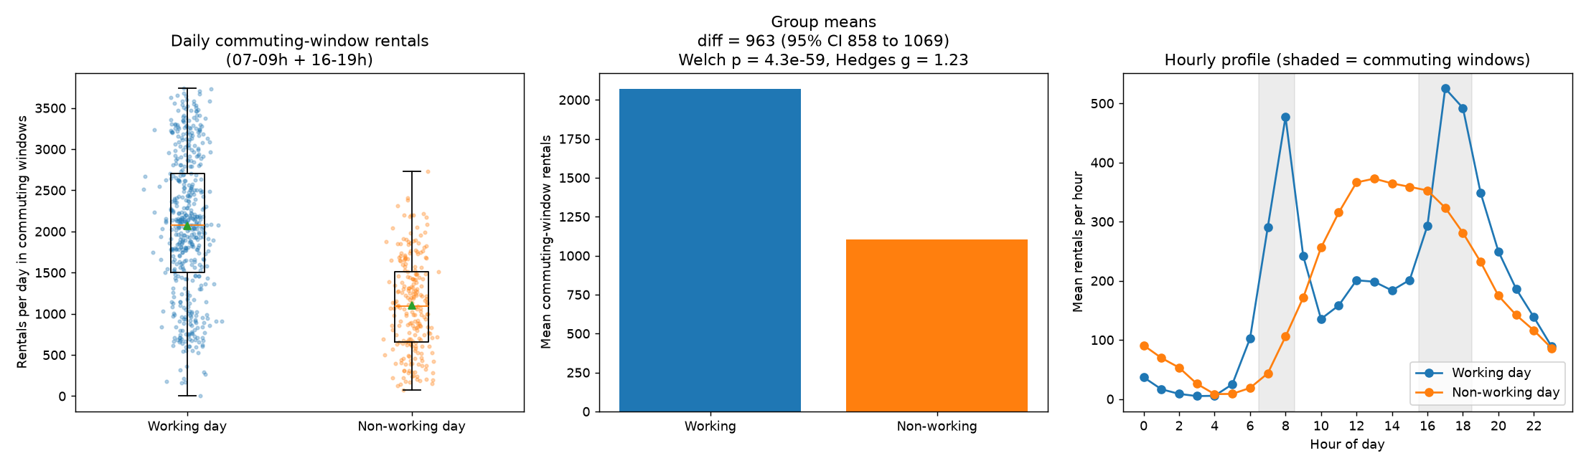
Figure: Hypothesis Test Visual Summary

5. Deliverable 3: Hourly Demand-Estimation Model
Implementation: src/train_model.py, src/predict.py, reports/model_results.md

5.1 Chronological Validation & Split Design (Zero Future Leakage)
Random train/test splitting is invalid for time-series demand estimation because adjacent hours share identical weather and unobserved demand shocks. We implemented a two-stage chronological evaluation protocol:
- Development Window (`2011-01-01 00:00` to `2012-06-30 23:00` — 13,003 hours, 18 months):
- Used for hyperparameter tuning via 4 expanding-window (rolling-origin) validation folds:
- Fold 1: Train 2011-01..2011-06 → Validate 2011-Q3 (Jul–Sep 2011)
- Fold 2: Train 2011-01..2011-09 → Validate 2011-Q4 (Oct–Dec 2011)
- Fold 3: Train 2011-01..2011-12 → Validate 2012-Q1 (Jan–Mar 2012)
- Fold 4: Train 2011-01..2012-03 → Validate 2012-Q2 (Apr–Jun 2012)
- Final Hold-Out Test Window (`2012-07-01 00:00` to `2012-12-31 23:00` — 4,376 hours, 6 months):
- Evaluated once after locking the winning model family and hyperparameters from the development folds.
- Why We Also Ran a Strict `2011 Train -> 2012 Test` Experiment:
- Because system ridership grew +64.9% between 2011 (yr = 0) and 2012 (yr = 1), any model trained exclusively on 2011 has zero variation in the yr feature and cannot learn the 2012 level shift.
- We ran both splits to quantify this exact phenomenon: on the strict 2011 → 2012 split, hgb_log still beats the baseline (RMSE 128.33 vs. 157.05, R² = 0.623 vs. 0.435), but suffers a `-89.65` rentals/hr negative bias because it predicts at 2011 volume levels. Including Jan–Jun 2012 in the development set allows the model to calibrate yr = 1 while keeping Jul–Dec 2012 strictly out-of-sample.
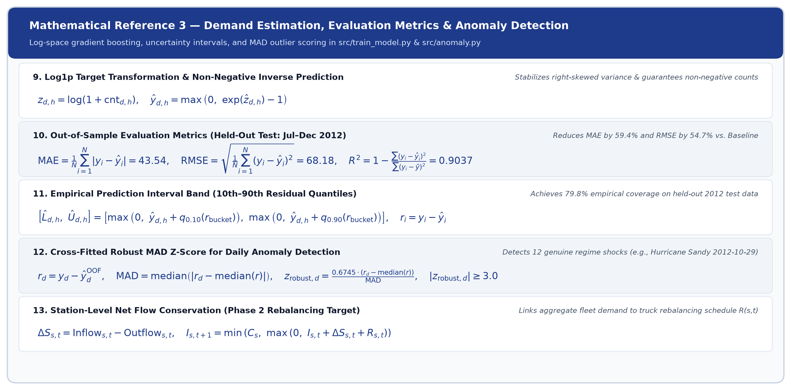
Figure: Mathematical Reference 3 — Demand Estimation, Evaluation Metrics and Anomaly Detection

5.2 Quantitative Model Comparison
Model Family | Best Hyperparameters (from Dev CV) | Dev CV RMSE | Dev CV MAE | Hold-Out Test MAE | Hold-Out Test RMSE | Hold-Out Test R² | Hold-Out Mean Bias
Baseline (`hr × workingday` mean) | Historical lookup table | 105.22 | 73.46 | 107.21 | 150.35 | 0.532 | -87.26
Random Forest (`rf_log`) | max_features=1.0, min_samples_leaf=1 | 77.96 | 52.80 | — | — | — | —
HistGradientBoosting (`hgb_poisson`) | lr=0.05, max_leaf_nodes=31, min_samples_leaf=50 | 69.64 | 46.09 | — | — | — | —
Selected: `hgb_log` (`log(1+y)` HGB) | lr=0.05, max_leaf_nodes=31, min_samples_leaf=50, l2=1.0 | 68.62 | 45.78 | 43.54 | 68.18 | 0.904 | -26.11

- 59.4% MAE Reduction & 54.7% RMSE Reduction: On the held-out Jul–Dec 2012 test set (mean actual demand = 254.1 rentals/hr), hgb_log achieves MAE = `43.54` rentals/hr, RMSE = `68.18` rentals/hr, and R² = `0.904`.
- Well-Calibrated 80% Prediction Intervals: Using out-of-fold 10th and 90th residual percentiles binned by predicted demand level on the development data, empirical coverage on the unseen Jul–Dec 2012 test set is 79.8% (target: 80.0%).
- Nonnegative-Output Policy: Combining the log(1 + y) target transform with max(0, exp(ẑ) - 1) guarantees that predictions and interval lower bounds are strictly nonnegative (≥ 0) under all possible inputs.
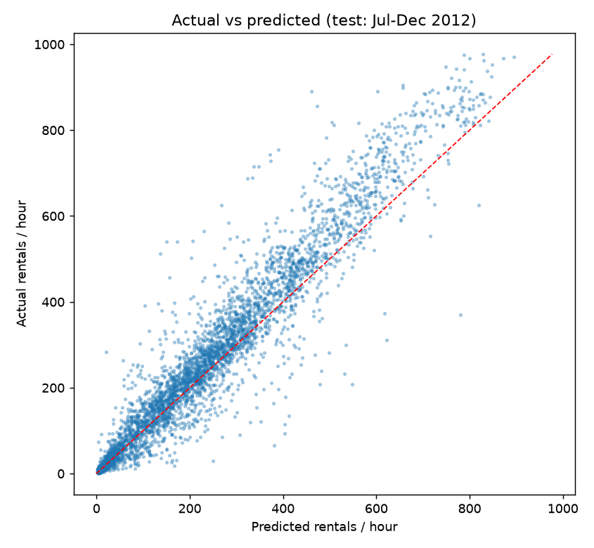
Figure: Actual vs Predicted Hourly Rentals on Test Period
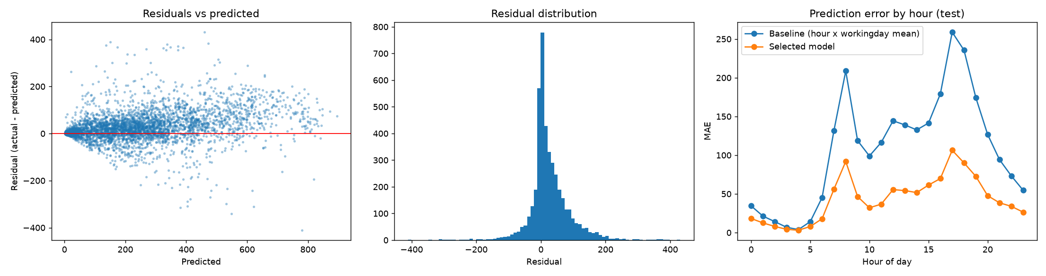
Figure: Residual Diagnostics and Hourly MAE Profile
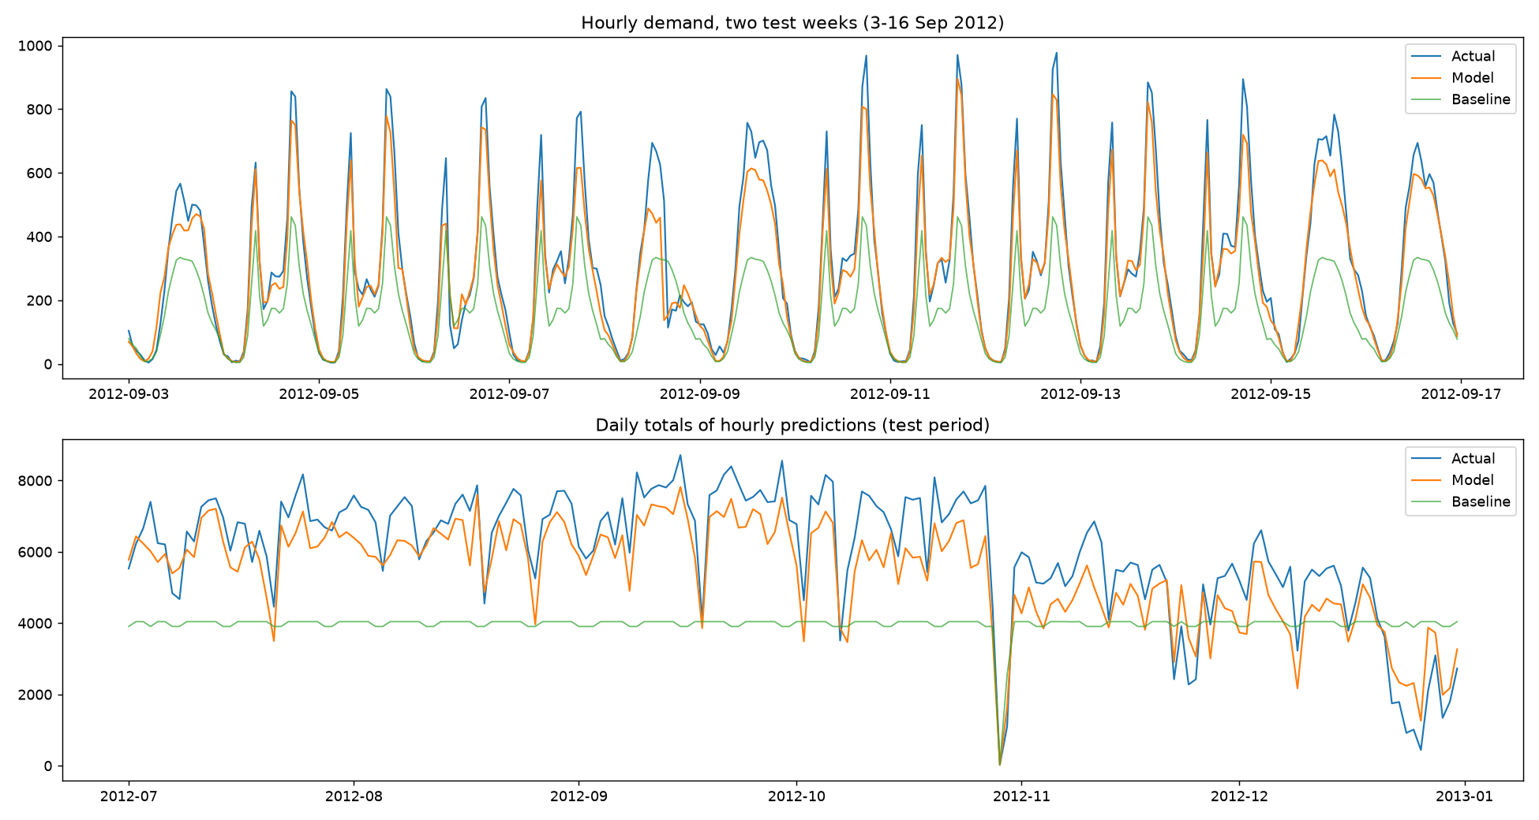
Figure: Chronological Test Window Comparison
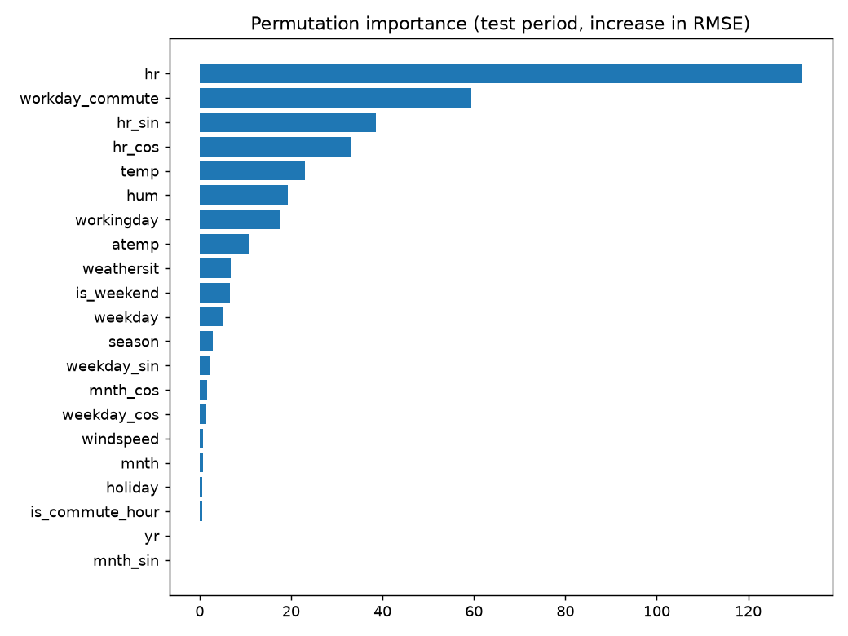
Figure: Permutation Feature Importance on Held-Out Test Set

6. Deliverable 4: Natural-Language Operations Prototype & Stretch Anomaly Detection
Implementation: app.py, src/query_engine.py, src/analysis.py, src/anomaly.py

6.1 How the Deterministic Natural-Language Engine Works
Rather than wrapping an LLM around raw text and risking hallucinated metrics, src/query_engine.py implements a two-stage deterministic NLU pipeline:
- Entity Extraction (`extract_entities`): Extracts hours (8 AM, 17:00, morning rush), weather categories (clear, light rain, heavy snow), physical weather values (22°C, 60% humidity, 15 km/h), day types (working day, weekend, holiday), specific weekdays, months, seasons, and years (2011, 2012).
- Intent Classification (`detect_intent`) & Grounded Execution (`HANDLERS`): Maps the query to one of 12 verified analytical handlers (peak_hours, compare_day_types, weather_effect, season_average, predict, monitor_hours, hypothesis, model_performance, anomalies, trend, hourly_pattern, overview). Every number, table, and chart is computed live from the validated dataset or trained model bundle. If a question is out of scope, the engine explicitly states that it will not guess and displays supported query templates.

6.2 Sample Computed Outputs for Core Operations Questions
Manager's Natural-Language Question | Detected Intent | Computed Grounded Response Summary
*"When is bike demand highest on working days?"* | peak_hours | Highest at `17:00` (`525` rentals/hr, 90th pct `782`), followed by `18:00` (`492`/hr, 90th pct `731`) and `08:00` (`477`/hr, 90th pct `692`).
*"Compare demand on working days and non-working days."* | compare_day_types | Working days average `4,585` rentals/day (bimodal peaks at 08:00 and 17:00, 84% registered) vs. `4,330` rentals/day on non-working days (single midday plateau 12:00–16:00 at `372`/hr, 69% registered).
*"How does weather affect rental demand?"* | weather_effect | Controlling for (hr, workingday, yr, mnth): Clear is `+8%` (205/hr), Mist is `-7%` (175/hr), Light rain/snow is `-40%` (112/hr), and Heavy rain/snow is `-66%` (74/hr, n = 3 hrs).
*"What is the average demand in summer?"* | season_average | Under official README labels (season = 2, ~21 Mar–20 Jun): `4,992` rentals/day (208/hr). Under calendar summer (season = 3, ~21 Jun–22 Sep): `5,644` rentals/day (236/hr).
*"Estimate bike rentals at 8 AM in summer on a working day."* | predict | Expected demand: `578` rentals/hr (indicative 80% range `461–691`; baseline = 477). With default +15% safety buffer: `665` bikes planning target.
*"Compare expected demand during clear weather and light rain."* | predict | Full-day working-day profile in summer: Clear weather → `6,003` rentals/day (peak 17:00 at 673/hr) vs. Light rain → `3,764` rentals/day (peak 17:00 at 451/hr) — a 37% drop.
*"Which hours should the operations team monitor most closely?"* | monitor_hours | Ranked by 90th-percentile busy-day load: 1) Working day `17:00` (p90 = 782), 2) Working day `18:00` (p90 = 731), 3) Working day `08:00` (p90 = 692), 4) Working day `16:00` (p90 = 524), 5) Working day `19:00` (p90 = 523), 6) Non-working day `13:00–15:00` (p90 = 590–605).

6.3 Stretch Goal: Conditional Anomaly & Event Detection
Instead of flagging raw high-demand days, src/anomaly.py uses 8-fold contiguous block cross-fitting on day.csv to compute expected 24-hour demand given season, year, month, holiday, weekday, working day, and weather, flagging days where |z_robust| ≥ 3.0 or shortfall ≤ -60%:
- Hurricane Sandy (`2012-10-29` & `2012-10-30`): Flagged with 22 actual vs. 2,451 expected rentals (-99.1%) on Oct 29 (only 1 hour logged before system suspension) and 1,096 actual vs. 2,855 expected (-61.6%) on Oct 30.
- Winter Blizzards & Ice Storms (`2011-01-27` & `2011-01-18`): Flagged with 431 actual vs. 2,418 expected (-82.2%) and 683 actual vs. 1,750 expected (-61.0%).
- Unmodeled Holiday Eves (`2012-12-24` & `2012-12-26`): Christmas Eve (coded as workingday = 1 in raw data) had 920 actual vs. 3,115 expected (-70.5%).
- Cherry Blossom & St. Patrick's Day Surge (`2012-03-17`): Flagged as the largest positive anomaly with 7,836 actual vs. 2,187 expected (+258.2%, `z_robust = +5.18`).
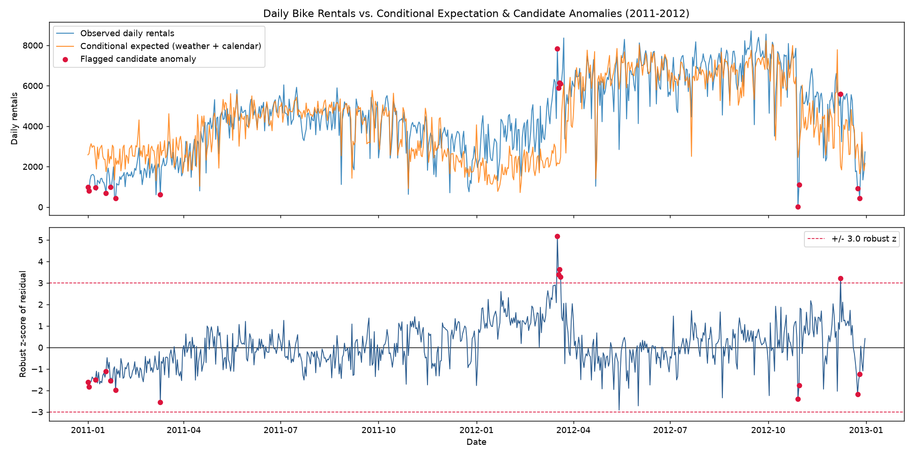
Figure: Conditional Anomaly Detection Across 2011-2012

7. Complete Mathematical & Statistical Formula Reference
To make every analytical step transparent for technical reviewers, the table below summarizes all 13 equations implemented in the codebase along with their variables and empirical outputs:
# | Analytical Component | Mathematical Formula (Unicode Notation) | Empirical Result / Operational Meaning
1 | Target Component Identity | cnt_{d,h} = casual_{d,h} + registered_{d,h}, with cnt_{d,h} ≥ 0 | 0 violations across 17,379 hours. casual & registered excluded from predictors to prevent target leakage.
2 | Cyclical Fourier Encodings | hr_sin = sin(2π · hr / 24), hr_cos = cos(2π · hr / 24)<br/>weekday_sin = sin(2π · weekday / 7), mnth_sin = sin(2π · (mnth - 1) / 12) | Preserves circular continuity across midnight (23:00 → 00:00), week boundaries, and year-end transitions.
3 | Physical Sensor De-Normalization | T_C = 41 · temp, AT_C = 50 · atemp, H_% = 100 · hum, W_kmh = 67 · windspeed | Converts normalized [0, 1] UCI weather features into physical units (°C, %, km/h).
4 | Daily Commuting-Window Total | Y_d = Σ cnt_{d,h} for h ∈ {7, 8, 16, 17, 18} (N = 731 days) | Working mean Ȳ₁ = 2,068.5 (n₁ = 500) vs. Non-working mean Ȳ₀ = 1,105.2 (n₀ = 231).
5 | Welch's Unequal-Variance t-Test | t = (Ȳ₁ - Ȳ₀) / √(s₁²/n₁ + s₀²/n₀) | t = 17.958, Satterthwaite df = 645.6, one-sided p = 4.33 × 10⁻⁵⁹, mean diff Δ = +963.3 (95% CI: [858.0, 1,068.7]).
6 | Hedges' g Effect Size | g = J(df) · (Ȳ₁ - Ȳ₀) / s_pooled | g = 1.231 (Very Large effect size; exceeds 0.80 benchmark by 54%).
7 | Mann-Whitney U & Rank-Biserial | r_rb = (2 · U) / (n₁ · n₀) - 1 | U = 94,178.5, one-sided p = 3.65 × 10⁻⁴³, r_rb = 0.631 (nonparametric confirmation).
8 | Newey-West HAC Semilog OLS | log(1 + Y_d) = β₀ + β₁·workingday_d + β₂·temp_d + β₃·temp_d² + β₄·hum_d + β₅·windspeed_d + γ_weather + δ_mnth + θ·yr_d + ε_d | β̂₁ = +0.6372 (HAC z = 19.50, p = 5.85 × 10⁻⁸⁵), implying exp(β̂₁) = 1.89× multiplier (R² = 0.682).
9 | Log1p Target Transformation | Forward: z_{d,h} = log(1 + cnt_{d,h}); Inverse: ŷ_{d,h} = max(0, exp(ẑ_{d,h}) - 1) | Stabilizes heteroskedastic variance at peak hours and enforces nonnegative rental predictions.
10 | Evaluation Metrics (Test Set) | MAE = (1/N) Σ ∣y_i - ŷ_i∣, RMSE = √((1/N) Σ (y_i - ŷ_i)²), R² = 1 - Σ(y_i - ŷ_i)² / Σ(y_i - ȳ)² | Test MAE = 43.54, RMSE = 68.18, R² = 0.9037 on Jul–Dec 2012 (59.4% MAE reduction vs. baseline).
11 | Calibrated 80% Prediction Band | [L̂_{d,h}, Û_{d,h}] = [max(0, ŷ_{d,h} + q_0.10(r_bucket)), max(0, ŷ_{d,h} + q_0.90(r_bucket))] | Achieves 79.8% empirical coverage on held-out 2012 test period (target 80.0%).
12 | Robust MAD Anomaly Z-Score | r_d = y_d - ŷ_d^OOF, MAD = median(∣r_d - median(r)∣), z_robust = 0.6745 · (r_d - median(r)) / MAD | Flags 12 major regime shocks (∣z_robust∣ ≥ 3.0), including Hurricane Sandy (-99.1%) & Cherry Blossom (+258.2%).
13 | Station Net Flow Conservation | ΔS_{s,t} = Inflow_{s,t} - Outflow_{s,t}, I_{s,t+1} = min(C_s, max(0, I_{s,t} + ΔS_{s,t} + R_{s,t})) | Links aggregate hourly demand forecasts to truck rebalancing schedule R_{s,t} when station telemetry is available.

8. Key Interview Talking Points (Methodology, Assumptions & Trade-offs)
When discussing this project during the technical and product interview rounds, highlight these five engineering decisions:
- Why We Audited & Replaced the Reference R ARIMA Approach:
- The legacy time-series-analysis.Rmd ran forecast::tsclean(), ma(order=7), and stl() across the *entire* 731-day series before taking a holdout slice (700:725), leaking future observations into the training series and erasing real events like Hurricane Sandy. Our Python pipeline splits strictly by timestamp before any fitting occurs.
- Why `casual` and `registered` Must Be Excluded:
- Because cnt = casual + registered is an accounting identity, using either sub-count to predict cnt leaks the target. In production, neither sub-count is known ahead of the hour being forecast.
- Why We Used Expanding-Window Validation + an 18-Month Development Split:
- Random K-fold cross-validation leaks contemporaneous weather and demand regimes from hour t + 1 into hour t. Expanding-window CV respects causal time ordering. Including Jan–Jun 2012 in development (and holding out Jul–Dec 2012 for final testing) allows tree-based models to learn the +64.9% 2012 expansion regime without touching the 6-month test set.
- Why We Used Log-Target Gradient Boosting (`hgb_log`) Over Linear or Pure ARIMA Models:
- Bike rental counts are nonnegative, right-skewed, and driven by strong non-linear interactions (hr × workingday and temp × hum × weathersit). Fitting HistGradientBoostingRegressor on log(1 + cnt) naturally models multiplicative weather effects, prevents negative predictions, and reduces test MAE by 59.4% over the conditional baseline.
- How to Extend This System if Station-Level Telemetry Becomes Available:
- Adding raw trip logs (start_station_id, end_station_id, start_time, end_time) and dock status snapshots (bikes_available, docks_available) would allow us to model net station flow (`Inflow_{s,t} - Outflow_{s,t}`), detect censored demand (when an empty station records 0 checkouts despite high true demand), and formulate a capacitated vehicle routing problem (CVRP) for rebalancing trucks.

