**File Logger Program for Archiving Files on the Geometry Server  
  
Description of Software**

**This software is used to create archives of the geometry.   
  
The Logs will be stored in the Logs folder within the project directory.**

**To Begin:**

**On a new archive, run the program File Logger.exe found in the dist folder.**

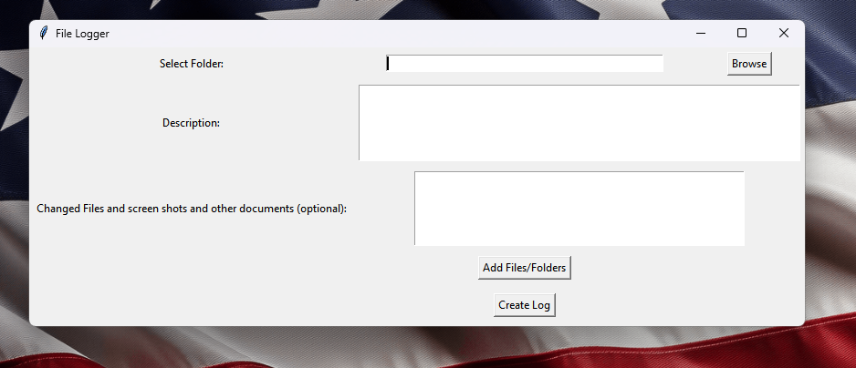

You will see the program open.

First select the folder you would like to save the Log files to. Click the Browse button.   
  
The Browse button will open the file navigation. You can navigate to the folder and select it. Then it returns to the File Logger program.  
  
Add a descripton in text of the changes you are making to the file.   
  
If this is a new archive please say something like beginning of archived files in the Description box.  
  
Next choose Add Files/Folders. You must select a base folder before you can select files and folders to archive.

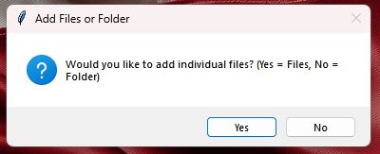  
  
You will see this pop up menu.  
Select “Yes” to add individual files or “No” to add whole folders.   
  
**WARNING:** Keep in mind **you cannot add the Log folder or the Folder you selected earlier with Browse as this would cause a recursive issue.** Not to worry though! This program has been coded to protect from recursive issues, however **DO NOT SELECT THE PARENT DIRECTORY OR C DRIVE OR ANYTHING LARGE**. **WARNING: This program must be used properly and the developer and its AI accept no liability for its improper usage.   
  
Finishing Up**

Next click “Create Log”.  
  
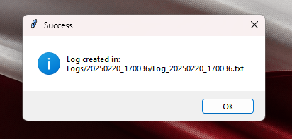  
  
CONGRATULATIONS! You DID IT

If you see the Pop up then your archive was successful.   
  
**Understanding the Log Folders**

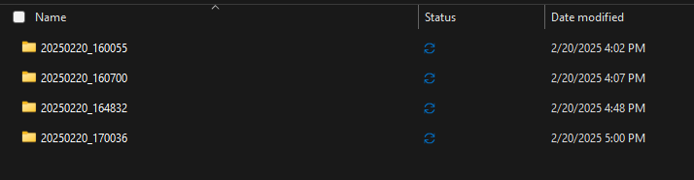

Inside of the directory there will be a folder called Logs that is all new. You can open it up.

Inside you can see your initial log and any new logs that have been added.   
  
The number string cooresponds to a date.   
  
For example:   
  
20250220_170036

Let’s break it down!!!   
  
2025 - 02 - 20 _ 17:00:36  
Its saying this was made Feb. 20, 2025 at about 5:00 PM using Military Time.

What’s inside?  
  
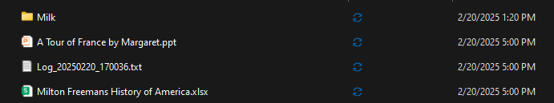  
  
Here’s an example of what’s inside the archive. I’ve created some sample files for this example.   
  
You can see that I archived a folder called “Milk” and that I archived two made up files named “A Tour of France by Margaret.ppt” and “Milton Freemans History of America.xlsx”. These were made up names for the example.   
  
For the geometry server you would be storing on the first archive all the files within the folder that are pertenent (probably all of them) for the first archive. Then, as you make changes to the files you will manually ammed the archive and then select the changed files and save them to a new log with the description of the changes made.   
  
What’s nice about this approach is it requires nothing extra. This is a no frills approach. There’s nothing you have to pay for or install. It just works. You can add your files like Request for Quote, you can add part prints, you can add whatever you want really. Screenshots or a detailed Word file. And you can even add things to these folders outside of the program. The program just gives you a quick way of getting everything posted together into the log at one time.   
  
  
  
  
  
  
  
  
  
  
  
  
  
  
  
  
  
  
  
  
  
  
  
  
  
  
  
  
  
  
  
**DEVELOPER NOTES:**  
  
Used Grok3 AI to make this.  
  
Use Python 3.12.0 Oct. 2 2023

Navigate to the directory

Use pyinstaller

Run command:

pyinstaller --onefile --noconsole file_logger.py