WEEK 3 Questions
Hardik Garg 220962071

Q1 CODE

<!DOCTYPE html>
<html lang="en">
<head>
<meta charset="UTF-8">
<meta name="viewport" content="width=device-width, initial-scale=1.0">
<title>Table and Image Animation</title>
<script src="https://code.jquery.com/jquery-3.6.0.min.js"></script>
<style>
body {
text-align: center;
font-family: 'Poppins', sans-serif;
background-color: #f4f4f4;
margin: 0;
padding: 20px;
}
.container {
display: inline-block;
position: relative;
transition: transform 1s linear;
background: white;
padding: 20px;
border-radius: 10px;
box-shadow: 0 4px 10px rgba(0, 0, 0, 0.1);
margin-top: 40px; /* Increased margin to prevent button obstruction */
}
table {
border-collapse: collapse;
width: 100%;
margin-bottom: 20px;
border-radius: 8px;
overflow: hidden;
}
th, td {
border: 1px solid #ddd;
padding: 12px;
text-align: center;
}
th {
background-color: #4CAF50;
color: white;
font-weight: bold;
}
tr:nth-child(even) {
background-color: #f2f2f2;
}
tr:nth-child(odd) {
background-color: #e0e0e0;
}
/* Increased image size */
img {
width: 250px;
height: auto;
display: block;
margin: 20px auto;
border-radius: 8px;
box-shadow: 0 4px 8px rgba(0, 0, 0, 0.1);
}
.button-container {
margin-bottom: 20px;
}
button {
padding: 12px 25px;
font-size: 16px;
cursor: pointer;
background-color: #007BFF;
color: white;
border: none;
border-radius: 5px;
transition: background-color 0.3s;
margin: 5px;
}
button:hover {
background-color: #0056b3;
}
</style>
</head>
<body>
<!-- Buttons to move table and image -->
<div class="button-container">
<button id="moveLeftBtn">Move Left</button>
<button id="resetBtn">Reset Position</button>
</div>
<div class="container" id="content">
<table>
<tr>
<th>cat</th>
<th>name</th>
<th>age</th>
</tr>
<tr>
<td>safed billa</td>
<td>sambhav</td>
<td>20</td>
</tr>
<tr>
<td>kaala billa</td>
<td>ayush</td>
<td>18</td>
</tr>
<tr>
<td>brown billa</td>
<td>kunal</td>
<td>24</td>
</tr>
</table>
<!-- Custom image -->
<img src="img1.jpg" alt="Custom Image">
</div>
<script>
$(document).ready(function(){
$("#moveLeftBtn").click(function(){
$("#content").animate({"margin-left": "-200px"}, 1000);
});
$("#resetBtn").click(function(){
$("#content").animate({"margin-left": "0px"}, 1000);
});
});
</script>
</body>
</html>

OUTPUT
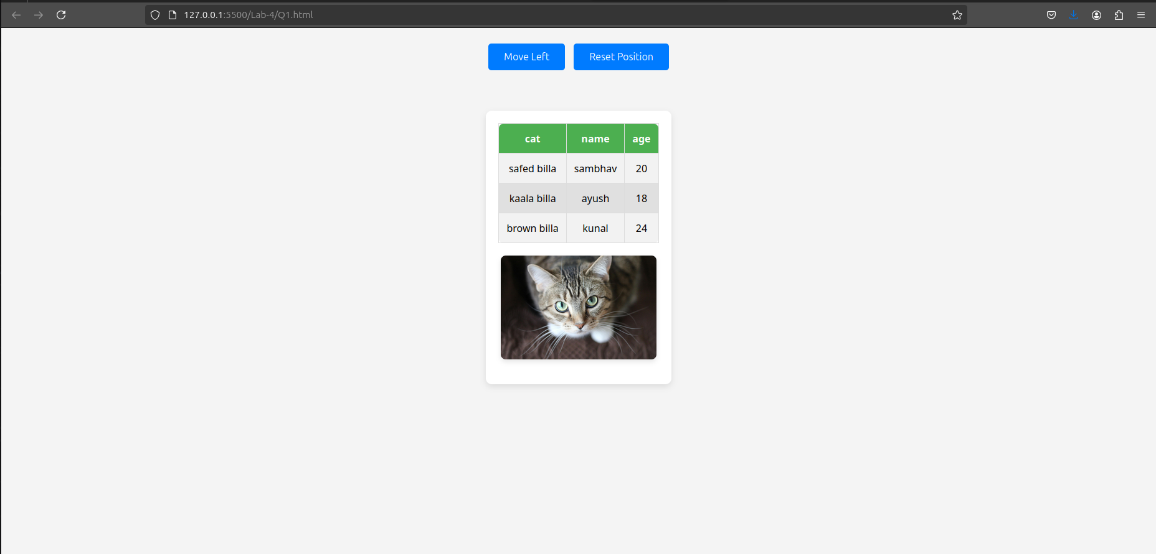
Q2 CODE
<!DOCTYPE html>
<html lang="en">
<head>
<meta charset="UTF-8">
<meta name="viewport" content="width=device-width, initial-scale=1.0">
<title>Calculator</title>
<script src="https://code.jquery.com/jquery-3.6.0.min.js"></script>
<style>
body {
text-align: center;
font-family: 'Times New Roman', Times, serif;
background-color: black;
padding: 30px;
}
.calculator {
display: inline-block;
background: pink;
padding: 20px;
border-radius: 10px;
box-shadow: 0 4px 10px rgba(0, 0, 0, 0.1);
text-align: center;
}
input {
width: 80px;
padding: 10px;
margin: 10px;
font-size: 18px;
text-align: center;
}
button {
padding: 10px 20px;
font-size: 18px;
cursor: pointer;
background-color: black;
color: pink;
border: none;
border-radius: 5px;
margin: 5px;
}
button:hover {
background-color: gray;
}
#result {
font-size: 20px;
margin-top: 40px;
}
</style>
</head>
<body>
<div class="calculator">
<h2>Calculator</h2>
<input type="text" id="num1" placeholder="Number 1">
<input type="text" id="num2" placeholder="Number 2">
<br>
<button id="add">+</button>
<button id="subtract">-</button>
<button id="multiply">×</button>
<button id="divide">÷</button>
<br>
<div id="result">Result: </div>
</div>

<script>
$(document).ready(function() {
function calculate(operation) {
let num1 = parseFloat($("#num1").val());
let num2 = parseFloat($("#num2").val());
let result;
if (isNaN(num1) || isNaN(num2)) {
$("#result").text("Please enter valid numbers");
return;
}
switch (operation) {
case 'add': result = num1 + num2; break;
case 'subtract': result = num1 - num2; break;
case 'multiply': result = num1 * num2; break;
case 'divide':
if (num2 === 0) {
$("#result").text("Cannot divide by zero");
return;
}
result = num1 / num2;
break;
}
$("#result").text("Result: " + result);
}
$("#add").click(function() { calculate('add'); });
$("#subtract").click(function() { calculate('subtract'); });
$("#multiply").click(function() { calculate('multiply'); });
$("#divide").click(function() { calculate('divide'); });
});
</script>
</body>
</html>
OUTPUT

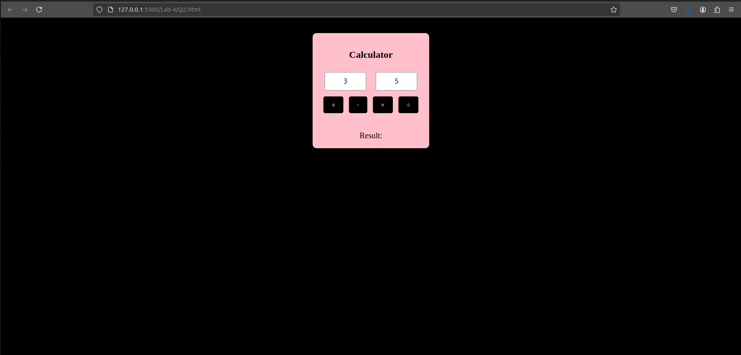
Q3 CODE

<!DOCTYPE html>
<html lang="en">
<head>
<meta charset="UTF-8">
<meta name="viewport" content="width=device-width, initial-scale=1.0">
<title>Birthday Card Designer</title>
<script src="https://code.jquery.com/jquery-3.6.0.min.js"></script>
<script src="https://cdnjs.cloudflare.com/ajax/libs/jspdf/2.5.1/jspdf.umd.min.js"></script>
<style>
body {
font-family: Arial, sans-serif;
text-align: center;
background-color: #f4f4f4;
padding: 20px;
}
.container {
display: flex;
justify-content: center;
align-items: center;
}
.controls {
padding: 20px;
background: darkseagreen;
border-radius: 10px;
box-shadow: 0 4px 10px rgba(0, 0, 0, 0.1);
margin-right: 20px;
}
.card {
width: 300px;
height: 400px;
padding: 20px;
text-align: center;
background-color: yellow;
border: 2px double black;
display: flex;
flex-direction: column;
justify-content: center;
align-items: center;
}
textarea {
width: 100%;
height: 60px;
}
button {
margin-top: 10px;
padding: 10px;
background-color: #007BFF;
color: white;
border: none;
border-radius: 5px;
cursor: pointer;
}
button:hover {
background-color: #0056b3;
}
</style>
</head>
<body>
<h1>Birthday Card Designer</h1>
<div class="container">
<div class="controls">
<label>Choose a background color:</label>
<input type="color" id="bgColor">
<br><br>
<label>Choose a font:</label>
<select id="fontStyle">
<option value="Arial">Arial</option>
<option value="Verdana">Verdana</option>
<option value="Times New Roman">Times New Roman</option>
</select>
<br><br>
<label>Font size:</label>
<input type="number" id="fontSize" value="25">
<br><br>
<label>Choose a border style:</label>
<select id="borderStyle">
<option value="none">None</option>
<option value="double">Double</option>
<option value="solid">Solid</option>
</select>
<br><br>
<input type="checkbox" id="addImage" checked> Add Default Image
<br><br>
<label>Enter greeting text:</label>
<textarea id="greetingText">Happy Birthday, and many more</textarea>
<br>
<button id="updateCard">Update</button>
<button id="exportPdf">Export as PDF</button>
</div>
<div class="card" id="card">
<h2 id="cardText">Happy Birthday, and many more</h2>
<img id="cardImage" src="img2.jpg" alt="Cake" width="150">
</div>
</div>
<script>
$(document).ready(function() {
$('#updateCard').click(function() {
$('.card').css('background-color', $('#bgColor').val());
$('#cardText').css({'font-family': $('#fontStyle').val(), 'font-size': $('#fontSize').val() + 'px'});
$('.card').css('border', '2px ' + $('#borderStyle').val() + ' black');
$('#cardText').text($('#greetingText').val());
$('#cardImage').toggle($('#addImage').is(':checked'));
});
$('#exportPdf').click(function() {
const { jsPDF } = window.jspdf;
let doc = new jsPDF();
doc.setFontSize(20);
doc.text($('#cardText').text(), 20, 40);
doc.save('birthday_card.pdf');
});
});
</script>
</body>
</html>

OUTPUT
