WEEK 2 WP LAB
Hardik Garg 220962071

Q1 code
<!DOCTYPE html>
<html lang="en">
<head>
<meta charset="UTF-8">
<meta name="viewport" content="width=device-width, initial-scale=1.0">
<title>Student Bio-data Form</title>
<style>
/* Reset some default styling */
* {
margin: 0;
padding: 0;
box-sizing: border-box;
}

/* Body Styling */
body {
font-family: Arial, sans-serif;
background-color: black;
display: flex;
justify-content: center;
align-items: center;
height: 100vh;
}

/* Form Container Styling */
.form-container {
background-color: beige;
padding: 30px;
border-radius: 10px;
box-shadow: 0 4px 15px rgba(0, 0, 0, 0.1);
width: 60%;
max-width: 800px;
min-width: 500px;
}

/* Form Heading */
h2 {
text-align: center;
margin-bottom: 20px;
color: black;
}

/* Label Styling */
label {
font-weight: bold;
margin-bottom: 8px;
display: block;
color: #555;
}

/* Input Textbox and Textarea Styling */
input[type="text"],
input[type="email"],
input[type="date"],
input[type="tel"],
textarea {
width: 100%;
padding: 12px;
margin-bottom: 20px;
border: 1px solid #ddd;
border-radius: 5px;
font-size: 16px;
background-color: #f9f9f9;
}

/* Button Styling */
button {
width: 100%;
padding: 12px;
background-color: black;
color: white;
border: none;
border-radius: 5px;
font-size: 18px;
cursor: pointer;
transition: background-color 0.3s;
}

button:hover {
background-color: red;
}

/* Textarea Styling */
textarea {
resize: none;
}

/* Group Radio Buttons */
.radio-group {
display:grid;
align-items: center;
justify-content: space-between;
gap: 20px;
margin-bottom: 20px;
}

.radio-group label {
font-weight: normal;
}

/* Group Checkbox Buttons */
.checkbox-group {
display: flex;
flex-wrap: wrap;
margin-bottom: 20px;
}

.checkbox-group label {
font-weight: normal;
margin-right: 20px;
}

/* Flexbox Layout for Form Fields */
.form-row {
display: flex;
justify-content: space-between;
gap: 20px;
}

.form-row div {
width: 48%;
}

/* Responsive Styling */
@media (max-width: 768px) {
.form-container {
width: 80%;
padding: 20px;
}

.form-row {
flex-direction: column;
gap: 0;
}

.form-row div {
width: 100%;
}
}

@media (max-width: 500px) {
.form-container {
width: 90%;
padding: 15px;
}
}
</style>
</head>
<body>
<div class="form-container">
<h2>Student Bio-data Form</h2>
<form>
<!-- Personal Information -->
<div class="form-row">
<div>
<label for="name">Full Name:</label>
<input type="text" id="name" name="name" required>
</div>
<div>
<label for="dob">Date of Birth:</label>
<input type="date" id="dob" name="dob" required>
</div>
</div>

<div class="radio-group">
<label>Gender:</label>
<div>
<input type="radio" id="male" name="gender" value="Male"><label for="male">Male</label>
<input type="radio" id="female" name="gender" value="Female"><label for="female">Female</label>
<input type="radio" id="other" name="gender" value="Other"><label for="other">Other</label>
</div>
</div>

<div class="form-row">
<div>
<label for="email">Email:</label>
<input type="email" id="email" name="email" required>
</div>
<div>
<label for="phone">Phone Number:</label>
<input type="tel" id="phone" name="phone" required>
</div>
</div>

<label for="address">Address:</label>
<textarea id="address" name="address" rows="4" required></textarea>

<!-- Education Information -->
<div class="form-row">
<div>
<label for="degree">Degree Program:</label>
<input type="text" id="degree" name="degree" required>
</div>
</div>

<label>Preferred Subjects:</label>
<div class="checkbox-group">
<div>
<input type="checkbox" id="math" name="subject" value="Math"><label for="math">Math</label>
</div>
<div>
<input type="checkbox" id="science" name="subject" value="Science"><label for="science">Science</label>
</div>
<div>
<input type="checkbox" id="english" name="subject" value="English"><label for="english">English</label>
</div>
</div>

<!-- Submit Button -->
<button type="submit">Submit</button>
</form>
</div>
</body>
</html>

Q1 Output
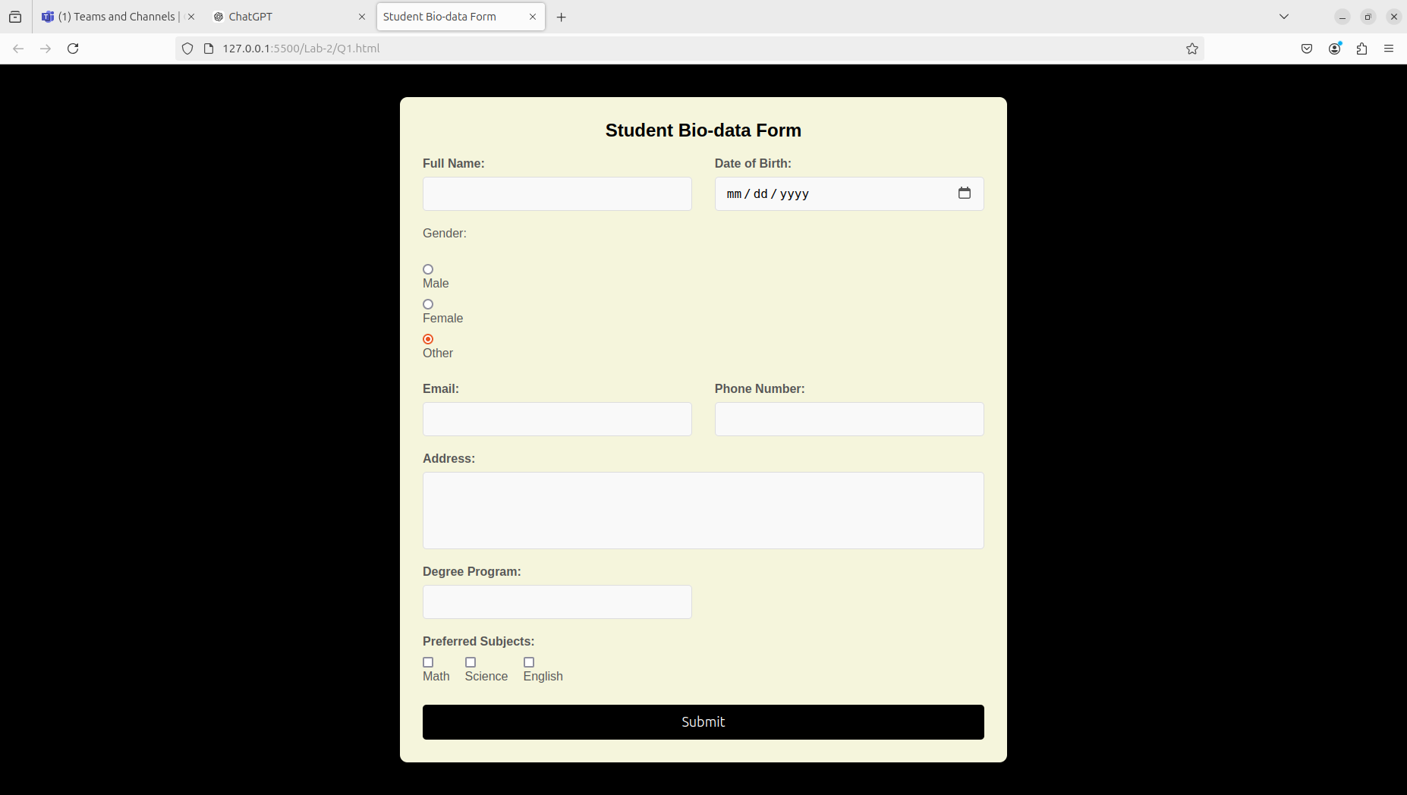
Q2
Code
<!DOCTYPE html>
<html lang="en">
<head>
<meta charset="UTF-8">
<meta name="viewport" content="width=device-width, initial-scale=1.0">
<title>Delhi Metro Ticket Booking</title>
<style>
body {
font-family: Arial, sans-serif;
background: linear-gradient(to bottom, #ffefd5, #f0e68c);
margin: 0;
padding: 0;
display: flex;
justify-content: center;
align-items: center;
height: 100vh;
}

.form-container {
background-color: #ffffff;
box-shadow: 0 8px 15px rgba(0, 0, 0, 0.2);
padding: 20px 30px;
border-radius: 10px;
width: 50%;
max-width: 600px;
border: 2px solid #4682b4;
}

.form-header {
text-align: center;
margin-bottom: 20px;
}

.form-header h1 {
font-size: 24px;
color: #4682b4;
}

.form-group {
margin-bottom: 15px;
}

.form-group label {
display: block;
font-weight: bold;
margin-bottom: 5px;
}

.form-group input,
.form-group select {
width: 100%;
padding: 10px;
font-size: 16px;
border: 1px solid #ccc;
border-radius: 5px;
}

.form-group input[type="radio"] {
width: auto;
margin-right: 10px;
}

.form-group .radio-label {
display: inline-block;
margin-right: 20px;
}

.form-group textarea {
width: 100%;
resize: none;
height: 80px;
padding: 10px;
font-size: 16px;
border: 1px solid #ccc;
border-radius: 5px;
}

.btn {
background-color: #4682b4;
color: white;
border: none;
padding: 10px 20px;
font-size: 18px;
border-radius: 5px;
cursor: pointer;
width: 100%;
}

.btn:hover {
background-color: #5a9bd5;
}

.footer {
text-align: center;
margin-top: 20px;
font-size: 14px;
color: #666;
}
</style>
</head>
<body>
<div class="form-container">
<div class="form-header">
<h1>Delhi Metro Ticket Booking</h1>
</div>
<form>
<div class="form-group">
<label for="fullName">Full Name:</label>
<input type="text" id="fullName" name="fullName" placeholder="Enter your full name" required>
</div>

<div class="form-group">
<label for="email">Email Address:</label>
<input type="email" id="email" name="email" placeholder="Enter your email address" required>
</div>

<div class="form-group">
<label for="phone">Phone Number:</label>
<input type="tel" id="phone" name="phone" placeholder="Enter your phone number" required>
</div>

<div class="form-group">
<label for="source">Source Station:</label>
<select id="source" name="source" required>
<option value="">-- Select Source Station --</option>
<option value="Rajiv Chowk">Rajiv Chowk</option>
<option value="Dwarka">Dwarka</option>
<option value="Noida City Centre">Noida City Centre</option>
<option value="Hauz Khas">Hauz Khas</option>
</select>
</div>

<div class="form-group">
<label for="destination">Destination Station:</label>
<select id="destination" name="destination" required>
<option value="">-- Select Destination Station --</option>
<option value="Rajiv Chowk">Rajiv Chowk</option>
<option value="Dwarka">Dwarka</option>
<option value="Noida City Centre">Noida City Centre</option>
<option value="Hauz Khas">Hauz Khas</option>
</select>
</div>

<div class="form-group">
<label>Ticket Type:</label>
<div class="radio-label">
<input type="radio" id="single" name="ticketType" value="Single" required>
<label for="single">Single Journey</label>
</div>
<div class="radio-label">
<input type="radio" id="return" name="ticketType" value="Return">
<label for="return">Return Journey</label>
</div>
</div>

<div class="form-group">
<label for="notes">Additional Notes:</label>
<textarea id="notes" name="notes" placeholder="Enter any additional information..."></textarea>
</div>

<button type="submit" class="btn">Book Ticket</button>
</form>
<div class="footer">
<p>&copy; 2025 Delhi Metro. All rights reserved.</p>
</div>
</div>
</body>
</html>

Q2 output
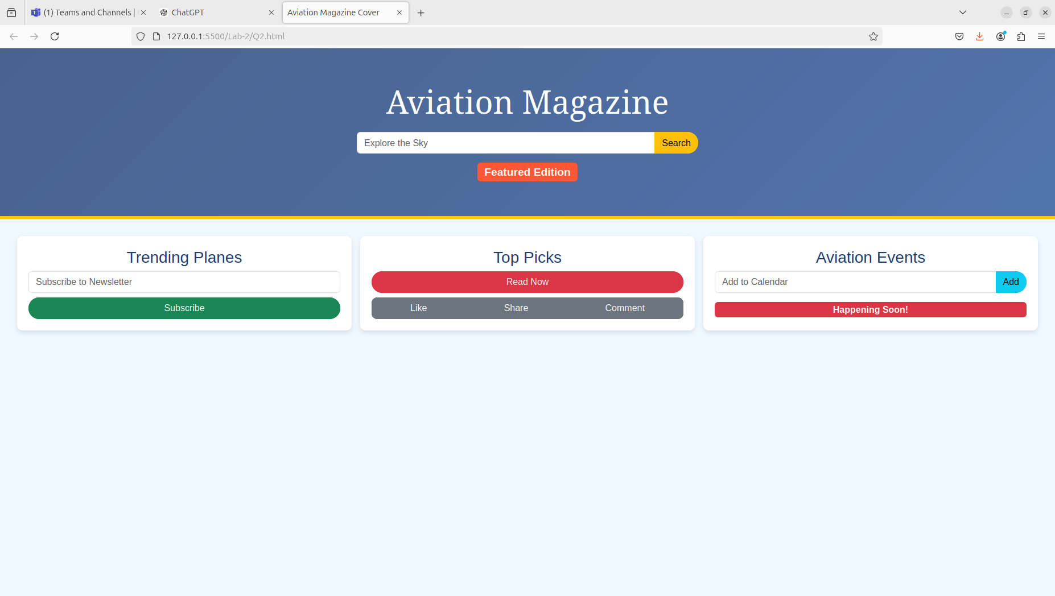
Q3
Code
<!DOCTYPE html>
<html lang="en">
<head>
<meta charset="UTF-8">
<meta name="viewport" content="width=device-width, initial-scale=1.0">
<title>Class Timetable</title>
<link href="https://cdn.jsdelivr.net/npm/bootstrap@5.3.0/dist/css/bootstrap.min.css" rel="stylesheet">
<style>
body {
font-family: 'Arial', sans-serif;
margin: 0;
padding: 0;
background-color: #f0f8ff;
}

.timetable-section {
padding: 40px;
background-color: #ffffff;
box-shadow: 0 4px 8px rgba(0, 0, 0, 0.1);
margin: 20px;
border-radius: 10px;
}

.carousel-inner img {
width: 100%;
height: 400px;
object-fit: cover;
}

table {
margin-top: 20px;
}

th {
background-color: #004085;
color: white;
}

td, th {
text-align: center;
vertical-align: middle;
}

.carousel-caption {
background-color: rgba(0, 0, 0, 0.5);
color: white;
padding: 10px;
border-radius: 5px;
}
</style>
</head>
<body>
<!-- Timetable Section -->
<div class="container">
<div class="timetable-section">
<h2 class="text-center mb-4">Class Timetable</h2>

<table class="table table-bordered">
<thead>
<tr>
<th>Day</th>
<th>9:00 AM - 10:00 AM</th>
<th>10:00 AM - 11:00 AM</th>
<th>11:00 AM - 12:00 PM</th>
<th>1:00 PM - 2:00 PM</th>
<th>2:00 PM - 3:00 PM</th>
</tr>
</thead>
<tbody>
<tr>
<td>Monday</td>
<td>Data Structures</td>
<td>Algorithms</td>
<td>Computer Networks</td>
<td>Operating Systems</td>
<td>Artificial Intelligence</td>
</tr>
<tr>
<td>Tuesday</td>
<td>Database Systems</td>
<td>Machine Learning</td>
<td>Web Development</td>
<td>Data Structures</td>
<td>Algorithms</td>
</tr>
<tr>
<td>Wednesday</td>
<td>Computer Networks</td>
<td>Operating Systems</td>
<td>Database Systems</td>
<td>Machine Learning</td>
<td>Artificial Intelligence</td>
</tr>
<tr>
<td>Thursday</td>
<td>Web Development</td>
<td>Data Structures</td>
<td>Algorithms</td>
<td>Computer Networks</td>
<td>Operating Systems</td>
</tr>
<tr>
<td>Friday</td>
<td>Machine Learning</td>
<td>Artificial Intelligence</td>
<td>Database Systems</td>
<td>Web Development</td>
<td>Data Structures</td>
</tr>
</tbody>
</table>
</div>

<!-- Carousel Section -->
<div id="carouselExample" class="carousel slide" data-bs-ride="carousel">
<div class="carousel-inner">
<div class="carousel-item active">
<img src="https://via.placeholder.com/800x400?text=AI+Workshop" class="d-block w-100" alt="AI Workshop">
<div class="carousel-caption">
<h5>Artificial Intelligence</h5>
<p>Discover the latest advancements in AI technology.</p>
</div>
</div>
<div class="carousel-item">
<img src="https://via.placeholder.com/800x400?text=ML+Class" class="d-block w-100" alt="ML Class">
<div class="carousel-caption">
<h5>Machine Learning</h5>
<p>Learn to build predictive models and analyze data.</p>
</div>
</div>
<div class="carousel-item">
<img src="https://via.placeholder.com/800x400?text=Data+Science+Event" class="d-block w-100" alt="Data Science Event">
<div class="carousel-caption">
<h5>Data Science</h5>
<p>Uncover insights from data with modern tools.</p>
</div>
</div>
</div>
<button class="carousel-control-prev" type="button" data-bs-target="#carouselExample" data-bs-slide="prev">
<span class="carousel-control-prev-icon" aria-hidden="true"></span>
<span class="visually-hidden">Previous</span>
</button>
<button class="carousel-control-next" type="button" data-bs-target="#carouselExample" data-bs-slide="next">
<span class="carousel-control-next-icon" aria-hidden="true"></span>
<span class="visually-hidden">Next</span>
</button>
</div>
</div>

<script src="https://cdn.jsdelivr.net/npm/bootstrap@5.3.0/dist/js/bootstrap.bundle.min.js"></script>
</body>
</html>

Q3 output
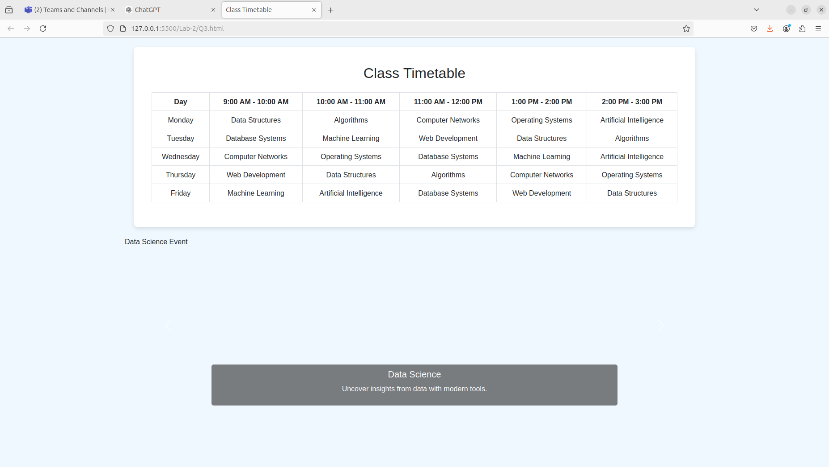
Q4
code
<!DOCTYPE html>
<html lang="en">
<head>
<meta charset="UTF-8">
<meta name="viewport" content="width=device-width, initial-scale=1.0">
<title>Delhi Metro Ticket Booking</title>
<style>
body {
font-family: Arial, sans-serif;
background: linear-gradient(to bottom, #ffefd5, #f0e68c);
margin: 0;
padding: 0;
display: flex;
justify-content: center;
align-items: center;
height: 100vh;
}

.form-container {
background-color: #ffffff;
box-shadow: 0 8px 15px rgba(0, 0, 0, 0.2);
padding: 20px 30px;
border-radius: 10px;
width: 50%;
max-width: 600px;
border: 2px solid #4682b4;
}

.form-header {
text-align: center;
margin-bottom: 20px;
}

.form-header h1 {
font-size: 24px;
color: #4682b4;
}

.form-group {
margin-bottom: 15px;
}

.form-group label {
display: block;
font-weight: bold;
margin-bottom: 5px;
}

.form-group input,
.form-group select {
width: 100%;
padding: 10px;
font-size: 16px;
border: 1px solid #ccc;
border-radius: 5px;
}

.form-group input[type="radio"] {
width: auto;
margin-right: 10px;
}

.form-group .radio-label {
display: inline-block;
margin-right: 20px;
}

.form-group textarea {
width: 100%;
resize: none;
height: 80px;
padding: 10px;
font-size: 16px;
border: 1px solid #ccc;
border-radius: 5px;
}

.btn {
background-color: #4682b4;
color: white;
border: none;
padding: 10px 20px;
font-size: 18px;
border-radius: 5px;
cursor: pointer;
width: 100%;
}

.btn:hover {
background-color: #5a9bd5;
}

.footer {
text-align: center;
margin-top: 20px;
font-size: 14px;
color: #666;
}
</style>
</head>
<body>
<div class="form-container">
<div class="form-header">
<h1>Delhi Metro Ticket Booking</h1>
</div>
<form>
<div class="form-group">
<label for="fullName">Full Name:</label>
<input type="text" id="fullName" name="fullName" placeholder="Enter your full name" required>
</div>

<div class="form-group">
<label for="email">Email Address:</label>
<input type="email" id="email" name="email" placeholder="Enter your email address" required>
</div>

<div class="form-group">
<label for="phone">Phone Number:</label>
<input type="tel" id="phone" name="phone" placeholder="Enter your phone number" required>
</div>

<div class="form-group">
<label for="source">Source Station:</label>
<select id="source" name="source" required>
<option value="">-- Select Source Station --</option>
<option value="Rajiv Chowk">Rajiv Chowk</option>
<option value="Dwarka">Dwarka</option>
<option value="Noida City Centre">Noida City Centre</option>
<option value="Hauz Khas">Hauz Khas</option>
</select>
</div>

<div class="form-group">
<label for="destination">Destination Station:</label>
<select id="destination" name="destination" required>
<option value="">-- Select Destination Station --</option>
<option value="Rajiv Chowk">Rajiv Chowk</option>
<option value="Dwarka">Dwarka</option>
<option value="Noida City Centre">Noida City Centre</option>
<option value="Hauz Khas">Hauz Khas</option>
</select>
</div>

<div class="form-group">
<label>Ticket Type:</label>
<div class="radio-label">
<input type="radio" id="single" name="ticketType" value="Single" required>
<label for="single">Single Journey</label>
</div>
<div class="radio-label">
<input type="radio" id="return" name="ticketType" value="Return">
<label for="return">Return Journey</label>
</div>
</div>

<div class="form-group">
<label for="notes">Additional Notes:</label>
<textarea id="notes" name="notes" placeholder="Enter any additional information..."></textarea>
</div>

<button type="submit" class="btn">Book Ticket</button>
</form>
<div class="footer">
<p>&copy; 2025 Delhi Metro. All rights reserved.</p>
</div>
</div>
</body>
</html>

Q4 output
