WEEK 3 Questions
Hardik Garg – 220962071

Q1 CODE
index.html

<!DOCTYPE html>
<html lang="en">
<head>
<meta charset="UTF-8">
<meta name="viewport" content="width=device-width, initial-scale=1.0">
<title>Online Quiz</title>
<link href="https://fonts.googleapis.com/css2?family=Poppins:wght@300;400;600&display=swap" rel="stylesheet">
<style>
body {
font-family: 'Poppins', sans-serif;
background: linear-gradient(to right, #ff7e5f, #feb47b);
margin: 0;
color: #fff;
text-align: center;
overflow-x: hidden;
}

/* Wrapper for centering and scrolling */
#wrapper {
display: flex;
flex-direction: column;
align-items: center;
width: 100%;
max-width: 800px;
padding: 20px;
box-sizing: border-box;
margin: 0 auto;
}

/* Ensure the body supports scrolling */
html, body {
height: 100%;
}

#wrapper {
min-height: 100vh;
}

/* Top container with "Quiz Time!" */
#top-container {
background: black;
padding: 20px 40px;
width: 100%;
border-radius: 15px 15px 0 0;
margin-bottom: 20px;
box-shadow: 0 4px 8px rgba(0, 0, 0, 0.1);
animation: fadeInTop 1s ease;
}

#top-container h2 {
font-size: 36px;
margin: 0;
text-transform: uppercase;
letter-spacing: 3px;
color: #fff;
font-weight: 600;
}

/* Main quiz container */
#quiz-container {
background: #fff;
border-radius: 15px;
padding: 30px;
width: 100%;
box-shadow: 0 10px 30px rgba(0, 0, 0, 0.1);
animation: fadeIn 1s ease;
overflow-y: auto;
}

h1 {
font-size: 28px;
margin-bottom: 20px;
color: #333;
font-family: 'Times New Roman', Times, serif;
text-transform: uppercase;
letter-spacing: 1.5px;
}

.question {
margin-bottom: 20px;
text-align: left;
}

.question h3 {
font-size: 20px;
color: #333;
margin-bottom: 10px;
}

.answers label {
display: block;
margin: 10px 0;
cursor: pointer;
font-size: 16px;
padding: 10px;
background: black;
border-radius: 5px;
transition: background 0.3s ease, color 0.3s ease;
}

.answers input {
display: none;
}

.answers input:checked + label {
background: #feb47b;
color: #fff;
border: 2px solid #ff7e5f;
}

.answers label:hover {
background: #ff7e5f;
}

.answers input:checked + label:hover {
background: white;
color: white;
}

#submit-btn {
background: #ff7e5f;
color: #fff;
border: none;
padding: 15px 30px;
font-size: 18px;
border-radius: 10px;
cursor: pointer;
transition: background 0.3s ease;
margin-top: 20px;
width: 100%;
}

#submit-btn:hover {
background: greenyellow;
}

.result {
margin-top: 20px;
font-size: 22px;
font-weight: 600;
color: #333;
}

@keyframes fadeIn {
0% { opacity: 0; }
100% { opacity: 1; }
}

@keyframes fadeInTop {
0% { opacity: 0; transform: translateY(-20px); }
100% { opacity: 1; transform: translateY(0); }
}

/* Ensure the page is responsive */
@media (max-width: 600px) {
#wrapper {
padding: 10px;
}

#quiz-container {
padding: 20px;
}

h1 {
font-size: 24px;
}

.question h3 {
font-size: 18px;
}

#submit-btn {
font-size: 16px;
padding: 12px 20px;
}
}

</style>
</head>
<body>

<div id="wrapper">
<div id="top-container">
<h2>Quiz Time!</h2>
</div>

<div id="quiz-container">
<h1>Online Quiz</h1>
<div id="quiz"></div>
<button id="submit-btn">Submit</button>
<div id="result" class="result"></div>
</div>
</div>

<script src="q1.js"></script>

</body>
</html>

Q1.js

// Define quiz questions and options
const quizQuestions = [
{
question: "What is the capital of France?",
options: ["Berlin", "Madrid", "Paris", "Lisbon"],
correctAnswer: 2
},
{
question: "Which planet is known as the Red Planet?",
options: ["Earth", "Mars", "Jupiter", "Saturn"],
correctAnswer: 1
},
{
question: "Who wrote 'Hamlet'?",
options: ["William Shakespeare", "Charles Dickens", "Jane Austen", "Mark Twain"],
correctAnswer: 0
},
{
question: "What is the largest ocean on Earth?",
options: ["Atlantic Ocean", "Indian Ocean", "Southern Ocean", "Pacific Ocean"],
correctAnswer: 3
}
];

// Function to display the quiz questions
function displayQuiz() {
const quizContainer = document.getElementById("quiz");
quizContainer.innerHTML = "";

quizQuestions.forEach((question, index) => {
const questionElement = document.createElement("div");
questionElement.classList.add("question");

const questionTitle = document.createElement("h3");
questionTitle.textContent = `${index + 1}. ${question.question}`;
questionElement.appendChild(questionTitle);

const answersContainer = document.createElement("div");
answersContainer.classList.add("answers");

question.options.forEach((option, optionIndex) => {
const label = document.createElement("label");
const input = document.createElement("input");
input.type = "radio";
input.name = `question${index}`;
input.value = optionIndex;
label.appendChild(input);
label.appendChild(document.createTextNode(option));
answersContainer.appendChild(label);
});

questionElement.appendChild(answersContainer);
quizContainer.appendChild(questionElement);
});
}

// Function to calculate the score
function calculateScore() {
let score = 0;

quizQuestions.forEach((question, index) => {
const selectedOption = document.querySelector(`input[name="question${index}"]:checked`);
if (selectedOption && parseInt(selectedOption.value) === question.correctAnswer) {
score++;
}
});

const resultElement = document.getElementById("result");
resultElement.textContent = `You scored ${score} out of ${quizQuestions.length}`;
resultElement.style.display = "block";
}

// Initialize the quiz
displayQuiz();

// Add event listener to the submit button
document.getElementById("submit-btn").addEventListener("click", calculateScore);

OUTPUT

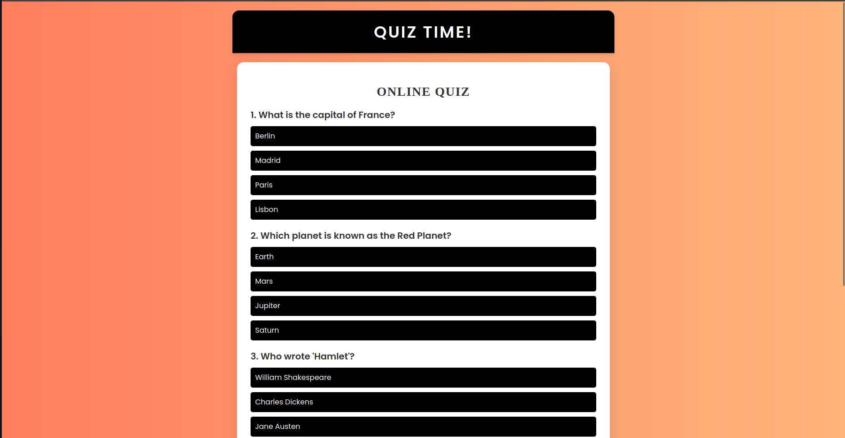
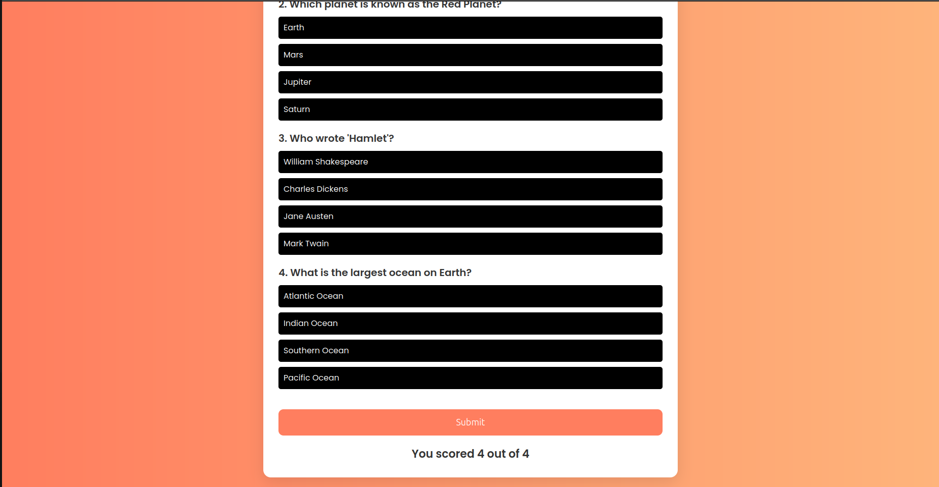
Q2 CODE
q2.html

<!DOCTYPE html>
<html lang="en">
<head>
<meta charset="UTF-8">
<meta name="viewport" content="width=device-width, initial-scale=1.0">
<title>Dynamic Clock & Greetings</title>
<link href="https://fonts.googleapis.com/css2?family=Poppins:wght@300;400;600&display=swap" rel="stylesheet">
<style>
body {
margin: 0;
font-family: 'Poppins', sans-serif;
display: flex;
justify-content: center;
align-items: center;
height: 100vh;
background: linear-gradient(to right, #6a11cb, #2575fc);
color: white;
text-align: center;
overflow: hidden;
}

.container {
background: rgba(255, 255, 255, 0.1);
border-radius: 20px;
padding: 30px;
box-shadow: 0 10px 30px rgba(0, 0, 0, 0.3);
max-width: 500px;
width: 90%;
text-align: center;
}

.greeting {
font-size: 24px;
font-weight: 600;
margin-bottom: 20px;
color: #ffda79;
}

.digital-clock {
font-size: 48px;
font-weight: bold;
color: white;
margin-bottom: 10px;
}

.date {
font-size: 18px;
font-weight: 400;
color: #f0f0f0;
}

.analog-clock-container {
margin: 30px auto;
width: 200px;
height: 200px;
}

button {
background-color: #ffda79;
color: #333;
font-size: 18px;
font-weight: 600;
border: none;
border-radius: 10px;
padding: 10px 20px;
cursor: pointer;
margin-top: 20px;
transition: 0.3s;
}

button:hover {
background-color: #ffd54d;
transform: scale(1.05);
}

@keyframes fadeIn {
0% { opacity: 0; transform: translateY(-20px); }
100% { opacity: 1; transform: translateY(0); }
}

.container {
animation: fadeIn 1.5s ease-in-out;
}
</style>
</head>
<body>
<div class="container">
<div class="greeting" id="greeting"></div>
<div class="digital-clock" id="clock"></div>
<div class="date" id="date"></div>
<div class="analog-clock-container">
<canvas id="analogClock" width="200" height="200"></canvas>
</div>
<button onclick="showGreeting()">Show Greeting</button>
</div>

<script>
// Function to update the digital clock and date dynamically
function updateClock() {
const now = new Date();
const hours = now.getHours().toString().padStart(2, '0');
const minutes = now.getMinutes().toString().padStart(2, '0');
const seconds = now.getSeconds().toString().padStart(2, '0');

const timeString = `${hours}:${minutes}:${seconds}`;
document.getElementById('clock').textContent = timeString;

const dateString = now.toDateString();
document.getElementById('date').textContent = dateString;

updateAnalogClock(); // Update the analog clock
setTimeout(updateClock, 1000);
}

// Function to determine greeting based on the hour
function getGreeting() {
const now = new Date();
const hours = now.getHours();

if (hours >= 5 && hours < 12) {
return "Good Morning! ☀️";
} else if (hours >= 12 && hours < 17) {
return "Good Afternoon! 🌤️";
} else if (hours >= 17 && hours < 21) {
return "Good Evening! 🌆";
} else {
return "Good Night! 🌙";
}
}

// Function to display greeting in a dialog box
function showGreeting() {
const greeting = getGreeting();
alert(greeting);
}

// Function to draw the analog clock
function updateAnalogClock() {
const canvas = document.getElementById('analogClock');
const ctx = canvas.getContext('2d');
const now = new Date();

const centerX = canvas.width / 2;
const centerY = canvas.height / 2;
const radius = Math.min(centerX, centerY) - 10;

// Clear canvas
ctx.clearRect(0, 0, canvas.width, canvas.height);

// Draw clock face
ctx.beginPath();
ctx.arc(centerX, centerY, radius, 0, Math.PI * 2);
ctx.fillStyle = '#fff';
ctx.fill();

// Draw clock border
ctx.lineWidth = 5;
ctx.strokeStyle = '#6a11cb';
ctx.stroke();

// Draw clock hands
const hours = now.getHours() % 12;
const minutes = now.getMinutes();
const seconds = now.getSeconds();

// Draw hour hand
drawHand(ctx, centerX, centerY, radius * 0.5, ((hours + minutes / 60) * 30) * (Math.PI / 180), 6);

// Draw minute hand
drawHand(ctx, centerX, centerY, radius * 0.7, ((minutes + seconds / 60) * 6) * (Math.PI / 180), 4);

// Draw second hand
drawHand(ctx, centerX, centerY, radius * 0.9, (seconds * 6) * (Math.PI / 180), 2, '#ff0000');

// Draw clock center
ctx.beginPath();
ctx.arc(centerX, centerY, 5, 0, Math.PI * 2);
ctx.fillStyle = '#333';
ctx.fill();
}

// Helper function to draw clock hands
function drawHand(ctx, x, y, length, angle, width, color = '#333') {
ctx.beginPath();
ctx.lineWidth = width;
ctx.strokeStyle = color;
ctx.moveTo(x, y);
ctx.lineTo(x + length * Math.cos(angle - Math.PI / 2), y + length * Math.sin(angle - Math.PI / 2));
ctx.stroke();
}

// Initial setup
document.addEventListener('DOMContentLoaded', () => {
// Display the initial greeting
document.getElementById('greeting').textContent = getGreeting();

// Start the dynamic clock
updateClock();
});
</script>
</body>
</html>

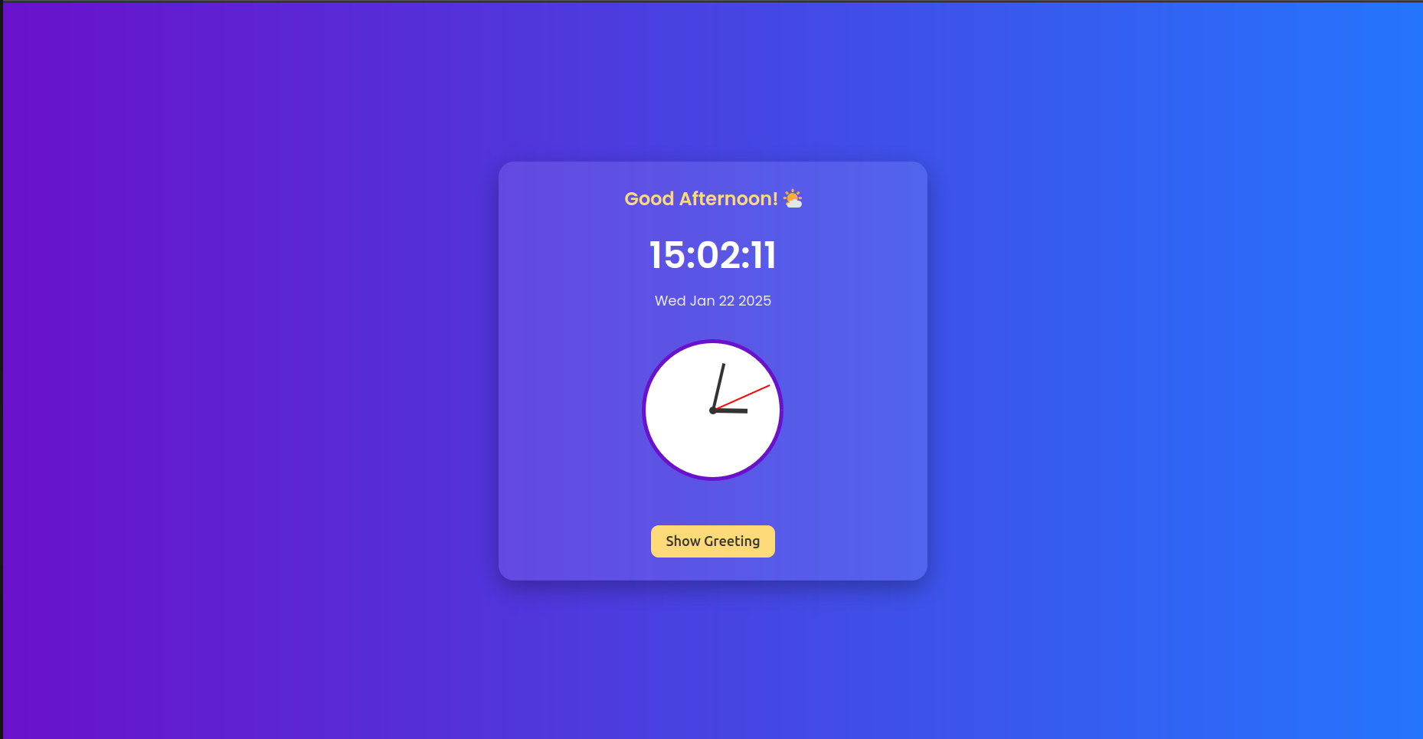
OUTPUT

Q3 CODE
q3.html

<!DOCTYPE html>
<html lang="en">
<head>
<meta charset="UTF-8">
<meta name="viewport" content="width=device-width, initial-scale=1.0">
<title>Grade Calculator</title>
<link href="https://fonts.googleapis.com/css2?family=Poppins:wght@300;400;600&display=swap" rel="stylesheet">
<style>
body {
margin: 0;
font-family: 'Poppins', sans-serif;
display: flex;
justify-content: center;
align-items: center;
height: 100vh;
background: linear-gradient(to right, #ff7e5f, #feb47b);
color: white;
}

.container {
background: rgba(255, 255, 255, 0.2);
border-radius: 20px;
padding: 30px;
box-shadow: 0 10px 30px rgba(0, 0, 0, 0.3);
max-width: 400px;
width: 100%;
text-align: center;
}

h1 {
font-size: 24px;
font-weight: 600;
margin-bottom: 20px;
}

input[type="number"] {
width: calc(100% - 20px);
padding: 10px;
margin: 10px 0;
font-size: 16px;
border: none;
border-radius: 5px;
outline: none;
}

button {
background-color: #fff;
color: #ff7e5f;
font-size: 18px;
font-weight: 600;
border: none;
border-radius: 10px;
padding: 10px 20px;
cursor: pointer;
margin-top: 20px;
transition: 0.3s;
}

button:hover {
background-color: #ffd1c1;
transform: scale(1.05);
}

.result {
font-size: 18px;
font-weight: 600;
margin-top: 20px;
color: #ffebcd;
}

.grade {
font-size: 24px;
font-weight: bold;
color: #fff;
}
</style>
</head>
<body>
<div class="container">
<h1>Grade Calculator</h1>
<input type="number" id="subject1" placeholder="Enter marks for Subject 1" min="0" max="100">
<input type="number" id="subject2" placeholder="Enter marks for Subject 2" min="0" max="100">
<input type="number" id="subject3" placeholder="Enter marks for Subject 3" min="0" max="100">
<input type="number" id="subject4" placeholder="Enter marks for Subject 4" min="0" max="100">
<button onclick="calculateGrade()">Calculate Grade</button>
<div class="result" id="result"></div>
</div>

<script>
function calculateGrade() {
// Get marks from input fields
const marks1 = parseFloat(document.getElementById('subject1').value) || 0;
const marks2 = parseFloat(document.getElementById('subject2').value) || 0;
const marks3 = parseFloat(document.getElementById('subject3').value) || 0;
const marks4 = parseFloat(document.getElementById('subject4').value) || 0;

// Calculate average
const average = (marks1 + marks2 + marks3 + marks4) / 4;

// Determine grade
let grade = '';
if (average > 90) {
grade = 'A';
} else if (average > 80) {
grade = 'B';
} else if (average > 70) {
grade = 'C';
} else if (average > 60) {
grade = 'D';
} else {
grade = 'F'; // Failing grade for averages <= 60
}

// Display result
const resultDiv = document.getElementById('result');
resultDiv.innerHTML = `
<p>Your Average: <span class="grade">${average.toFixed(2)}</span></p>
<p>Your Grade: <span class="grade">${grade}</span></p>
`;
}
</script>
</body>
</html>

OUTPUT
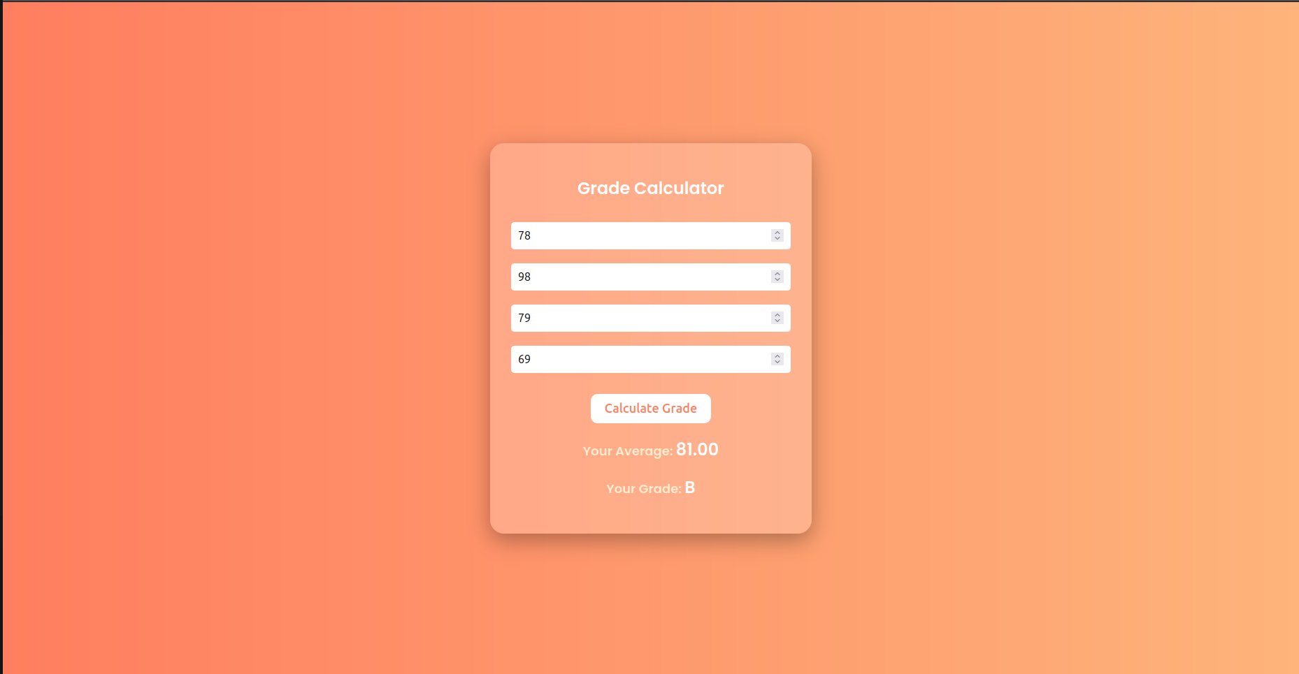
Q4 code
q4.html
<!DOCTYPE html>
<html lang="en">
<head>
<meta charset="UTF-8">
<meta name="viewport" content="width=device-width, initial-scale=1.0">
<title>Color Selector</title>
<style>
body {
font-family: Arial, sans-serif;
margin: 0;
padding: 20px;
display: flex;
flex-direction: column;
align-items: center;
justify-content: center;
height: 100vh;
background-color: #f9f9f9;
}

h2 {
margin-bottom: 20px;
}

.radio-group {
display: flex;
flex-direction: column;
align-items: flex-start;
}

.radio-group label {
font-size: 18px;
margin: 5px 0;
}

.color-box {
width: 200px;
height: 100px;
margin-top: 20px;
border: 2px solid #000;
background-color: red; /* Default color */
transition: background-color 0.3s ease-in-out;
}
</style>
</head>
<body>
<h2>Choose a Color</h2>
<div class="radio-group">
<label><input type="radio" name="color" value="red" checked onchange="changeColor()"> Red</label>
<label><input type="radio" name="color" value="green" onchange="changeColor()"> Green</label>
<label><input type="radio" name="color" value="blue" onchange="changeColor()"> Blue</label>
</div>
<div class="color-box" id="colorBox"></div>

<script>
function changeColor() {
// Get the selected color from the radio buttons
const selectedColor = document.querySelector('input[name="color"]:checked').value;
// Get the color box element
const colorBox = document.getElementById('colorBox');
// Change the background color of the box
colorBox.style.backgroundColor = selectedColor;
}
</script>
</body>
</html>

OUTPUT
